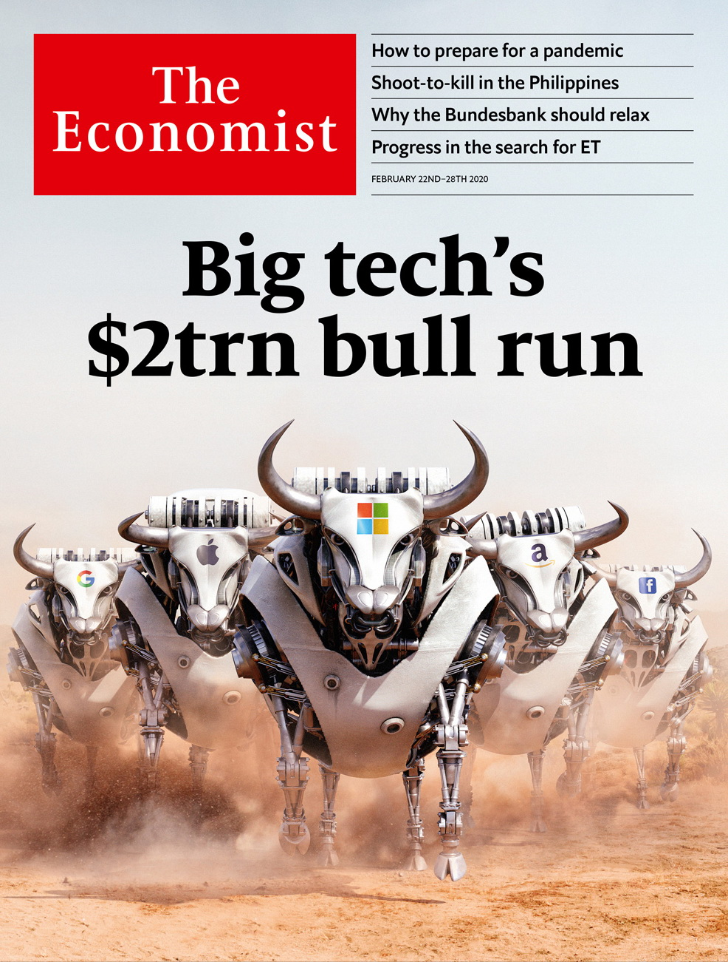

# Table of Contents

The world this week

Politics this week

Business this week

KAL’s cartoon

Leaders

Big tech: Big tech’s $2trn bull run

The Bundesbank and the ECB: Couples therapy

Britain’s legal system: Boris v the judges

Climate philanthropy: The great Bezos giveaway

Letters

Letters to the editor: On Clayton Christensen, Bernie Sanders, puberty blockers, private equity, police, China, sad songs

Briefing

The Philippines: Still the people’s choice

United States

South Carolina’s Democratic primary: Twilight of the moderates

The Democratic debate: Mike drop

Presidential approval ratings: A bogus bump

Peter Hotez, vaccine campaigner: Anger in a time of autism

Boy Scouts of America enters Chapter 11: Scout’s (dis)honour

Medicine and the law: Kidney failure

Gentrification in Washington, DC: A no Go-Go area

Lexington: The other war on migrants

The Americas

Uruguay’s next president: Changing the guard

Pipeline protests: Shut down Canada

Asia

Japan’s economy: Typhoon, pestilence and tax

Manufacturing in Australia: Holden folds

Marriage in Pakistan: Clawless clauses

Elections in Afghanistan: To the victor the toils

Banyan: Mandarins for Mandarin

China

The coronavirus epidemic: Casualties of war

Diplomatic rhetoric: Discovering Twitter

Chaguan: Putting faces to the numbers

Middle East and Africa

American policy in Africa: A strategy on autopilot

Voting in Africa: Why the young and rich vote less

Delivering letters in Congo: The postman never rings at all

South Sudan: Inching towards peace

Jews in Egypt: Welcome back, sort of

Arab states and the IMF: A bit too austere

Europe

France’s economy: The president’s paradox

French puritanism: Liaisons dangereuses

China v Sweden: Shotgun diplomacy

Russia v Yukos: Much ado about “such”

Orthodox Christianity: The sound of schism

Turkish justice: Guilty of caring

Charlemagne: How to mess up immigration

Britain

Constitutional reform: Judging the judges

Brexit negotiations: Will Britain lose its marbles?

Immigration policy: Points mean prizes

Brexit negotiations: Why Britain isn’t Canada

Trade unions: Uncomradely behaviour

Reshuffle revisited: Revolving doors

Members’ clubs: More woke than coke

Bagehot: The imperial prime minister

International

Covid-19: Watchful waiting

Special report

The data economy: Mirror worlds

Economics: Digital plurality

Infrastructure: Spreading out

Business: The new AI-ssembly line

Geopolitics: Virtual nationalism

Policy: And the winner is…

Business

Business and the next recession: Downturn, disrupted

Tech regulation: The Brussels effect, continued

Apple in China: Red plateau

Force majeure: A force to be reckoned with

Bartleby: Cutting the pie

Schumpeter: The CEO who loved me

Finance and economics

The Bundesbank: Spheres of influence

Labour hoarding: Are there too many central bankers?

HSBC pivots east, again: The incredible shrinking bank

Michael Milken: Friends in high places

Buttonwood: The cash bug

Cross-border capital flows: Following the money

Young, gifted and in the red: Student debt in America amounts to over $1.5trn

Free exchange: Shock therapy

Science and technology

The American Association for the Advancement of Science: Is there anybody out there?

Soil microbiology: Three’s company

Psychology: Face blind

Cell biology: An atlas of the innerverse

Books and arts

Histories of the web: Paradise lost

Jean history: Rhapsody in blue

Mountaineering wars: Summit diplomacy

Kurdish art: Remember, remember

Russian lives: The grey zone

Economic and financial indicators

Economic data, commodities and markets

Graphic detail

Discrimination in China: Call me maybe

Obituary

“Mad Mike” Hoare: Living dangerously



### Friday, February 21, 2020

|  |  |
| --- | --- |
| The world this week | 3 |
| Leaders | 5 |
| Letters | 1 |
| Briefing | 1 |
| United States | 8 |
| The Americas | 2 |
| Asia | 5 |
| China | 3 |
| Middle East and Africa | 6 |
| Europe | 7 |
| Britain | 8 |
| International | 1 |
| Special report | 6 |
| Business | 6 |
| Finance and economics | 8 |
| Science and technology | 4 |
| Books and arts | 5 |
| Economic and financial indicators | 1 |
| Graphic detail | 1 |
| Obituary | 1 |

|  |  |  |
| --- | --- | --- |
|  | Sections | Leaders |

The world this week

Politics this week

.

Business this week

.

KAL’s cartoon

.

|  |  |  |
| --- | --- | --- |
|  | Sections | Leaders |

|  |  |  |  |
| --- | --- | --- | --- |
|  | Articles | Sections | Next |

# Politics this week

Feb 22nd 2020 |

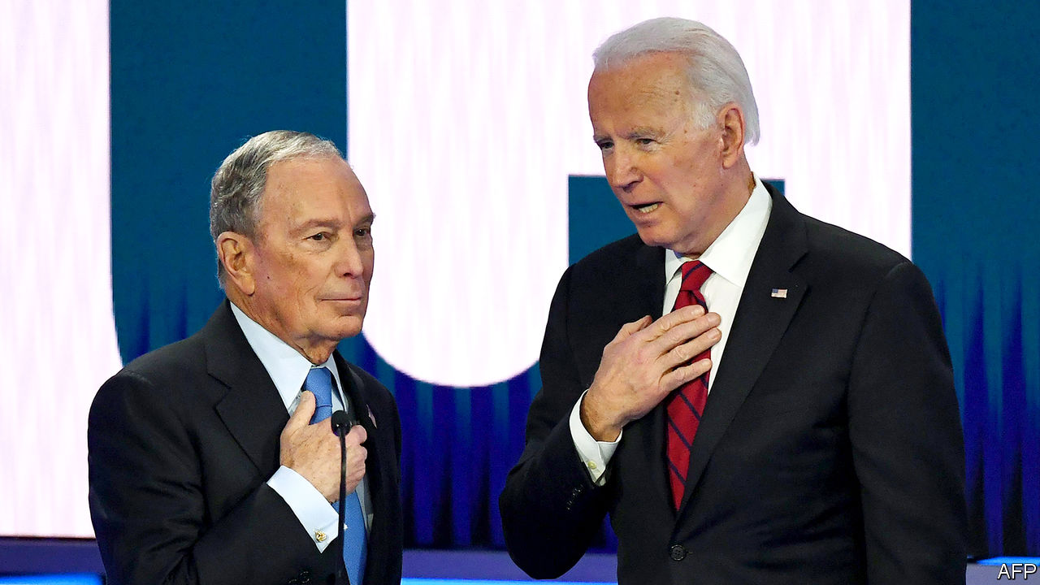

Mike Bloomberg took part in a Democratic presidential debate for the first time, after a surge in his opinion-poll standing qualified him for inclusion. The other candidates attacked him over lewd comments he has made in the past and his billionaire status. Mr Bloomberg will reportedly sell his media company if he is elected president. See [article](https://www.economist.com/node/21780473).

More than 2,600 former lawyers and officials from the Justice Department signed a letter calling on William Barr to resign as attorney-general. Mr Barr recently intervened to reduce the recommended sentence in the case of Roger Stone, a disgraced confidant of the president.

Using the power of the presidency Mr Trump pardoned a Who’s Who of business and political felons. These included Michael Milken, the “junk-bond king”, who was imprisoned in the 1990s, and Rod Blagojevich, a former governor of Illinois, whose prison sentence for trying to sell a Senate seat was commuted.

## Opening a new front

The UN-backed government of Libya pulled out of peace talks with representatives of Khalifa Haftar, a rebellious general, after his forces attacked the port of Tripoli. The government is based in the capital, which has been under siege by General Haftar’s forces for a year. Turkey has intervened on the side of the government. Egypt, Russia and the United Arab Emirates back General Haftar. The EU said it would patrol the eastern Mediterranean, enforcing a long-ignored UN arms embargo on Libya.

Recep Tayyip Erdogan, Turkey’s president, said it is “only a matter of time” before he launches an operation to stop the Syrian army’s offensive on Idlib, the last rebel-held province in Syria. The regime of Bashar al-Assad, which is backed by Russia, has rejected Turkey’s demands to pull back. Turkey, which has troops in the area and supports some of the rebels, fears a new influx of refugees. The UN says its aid operation is “overwhelmed”.

Dozens of people were killed in Burkina Faso and Mali in ethnic or jihadist violence. They include 24 people gunned down in a church in northwestern Burkina Faso; jihadists were blamed for that attack. The deterioration in security comes after France promised to send another 600 troops to help stabilise the region.

Government forces in Cameroon were blamed for an attack that killed 22 civilians including 14 children in an English-speaking region. The government said the incident was an “unfortunate accident” during a firefight with rebels.

## Terror on the streets

A gunman went on a shooting spree in the German city of Hanau, killing at least ten people and himself. The suspect was reported to have published racist videos and manifestos before the attack. Xenophobic terrorism in Germany appears to be growing; earlier this month police arrested 12 men suspected of planning attacks on mosques.

The British government set out plans to overhaul the immigration system. Workers from EU countries would be treated the same as non-EU workers if the plan becomes law. Fewer low-skilled migrants would be admitted, though the definition of “skilled” would expand. See [article](https://www.economist.com/node/21780426).

A Dutch appeals court reinstated an international court’s ruling that Russia owes $50bn to the shareholders of Yukos, an oil company it bankrupted and dismantled in 2003-07. The firm’s seizure was a battle between President Vladimir Putin and Mikhail Khodorkovsky, the CEO of Yukos, who had political ambitions. Russia will appeal against the verdict to the Dutch supreme court. See article.

A Turkish court acquitted a group of civic activists who took part in protests to save a park in Istanbul from development in 2013 of conspiring to overthrow the government. President Recep Tayyip Erdogan’s repression of civil society worsened after the Gezi Park demonstrations. Prosecutors immediately re-arrested one of the activists on charges of taking part in an attempted coup in 2016. See [article](https://www.economist.com/node/21780437).

## No hiding place

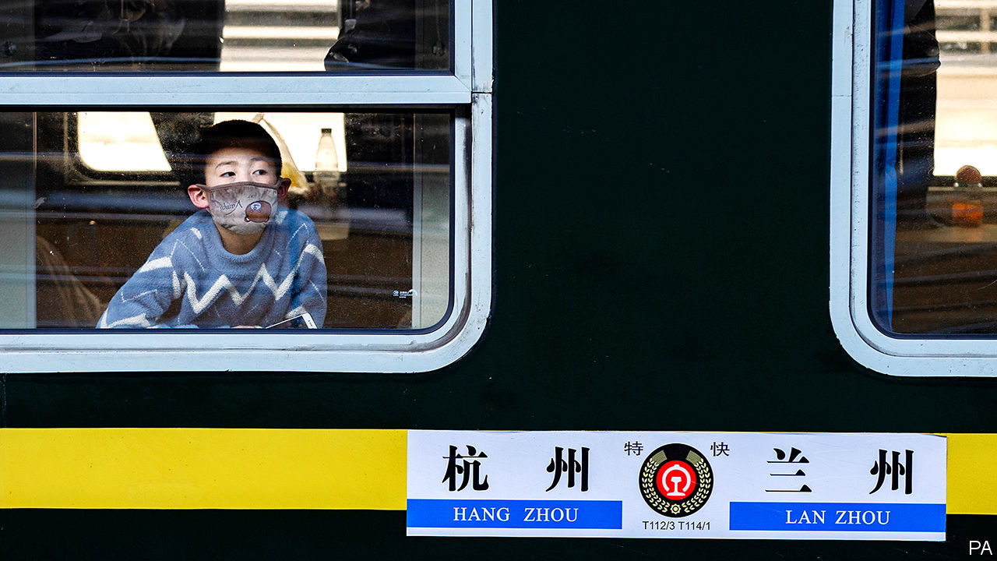

Despite a fall in daily numbers of newly confirmed infections, many places in China maintained tight controls to curb the spread of covid-19. In Wuhan, where the new coronavirus was first discovered, officials banned outdoor activities. Beijing required anyone entering from another province to undergo 14 days of quarantine. In Japan, the quarantine of a cruise ship, the Diamond Princess, wound down, with hundreds of passengers allowed to leave. Over 600 others had been infected with the virus; two people died. Russia all but barred visits by Chinese citizens. See article.

China announced the expulsion of three China-based correspondents of the Wall Street Journal. It said this was in response to the newspaper’s publication of an opinion piece under the headline “China is the real sick man of Asia”. A day earlier, America designated five Chinese state-linked news organisations as “foreign missions”.

Afghanistan’s electoral commission announced the results of the presidential election, five months after the vote was held. It said the incumbent, Ashraf Ghani, had won with 50.6% of the vote, narrowly avoiding a run-off. His closest rival, Abdullah Abdullah, dismissed the results as fraudulent and declared himself the winner. See article.

## Time for a haircut

IMF officials held a round of talks with Argentina. The IMF said the country’s debt position was now “unsustainable”, meaning that private creditors must make a “meaningful contribution”. The IMF expects Argentina to repay the money it lent the government in full.

In Canada a protest by indigenous groups and environmentalists against a proposed pipeline to transport gas to the Pacific coast shut one of the country’s busiest rail routes, disrupting passenger and freight trains. See article.

Jair Bolsonaro, Brazil’s president, appointed General Walter Braga as his new chief of staff, bringing to nine the number of men in the 22-member cabinet who come from the armed forces. Mr Bolsonaro is a former army captain. He has remarked that the third floor of his presidential office “is now completely militarised”.

All those military minds in the presidential palace are trained on the biggest threat to Brazil in the next 20 years: France. A leaked document from the defence ministry suggested that although China, Russia and even Venezuela could be considered bigger menaces, the top brass is worried that France might try to interfere in the Amazon, possibly launching an invasion from next door French Guiana. France is Brazil’s main military partner.

This article was downloaded by calibre from <https://www.economist.com/the-world-this-week/2020/02/22/politics-this-week>

|  |  |  |  |
| --- | --- | --- | --- |
|  | Articles | Sections | Next |

|  |  |  |  |
| --- | --- | --- | --- |
| Previous | Articles | Sections | Next |

# Business this week

Feb 22nd 2020 |

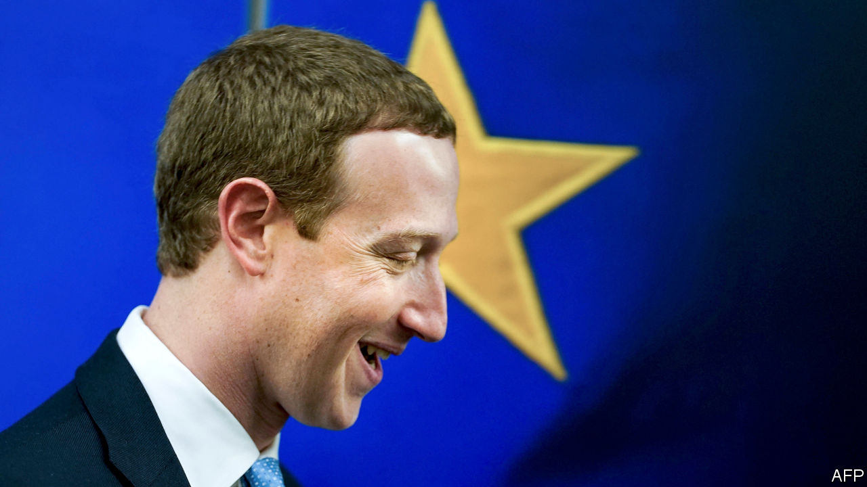

The European Commission published its wide-ranging digital strategy that, among other things, seeks a “guarantee” of human oversight over artificial intelligence and a raft of measures, such as data sharing, to restrain America’s tech giants. Mark Zuckerberg, Facebook’s boss, visited Brussels to push his alternative plan on regulating social-media content, which emphasises monitoring standards and systems rather than holding firms liable for content. See [article](https://www.economist.com/node/21780452).

The coronavirus outbreak in China caused Apple to lower its sales forecast for the quarter. The company said it was “experiencing a slower return to normal” than it had expected in a country where most of its products are assembled. Its renowned just-in-time supply chain has been disrupted by the restrictions on movement. See article.

HNA group, one of China’s most acquisitive conglomerates until the government told it and others to rein in their debt-fuelled spending, was reportedly on the verge of collapse. The group’s main asset is Hainan Airlines, which, along with other carriers in the region, has been hit hard by the coronavirus, complicating HNA’s debt- restructuring scheme.

A year after its merger plan with Siemens was derailed by the EU’s competition regulator, Alstom announced that it was buying Bombardier’s trainmaking business, which Bombardier valued at €7.5bn ($8.1bn). Alstom supplies many rail systems around the world (it built half the trains on the London Underground). The deal should help the French group compete against China’s globally ambitious state-backed train manufacturer, which has reportedly said it could build Britain’s HS2 high-speed rail line in just five years.

UBS appointed Ralph Hamers as its new chief executive. Mr Hamers currently headsING, a Dutch bank. He will start his new job in November, taking over from Sergio Ermotti, who turned the Swiss bank’s fortunes around after the tumult of the financial crisis.

Burdened with write-downs, HSBC’s pre-tax profit sank by a third last year, to $13.3bn. The bank announced yet another restructuring, slashing 35,000 jobs (analysts had expected 10,000), shedding $100bn in risk-weighted assets and shrinking its business in Europe and America in order to concentrate on Asia. See [article](https://www.economist.com/node/21780459).

## A common purpose

Royal Bank of Scotland also unveiled a new strategy, through which it will pare its investment-banking business and become a “purpose-led organisation” tackling green issues. RBS, still majority-owned by the taxpayer after its bail-out a decade ago, is changing its group name outside Scotland to NatWest.

Morgan Stanley announced a takeover of E*Trade, an online trading platform that specialises in retail clients. The $13bn deal is one of the biggest in finance since the global crisis of 2007-09. In another big acquisition, Franklin Templeton, an asset manager, said it would buy Legg Mason, a rival, for $6.5bn. The combined business will manage $1.5trn in assets.

Japan seemed to be heading for a recession, as data showed the economy shrinking by 6.3% at an annualised rate in the final quarter of 2019. A rise in the consumption tax was blamed; an increase to the tax in 2014 led to a similar contraction. See [article](https://www.economist.com/node/21780421).

Britain’s annual inflation rate leapt to 1.8% in January from 1.3% in December, raising questions about the prospect of an interest-rate cut from the Bank of England.

The Turkish central bank lowered its benchmark interest rate by half a percentage point, to 10.75%. That was the smallest in a series of cuts over the past year but keeps the bank on course to fulfil a pledge by Turkey’s president, Recep Tayyip Erdogan, to get the rate into single figures as he seeks a return to growth backed by credit. The cut complicates the government’s attempts to stabilise a weakening lira.

## Return of the jedi contract

A judge slapped a temporary injunction on Microsoft from working on the Pentagon’s Joint Enterprise Defence Infrastructure project, giving a new hope to Amazon in its legal claim that it was not awarded the contract because of Donald Trump’s feud with Jeff Bezos, the company’s boss. Amazon’s cloud-computing business had been the front-runner in the bidding for the $10bn contract. In a court filing, Amazon itself came under fire from Oracle, which questioned the incentives offered to two former Pentagon employees.

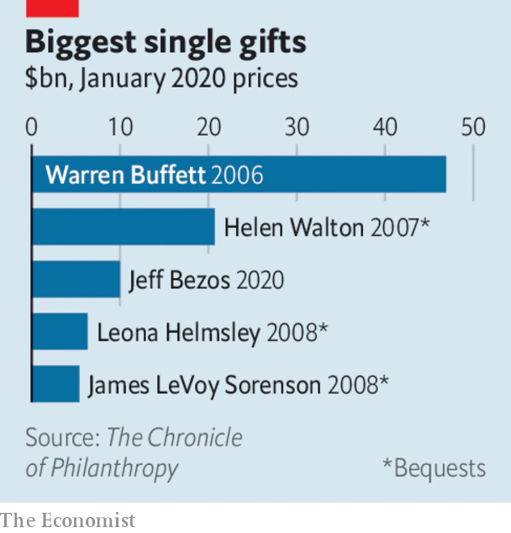

Under pressure from a green workers’ group at Amazon, Jeff Bezos pledged to give $10bn to scientists, activists and NGOs working to mitigate climate change. Amazon’s carbon footprint is substantial because of its vast delivery network and powerful data centres. “We can save Earth,” said Mr Bezos, who recently bought a sizeable chunk of earth when he paid $165m for a mansion estate in Beverly Hills. See article.

This article was downloaded by calibre from <https://www.economist.com/the-world-this-week/2020/02/22/business-this-week>

|  |  |  |  |
| --- | --- | --- | --- |
| Previous | Articles | Sections | Next |

|  |  |  |  |
| --- | --- | --- | --- |
| Previous | Articles | Sections | Next |

# KAL’s cartoon

Feb 22nd 2020 |

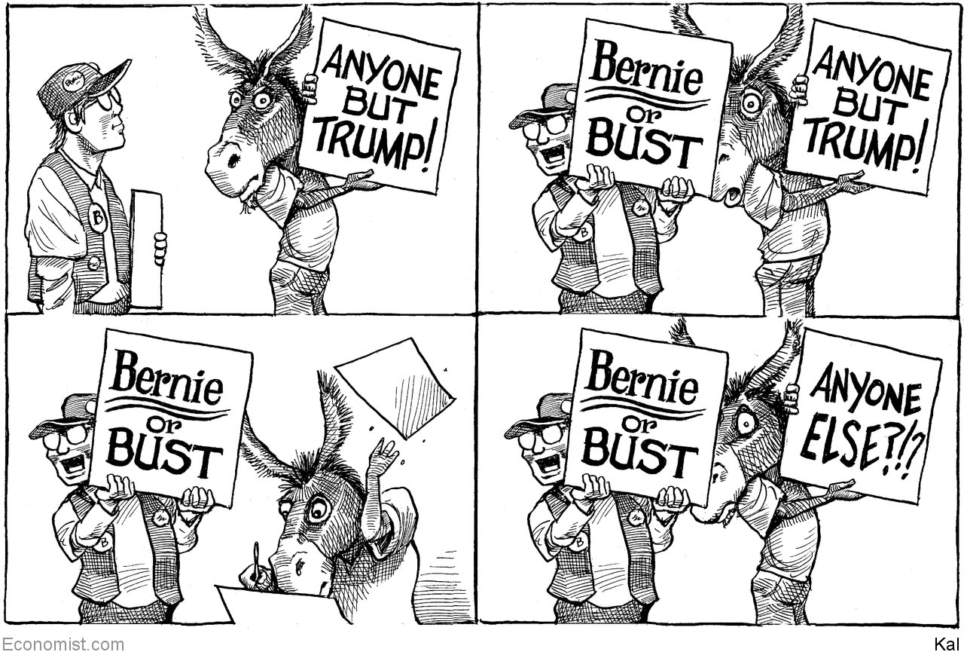

This article was downloaded by calibre from <https://www.economist.com/the-world-this-week/2020/02/22/kals-cartoon>

|  |  |  |  |
| --- | --- | --- | --- |
| Previous | Articles | Sections | Next |

|  |  |  |
| --- | --- | --- |
| The world this week | Sections | Letters |

Leaders

Big tech: Big tech’s $2trn bull run

.

The Bundesbank and the ECB: Couples therapy

.

Britain’s legal system: Boris v the judges

.

Climate philanthropy: The great Bezos giveaway

.

|  |  |  |
| --- | --- | --- |
| The world this week | Sections | Letters |

|  |  |  |  |
| --- | --- | --- | --- |
|  | Articles | Sections | Next |

#### Big tech

# How to make sense of the latest tech surge

The big tech firms’ shares have been on a tear

Feb 20th 2020 |

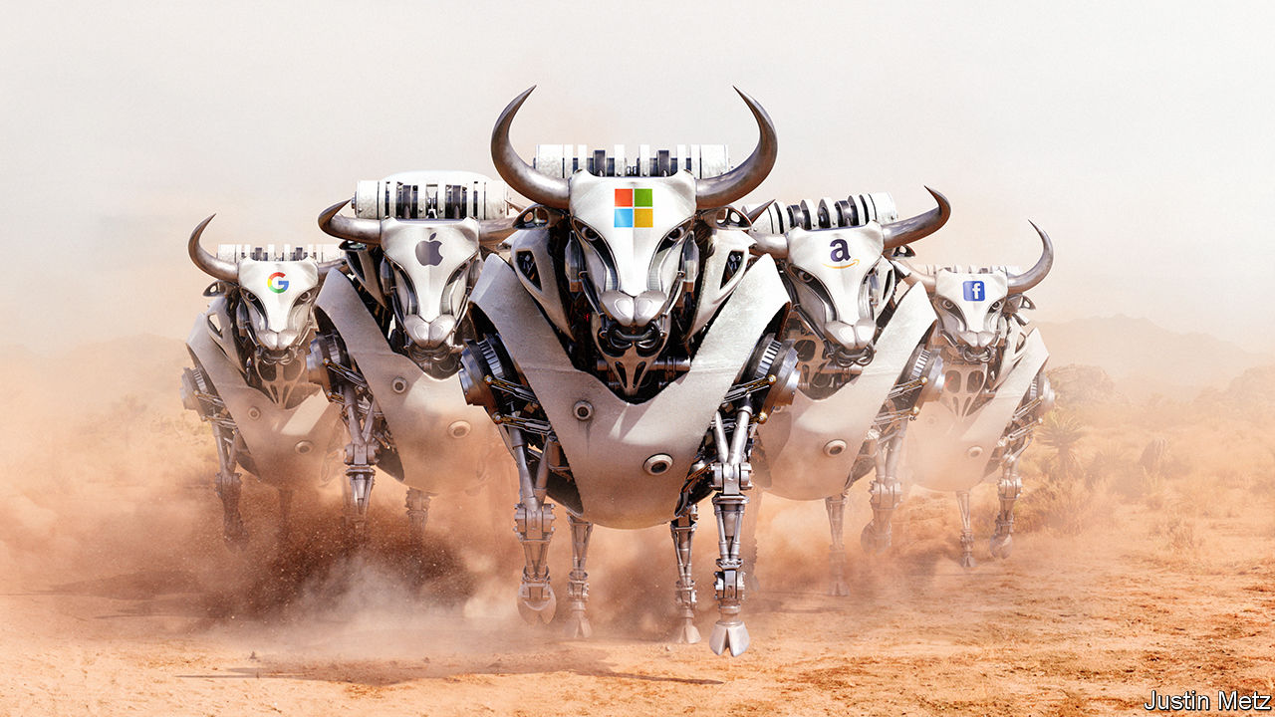

IN 2018 A new word entered Silicon Valley’s lexicon: the “techlash”, or the risk of a consumer and regulatory revolt against big tech. Today that threat seems empty. Even as regulators discuss new rules and activists fret about the right to privacy, the shares of the five biggest American tech firms have been on a jaw-dropping bull run over the past 12 months, rising by 52%. The increase in the firms’ combined value, of almost $2trn, is hard to get your head round: it is roughly equivalent to Germany’s entire stockmarket. Four of the five—Alphabet, Amazon, Apple and Microsoft—are each now worth over $1trn. (Facebook is worth a mere $620bn.) For all the talk of a techlash, fund managers in Boston, London and Singapore have shrugged and moved on. Their calculus is that nothing can stop these firms, which are destined to earn untold riches.

This surge in tech giants’ share prices raises two worries. One is whether investors have stoked a speculative bubble. The five firms, worth $5.6trn, make up almost a fifth of the value of the S&P 500 index of American shares. The last time the market was so concentrated was 20 years ago, before a crash that triggered a widespread downturn. The other, opposite concern is that investors may be right. The big tech firms’ supersized valuations suggest their profits will double or so in the next decade, causing far greater economic tremors in rich countries and an alarming concentration of economic and political power.

The question of a bubble is a reasonable one. Tech cycles are an integral part of the modern economy. The 1980s saw a semiconductor boom. Then, in the 1990s, came PCs and the internet. Each cycle fades or ends in a bust.

Today’s upswing got going in 2007 with the launch of the iPhone. By 2018 it, too, seemed to be showing its age. Sales of smartphones were stagnating. Data scandals at Facebook crystallised anger about the tech giants’ flippant approach to privacy. Global antitrust regulators were on the alert. And the loss-making antics of flaky tech “unicorns”, such as Uber and WeWork, evoked the kind of speculative froth often seen at the tail end of a long boom.

In fact, at least for the biggest tech giants, today’s valuations are built on more solid foundations. Together, the five biggest firms have cranked out $178bn of cashflow after investment in the past 12 months (see Buttonwood). Their size has yet to slow their expansion: their median sales growth, of 17% in the latest quarter, is still as impressive as it was five years ago.

Consumers say they care about privacy but act as if they care much more about getting stuff, and preferably without having to pay for it in cash. Since the end of 2018 the number of people using Facebook’s services (including Instagram, Messenger and WhatsApp) has risen by 11%, to 2.3bn. Regulators have punished tech firms for tax, privacy and competition misconduct, but so far their efforts have been like bringing a pea-shooter to a gun fight: the fines and penalties they have imposed amount to less than 1% of the big five’s market value, a tolerable cost of doing business. And the agonies of some of the unicorns, and their biggest backer, SoftBank, have only demonstrated how hard it is to replicate the scale and network effects of the big five.

Meanwhile, the size of the opportunity is vast. As our special report in this issue explains, many parts of the economy have yet to digitise. In the West only a tenth of retail sales are online, and perhaps a fifth of computing workloads sit in the cloud with the likes of Amazon and Microsoft. Big tech operates globally, giving it more space to expand, especially in emerging economies where spending on digital technology is still relatively low.

The trouble is that if you think that tech firms will get much bigger and diversify into more industries, from health care to agriculture, it is logical to assume that the backlash against them will not fade away but, eventually, get bigger.

As big tech’s scope expands, more non-tech firms will find their profits dented and more workers will see their livelihoods disrupted, creating angry constituencies. One crude measure of scale is to look at global profits relative to American GDP. By this yardstick, Apple, which is expanding into services, is already roughly as big as Standard Oil and US Steel were in 1910, at the height of their powers. Alphabet, Amazon and Microsoft are set to reach the threshold within the next ten years.

When recession strikes it will fuel new resentments. Big tech could face a storm that few have yet paid much attention to (see article). The big five firms employ 1.2m people and are now by far the biggest investors in corporate America, spending almost $200bn a year. Their decisions about whether to squeeze suppliers, slash investment or attack weaker rivals will prove as controversial as those of carmakers when Detroit still ruled in the 1970s, or even of Wall Street in 2007-08. Big tech’s role in politics is already toxic; social media and videos influence elections from Minnesota to Myanmar.

All this means that, far from having peaked, anger may be in the foothills. Executives hope that slick lobbying will protect them. But even today, the picture outside America is not of inaction but a tumult of regulatory experiments. China keeps its internet giants under tacit state control and wants to rely less on Silicon Valley, including Apple, which is already dealing with the covid-19 virus and other headwinds there. At least 27 countries have or are considering digital taxes. India has cracked down on e-commerce and online speech. The European Union (EU) wants individuals to own and control their own data, an approach this newspaper favours, although it may take years of innovation to create a system that is easy for consumers to use and profit from. This week the EU proposed curbs on artificial intelligence. Even in America, trustbusters may limit big tech’s ability to gobble up startups, a strategy which has been instrumental to the success of Alphabet and Facebook in particular.

## Just when you thought platforms were back in fashion

The $5.6trn market value of tech’s formidable five is a testament to some of the most commercially successful companies ever created. But it also assumes that they will get a lot bigger even as the world stands by and watches placidly. Until today, big tech has been largely unscathed. The bigger it becomes, the more reason there is to doubt this can continue.■

This article was downloaded by calibre from <https://www.economist.com/leaders/2020/02/20/how-to-make-sense-of-the-latest-tech-surge>

|  |  |  |  |
| --- | --- | --- | --- |
|  | Articles | Sections | Next |

|  |  |  |  |
| --- | --- | --- | --- |
| Previous | Articles | Sections | Next |

#### The Bundesbank

# Healing the rift in Europe’s single currency

The central bank is one of Germany’s most trusted institutions

Feb 22nd 2020 |

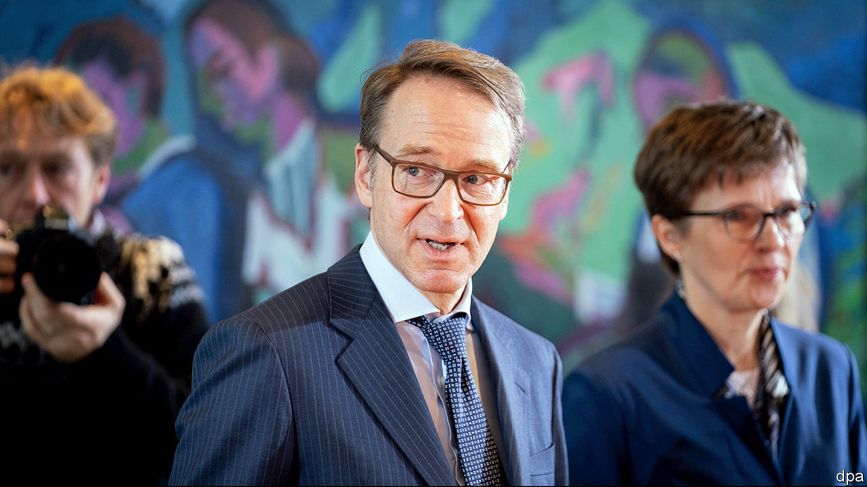

FEW POST-WAR economic institutions have been as successful as the Bundesbank. Its tough stance on inflation in the 1970s ensured that, while the world battled double-digit price rises, those in Germany were relatively contained. Its credibility with the public and markets was so strong that other countries were keen to harness its might, leading to the creation of the single currency in 1999. Jacques Delors, a European politician, once joked not all Germans believe in God, but they all believe in the Bundesbank. Others in Europe were ready converts, ceding monetary sovereignty to the European Central Bank (ECB), which is based in Frankfurt, and was at first heavily influenced by German economic doctrine.

The Bundesbank has a distinct role and identity—it represents Europe’s biggest economy at the ECB, runs payments systems, operates in the bond markets and continues to be admired by most Germans. But relations with the ECB have soured, partly as a result of the euro-zone sovereign-debt crisis. After 2011 influence gradually drained away from the Bundesbank and power became concentrated under Mario Draghi, then president of the ECB (see [article](https://www.economist.com/node/21780458)). His successor, Christine Lagarde, wants a fresh start. Both sides need to make up. If they do not, they risk a botched response to the next recession and a deadly seeping away of German voters’ trust in the euro.

Like most Germans, the Bundesbank has a horror of debt-monetisation and an aversion to inflation. Its austere philosophy has come into conflict with the ECB’s efforts to hold the euro together and prop up growth. In a court case in 2013 Jens Weidmann, the Bundesbank’s boss, gave evidence against Mr Draghi’s commitment to do “whatever it takes” to save the euro through unlimited bond purchases (outright-monetary transactions, or OMTs). By the end of Mr Draghi’s term, the quarrel seemed personal. Interest-rate cuts and the resumption of quantitative easing (QE) last autumn prompted a backlash in the German press. Mr Weidmann has supported rate cuts, but German public opinion has turned against the ECB on his watch. Bild, a German tabloid, has depicted Mr Draghi as a vampire feeding on German savings.

All central banks benefit from debate—indeed, some could do with more of it. But the stand-off could harm the ECB. When a downturn strikes, it cannot afford to be side-tracked by infighting. And recession is an ever-present risk. In the last quarter of 2019 output either fell or stagnated in France, Germany and Italy, which together make up around two-thirds of the euro zone’s GDP. Because interest rates are already negative, the ECB’s best hope for providing stimulus would be to buy more bonds. But this would eventually require raising the ECB’s self-imposed limits on the share of a country’s debt it can hold. The Bundesbank would almost certainly resist that.

A more insidious risk is a leaching away of faith in the single currency from its largest member state. That would be a disaster, undermining the viability of the euro in the long run, and posing a mortal threat to both the ECB and the Bundesbank.

Both sides have work to do. The Bundesbank is entitled to its own philosophy. But it needs to accept that the facts have changed. Its fears that loose monetary policy would cause a surge in inflation have not materialised. Agreeing to a proposal to make the ECB’s inflation target symmetrical around 2%, by removing the “close to, but below” wording, would signal that it is principled but not ideological. And it could wield its influence at home more effectively. Isabel Schnabel, Germany’s new pick for the ECB’s executive board, has begun to take on misconceptions of its policy—showing, for instance, that real interest rates on savings deposits in Germany are close to their average over the past 24 years. Mr Weidmann could do more to defend collective decisions.

In return for the Bundesbank taking more responsibility, the ECB should try to bring it back into the fold. On paper it makes decisions by consensus. But by the end of Mr Draghi’s term the dissenters were being left by the wayside.

So far the signs are promising. Ms Lagarde’s arrival makes it easier to leave behind the emotional baggage of the Draghi era. She has vowed to be more inclusive and launched a wide-ranging strategy review. This is an opportunity for Mr Weidmann. To his credit, he has become less uncompromising, saying last year that OMTs are part of the ECB’s toolkit, and cautioning against Germany fetishising its own fiscal rules. Ironing out the differences today could spare the ECB from a speculative attack in the next recession.

The Bundesbank is still a mighty intellectual and institutional force. But that will count for little if its intransigence causes Europe’s economy to weaken needlessly. And if the single currency falters, obstinacy will be self-defeating.■

This article was downloaded by calibre from <https://www.economist.com/leaders/2020/02/22/healing-the-rift-in-europes-single-currency>

|  |  |  |  |
| --- | --- | --- | --- |
| Previous | Articles | Sections | Next |

|  |  |  |  |
| --- | --- | --- | --- |
| Previous | Articles | Sections | Next |

#### British legal system

# Boris Johnson takes on the judges

The government wants to restrict the power of the judiciary. It shouldn’t

Feb 22nd 2020 |

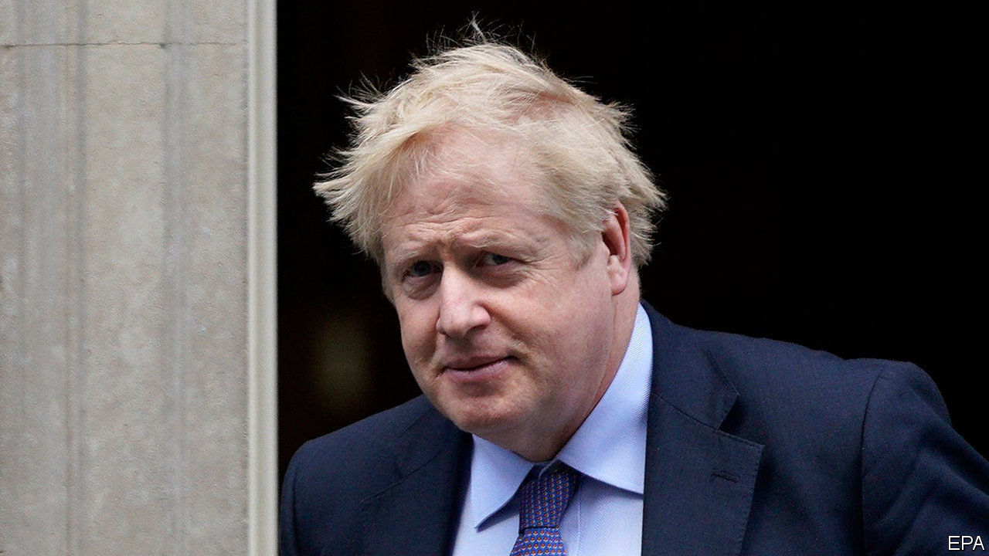

IN SEPTEMBER LAST year, when the Supreme Court overruled a government attempt to suspend Parliament during the Brexit negotiations, Boris Johnson called the decision “unusual”, but a source from Number 10 was franker: the court had made “a serious mistake in extending its reach into these political matters”. Payback, it seems, is coming. Mr Johnson has appointed a new attorney-general, Suella Braverman, who has made clear her enthusiasm for curbing the judiciary’s power (see article).

That the power of judges has grown in the past few decades is not in doubt. This is the consequence of three factors: the public’s growing enthusiasm for taking the government to court through judicial review; the spread of law to corners of people’s lives into which it did not previously much intrude (such as family life and the environment); and the Blair government’s espousal of constitutional reform.

Among Britain’s messy constitutional arrangements, the rules governing the judiciary’s role were particularly anomalous. The top judges, for instance, sat in the House of Lords, the legislature’s second chamber. Tony Blair’s new dispensation took the judges out of the Lords and housed them in a new Supreme Court over the road, removed the power of appointing judges from the government and gave it to an independent Judicial Appointments Commission, and extended the judges’ powers through the Human Rights Act (HRA).

This government takes the view that the balance of power has tipped too far from politicians and towards an unelected caste of lawyers whose views are out of kilter with voters’. The argument is not driven purely by the judges’ willingness to put Mr Johnson’s nose out of joint. There is a genuine worry among its proponents about a popular backlash against Britain’s system of government, of which Brexit is Exhibit A. Judicial decisions—over the rights of foreign criminals to avoid deportation, for instance, or British forces’ treatment of enemy fighters in the wars in Afghanistan and Iraq, or Muslim clerics preaching hatred of Britain—that are out of line with public opinion are said to be stoking popular anger. In an article on the Conservative Home website published last month, which was widely interpreted as a job application, Ms Braverman criticised the judiciary for “trespass[ing] into inherently political terrain for which a legal answer is wholly insufficient”.

The best way, goes this argument, of discouraging newspapers from labelling judges “enemies of the people”—as the Daily Mail did when the High Court decided that Parliament should have oversight of a decision about Brexit—is to reassert a degree of political control over judges. Three main proposals are under discussion: a review of judicial review; putting the judges back in the House of Lords; and reintroducing some sort of political control over judicial appointments.

Sinister headlines aside (though they are not entirely beside the point, since the author of the Mail’s is now Mr Johnson’s official spokesman), claims of a backlash against the judiciary are ill-founded. A recent survey found that, whereas 81% of Britons trust judges, just 14% trust politicians. Nor is judicial overreach to blame for most of the decisions that are said to outrage the public. The extension of the purview of law into previously personal areas of life and the rise of judicial review are the result of new legislation, and are thus the politicians’ fault.

If the government thinks that the state intrudes too far into people’s lives, then it could legislate to that effect, thereby also curtailing judicial review. And if it reckons the HRA does not have public support, then, although this newspaper would regret it, it could repeal the act.

For the executive to curb the judiciary directly would neither achieve those ends nor serve the British people. An independent judiciary is an essential check on the tendency of majorities to mistreat minorities and of executives towards authoritarianism. Enthusiasm for undermining that independence, as in Poland and Hungary, is a good indicator of a government’s authoritarian instincts. The Supreme Court should remain physically separate from the House of Lords, for that is an expression of its independence. Judicial appointments should also be kept safely beyond the reach of politicians. Where that is not so, partisan rows over appointments undermine faith in the courts. The former attorney-general, Geoffrey Cox, said that the government did not intend to go down the American route; it is to be hoped that Ms Braverman takes a similar view.

Post-Brexit, the government is in a radical mood. That is a good thing. It should be open to ideas about how Britain might do things better. Limiting the power and independence of judges is not among them.■

This article was downloaded by calibre from <https://www.economist.com/leaders/2020/02/22/boris-johnson-takes-on-the-judges>

|  |  |  |  |
| --- | --- | --- | --- |
| Previous | Articles | Sections | Next |

|  |  |  |  |
| --- | --- | --- | --- |
| Previous | Articles | Sections | Next |

#### Moonshots, from literal to metaphorical

# Jeff Bezos wants to help save the climate. Here is how he should do it

Make no small plans

Feb 22nd 2020 |

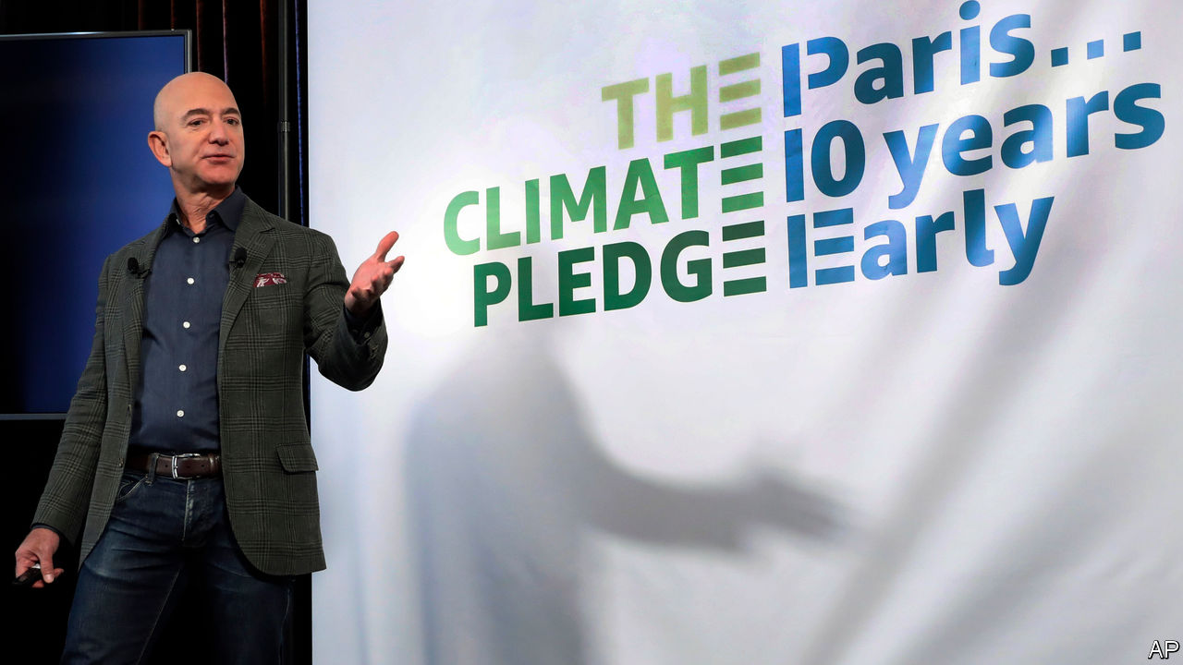

JEFF BEZOS, the boss of Amazon and the world’s richest man, has long had a reputation as a peculiarly frugal plutocrat. A quarter of a century after Amazon was founded, the firm, now worth over a trillion dollars, still does not pay dividends to its shareholders. Lately, though, his personal purse-strings have loosened. Earlier this month Mr Bezos paid $165m for a mansion in Beverly Hills. On February 18th he announced that he would be spending $10bn (around 8% of his fortune) setting up the Bezos Earth Fund. Climate change, he said, was the biggest threat facing humanity, and the fund’s resources would be available to any effort that offered a “real possibility to help preserve and protect the natural world”.

Mr Bezos has long been gripped by an environmentalist dream—albeit an unusual one. In the 1970s Gerard O’Neill, a Princeton physicist, advocated moving industry into orbit so that Earth’s environment could be repaired and preserved. Mr Bezos subscribes to this vision. He has invested billions of dollars in a rocketry firm, Blue Origin, devoted to the industrialisation of space. Now he is turning to the preservation of the Earth.

In the context of climate change, $10bn is both a lot and a little. The Earth Fund will have to hand out at least $500m a year to avoid tax penalties, and Mr Bezos could add to the pot. The next-biggest climate donor, the Hewlett Foundation, disburses around $120m a year in the area. But the scale of the problem dwarfs even Mr Bezos’s vast resources. The cost of meeting the Paris agreement, which aims to prevent the planet warming by more than 2°C, compared with pre-industrial levels, has been estimated at 2.5% of the world’s $86trn GDP every year.

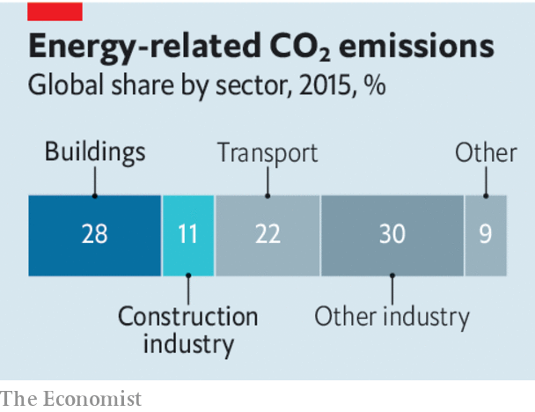

As a technically minded space cadet, though, Mr Bezos surely knows his Archimedes. Moving the Earth is not a matter of brute force, but of finding the right lever. There are, broadly, two types of leverage open to him. One is political: turn the tide of opinion and politics in America, thereby adding a superpower’s force to his efforts. The other is technological; take things that the market is ignoring and build them up to the point where, in the right political environment, they can make money for other people. Then watch those other people do just that.

The political route is risky. Existing philanthropies have spent a great deal of money trying to shift the debate in America, to little avail. It is also, potentially, over-subscribed. Mike Bloomberg—another climate-conscious billionaire—is spending vast sums to try to oust Donald Trump from the White House.

In technology, progress will come from putting large amounts in well-chosen areas outside the mainstream. There is little point in ploughing money into solar and wind power, or electric vehicles. Better to focus on taking the risk out of things which the world needs but markets will not yet invest in. Building full-scale pilot plants for emissions-free steel-smelting and concrete-making would be helpful. So, too, would creating farms that maximise both crop yields and carbon storage, becoming sinks for greenhouse gases instead of sources.

A smaller chunk of the fund could be reserved for technologies much further from acceptance. One such is solar geoengineering—cooling the Earth by reflecting away some incoming sunlight. In most discussion of climate action this approach, widely seen as unpalatable and dangerous, is sidelined. Although by no means a silver bullet, or even necessarily a desirable strategy, assessing how it might be undertaken in a responsible way deserves more attention. Funding is feeble at present—perhaps $20m a year worldwide. Mr Bezos could double that at the stroke of a pen.

His goal of creating a new civilisation in the heavens to save Earth remains far-fetched and, to many, unattractive. But he does not need to achieve that to speed up the fight against climate change. He just needs to spend copiously, but wisely. And that is how he got rich in the first place.■

This article was downloaded by calibre from <https://www.economist.com/leaders/2020/02/22/jeff-bezos-wants-to-help-save-the-climate-here-is-how-he-should-do-it>

|  |  |  |  |
| --- | --- | --- | --- |
| Previous | Articles | Sections | Next |

|  |  |  |
| --- | --- | --- |
| Leaders | Sections | Briefing |

Letters

Letters to the editor: On Clayton Christensen, Bernie Sanders, puberty blockers, private equity, police, China, sad songs

.

|  |  |  |
| --- | --- | --- |
| Leaders | Sections | Briefing |

|  |  |  |  |
| --- | --- | --- | --- |
|  | Articles | Sections | Next |

#### On Clayton Christensen, Bernie Sanders, puberty blockers, private equity, police, China, sad songs

# Letters to the editor

A selection of correspondence

Feb 22nd 2020 |

Letters are welcome and should be addressed to the Editor at letters@economist.com

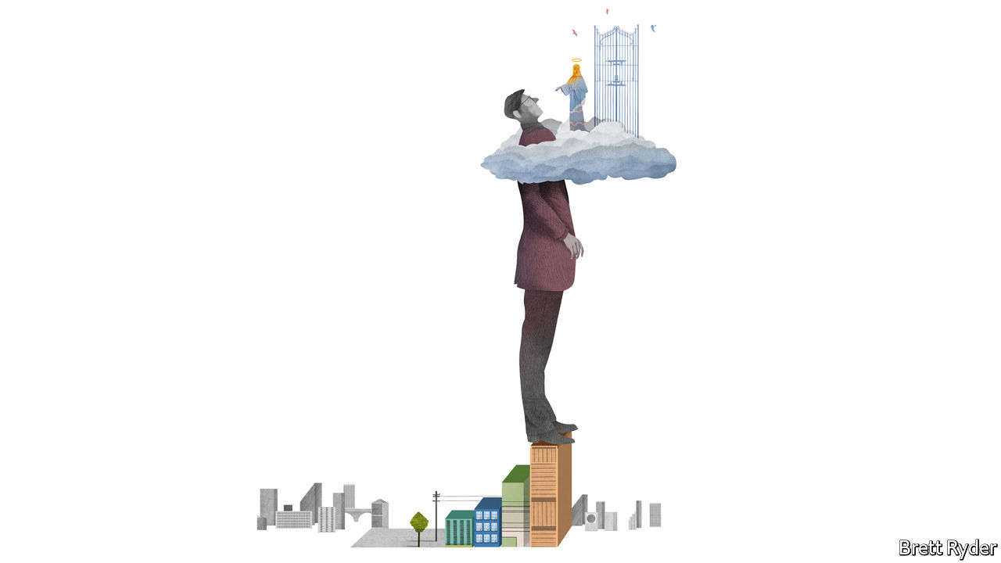

## Disruption and competition

Schumpeter’s otherwise worthy encomium for Clayton Christensen makes the mistaken claim that he asserted a monopoly on disruptive wisdom ([February 1st](https://www.economist.com/business/2020/01/30/clayton-christensens-insights-will-outlive-him)). After his seminal “The Innovator’s Dilemma”, Clayton only ever wrote with co-authors, and he took every opportunity to attribute the staying power of the theory to other writers, for he valued work that challenged the theory even more than work that confirmed it.

Furthermore, claiming that Clayton “shrugged off” Apple and “brushed off” Tesla and Uber is also mistaken. Clayton pointed out, correctly, that these companies were not following a disruptive path to success over rivals. Apple disrupted the personal computer, but it did not disrupt Nokia or BlackBerry: it out-competed them in good old-fashioned Michael Porter style. Clayton’s mistaken prediction that Apple would fail led him to develop a more careful specification of the limits of disruption theory, which places his work within the context of other theories that explain different phenomena. Subsequent analyses of Tesla and Uber (neither of which have followed disruptive paths regards relevant competitors) reflect this. That is a story of learning and progress to which we should all aspire.

MICHAEL RAYNOR  
Mississauga, Canada

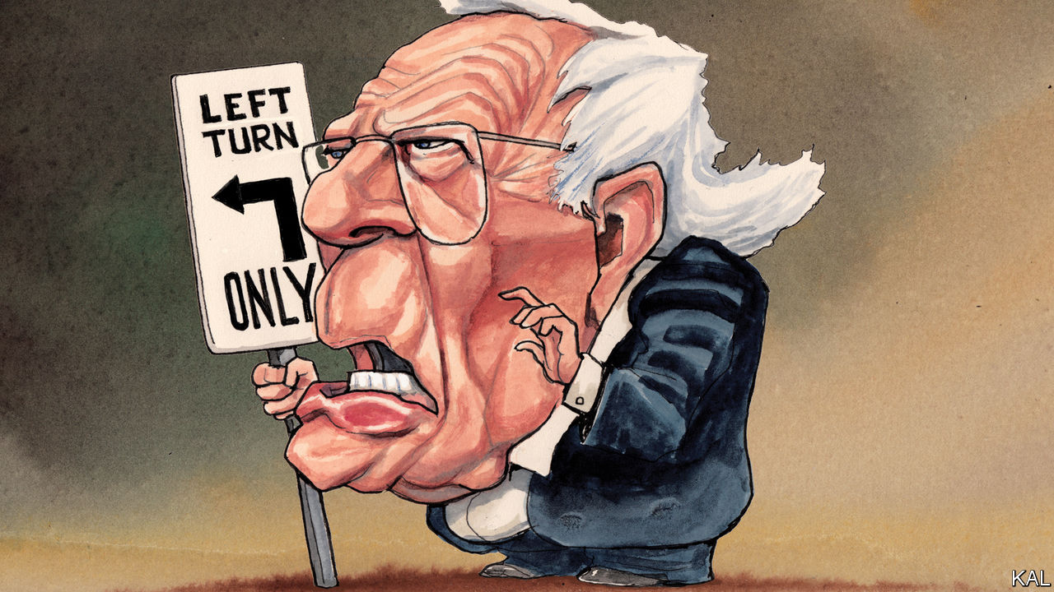

## Nevada? South Carolina?

The answer to Lexington’s question “Could it be Bernie?” is a resounding no ([January 25th](https://www.economist.com/united-states/2020/01/25/could-it-be-bernie)). It is inconceivable to me, a life-long Republican who will not be voting for Donald Trump, that the Democrats could choose the only person whom Mr Trump could beat. When Bernie Sanders jumped to the lead, Mr Trump tweeted nice things about him. He knows he can beat Bernie with an impeached arm tied behind his back. The Democrats’ mantra should be electability, plain and simple. Choosing Bernie would only show that they can screw up the sleeves on a vest.

STEPHEN COONEY  
Pottstown, Pennsylvania



## Treating transgender kids

Regarding puberty blockers for transgender children (“[Pill-pushers](https://www.economist.com/leaders/2020/01/30/what-to-do-about-puberty-blockers)”, February 1st), it broke our hearts to watch our brilliant, funny kid descend into a deep depression once puberty started. It took every ounce of courage she had to tell us she was transgender. We took her at her word, and have supported her these past two years as she began her transition. We were told of the risks of hormone therapy, but for us there was never any question. On hormones, our child has a chance for a happy and fulfilling life. Without them, we might have lost her, and that is a risk we simply were not willing to take.

JESSICA VETER  
Dundas, Canada

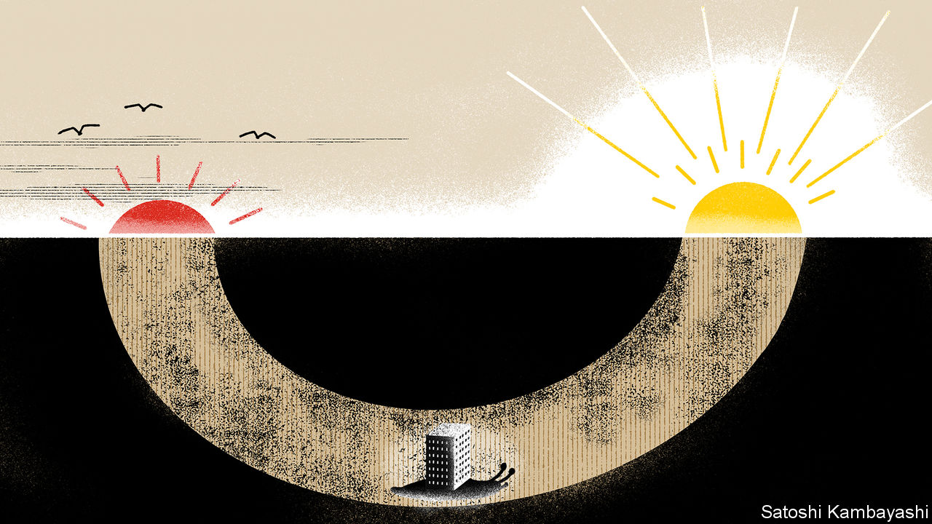

## Debt and private equity

Your otherwise excellent report on private markets repeated a well-known shibboleth in private equity (“[Privacy and its limits](https://www.economist.com/finance-and-economics/2020/01/30/everyone-now-believes-that-private-markets-are-better-than-public-ones)”, February 1st). This is the idea that buy-outs use high external debt levels to sharpen the performance of operating managers, which is sometimes called the “discipline of debt”.

For 30 years the story has been that high debt levels give buy-out managers a financial incentive to focus on maximising cashflow. On the face of it that sounds plausible. The flaw in the argument where private equity is concerned is that buy-out firms already have all the financial incentive they need: their “carried interest” typically pays them 20% of the profits they generate. The idea that buy-out firms need high interest payments as well as this incentive to focus on cashflow defies belief.

High debt levels in private equity are not just logically redundant. At least one empirical example shows high debt is unnecessary in practice, too. Melrose Industries, a publicly listed company, follows a strategy which it calls “Buy, Improve, Sell”. This is private equity in all but name. Melrose has generated high returns and its market capitalisation is now almost £12bn ($15.5bn). But Melrose has not needed high leverage. It makes a point of using the lower debt levels seen in quoted companies.

It suits buy-out insiders and investors to suggest that their use of high debt involves more than just financial engineering. Unfortunately, this idea fails to pass muster either in theory or in practice.

PETER MORRIS  
London

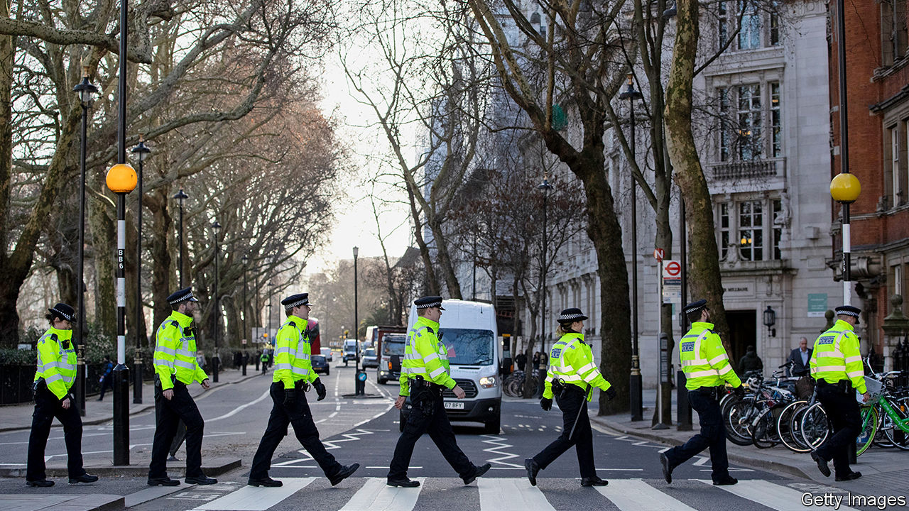

## Keep ’em peeled

Without more resources, you say, increasing the number of police officers in Britain will result in more of the accused in courts and more prisoners (“[What’s going wrong here?](https://www.economist.com/britain/2020/01/16/britains-20000-new-cops-wont-get-the-justice-ministry-celebrating)”, January 18th). But there is also an opportunity cost. Bobbies on the beat are associated with crime prevention. Potential criminals feel more restrained if detection rates improve and they think they could get caught. So if 20,000 extra police are put on the streets and into detection and technology channels, a lot of crime could be prevented.

DEEP SAGAR  
Former chair  
Audit and assurance board  
National Police Chiefs’ Council  
Berkhamsted, Hertfordshire

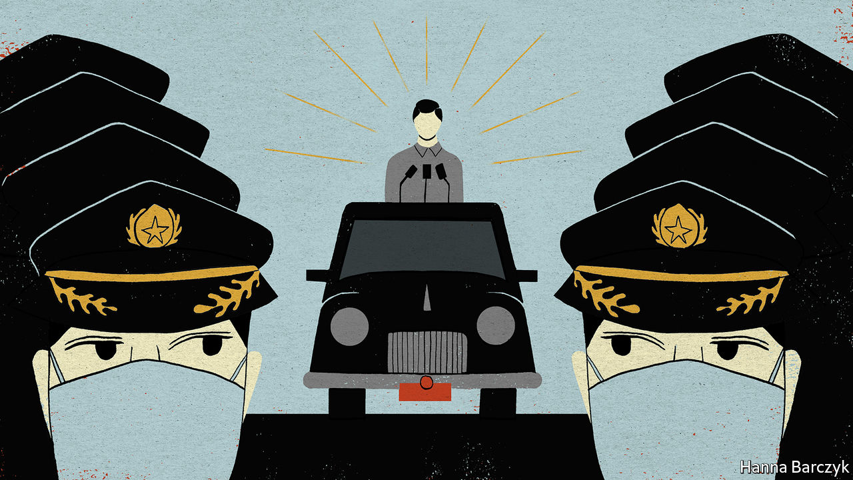

## The coronavirus epidemic

You hold a prejudice against China’s political system when reporting on the country’s fight against the coronavirus epidemic ([Chaguan](https://www.economist.com/china/2020/01/30/xi-jinping-wants-to-be-both-feared-and-loved-by-chinas-people), February 1st). The Communist Party puts a priority on people’s lives and health. President Xi Jinping has set up a task force to lead effective prevention and control, describing the coronavirus as a “devil”, which “we will not let hide”. Under strong leadership China has taken swift and concerted action to contain the disease. Information has been released in an open and transparent manner. China has closely co-operated with the WHO and the wider international community to safeguard the safety of people in Hubei province, in China and in the world.

Tedros Adhanom Ghebreyesus, the WHO’s director-general, has hailed the speed and scale of China’s actions. He has said that other countries should learn from China’s experience, pointing out that President Xi’s personal guidance and deployment show his great leadership capability.

Turning a blind eye to China’s hard efforts and their effective results and trying to politicise the issue is not conducive to the prevention and control of the novel coronavirus epidemic. The Chinese people are united and have full confidence that we can win this battle.

ZENG RONG  
Spokesperson of the Chinese Embassy  
London

## Love will tear us apart

The Graphic detail on why people listen to sad songs in February ([February 8th](https://www.economist.com/graphic-detail/2020/02/08/data-from-spotify-suggest-that-listeners-are-gloomiest-in-february)) brought to mind “The Saddest Music in the World”. Directed by Guy Maddin, known for his homages to Russian and German Expressionist films, it stars Isabella Rossellini as a brewery heiress with plexiglass prosthetic legs (filled with beer, of course). She holds a contest to find which country has the saddest music, parodying the Olympics. Great fun.

KEITH CARLSON  
Belmont, Massachusetts

Missing from your analysis was the Valentine’s Day factor. That’s the time when broken hearts get to see their ex-partner Instagramming cuddly pictures with their new catch. There’s no happiness in that.

ZUMME MPHATSO CHIRWA  
Blantyre, Malawi

This article was downloaded by calibre from <https://www.economist.com/letters/2020/02/22/letters-to-the-editor>

|  |  |  |  |
| --- | --- | --- | --- |
|  | Articles | Sections | Next |

|  |  |  |
| --- | --- | --- |
| Letters | Sections | United States |

Briefing

The Philippines: Still the people’s choice

.

|  |  |  |
| --- | --- | --- |
| Letters | Sections | United States |

|  |  |  |  |
| --- | --- | --- | --- |
|  | Articles | Sections | Next |

#### Shoot-to-kill in the Philippines

# Rodrigo Duterte’s lawless war on drugs is wildly popular

And he is unlikely ever to be held to account for it

Feb 22nd 2020 | MANILA

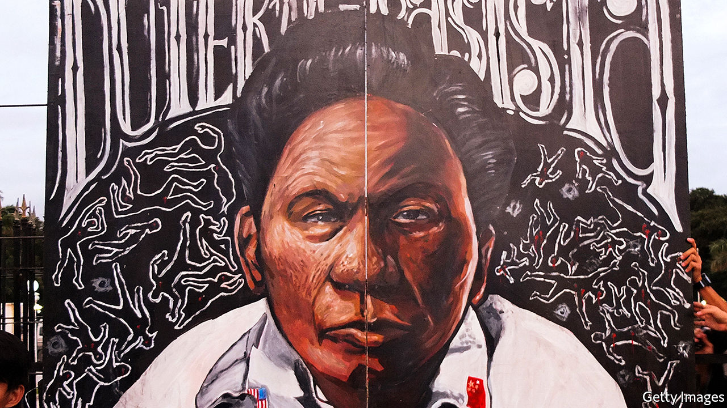

THE WOMEN agree among themselves. As field staff for Social Weather Stations (sws), a pollster in Metropolitan Manila, they find that the vast majority of Filipinos approve of President Rodrigo Duterte’s campaign against illegal drugs. People repeatedly tell them that they just want the drugs trade controlled, and the results of their inquiries show that almost two in three Filipinos believe that the number of drug users in their area has dropped since Mr Duterte came to power in 2016. Their own experience tells them something similar. They say they can now go about their polling in parts of drug-ravaged cities that were once too dangerous.

“Find them all and arrest them. If they resist, kill them all.” Mr Duterte’s hard line on drug dealers and other miscreants was at the core of his election campaign. The number of suspected criminals dispatched since his victory is hard to assess, but large. The country’s human-rights commission believes the total number of extra-judicial killings to be some 27,000. One can only guess how many private scores have been settled under cover of the drug war. The death toll bears comparison to the 30,000 who “disappeared” under the Argentinian junta of the late 1970s, though Argentina’s population was a lot smaller—there are 106m Filipinos.

The police, for their part, reported more than 23,000 “homicide cases under investigation” during the two years from July 2016; it is unclear how such cases are incorporated into the compilation of official crime statistics, and which involve drugs. Police data also show a 21.5% drop in reported crime over the same period. But Leni Robredo, the vice-president, claimed in January that figures presented to a government anti-drugs committee showed just 1% of the country’s total supply of crystal meth had been seized over the past three years. Ms Robredo is a staunch critic of the president—Filipinos elect their president and vice-president on separate tickets—and Mr Duterte’s allies derided her claim, though not always compellingly. The president’s spokesman argued that even if Ms Robredo’s calculations were accurate “it does not mean it’s a failure”.

In all this uncertainty, the costs of the bloodshed to Mr Duterte’s reputation are much easier to gauge. There have been almost none. Filipinos harbour few illusions about the drugs war. Polls published by SWS last month found that more than three in four see “many” human-rights abuses in the campaign; an even higher share believes that “ninja cops” sell on the drugs they have confiscated. Nevertheless, most Filipinos—including, often, people whose families have lost loved ones—continue to support the campaign and the man who promised it to them. More than three years into his six-year term he remains consistently popular. Filipino presidents often enjoy popularity for their first few years in office before falling quickly from grace, as Mr Duterte’s immediate predecessor, Benigno Aquino III, did (see chart 1). Mr Duterte looks likely to maintain his touch to the end.

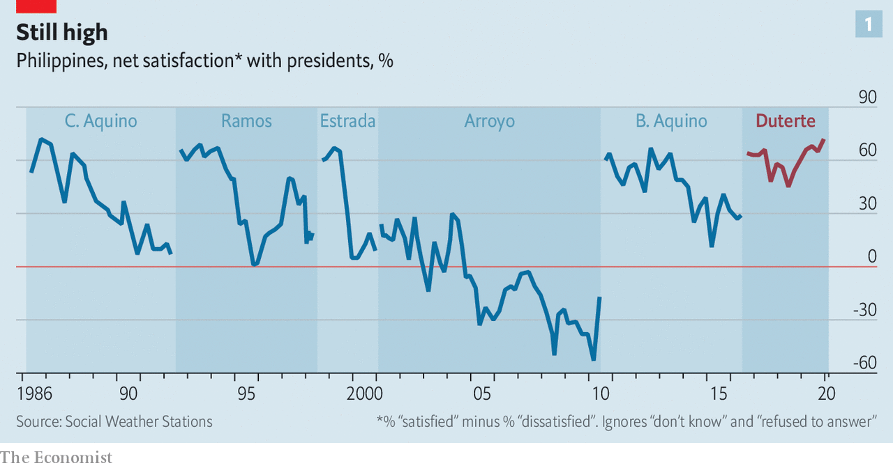

If Mr Duterte’s remarkable rhetoric—in office he has labelled both the pope and Barack Obama sons of whores, called God “stupid” and offered to eat the liver of a terrorist—and explicit encouragement of extrajudicial killing outrages some in the country’s political elite, their disquiet does not count for much with the people. Indeed, what looks like hand-wringing may bolster the president’s support.

The voters elevated Mr Duterte from mayor of Davao, a tough city on the southern island of Mindanao, to president because they were tired of the status quo overseen by an entrenched and arrogant elite. When, in 1986, protests ousted Ferdinand Marcos, the dictator who had run the country since 1965, there was a widespread hope that the restoration of democracy would bring economic and social progress. Income per head did indeed increase nearly sevenfold over the next three decades, and life expectancy rose by seven years to 71. But many Filipinos were discontent. Infrastructure was crumbling; corruption was rampant. Inequality, though falling, remained pervasive. “People saw electoral politics as a basketball game among the elite with the ball being passed between them,” says Sheila Coronel, a journalist.

Mr Duterte’s vulgar hyperbole—by his own estimate, only two in every five of his statements are true—showed that there was a new type of player on the court. But his aggressive populism does not alienate the middle class and university graduates: indeed they cleave to him. His sexism does not seem to put off women any more than his blasphemy and anticlericalism puts off the four in five Filipinos who still declare themselves Catholic.

Term limits mean Mr Duterte cannot capitalise on this with a second election campaign when his six years are up in 2022. Instead he has a “legacy campaign” launched with a huge shindig in Manila on January 17th. Beyond the chilling discovery that the public has supported his brutality in deed as well as word, what sort of legacy will it be?

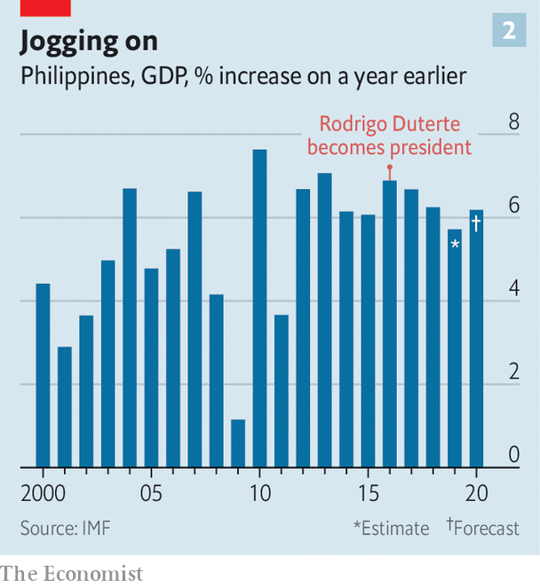

Economic performance, in which he has little interest, has been adequate (see chart 2). His enthusiasm for infrastructure spending will leave his successor with plenty of big juicy projects in the pipeline. His move towards China in foreign policy may prove contentious—or may look like getting ahead of the curve.

## Welterweights and oligarchs

Other aspects of his legacy-to-be look more troubling: those which, like the tolerated bloodshed, lower the bar for future presidents. Beyond the matter of his own rhetoric, he has benefited from virulent social-media trolling campaigns—Manila is home to hundreds of troll farms whose computer whizzes can be hired to splatter a client’s opponents or boost his favourites. He has bullied and intimidated the press. The latest outrage, for his critics, came on February 10th when the government filed a petition in the supreme court to void the franchise of media giant ABS-CBN, which it claims to have been engaged in “highly abusive practices”. He has taken various actions to limit the risk of his eventually facing justice over extrajudicial killings.

And he has not delivered the deep elite-uprooting change he promised. At the launch of his legacy campaign, when a communications minister declared him “a father to our nation”, it might have been more salient to note that he is father to Sara Duterte-Carpio, his successor as mayor of Davao and potentially as president. All in all, he seems unlikely to leave the Philippines with a political system more responsive to the needs of the people, or better placed to fulfil the promise of democracy. This is because, though extreme, Mr Duterte is not a departure from the Philippines’ dysfunctional political system. He is its grim product.

The Philippines is a country of strong political characters and weak political parties. Politicians tend to join the party of a winning president upon his or her entry into office to ensure continued funds for their districts; one of the reasons to think that Mr Duterte looks set for continued success is that he gained further such support in last year’s mid-term elections. The opposition now holds just four of the senate’s 24 seats. And only three of them actually sit. The fourth, Senator Leila de Lima, has been locked up for three years for her alleged links to drug lords.

Senate elections are hard slogs, with all the candidates competing nationally. A pre-existing fan base as a movie or sports star makes things easier; Senator Manny Pacquiao, once one of the world’s greatest boxers, combines his legislative duties with continuing to defend his WBA (super) welterweight title. If you can’t boast 39 knockouts in 71 matches, a well-known surname makes an excellent alternative. Devolution of power to local authorities after the overthrow of Marcos further entrenched the power of the fairly small number of families, often large landowners, that control fiefs around the Philippines. It is they who play Ms Coronel’s basketball game.

For all that Mr Duterte presents himself as an outsider unfamiliar with Manila’s swamp, it is from this world of established power that he comes. He mastered local politics as a scion of a well-nested family in Mindanao, the poorest part of the country; his father was, for a time, a provincial governor there. Originally a prosecutor, Mr Duterte was appointed to his first political job in 1986, when he was 40. He ran for mayor of the island’s largest city, Davao, two years later and dominated its politics for more than two decades, avoiding pesky term limits by switching jobs with his daughter. For a while he became a member of congress, just for a change.

The city provided a base in which to establish his reputation. He introduced a public smoking ban and a curfew after 10pm for loiterers and youngsters. His first campaign against drugs took place there: tales of its brutal tactics helped secure his presidential victory.

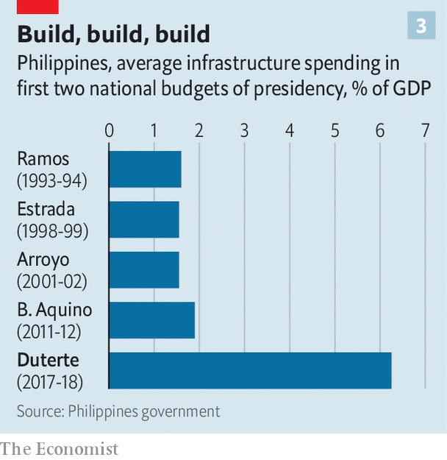

Along with a propensity for violence, he also brought a mayoral enthusiasm for infrastructure to the presidency. Under Mr Aquino the average infrastructure spend was 3% of GDP. Mr Duterte wants to get that up to 7%. (In nearby Indonesia, where the economy is much larger and an infrastructure push is also under way, the equivalent number sits just under 6% of GDP.) This translates into $158bn-$178bn allocated for roads, bridges, airports and other projects through a scheme known, with characteristic subtlety, as “Build, Build, Build” (see chart 3).

That enthusiasm has been matched with friendliness towards the world’s builders supreme. Mr Duterte has secured Chinese promises of $9bn in infrastructure investment (though only $900m-worth has been signed over in formal agreements). China says it sees common aims between its Belt and Road Initiative and Mr Duterte’s zeal for construction. Whereas Mr Aquino challenged China’s claims in the South China Sea—or the West Philippine Sea, as Filipinos know it—Mr Duterte has joked about making the Philippines a “province” of China. It is one of the few areas where he is at odds with the public.

In his campaign Mr Duterte said that he would hire “the economic minds of the country” to ensure growth. In practice this has meant leaving things largely in the hands of Carlos Dominguez, the finance secretary, and his team. The economy expanded 5.9% in 2019 and looks set to do better this year; the country remains one of the zappier growth prospects in South-East Asia. Debt levels are manageable and remittances from Filipinos working abroad as maids, sailors and nurses, equivalent to about a tenth of the economy, prop up household spending.

In 2018 the first batch in a series of tax reforms lifted the income-tax threshold and raised the top rate from 30% to 35%, as well as increasing consumption taxes on a range of goods, including petrol and sugar. The inflationary pain which followed was eased by getting rid of the country’s limit on the volume of rice imports. Over the rest of his term Mr Duterte’s advisers intend to ease the corporate tax rate from 30% (the highest in the region) down to 20%. The hope is that these reforms will make the country more enticing for investors.

## Let them eat rice

Growth was higher in the early 2010s. But then its proceeds went largely to the well off; in 2015 26% of the population was living on less than $3.20 per day. According to a recent report from the World Bank, that share should drop to below 20% this year. Lower rice prices since the tariff reform and the consistent support provided by a 12-year-old conditional-cash-transfer system have been a particular help. “[Mr Duterte’s] heart is with the poor,” reckons one Manila business executive.

Many of the country’s poorest people live on Mindanao, where unrest and terrorism have contributed to their misery. Here, on his home turf, Mr Duterte has been active. In 2017 government forces fought a five-month-long battle against terrorists with links to the so-called Islamic State who were holed up in the city of Marawi. The terrorists were eventually beaten, and the two and a half years of martial law which accompanied the fighting have now come to an end, though thousands of people remain displaced. Elsewhere on Mindanao Mr Duterte pushed through a peace deal that brought to an end decades of fighting in what is now the Bangsomoro Autonomous Region.

The president’s plans for decentralisation on a national scale have not fared as well. A large-scale federalist revision to the constitution, never one of Mr Duterte’s more popular proposals, has been abandoned. But a task force he established to work on smaller constitutional adjustments has produced several interesting ideas. One proposed amendment would devolve some more power and resources from Manila, in line with a supreme-court ruling last April which found that local governments should get to keep more of the revenues they collect. A constitutional change easing controls on foreign ownership might also be a boon to prosperity.

Tightening the rules on campaign financing and on swapping political parties is also under debate, as is an amendment to discourage dynasticism, perhaps by banning close relations from succeeding each other. These initiatives will struggle to pass given that congress is stuffed with dynasties. High-ranking politicians bluster when asked about them. But there is appetite for the reforms away from Congress. The task force behind the ideas says hundreds of mayors and governors across 60 provinces have signed up in support of them. That matters: a national plebiscite might be part of the process which introduces the amendments.

The president’s popularity, along with his willingness to challenge convention, might allow him to side with the people on reforms more risk-averse politicians would avoid—such as those which lessen the clout of political families. His time in office, though, does little to suggest he will afford himself the opportunity.

In 2018 his daughter, Ms Duterte-Carpio, founded a loose coalition called Hugpong ng Pagbabago (Faction for Change). The president’s standing helped propel almost all its candidates in the mid-terms to victory. One of its successful senatorial candidates was Imee Marcos, the daughter of the dictator. Mr Duterte has boasted that his father stood by hers in Marcos’s “darkest hours”, and relations between the two families remain warm. Imee’s brother Bongbong ran for vice-president in 2016. Since Mr Marcos lost to Ms Robredo he has waged a constant battle to overturn her victory in the courts.

The intensity of his efforts may stem from persistent anxiety over the president’s health. In the past Mr Duterte has used fentanyl to help him cope with back pain. In 2018 he did little to curb speculation that he might have cancer after receiving a colonoscopy. In October he spoke about suffering from a chronic autoimmune disease, and was forced to cut short a trip to Japan owing to “unbearable pain” caused by a motorcycle fall.

If he survives to retirement, Mr Duterte will be keen on a less litigious, and indeed carceral, one than those endured by his three most recent predecessors. Mr Aquino has faced various charges related to government spending on infrastructure projects and, separately, to a botched counter-terrorism operation in 2015. His predecessor, Gloria Macapagal Arroyo, spent nearly five years in detention until the supreme court acquitted her of misusing state lottery funds in 2016. While in office Ms Arroyo pardoned her predecessor, Joseph Estrada, who was sentenced to life in prison for plunder in 2007.

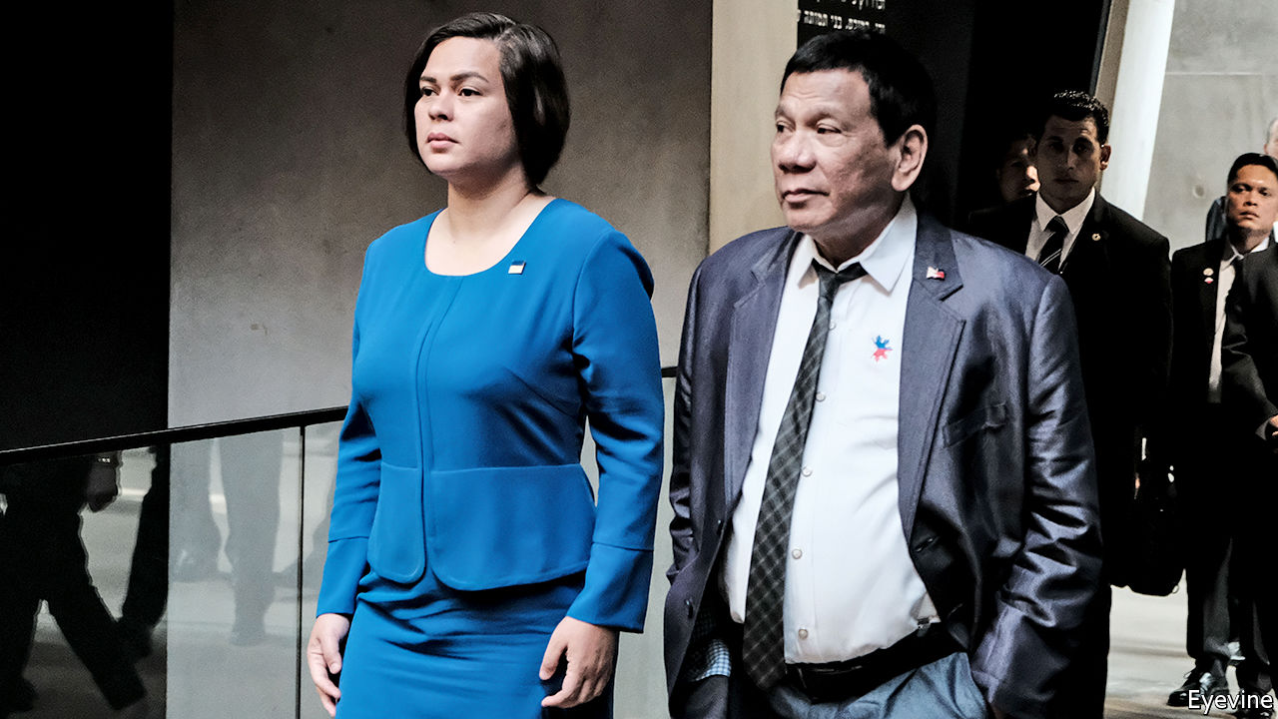

Like father like daughter?

## Success and succession

In March the Philippines withdrew from the International Criminal Court, which had been conducting a preliminary inquiry into whether Mr Duterte and other officials had committed crimes against humanity during the drug campaign. The chief justice of the supreme court—“the kingpin of the judiciary”, in Dutertese—was ousted in 2018 after she pushed back against the drug war. Subsequent vacancies on the bench have been filled with relatively youthful judges who will serve long after Mr Duterte’s departure from office loses him his immunity from prosecution.

All the while Mr Duterte keeps up his attacks on the media. Parallels with America, the archipelago’s former colonial ruler, readily suggest themselves. Filipinos are more likely to express a favourable opinion of President Donald Trump than almost anyone else in the world, according to the Pew Research Centre, an American think-tank. Mr Trump returns the favour. In January America cancelled the visa of Senator Ronald Dela Rosa, an ally of Mr Duterte’s in the drug war. Mr Duterte declared his intention to respond by cancelling a long-standing agreement which allows American troops to participate in joint exercises in the Philippines. America’s embassy in Manila labelled this “a serious step with significant implications”. Mr Trump, though, said he didn’t mind.

The president’s peaceful retirement may end up depending on the identity of his successor. Speculation is rife that Ms Duterte-Carpio will try to fill her father’s shoes. They have not always agreed on policies. But she is not unlike him. She rose to national attention when, as mayor of Davao herself, she punched a sheriff in a dispute over the demolition of slum housing.

She has not declared a run for the presidency; but today would be too soon to do so. In principle, were he to throw his weight behind the anti-dynasticism measure, her father could stop her rise. “If the reforms get through then you can argue that Duterte was the chemotherapy the country needed,” argues Julio Teehankee of De La Salle University in Manila, a critic of the oligarchic elite. That might be a fitting legacy for the man elected president on the basis of promises to be savage and deadly. For the scion of a powerful political family, though, it looks unlikely.■

This article was downloaded by calibre from <https://www.economist.com/briefing/2020/02/22/rodrigo-dutertes-lawless-war-on-drugs-is-wildly-popular>

|  |  |  |  |
| --- | --- | --- | --- |
|  | Articles | Sections | Next |

|  |  |  |
| --- | --- | --- |
| Briefing | Sections | The Americas |

United States

South Carolina’s Democratic primary: Twilight of the moderates

.

The Democratic debate: Mike drop

.

Presidential approval ratings: A bogus bump

.

Peter Hotez, vaccine campaigner: Anger in a time of autism

.

Boy Scouts of America enters Chapter 11: Scout’s (dis)honour

.

Medicine and the law: Kidney failure

.

Gentrification in Washington, DC: A no Go-Go area

.

Lexington: The other war on migrants

.

|  |  |  |
| --- | --- | --- |
| Briefing | Sections | The Americas |

|  |  |  |  |
| --- | --- | --- | --- |
|  | Articles | Sections | Next |

#### Twilight of the moderates

# Joe Biden’s rivals scramble to capitalise on his woes in South Carolina

What happened to the ex-frontrunner’s firewall?

Feb 22nd 2020 | NORTH CHARLESTON

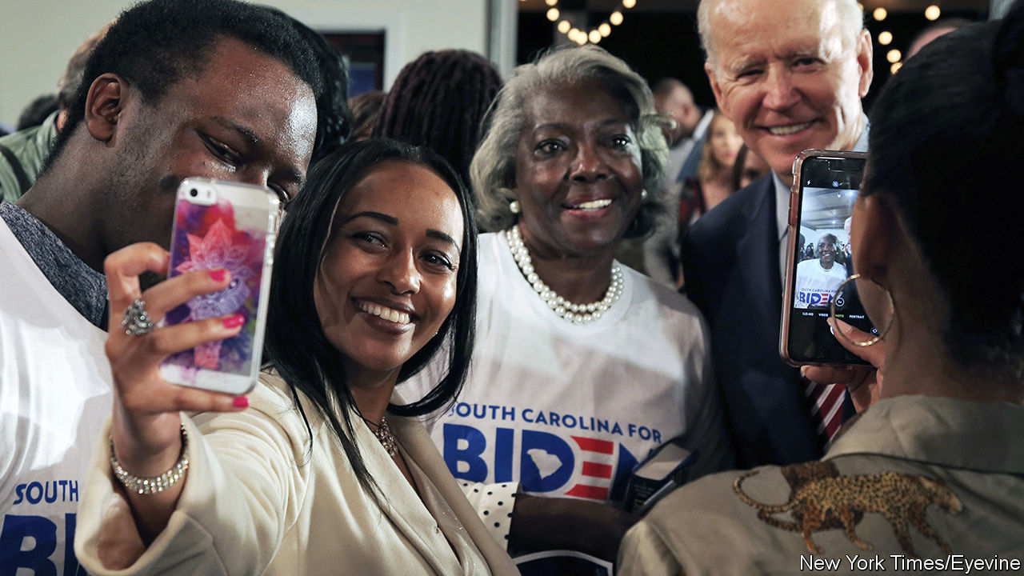

JILL BIDEN was in her element. A lifelong teacher, even during her two terms as Second Lady, she headlined an “Educators for Biden” event in a modest Baptist church in North Charleston. The smartly dressed, mostly African-American crowd was on the older side (it was mid-afternoon on a weekday), as is Joe Biden’s support generally. It felt less like a “getting to know you” than a “nice to see you again” event. Rev Bernard Brown, who said he had been “associated with” Mr Biden for a long time, called the former vice-president “a man of good character.” David Mack, a state representative from Charleston, said the Bidens had sent flowers after his mother died, just a few weeks earlier. The afternoon’s biggest applause was for a woman in the audience who said she was “voting for Joe because he’s an elder statesman. He’s been there.”

Being an elder statesman has not turned out to be the advantage the Biden campaign hoped. Mr Biden’s team has always seen South Carolina as his firewall. A resounding victory in its primary on February 29th, courtesy of a Democratic electorate that is majority-black, would protect him from results in Iowa and New Hampshire. South Carolina’s somewhat conservative African-American Democrats, the campaign thought, trust Mr Biden and appreciate his fidelity to Barack Obama. That argument, which treated black voters as more monolithic than they are, looks less plausible after drubbings in the first two states and falling numbers in South Carolina, where Mr Biden still leads but by less than five points, compared with 20 points at the start of the year.

The chief beneficiary of Mr Biden’s polling tumble, Mike Bloomberg, is not on the ballot in South Carolina (he skipped the four early states to focus on Super Tuesday). But that does not mean South Carolinians are not thinking about his candidacy—and particularly about his record on race. Many black voters seem less incensed about stop and frisk than white progressives think they should be. The practice, championed by Mr Bloomberg when he was mayor of New York, of stopping people, disproportionately young black and brown men, in an attempt to cut gun crime was found to be unconstitutional. Mr Bloomberg defended the policy for too long: for a data-nerd, he was reluctant to acknowledge evidence of his mistake.

South Carolina’s Democratic electorate, which is older and more churchgoing than the Democratic average, seem not to find it disqualifying. Clay Middleton, a major in South Carolina’s army national guard who previously held senior positions in the campaigns of Hillary Clinton and Cory Booker, expresses it this way: “I’m 38 years old and there’s one or two things I wish I hadn’t said or done. [Mr Bloomberg] is 78: I would have a problem if he didn’t regret some things. ...I’m not saying I would vote for Bloomberg, but if I don’t it won’t be because of stop and frisk.”

Mr Bloomberg may not be on the ballot, but a more mercenary version of his big-spending strategy is being road-tested in South Carolina—by Tom Steyer. The other billionaire in the Democratic race has spent nearly $19m in the state, building an extensive field operation, hiring prominent legislators as campaign advisers and ensuring that virtually no South Carolinian can open a web browser or mailbox without seeing a Steyer ad. Jerry Govan, who chairs South Carolina’s legislative black caucus and whose firm has been paid more than $40,000 by the Steyer campaign, says “there are no perfect candidates”, but that Mr Steyer represents “a good transition [and has] supported good causes”. Mr Steyer’s return on investment has been to eclipse Pete Buttigieg, Amy Klobuchar and Elizabeth Warren in South Carolina’s polls.

The bad news for Mr Steyer is that his war-chest is feeble compared with Mr Bloomberg’s. The former mayor has spent twice as much on advertising in Super Tuesday states as the rest of the field combined and already has a full-time campaign staff of 2,400. His record of entrepreneurship, three mayoral terms in New York and subsequent philanthropy also give him more to brag about than Mr Steyer.

If Mr Bloomberg can afford to sit-out and watch South Carolina without worrying about what the result there will do to his campaign infrastructure, Mr Buttigieg, Ms Klobuchar and Ms Warren cannot. Ms Warren’s South Carolina polling matches national trends: a rise last year, followed by a steady decline. Positioning herself as a candidate who can unify the party’s progressive and centrist wings has made neither one flap. After her fourth-place finish in New Hampshire, Ms Warren pulled her TV advertising in South Carolina, telegraphing pessimism about the outcome.

Mr Buttigieg has six field offices and 55 paid staff in-state, which outside Bloomberg-land counts as a sizeable operation. He has picked up at least one prominent backer. J.A. Moore, a young legislator who had backed Kamala Harris, endorsed Mr Buttigieg because in their conversations, “he listened more than he talked”, and “he can restore some grace and dignity to the office of president.” But he has still struggled mightily with African-American voters. Lauren Brown, his South Carolina spokesman, says his campaign is “looking at veterans, people of faith, rural voters—communities that cut across race”. That too sounds like expectations-lowering.

Ms Klobuchar’s presence in South Carolina, by contrast, is hardly detectable. A pro-Klobuchar SuperPAC is spending heavily on ads here and in Super Tuesday states. But she has no in-state endorsements, and has held fewer events than Kamala Harris and Mr Booker, neither of whom remains in the race.

If neither Mr Biden, Ms Klobuchar nor Mr Buttigieg can make the case that they are the best hope of the majority of Democrats—who do not yearn for socialism—they could still divide that part of the party into units so small that Mr Sanders is able to build up a commanding lead. That could set up a contest between Mr Sanders and Mr Bloomberg, and make the 2016 Democratic primary, which seemed bitter enough at the time, look like a love-in.■

Dig deeper:  
Sign up and listen to Checks and Balance, our new [newsletter](https://www.economist.com/checksandbalance/) and [podcast](https://www.economist.com/podcasts/2020/02/14/checks-and-balance-our-new-weekly-podcast-on-american-politics) on American politics

This article was downloaded by calibre from <https://www.economist.com/united-states/2020/02/22/joe-bidens-rivals-scramble-to-capitalise-on-his-woes-in-south-carolina>

|  |  |  |  |
| --- | --- | --- | --- |
|  | Articles | Sections | Next |

|  |  |  |  |
| --- | --- | --- | --- |
| Previous | Articles | Sections | Next |

#### Mike drop

# Michael Bloomberg gives an unconvincing performance in Nevada’s Democratic debate

The world’s 12th richest man must learn to be quicker on his feet

Feb 22nd 2020 |

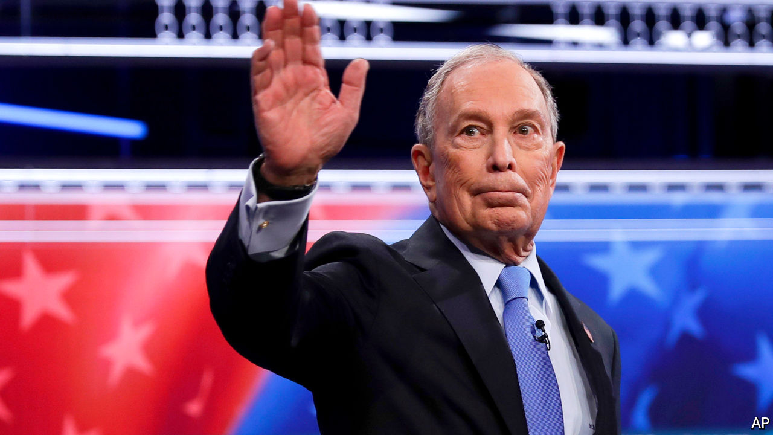

IN ONE SENSE, political debates are evanescent. Six candidates squared off in Las Vegas on February 19th—the ninth such debate—ahead of the Nevada caucuses on February 22nd. They will spar again on February 25th, ahead of the primaries in South Carolina and the delegate-rich Super Tuesday primaries. But some debates matter more than others, and the one in Las Vegas came at an important moment in the Democratic campaign to choose a candidate to challenge President Donald Trump.

Ever since Bernie Sanders’s impressive performances in Iowa and New Hampshire, many Democrats have worried that nominating a self-declared socialist will cost them the election and their House majority. So in Las Vegas all eyes were on Mike Bloomberg, a billionaire former mayor of New York who has been closing the gap with Mr Sanders in the polls through an unorthodox self-funded advertising blitz. Mr Bloomberg is not standing in Nevada—he will enter the fray on Super Tuesday—but in Las Vegas he appeared on the campaign stage for the first time. The question was: how would he perform, and how would the other candidates react to him?

Elizabeth Warren answered the second question immediately, ripping into Mr Bloomberg for having made sexist remarks. Later, Ms Warren pressed Mr Bloomberg to release women who worked for him from non-disclosure agreements they had signed. Mr Bloomberg refused, saying “Maybe they didn’t like a joke I told,” and, finally, that the agreements “were made consensually” and he would not void them. That answer was smug, mandarin and indifferent.

Debates are not Mr Bloomberg’s strong suit. He is not particularly charismatic, and perhaps the world’s 12th richest man, the founder of one of the world’s most prominent media and finance companies, does not often encounter people who disagree with him. Still, his flat-footedness in responding to this predictable question was surprising. His answer when challenged about stop-and-frisk—another predictable line—was too exculpatory and defensive. He was, though, the only candidate who really traded punches with Mr Sanders. Neither knocked the other off stride—neither man is lacking in self-assuredness—and their skirmishes here may have presaged the rest of the primary campaign.

Oddly, Mr Bloomberg also seemed reluctant to trumpet all the good he has done. He has a record of giving generously to liberal candidates and causes, and of climate-change activism and philanthropy. Yet, he gave boilerplate answers when he has a far more substantive environmental record than anyone else on stage.

His closing statement made clear that he views the presidency as, in essence, a managerial role. It is certainly that, but not solely. Presidents must also inspire, lead and set the country’s tone. Perhaps enough Americans are yearning for quiet competence that they will be happy to pull the lever for a capable technocrat, and let the bully pulpit sit quiet for a while. He certainly came as a relief to many New Yorkers after the Sturm-und-Drang mayoralty of Rudy Giuliani. But it is quite a gamble. Being slightly quicker on his feet would help.■

Dig deeper:  
Sign up and listen to Checks and Balance, our new [newsletter](https://www.economist.com/checksandbalance/) and [podcast](https://www.economist.com/podcasts/2020/02/14/checks-and-balance-our-new-weekly-podcast-on-american-politics) on American politics

This article was downloaded by calibre from <https://www.economist.com/united-states/2020/02/22/michael-bloomberg-gives-an-unconvincing-performance-in-nevadas-democratic-debate>

|  |  |  |  |
| --- | --- | --- | --- |
| Previous | Articles | Sections | Next |

|  |  |  |  |
| --- | --- | --- | --- |
| Previous | Articles | Sections | Next |

#### A bogus bump

# Why Donald Trump’s high approval ratings may be misleading

A statistical wrinkle makes the president appear more popular

Feb 22nd 2020 | WASHINGTON, DC

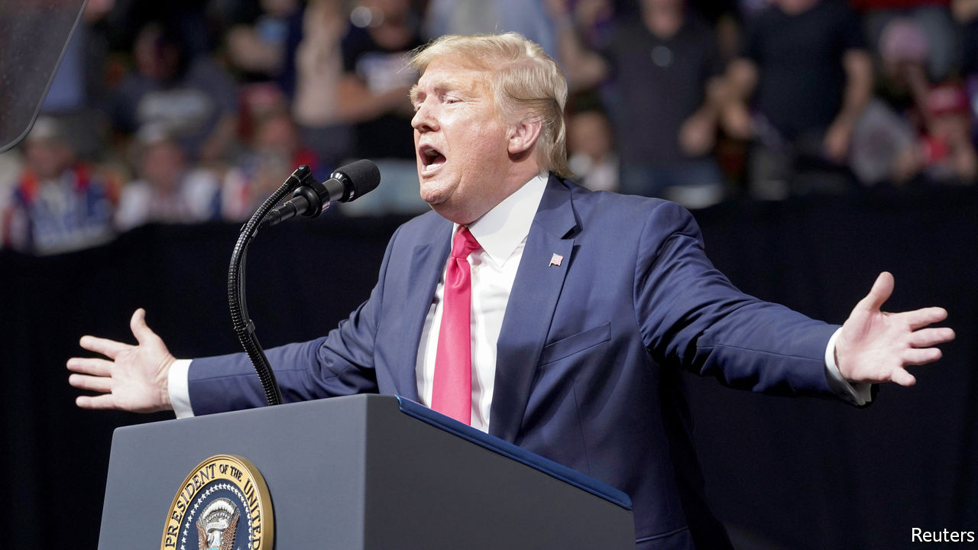

ON ANY GIVEN day since he took office, Donald Trump has had a lower job-approval rating than almost every other modern president at the same point in their tenure. But over the past two weeks the polls have finally been giving Mr Trump some good news. According to an average of public polling data calculated by FiveThirtyEight, a data-journalism website, he is more popular than he has been since March 2017, two months after he took office. The BBC called it Mr Trump’s “best week” yet in office. Political betting markets increased his chances of re-election by roughly ten percentage points.

These positive appraisals have overlooked a crucial fact about the methods of conducting opinion polls in America. Because the people who take part in surveys are often not representative of the population as a whole, pollsters use a statistical procedure called “weighting”, which adjusts the findings to meet certain demographic targets. The technique helps firms ensure that their surveys have enough young people in them, for example, and that they achieve a good balance of minorities and working-class whites.

But even after correcting for demographic biases, pollsters’ data can still be unrepresentative. They may have the right shares of Latino voters and boomers, but nevertheless have too many Republicans or Democrats. This concern is pronounced when an event causes especially good, or bad, news for a political party. At such times surveys can suddenly be swamped with partisans who are eager to voice their love, or hate, for the president.

In the wake of Mr Trump’s acquittal in the Senate, pollsters suspect that such a bias could be affecting polls. Courtney Kennedy, the director for survey research at the Pew Research Centre, says that there is a “strong possibility” that the recent uptick in Mr Trump’s ratings has a wave of optimistic Republicans as its source. She says that outlets can control this problem by adjusting their data to have the correct shares of Democratic- and Republican-leaning voters, but the idea is relatively new and few pollsters have data good enough to perform such corrections.

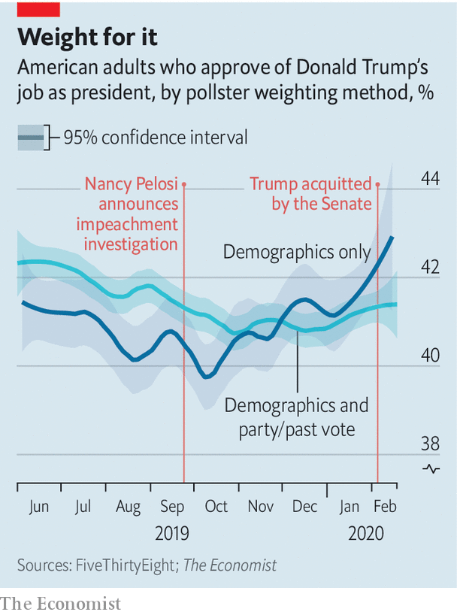

The Economist’s analysis of polls taken during Mr Trump’s impeachment proceedings affirms Ms Kennedy’s suspicion. In polls that weight their data to represent America’s partisan balance or the results of the 2016 election, the share of adults who approve of Mr Trump’s job as president has risen by half a percentage point since impeachment proceedings began in earnest last October. But in polls that do not, Mr Trump’s ratings have increased by over three percentage points.

Data from YouGov, which conducts online polls with The Economist and adjusts its numbers for partisan bias, confirm that Republicans have become more likely to take part in their surveys over the past four months. In early September, before Nancy Pelosi announced impeachment proceedings, YouGov had to weight the attitudes of Republicans about 10% higher than the average respondent in order to achieve a sample that accurately reflected the results of the 2016 election. This higher-than-average weight implied that Republicans were less likely than Democrats to take their surveys. But by the first week of February, the firm’s weight for the average Republican was the same as for the average respondent, suggesting that they had become much more likely to fill out their surveys.

Hence pollsters who do not adjust for partisan bias have picked up a recent—and mostly phantom—swing in Mr Trump’s favour. Yet Ms Kennedy is quick to say that weighting is not a magic wand for ensuring high-quality results. A recent Pew report found that online surveys, in particular, can also be unduly influenced by so-called bogus participants who could be causing even more errors in pollsters’ measurements by submitting nonsensical, and disproportionately positive, responses. “Although it is not a large effect,” says Ms Kennedy, “it’s systematic”, and could be enough to nudge even a collection of different polls in one direction. Such are the challenges pollsters face if they want to be sure that movements in public opinion—like the recent shift towards Mr Trump—are in fact real.■

Dig deeper:  
Sign up and listen to Checks and Balance, our new [newsletter](https://www.economist.com/checksandbalance/) and [podcast](https://www.economist.com/podcasts/2020/02/14/checks-and-balance-our-new-weekly-podcast-on-american-politics) on American politics

This article was downloaded by calibre from <https://www.economist.com/united-states/2020/02/22/why-donald-trumps-high-approval-ratings-may-be-misleading>

|  |  |  |  |
| --- | --- | --- | --- |
| Previous | Articles | Sections | Next |

|  |  |  |  |
| --- | --- | --- | --- |
| Previous | Articles | Sections | Next |

#### Peter Hotez, vaccine campaigner

# Anger in a time of autism

A prominent scientist wants to lead a campaign against anti-vaxxers

Feb 22nd 2020 |

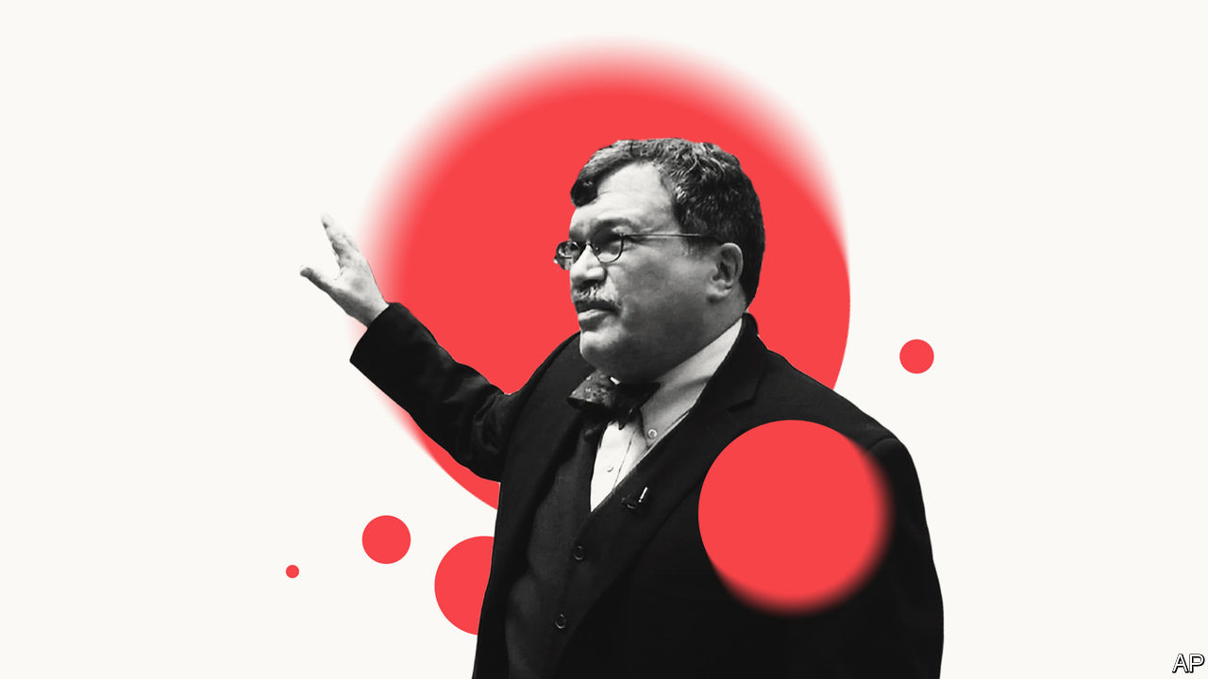

AS A BOY, Peter Hotez was drawn to roadside puddles and stagnant ponds in Connecticut. After squeezing sample water droplets on glass slides, he spent hours with his eye glued to a microscope. Another world would emerge as protozoa and rotifers wiggled into focus. He dreamed of more exotic micro-organisms, of finding one new to science.

Boyhood pursuits foreshadowed his life’s work. Mr Hotez studied how parasitic diseases infected hundreds of millions of people in China. His knowledge of that part of the world helps explain his frequent appearances on cable TV this year, discussing how covid-19 may spread and the hopes, one day, for a vaccine. He helped develop vaccines that, if current clinical trials succeed, could eradicate hookworm (thought to infect some 500m-700m people globally) and bilharzia. He can also talk: he helped persuade George W. Bush’s administration, in 2004, to fund global vaccinations globally that benefit 1bn people.

Inspired by Britain’s two schools of tropical medicine, in Liverpool and London, he helped to found America’s first: the National School of Tropical Medicine, part of Baylor College of Medicine, in Houston. It is a modest affair, so far, but he has persuaded a dozen scientists to move there, to work on vaccines against half a dozen other illnesses, such as chagas and leishmaniasis, mostly ones that afflict the poor.

He also campaigns, reminding Americans, lest they forget, how vaccines protect them. As a paediatrician in the 1980s he recalls the horror of diagnosing children with “invasive Hib”, an aggressive strain of meningitis. Recovery was agonising, and parents would be traumatised. Worse, it killed some 1,000 American children a year. Then a Hib vaccine was licensed in 1987 and almost magically, within a few years, it had all but gone. Now barely 40 cases are identified in America each year.

The problem is that people forget, within a generation or two, the illnesses that once stalked them. In America he counts at least 14 vaccines that have eradicated, or nearly, diseases including tetanus, diphtheria, mumps and rubella, polio, hepatitis and smallpox. He points out how, before mass vaccinations in the 1960s, measles sent 50,000 infected children to hospital each year, and typically killed 500 of them.

Yet anti-vaxxers brush aside measles as trivial (though in 2018, around the world, the disease killed over 140,000 people). In the past decade the anti-vax movement has only grown stronger, warns Mr Hotez. Though most American parents still vaccinate their children, pockets of scepticism and vaccine refusal are growing. Misinformed celebrities are stirring up fear—none more than Robert F. Kennedy junior, a charismatic environmental campaigner turned vaccine obsessive. Online, companies profit by seeding doubts about science, then selling homeopathic and “natural” remedies. Firms like Amazon and Facebook meanwhile fail to discourage those who spread lies on their platforms.

He worries that a new outfit, the Children’s Health Defence, founded by Mr Kennedy, looks especially slick and able to stir mistrust of vaccines. A study this year by Vaccine, an academic journal, found just two anti-vax campaigns, including Mr Kennedy’s, paid for over half of all Facebook ads that were tracked as spreading misinformation on vaccine safety.

Officials, doctors and scientists do push back, hoping to educate parents by sharing worthy statistics on vaccine safety. That has limited impact. Tara Smith, at Kent State University, who studied how to address the spectrum of outright vaccine deniers, the vaccine-hesitant and merely curious “lurkers”, says parents almost never lack facts. Instead they are stirred by emotional anecdotes, especially the most egregious tales of patient harm. Mr Hotez argues for fighting back harder. “We need people to get emotionally involved,” he says. He equates anti-vaxxers to a destructive, religious cult and wants scientists to deliver direct, “declarative”, even confrontational messages against them. Worried parents remember and share stories, not statistics, he says. Mr Hotez, whose own daughter is autistic, has written a memoir explaining that vaccines did not cause the condition, as a large number of parents have come to believe.

Ideally, he says, someone would fund his plan for a pro-vaccine group to counter outfits like Mr Kennedy’s, and to press tech firms and online retailers to act. Anti-vax books, films, posters and other merchandise proliferate online. Until The Economist pointed it out last week, Amazon was taking payment to promote the sale (for $7.95) of a sponsored sticker that urged “Just say no to vaccines.” Amazon removed that, but also says it will not censor free speech. Mr Hotez calls the site the source of the “most pervasive and active” misinformation that helps anti-vaxxers. ■

This article was downloaded by calibre from <https://www.economist.com/united-states/2020/02/22/anger-in-a-time-of-autism>

|  |  |  |  |
| --- | --- | --- | --- |
| Previous | Articles | Sections | Next |

|  |  |  |  |
| --- | --- | --- | --- |
| Previous | Articles | Sections | Next |

#### Scout’s (dis)honour

# The Boy Scouts of America files for bankruptcy amid child-abuse lawsuits

Some victims see it as a get-out-of-jail-free card for the organisation

Feb 22nd 2020 | NEW YORK



RALPH MORSE was 11 years old when the abuse began in the 1960s. John Brown, his scoutmaster, a supposedly upstanding man in his small upstate New York town, molested him regularly. While looking up at the constellations to earn merit badges, Mr Morse remembers, “he’d come up behind you in the dark, pressing himself up against you in a field. You’re standing in pitch black with this humongous man taking hold of you. And what do you do? What do you say to stop?”

Mr Morse kept the torment to himself, but is convinced that scout leaders suspected. The emotional scars were long-lasting. The former honours student dropped out of school, became an alcoholic and lost a marriage. Mr Brown was eventually arrested two decades later for abusing another boy.

Last year Mr Morse filed a lawsuit against the Boy Scouts of America (BSA) under New York’s new Child Victims Act. This law changed the statute of limitations for prosecuting and filing civil suits against abusers and their affiliated institutions. It also included a one-year window during which victims can seek damages, no matter when the abuse occurred. More than a dozen states passed similar laws. Schools, hospitals, the Catholic church and other religious groups have all been sued under the new bills. The BSA has received about 275 suits, including accusations dating from the 1940s, and expects more. Its potential liability is huge. It spent more than $150m on settlements and legal fees in 2017-19 alone. It filed for bankruptcy on February 18th.

More than 130m people have taken part in BSA youth programmes, including several presidents (Gerald Ford was an Eagle Scout). Boys were told that their Boy Scout manual was, next to the Bible, the most important book they would ever own. But membership has been falling, from 6.5m in 1972 to just 2.2m today. After years of resisting, the 110-year-old BSA now welcomes girls, as well as transgender and gay scouts. That decision pushed the Church of Jesus Christ of Latter-day Saints to end its relationship with the organisation on December 31st, removing 400,000 Mormon scouts and much-needed revenue.

The Boy Scouts are not disappearing. Nineteen Catholic dioceses have filed for bankruptcy and are still standing. But like them the BSA, which owns thousands of acres of land, may have to sell property.

The current leaders seem sincere in wanting to help. In an open letter to victims Jim Turley, the national chairman, apologised, saying “We believe you, we believe in compensating you.” Last week the Scouts announced a partnership with 1in6, a non-profit that helps victims of sexual abuse.

But the organisation has known about abuse going back nearly a century, even creating an internal secret file called “P” (for perversion), to track leaders and volunteers accused of child sexual abuse. In 1935 the then head of the BSA told the New York Times that almost 1,000 men had been removed from Scouting because they “sometimes give way to temptation”.

Chapter 11 will allow the BSA to put money for victims into a shared pot so that everyone receives compensation, according to Marie Reilly, a law professor at Pennsylvania State University. Still, some of the abuse survivors are upset about the bankruptcy filing. A lawsuit was their chance to speak. “I’ve been silent for 50 years,” says Mr Morse. “The bankruptcy is just their get-out-of-jail-free card.”■

This article was downloaded by calibre from <https://www.economist.com/united-states/2020/02/22/the-boy-scouts-of-america-files-for-bankruptcy-amid-child-abuse-lawsuits>

|  |  |  |  |
| --- | --- | --- | --- |
| Previous | Articles | Sections | Next |

|  |  |  |  |
| --- | --- | --- | --- |
| Previous | Articles | Sections | Next |

#### Kidney failure

# A quirk in the law means that America’s kidney shortage costs taxpayers

Lightening regulation on organ transplants could save lives and money

Feb 22nd 2020 |

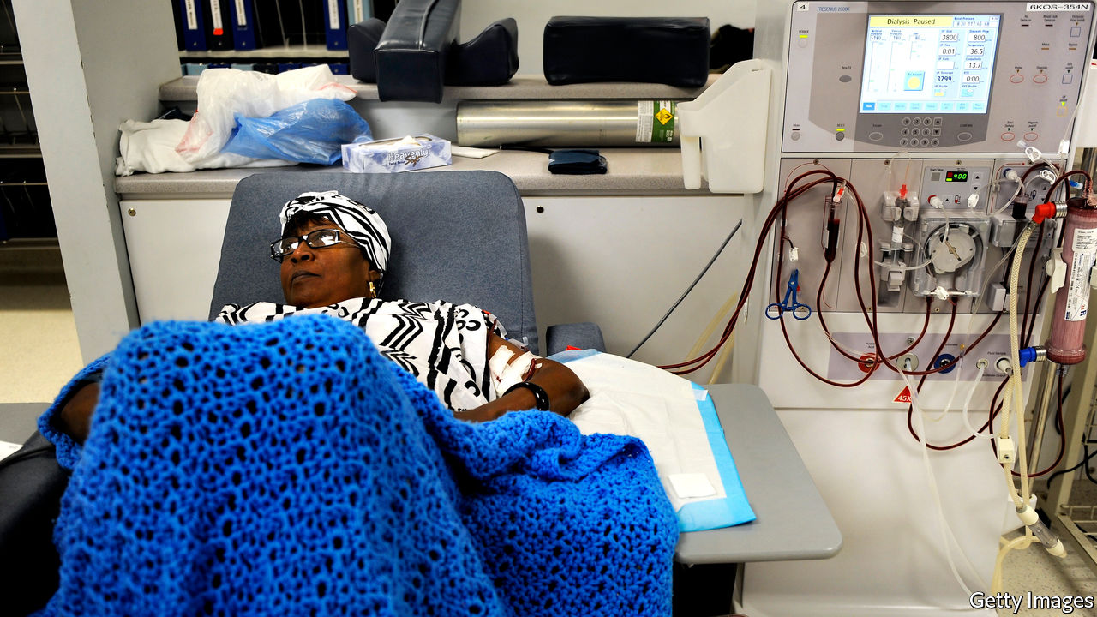

IN 1971, AN unemployed salesman named Shep Glazer upended the typically somnolent hearings of the House Ways and Means Committee by giving a live demonstration of dialysis before aghast congressmen. The shock seemed to pay off. Mr Glazer’s goal—to ensure that all patients reliant on blood-filtering dialysis machines, because of failing kidneys, would be covered by a then-newfangled programme called Medicare, the government health-insurance scheme for the elderly, regardless of age—soon became law. Through the new end-stage renal disease (ESRD) programme, Medicare for All became a reality for a certain portion of the sick, and has remained so for nearly 50 years.

What seemed like a small exemption then has morphed into something much larger. Originally designed to cover 10,000 patients, the ESRD programme now includes 512,000. Dialysis is expensive: a machine must filter out toxins and excess fluids from the blood, often for several hours a day and several times per week. It is a life-or-death treatment. Still, two-thirds of patients with ESRD die within five years. A year of treatment in a specialised centre costs $91,000. The small programme created in the 1970s now costs over $35bn, or roughly 6% of all Medicare spending.

Much of this is due simply to rising need. Diabetes and high blood pressure, which have been rising, are precursors of chronic kidney disease. Because Medicare sets prices, costs for dialysis have grown more slowly than for other health-care procedures. The operation of dialysis centres has nonetheless become brisk business (in part because private-insurance companies pay more). A near-duopoly controls 70% of the market, earning net profits of 18%.

For many patients a kidney transplant is a much better option than several years of dialysis before death—life expectancy is much longer, and that life is of higher quality. It also saves money for the taxpayer, notes Mario Macis of Johns Hopkins University. “The math is such that every kidney transplant generates savings for Medicare of about $150,000,” says Mr Macis.

The problem is that there are almost 100,000 people on the waiting list, and the typical waiting time is more than four years, meaning thousands die before their turn. Incentivising organ donations is morally fraught. But at present, there are strong disincentives to living organ donations. Though there is no medical bill for giving up a kidney, costs for transport, lodging and lost wages during recovery are not reimbursed. For three-quarters of prospective donors, these can amount to one month of income. Research from Mr Macis and two colleagues shows that Americans are much more keen on reimbursement if it is offered by a public agency—as opposed to direct purchase—and if it meaningfully increases the supply of organs.

The curious case of the kidney gives a few insights into the larger workings of the American health-care system. Small, fossilised provisions morph into huge programmes decades later. Government influence over prices may limit overall growth in costs, but can coincide with abnormally high profits for a few operators. And comparatively clear ideas for reducing billions in costs while improving thousands of lives can go ignored for years.■

This article was downloaded by calibre from <https://www.economist.com/united-states/2020/02/22/a-quirk-in-the-law-means-that-americas-kidney-shortage-costs-taxpayers>

|  |  |  |  |
| --- | --- | --- | --- |
| Previous | Articles | Sections | Next |

|  |  |  |  |
| --- | --- | --- | --- |
| Previous | Articles | Sections | Next |

#### A no Go-Go area

# Washington DC’s declining black population fights to preserve its musical heritage

Protesters want to stop gentrifiers “muting” the capital

Feb 22nd 2020 |

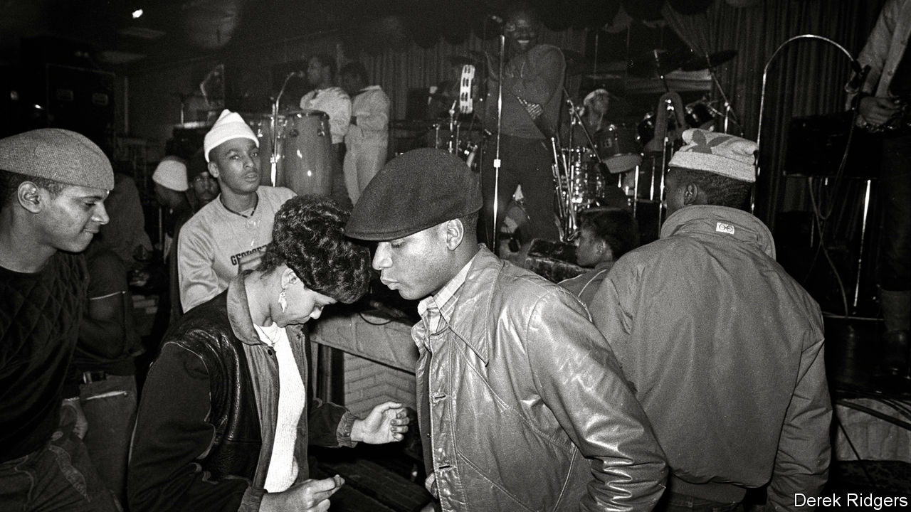

PEOPLE OFTEN slow down to bop as they pass Donald Campbell’s mobile-phone shop in Shaw, a neighbourhood in Washington, DC. Until 7pm every day speakers outside blast Go-Go, a drum-based fusion of funk, R&B and soul that is indigenous to the city. In an area that was once dotted with Go-Go clubs, several of them owned by Mr Campbell, this is one of the last public places the music is played regularly. It is also the scene of a row that has forced a reckoning on how gentrification is eroding the culture of a once black-majority city.

Last spring residents of a glossy new apartment block, mostly inhabited by young, white newcomers to the area, complained about the racket. T-Mobile, which owns the shop, asked Mr Campbell to turn it off, which he did. That unleashed a torrent of anger from African-Americans across Washington. There were large street protests at which Go-Go bands played, a #DontMuteDC social-media campaign and an online petition. After a few days of this John Legere, T-Mobile’s boss, tweeted that “the music should NOT stop in D.C.” Mr Campbell turned it back on.

DontMuteDC has since morphed into a wider protest movement against gentrification, with Go-Go its symbol. Created in the 1970s by Chuck Brown, whose “Bustin’ Loose” was for years the Washington Nationals’ home-run celebration song, Go-Go was the last flourish of a black-majority city’s vibrant musical culture. Shaw was at its centre. By the 1980s, Go-Go bands played every night in the neighbourhood and beyond.

Go-Go’s decline began the following decade when, in an effort to curb violence, the city forced clubs to close earlier and to stop serving alcohol. Around the same time blacks began moving out to the Maryland suburbs. Gentrification has accelerated that process. By 2015 the proportion of black Washingtonians had dropped below 50% for the first time since the 1950s.

These changes have particularly harmed Go-Go because it was created to be experienced live. Its characteristics include call-and-response, which turns the audience into part of the performance, and the use of percussive solos instead of pauses between songs—which is how Go-Go got its name. That makes the music unsuitable for radio or three-minute hits. Without live venues, a new generation had mostly given it a miss.

That, says Mr Campbell, has changed since last year’s protests. He is developing an internet streaming service for his huge collection of live recordings. A Go-Go museum is in the works and this week DC Council declared Go-Go the city’s “official music”. Though it is not clear quite what that will entail, it seems likely to involve tourists. The efforts to preserve Go-Go may end up gentrifying a form of music that was created to be anything but.

This article was downloaded by calibre from <https://www.economist.com/united-states/2020/02/22/washington-dcs-declining-black-population-fights-to-preserve-its-musical-heritage>

|  |  |  |  |
| --- | --- | --- | --- |
| Previous | Articles | Sections | Next |

|  |  |  |  |
| --- | --- | --- | --- |
| Previous | Articles | Sections | Next |

#### Lexington

# Companies can now get away with killing America’s birds

America owes its great love of its feathered friends to a century-old law that the administration is attempting to gut

Feb 22nd 2020 |

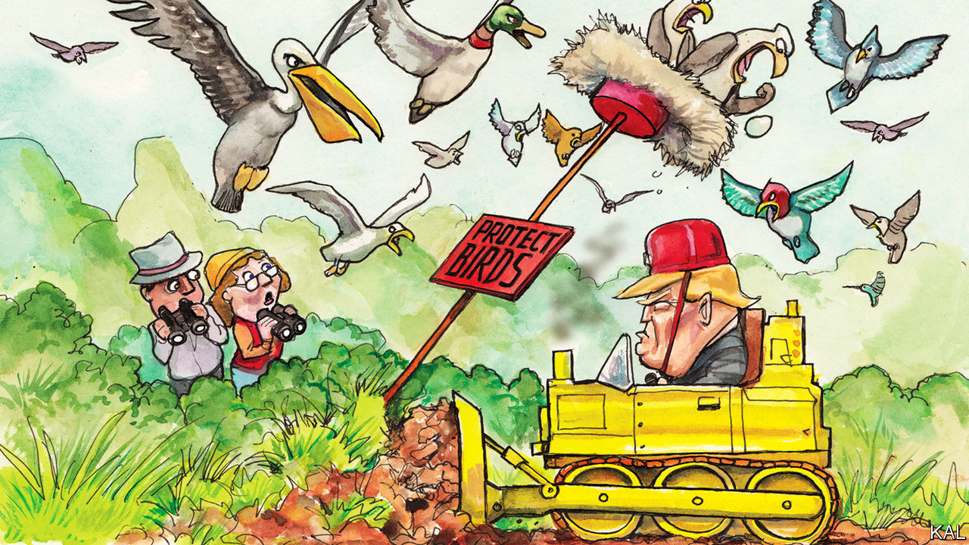

ONE AFTERNOON in 1896, a Bostonian socialite called Harriet Lawrence Hemenway read an article about the devastation of a colony of nesting birds by plume-hunters. Disgust at their grisly trade, which was eradicating millions of birds a year to meet Americans’ demand for feathery swank, surged in her like a ball of regurgitated feathers and crustaceans from a grebe’s crop. This would prove to be a turning-point in America’s relationship with nature.

Following the example of some similarly well-connected British women—originators of the Royal Society for the Protection of Birds—Hemenway launched a campaign against wearing feathers for fashion. It was audacious. During two strolls through Manhattan, an ornithologist identified the remnants of 40 native species, including warblers and woodpeckers, on over 500 women’s heads. Yet Hemenway’s Massachusetts Audubon Society, named after the bird-painter James Audubon, was replicated by like-minded women in over a dozen states. The National Audubon Society they formed in 1905 was even more effective. It had heavyweight fans such as Theodore Roosevelt and a flair for sensationalism. “Woman as a bird enemy” was the title of one of its lectures.

Lobbying by Audubon groups helped produce a remarkable series of bird protections, including the Lacey Act of 1900 and, following a pro-bird pact with British Canada, the Migratory Bird Treaty Act (MBTA) of 1918, which made it illegal to harm most native birds not hunted for sport. This landmark environmental law—and model for later ones such as the Endangered Species Act—probably saved several decorative birds, such as the snowy egret and sandhill crane, from extinction. Following additional pro-bird treaties with Mexico, Japan and the Soviet Union, the act now covers over 1,000 species. Since the 1970s its implementation has been mainly focused on warding off the threat they face from industrial development and pollution. After over a million birds were killed in 2010 by an oil-spill in the Gulf of Mexico, the company responsible, BP, was fined $100m under the MBTA. Most of the money was spent on restoring contaminated bird habitat.

The success of the avian conservation movement has changed people as well as the outlook for birds. According to a survey by the US Fish and Wildlife Service (FWS), America has 45m birdwatchers—roughly three times the number of people who watch American football on television. Diverse and widely spread—though with a tendency to be white, well-educated and female—they are estimated to spend $41bn a year on bird-related travel and kit. This mass enthusiasm, which Lexington observed on a recent visit to the St Marks wildlife refuge in Florida—the first and last landfall for millions of avian migrants across the Gulf of Mexico—is not merely a response to America’s even more diverse birdlife. As in similarly bird-dotty Britain, it is a culture that has sprung from a political decision to treat birds as precious and inviolable.

Donald Trump’s administration wants to devalue them. A new regulation published by the FWS this month would eviscerate theMBTA by ending the decades-old practice of penalising the “incidental take” of protected birds. So long as a person or company can claim to have killed or injured birds accidentally, he or it would be free to do so. Thus, a contractor could hose cliff-swallow nests off a road bridge, because cleaning the bridge, not killing swallow chicks, was his intention. If BP killed another million seabirds, it would face no penalty under the MBTA.

Assailed by Hemenway, the powerful millinery industry claimed that most of its feathers had been shed naturally. The arguments for the Trump rewrite are equally hollow. Pointing to the statute’s ambiguous language on incidental take, the administration claims it “hangs the sword of Damocles” over economic development. In fact, after decades of fairly consistent implementation of the law, America’s industrial-scale bird-killers understand perfectly well the potential cost of failing to alert birds to their electric lines or to cover their oil pits. They also understand the benefits of working with the FWS to mitigate the slaughter. The administration’s depiction of government and industry at war over the MBTA is inaccurate. Its predecessors, Republican and Democratic alike, tended to view the law mainly as a means to improve industrial practice, and they therefore penalised only persistent or egregious offenders. The number of birds drowning in oil-pits, meanwhile, fell by half, to around 750,000 a year.

Despite improvements in signalling electric lines, these kill even more: perhaps 25m a year. Climate change and habitat loss may be bigger threats; a recent study found America’s bird population had fallen by 30% over the past 50 years. The fact that the administration is nonetheless intent on gutting birds’ main legal protection shows how far it is from honouring its spirit—and the decades-old bipartisan consensus behind it. A pronounced conservative association with bird-watching, and conservation more broadly, was a feature of that. Prominent Republican birders include John McCain and Laura Bush. Mr Trump prefers corporatism. The overseer of the MBTA rewrite, David Bernhardt, the secretary of the interior, is a former oil-industry lobbyist.

## Tar and feathers

What of America’s bird-loving millions? If Mr Trump wins re-election, they are unlikely to stop his scheme. Like gun control or taxing the rich, conservation is something most voters support, but not forcefully enough to overcome resistance from a well-funded, politically favoured lobby. The fact that the FWS is already advising companies that they can get away with killing birds, accidentally on purpose, has sparked little protest.

Another question, if the administration gets its way, is what will become of America’s mass enthusiasm for the beauty and elusiveness of birds? It is a culture founded on law, regulation and the high status that birds have gained from them. If birds are less protected, that suggests, they may in time be less loved.■

This article was downloaded by calibre from <https://www.economist.com/united-states/2020/02/22/companies-can-now-get-away-with-killing-americas-birds>

|  |  |  |  |
| --- | --- | --- | --- |
| Previous | Articles | Sections | Next |

|  |  |  |
| --- | --- | --- |
| United States | Sections | Asia |

The Americas

Uruguay’s next president: Changing the guard

.

Pipeline protests: Shut down Canada

.

|  |  |  |
| --- | --- | --- |
| United States | Sections | Asia |

|  |  |  |  |
| --- | --- | --- | --- |
|  | Articles | Sections | Next |

#### Changing the guard

# An interview with Uruguay’s president-elect, Luis Lacalle Pou

He favours austerity, and using paramilitaries to fight crime

Feb 22nd 2020 | MONTEVIDEO

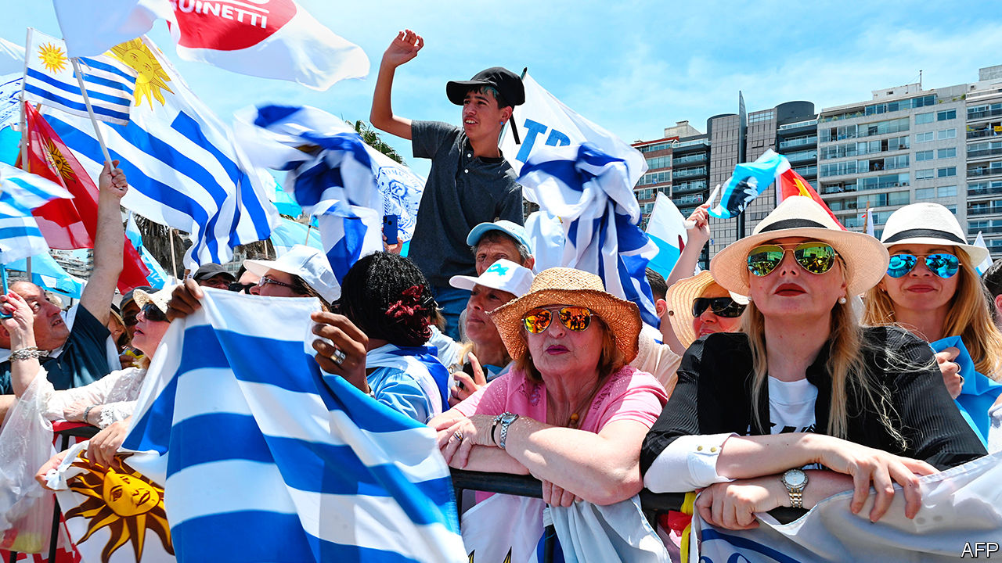

AT HIS campaign headquarters on Artigas Boulevard, named after Uruguay’s founding hero, the man who hopes to be its next one was energised. Luis Lacalle Pou, the country’s conservative president-elect, is 46 years old but looks younger, with floppy brown hair, no jacket and sleeves rolled up. Days ahead of his swearing-in on March 1st, in an interview with The Economist, Mr Lacalle Pou set out a wide range of plans, from relaxing immigration rules to cutting public spending. But what obsessed him most of all was tackling a recent surge in crime (see chart). He lamented that just down the road were “no-go areas” overrun with violence. “It’s time to take back the streets,” he said, “by force if need be.”

The first step was to take back power. Last November, in a run-off, Mr Lacalle Pou narrowly defeated Daniel Martínez, the candidate of the Broad Front, a leftist coalition that had ruled Uruguay for 15 years. (The last president from Mr Lacalle Pou’s National Party was his father, in the 1990s.) The Broad Front had maintained economic and constitutional stability, and liberalised marijuana use and same-sex marriage. But it also presided over sharp rises in public employment, the fiscal deficit and violent crime. The homicide rate in Uruguay, a traditionally safe country of about 3.5m, shot up by 46% in 2018, to 11.8 per 100,000 people, lower than Brazil’s but higher than Argentina’s. Mr Lacalle Pou’s coalition blames lax policing and light sentencing.

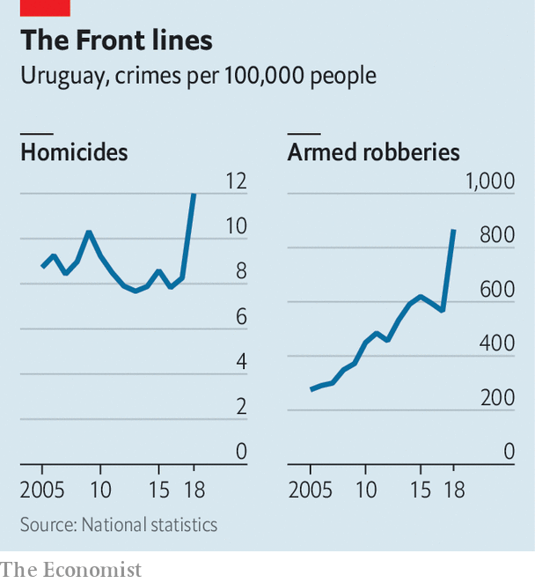

“Not even priests feel safe here,” says Mercedes Rossi, a housewife in the working-class quarter of Casavalle, 20 minutes from downtown Montevideo, the capital. “The delinquents rule this neighbourhood with guns and knives.” Such fears helped Mr Lacalle Pou win.

So it is unsurprising that he sounds so gung-ho about security. His appointment of Jorge Larrañaga, an experienced politician and longtime rival within his own party, as interior minister, was further confirmation. The incoming minister has promised a “very tough hand”, and his record suggests as much. Last year Mr Larrañaga pushed a “Live Without Fear” plebiscite, which proposed harsh measures: deploying soldiers to fight crime, encouraging night raids by police and imposing draconian prison sentences. That initiative failed, by 47% to 53%.

But its proposals may be revived, with minor alterations. Mr Lacalle Pou said his government intends to deploy paramilitary units from the existing Republican Guard and a new National Guard, as well as double some sentences for serious crimes. This is part of an emergency package to address public safety but also housing, education and the budget. With coalition partners, the new president can probably push it through. “This will not be brutal,” Mr Lacalle Pou insisted; “it will be decisive in giving people security again.” The opposition disagrees. Carolina Cosse, a politician in the Broad Front, decries the tough-on-crime measures as “an authoritarian attack on democracy”. Her colleagues are supporting planned strikes to coincide with congressional debate on the legislation.

## The man who would bin bureaucrats

The incoming government has economic woes, too. It will inherit a budget deficit of about 4.7% of GDP and anaemic growth. This is in part because Uruguay tends to suffer economically when next-door Argentina and Brazil do. As a candidate, Mr Lacalle Pou, who is pro-business and pro-austerity, favoured fiscal discipline. He committed to reducing public spending by $1bn. Cuts will come, he has promised, from government jobs and infrastructure, not services in what is often regarded as Latin America’s oldest welfare state. Nonetheless the axe will hurt. Adolfo Garcé, a political analyst, predicts that hitting the target will require slashing public-sector jobs by a third.

Foreign investment and talent could provide a boost. “We are one of the best countries in the world to live in,” said Mr Lacalle Pou. To tempt foreigners, he plans to make it easier for them to seek residency in Uruguay, where they already enjoy low taxes and exemptions on some types of foreign income, such as pensions. The target audience is Argentina. Immigration lawyers report that many Argentines seek to live across the River Plate as a result of their country’s economic crisis.

Next month’s inauguration offers an opportunity to reintroduce Uruguay to the world. In some ways the ceremony will reflect the country’s perennial position, predetermined by geography, as a sober intermediary between its bigger, more powerful and less temperate neighbours. Jair Bolsonaro, Brazil’s populist president, and Alberto Fernández, his centre-left counterpart in Argentina, were expected to meet at the ceremony after a public spat. Now it seems that Mr Fernández has cancelled. Mr Lacalle Pou promises to work with both men to reinvigorate the Mercosur trade bloc, comprised of their three countries plus Paraguay. But the guest-list also marks a noticeable shift: the authoritarian leftist leaders of Venezuela, Cuba and Nicaragua are personae non gratae.

The next president faces high expectations and only a short period, maybe a year or 18 months, in which to meet them, predicts Mr Garcé. Voters were split in the last election. And the opposition, especially the trade-union movement, remains strong. Reforms must strike a balance between reassurance and disruption. Mr Lacalle Pou seeks a middle way, in line with the people who elected him. “I voted for change, and I’m optimistic our president will be a vehicle for change,” says Ernesto Cis, a driver and tour guide. “We Uruguayans don’t do revolutions. We like change with continuidad.” ■

This article was downloaded by calibre from <https://www.economist.com/the-americas/2020/02/22/an-interview-with-uruguays-president-elect-luis-lacalle-pou>

|  |  |  |  |
| --- | --- | --- | --- |
|  | Articles | Sections | Next |

|  |  |  |  |
| --- | --- | --- | --- |
| Previous | Articles | Sections | Next |

#### Pipe of discord

# A pipeline through historically native land has sparked protests in Canada

Prime Minister Justin Trudeau has no good options

Feb 22nd 2020 | VANCOUVER

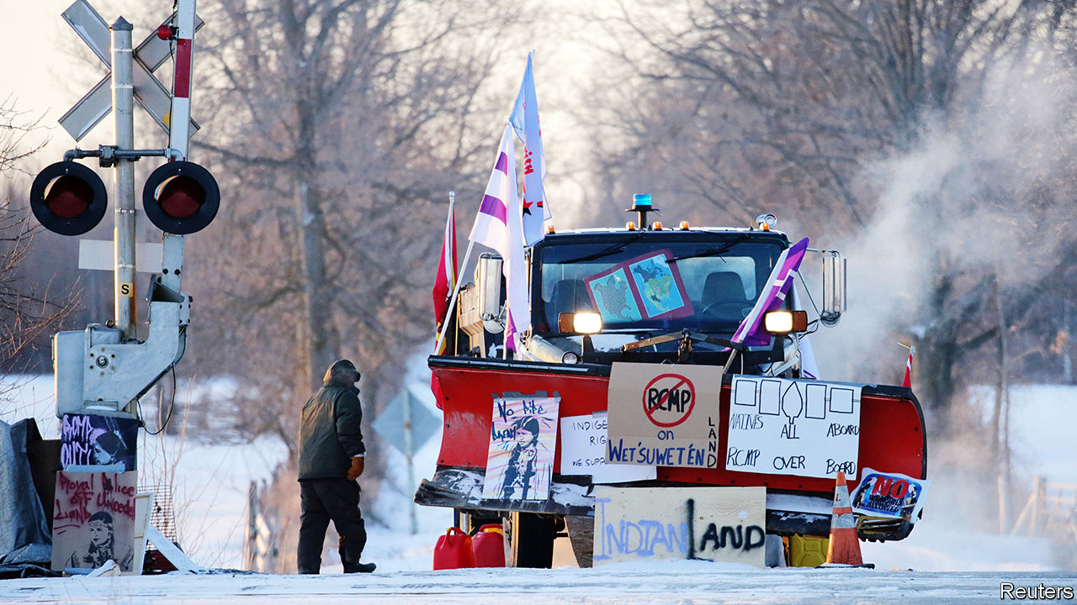

“STOP THE INVASION! No pipelines on stolen native land!” So chanted dozens of protesters on a chilly afternoon this week in Vancouver. With placards in hand, they blocked traffic on a busy thoroughfare, doing their part to “shut down Canada”. That has become the rallying cry against the Coastal GasLink pipeline, a C$6.6bn ($5bn) project which will transport natural gas 670km (420 miles) across British Columbia to the Pacific coast, where a liquefied natural gas (LNG) plant is under construction.

The pipeline is an “invasion”, detractors say, because about a quarter of its route passes through land traditionally belonging to the Wet’suwet’en, a First Nations people. Since early February, when police broke up a blockade (with an injunction to do so) local disputes have escalated to national unrest. Allies of the Wet’suwet’en have organised copycat demonstrations far away from the pipeline itself.

None of this has scuppered the plans, but it has disrupted the economy and embarrassed the Liberal government. Canadian National Railway (CN) shut down lines in the east of the country and temporarily laid off about 450 workers; Via Rail, a passenger service, is doing the same to nearly 1,000. Food, heating fuel, farm exports and commodities are gridlocked. Cars and ships have been unable to get through bridges, ports and the border with the United States. Public sentiment is against the protesters, reckons Janice, a regular rail rider who missed work because of cancellations. A court granted CN an injunction against demonstrators on its rail line in Alberta; fed-up counter-protesters have tried to dismantle blockades themselves.

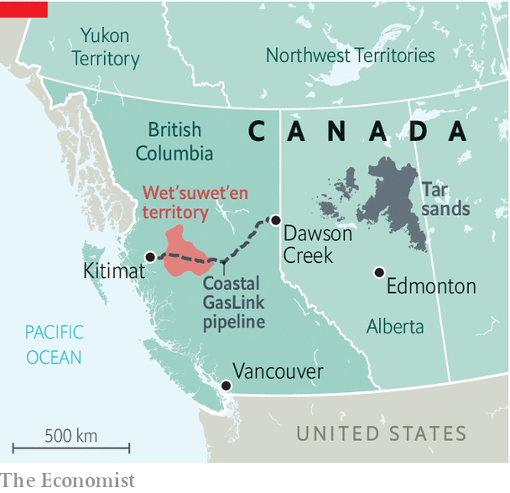

Justin Trudeau, the prime minister, has asked for patience. He missed the first week or so of chaos because he was abroad, lobbying for a seat on the UN Security Council. Mounting pressure forced him to cancel his next stop, to Barbados, and hold crisis talks in Ottawa. This is a thorny issue for Mr Trudeau, because he must juggle a trio of promises. He has promised to promote reconciliation with indigenous people—he calls their relationship with the government Canada’s most important. But he has yet to unveil a new set of rules for that relationship that was expected before last year’s election. He has promised to protect the environment, but the pipeline will carry a fossil fuel, which many greens would rather leave in the ground. And he has promised to boost economic growth, which exporting gas would obviously help.

Mr Trudeau’s timing is unlucky. He has inherited this problem from successive governments which have failed to resolve tensions between national and indigenous laws. Worse, past attempts have contributed to present confusion. An act in 1876 artificially divided the First Nations into elected “band” councils. Hereditary leaders still dispute elected representatives’ authority. In the pipeline debate, even as some hereditary chiefs have refused to consent, all 20 elected bands along the route of the Coastal GasLink signed C$338m in benefit agreements with TC Energy, the company sponsoring the pipeline, plus C$620m in contract work for indigenous businesses. Protesters (many of them non-indigenous) may jeopardise such investment.

Mr Trudeau has ruled out force, despite pressure from Conservatives, who accuse him of weakness, to send in police. Hansen Lee, a retired engineer in Vancouver, worries that such passivity has turned Canada into a “laughing stock”. Lawmakers are wary of repeating past showdowns with indigenous leaders that turned bloody. In a dispute over a plan to build a golf course near Oka in 1990 a policeman was killed; in the Ipperwash Provincial Park in 1995 a protester was shot.

A deal to resolve the conflict would probably mean the Canadian government trading land, power and money for an end to protests, claims and court action. Future projects, such as a planned expansion of the Trans Mountain oil pipeline, are sure to reignite debate even if the particulars of the Coastal GasLink are resolved. Mr Trudeau now has a choice: he can exercise power or cede more of it. So far he seems unwilling to do either.■

This article was downloaded by calibre from <https://www.economist.com/the-americas/2020/02/22/a-pipeline-through-historically-native-land-has-sparked-protests-in-canada>

|  |  |  |  |
| --- | --- | --- | --- |
| Previous | Articles | Sections | Next |

|  |  |  |
| --- | --- | --- |
| The Americas | Sections | China |

Asia

Japan’s economy: Typhoon, pestilence and tax

.

Manufacturing in Australia: Holden folds

.

Marriage in Pakistan: Clawless clauses

.

Elections in Afghanistan: To the victor the toils

.

Banyan: Mandarins for Mandarin

.

|  |  |  |
| --- | --- | --- |
| The Americas | Sections | China |

|  |  |  |  |
| --- | --- | --- | --- |
|  | Articles | Sections | Next |

#### Fiscal, natural, viral

# Japan’s GDP shrinks dramatically after a tax rise and a typhoon

Coronavirus may compound matters

Feb 20th 2020 |



ECONOMISTS STILL argue about the merits of Abenomics, the experimental mix of policies introduced by Japan’s prime minister, Abe Shinzo, seven years ago, in an effort to chase away deflation and stagnation. But two lessons are beyond debate. Japan’s bond market is remarkably docile despite the government’s towering debt. Japanese households, however, are painfully sensitive to increases in the consumption tax, a broad value-added tax imposed on most of their purchases. After the government raised the tax from 8% to 10% on October 1st, the economy shrank at an annual pace of 6.3% in the fourth quarter of 2019, according to figures released on February 17th (see chart ).

The tax increase was an unforced error. The government faces no immediate need for additional revenue. Despite gross debt nearing 240% of GDP, its borrowing remains absurdly cheap. The yield on a ten-year government bond is stuck at about zero, where the country’s central bank, the Bank of Japan (BoJ), has pegged it since 2016. That peg obliges the BoJ to buy as much government debt as necessary to keep long-term interest rates low. Such determined efforts to stimulate borrowing are needed chiefly because private spending has been weak—too weak, at least, to lift inflation to the BoJ’s target of 2% from the current 0.8%. Thus the consumption-tax rise was doubly strange. It made it even harder for firms to sell goods to Japan’s inhibited consumers, for the sake of reducing the number of bonds Japan’s government sells to a customer who has sworn to bid for them anyway. It was like adding ballast to the waterlogged side of a ship.

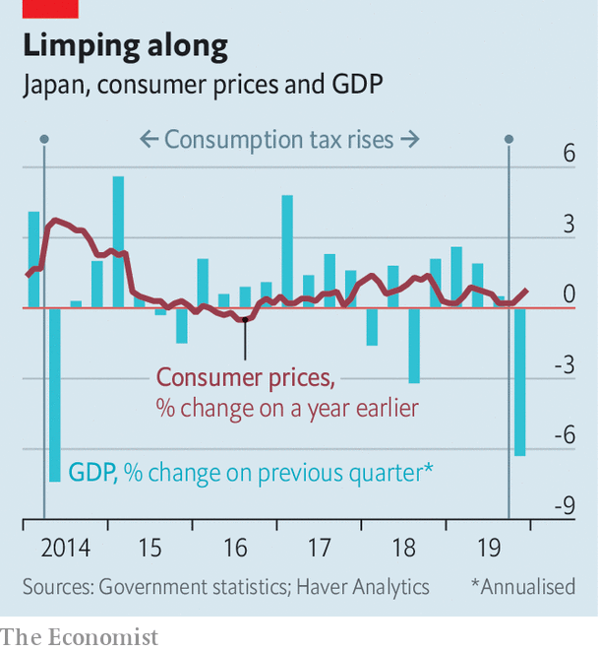

The error was foreseeable as well as unforced. A rise in the same tax in 2014 was followed by a similarly dramatic contraction in the economy, undermining the early momentum of Mr Abe’s reflationary push. The government had hoped to avoid a repeat of that experience by sparing food, newspapers and drinks (except alcohol) from the higher rate and by adding various compensatory measures. These included free child care and education for pre-school kids and a “rewards” system giving discounts to customers who make cashless purchases in small shops and convenience stores. These measures may have softened the blow in some ways: consumer spending on non-durable goods fell by less last quarter than it did in the 2014 episode. Unfortunately, these offsetting measures were themselves offset by another aggravating factor: the impact of Typhoon Hagibis, which inundated many towns and killed almost 100 people in October. As a consequence, capital spending by firms shrank even faster than it had after the tax increase six years ago.

The economy’s prospects for recovery are threatened further by the new coronavirus. Covid-19 has already killed one person in Japan; 73 have been infected (not counting hundreds diagnosed on a cruise ship docked in Yokohama, south of Tokyo). Japan is tightly integrated into Asian manufacturing supply chains that will be disrupted by factory shutdowns in China. It has also been counting on the Tokyo Olympics, which start in July, to lift spirits and spending. That happy prospect must now be in doubt. The government has already said that only elite athletes can take part in the Tokyo marathon on March 1st.

Faced with these fiscal, meteorological and viral setbacks, how will policymakers respond? The government has announced a fiscal stimulus worth about $120bn (2.4% of GDP), which will help repair typhoon damage and shield the country from future floods and other disasters. But the money will be spread over more than a year and may not add much to the prior trajectory of spending. The BoJ, for its part, seems largely out of ideas. Inflation has persistently undershot its target, which would call for easier monetary policy. But the BoJ’s tiered system of interest on the reserves that banks deposit with it, with some of them earning a negative rate (-0.1%), is already unpopular with savers, banks and insurance companies. An even lower rate might be counterproductive if it inflicts too much damage on Japan’s financial institutions, which struggle to pass the negative rates on to their own depositors.

A possible solution, proposed by Stefan Angrick of Oxford Economics, a British consultancy, would be for the BoJ to pay positive interest on more reserves, to shore up the banks’ profitability, but even lower rates on the remainder, to help stimulate borrowing. A more sharply tiered system like this helped Switzerland’s central bank cut interest rates to -0.75%.

One twist is that all three of Japan’s recent disasters—the tax increase, the typhoon and the virus—ought to put upward pressure on prices, even as they depress demand. That should prevent any return to outright deflation. But even policymakers desperate to ensure Japan escapes from deflation are unlikely to prefer stagflation. ■

This article was downloaded by calibre from <https://www.economist.com/asia/2020/02/20/japans-gdp-shrinks-dramatically-after-a-tax-rise-and-a-typhoon>

|  |  |  |  |
| --- | --- | --- | --- |
|  | Articles | Sections | Next |

|  |  |  |  |
| --- | --- | --- | --- |
| Previous | Articles | Sections | Next |

#### Holden folds

# Holden, a (sort-of) Australian icon, succumbs to globalisation

The cars, said to be as Aussie as meat pies and kangaroos, were actually made by GM

Feb 22nd 2020 | SYDNEY



“SHE’S A BEAUTY!” grinned the prime minister of the day, Ben Chifley, as the first car built entirely in Australia rolled off the assembly line in 1948. The Holden FX, as it was known, was greeted as a totem of a young nation joining the ranks of industrialised economies. Better yet, it had an Australian pedigree, even if General Motors owned the factory. Holden had been a saddle-making firm in Adelaide that began to manufacture car bodies to go with imported engines and chassis in 1919. GM bought it in 1931, but retained the brand. For a long time its advertising slogan was “People Trust Holden”. So when GM announced this week that it was eliminating the brand, indignation and nostalgia abounded.

Scott Morrison, the prime minister, scolded GM for allowing Holden to “wither away” even though “Australian taxpayers put millions into this multinational company.” Unions blamed his government for slashing the subsidies which might have kept Holden sputtering on. The government is so devoutly free-market that it will “not lift a finger” to protect Australian jobs, grumbled Sally McManus of the Australian Council of Trade Unions.

GM says it cannot justify further investment in a long-unprofitable business. Although Holden made almost half of all new cars sold in Australia in the late 1950s, locals nowadays prefer nippier runarounds or sleek SUVs to the chunky sedans it is known for, even if, as an ad jingle put it, the essence of Australia is “football, meat pies, kangaroos and Holden cars”. (The jingle was an adaptation of an ad about Chevrolet being an all-American brand.) Last year Holden flogged just 43,000 vehicles, a third of its sales a decade ago.

Holden had already closed its last factory in Australia in 2017; its vehicles are now imported, from Thailand among other places. Ford and Toyota closed Australian assembly lines at the same time, leaving Australia with no carmakers. To be competitive, analysts reckoned, Australian factories needed to churn out 200,000-300,000 cars a year. On the eve of its plant’s closure, Holden was making just 80,000. It didn’t help that “the nearest significant market was 10,000km away,” notes John Daley of the Grattan Institute, a think-tank. What is more, KPMG, an accounting firm and consultancy, calculated that in 2012 Australia was the second most expensive place to make car components, after Japan. High labour costs, inevitably, played a part.

The industry survived so long only because successive governments refuelled it with subsidies. GM guzzled about A$2bn ($1.3bn) before the handouts were cut by Mr Morrison’s party in 2013. Rightly so, according to a report released the following year by the Productivity Commission. It found no evidence that they had helped the wider economy, concluding that the “costs of such assistance outweigh the benefits”.

Manufacturing’s share of Australia’s economy peaked in the 1960s, in Holden’s heyday. It now accounts for just under 6% of GDP, well below the level of most other rich countries. But that has not stopped the Australian economy—and local wages—from growing faster than their peers. ■

This article was downloaded by calibre from <https://www.economist.com/asia/2020/02/22/holden-a-sort-of-australian-icon-succumbs-to-globalisation>

|  |  |  |  |
| --- | --- | --- | --- |
| Previous | Articles | Sections | Next |

|  |  |  |  |
| --- | --- | --- | --- |
| Previous | Articles | Sections | Next |

#### Clawless clauses

# How Pakistani brides inadvertently sign away their rights

Mandatory contracts intended to protect them often do nothing of the sort

Feb 22nd 2020 |

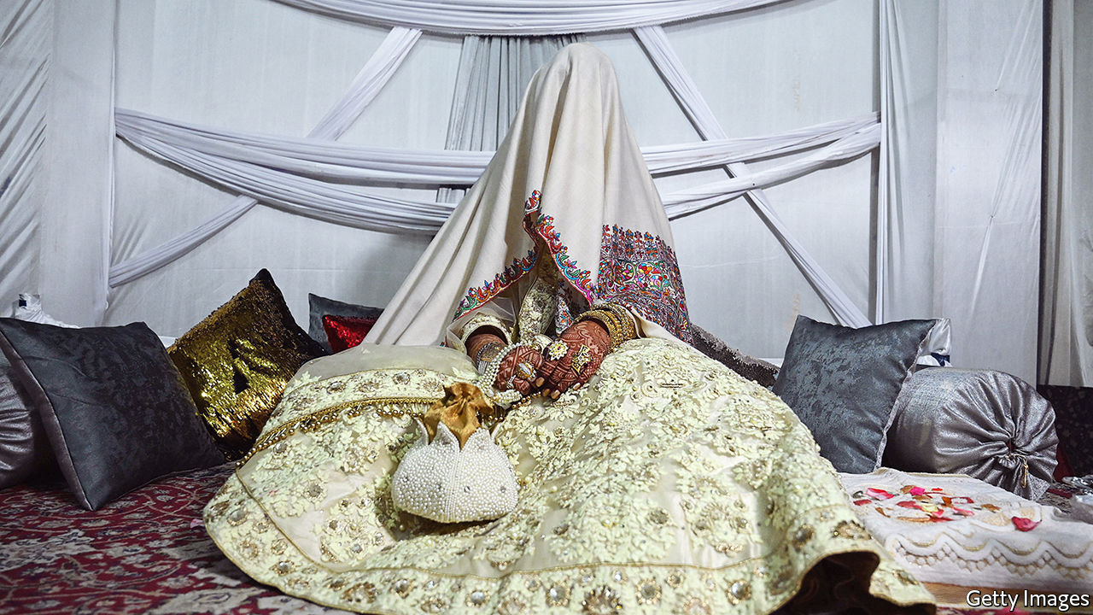

HOURS BEFORE her wedding ceremony, Aisha Sarwari, then a recent graduate of an American university, was called into a room full of men: her brother, her uncle, a marriage registrar and her fiancé. The registrar asked three times if she consented to marry the groom. She said yes. Then he told her to sign a contract she had never seen, with her name and a thumb-print. She said yes to that, too. “It didn’t even occur to me that I should look at the document,” she says now. That document, known as a nikah nama, is a marriage registration and a pre-nuptial agreement all in one. It determines all sorts of things that may end up being of critical importance to the bride, in particular, from the way in which she may seek a divorce to the division of property if the marriage comes to an end.

Yet many wives-to-be in Pakistan sign their nikah namas without reading them. Plenty do not know what they are signing. In Peshawar, a city in the north-west, nearly three-quarters of women, many of them illiterate, say they were not consulted on their marriage contracts. But asking for a say in the drafting would be fraught, anyway. At best, women who do will be accused of bad manners (for not trusting their new husband) or of courting disaster (because it is unlucky to talk of divorce before the marriage has even started). At worst, it would be seen as inexcusable uppitiness that might put the wedding in jeopardy. In some cases, marriage registrars, who are often imams, take matters into their own hands, simply crossing out bride-friendly clauses on the contracts. Even though such changes are illegal, an analysis of about 14,000 nikah namas in Punjab province found that 35% had been amended in this way, according to Kate Vyborny, one of the researchers involved. “It’s ludicrous,” says Ms Sarwari.

Yet when the nikah nama, an Islamic tradition, was incorporated into Pakistani law in 1961, the government’s intention was to “secure to our female citizens the enjoyment of their rights under Qur’anic laws”. In fact, the ordinance in question did not just enshrine Islamic practice in law; it modernised it, modestly circumscribing a man’s rights and codifying those of women. Men are still free to marry up to four women, but have to tell new wives about existing ones. Men can still divorce at will, but have to register the divorce in writing, and so on. Husbands are also required to state at the time of marriage, in the nikah nama, whether they concede their wives the same right they have, to end the marriage whenever they want, without having to go to court.

These rules are not as favourable to women as those in many Muslim countries. Wives who have not obtained the right to divorce at will can still seek one in court but, by doing so, usually forfeit their dowry, which they would normally be entitled to keep in case of divorce as a form of financial compensation. That is not the case in Malaysia and Morocco. Nonetheless, the reforms were controversial from the start. Boosters, such as Ayub Khan, the president at the time, said they could “liberate Islam from the debris of wrong superstition and prejudice”. Religious leaders denounced them as unIslamic.

Nearly 60 years later, the tension still festers. Feminists would like women to get more of the family’s assets after a divorce. But Zubair Abbasi of the Shaikh Ahmad Hassan School of Law, in Lahore, doubts that will happen. “This is such a sensitive issue,” he says, “no political party wants to take it on.” Instead, most activists are focusing on securing the freedoms already on the books. Fauzia Viqar, former head of the Punjab Commission on the Status of Women, says there should be mandatory training for marriage registrars, most of whom, surveys suggest, have none. When the commission helped sponsor a pilot training scheme, they found it reduced the illegal meddling with nikah namas by about a third. There should also be a public-awareness campaign aimed at both men and women, Ms Viqar argues.

Punjab, Pakistan’s most populous province, has already made it a criminal offence for registrars to fill out the nikah nama incorrectly. But the bigger obstacle to securing brides’ rights may be cultural. Ms Sarwari was lucky. Her husband had given her the right of unilateral divorce. The dowry was generous. And the imam had not tampered with the document. But her own relatives had urged her husband not to be too liberal, telling him: “Don’t give her any ideas.” At the reception, an older female guest yelled at her for being too chatty, since the ideal bride is shy and demure. Whatever the legal niceties, such entrenched expectations, Ms Sarwari says, make it difficult for brides even to ask about their rights. ■

This article was downloaded by calibre from <https://www.economist.com/asia/2020/02/22/how-pakistani-brides-inadvertently-sign-away-their-rights>

|  |  |  |  |
| --- | --- | --- | --- |
| Previous | Articles | Sections | Next |

|  |  |  |  |
| --- | --- | --- | --- |
| Previous | Articles | Sections | Next |

#### To the victor the toils

# Afghanistan’s disputed presidential election comes at a tricky time

The winner needs a strong mandate to negotiate with the Taliban

Feb 22nd 2020 | KANDAHAR

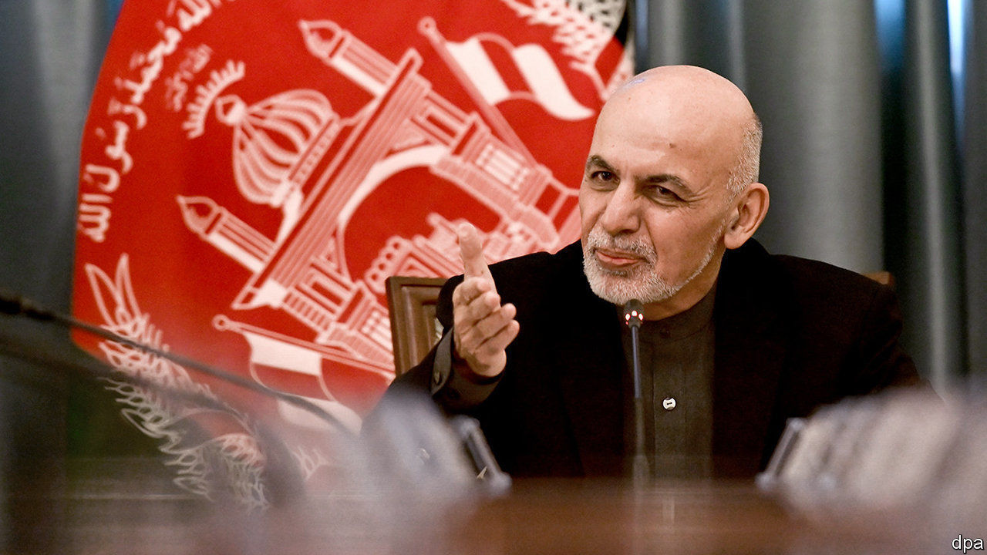

ELECTIONS ARE supposed to bring stability to politics and legitimacy to the victor. Afghanistan’s recent presidential poll, alas, has provided neither. For one thing, only a small proportion of Afghans voted. Worse, it has taken the election commission an agonising five months to count the ballots, adjudicate disputes and declare a winner: Ashraf Ghani, the incumbent, with 50.6% of the vote. What is more, his closest rival, Abdullah Abdullah, rejects the result and has declared himself president, despite winning only 39.5% by the official tally. It does not help that there would have been a run-off had Mr Ghani not scraped above 50%, lending weight to Mr Abdullah’s complaints. And the whole election has anyway been overshadowed by America’s continuing negotiations with the insurgents of the Taliban, which threaten to turn Afghanistan’s already tumultuous politics upside down.

This is not Afghanistan’s first disputed election. Mr Abdullah claimed the previous vote, in 2014, was also rigged. He lost then to Mr Ghani, too, and was only persuaded to abide by the result when Mr Ghani agreed to create a special job for him—chief executive—in a power-sharing government. Their joint administration was unhappy and the rivals are said barely to speak. Mr Ghani explicitly and emphatically ruled out any extension of the current arrangement before the election.

Even if Mr Abdullah can be mollified, Mr Ghani cannot claim much of a mandate. Only about 10% of the voting-age population actually turned out. That means a mere 5% of adult Afghans plumped for him. Voters were scared away from polling stations by the risk of being murdered, and disillusioned by the familiar choice.

The stand-off comes at an awkward time. Eighteen months of talks between America and the Taliban in Qatar appear to be on the verge of bearing fruit. The two sides say they are close to resurrecting a deal called off by President Donald Trump last year. Any agreement is likely to require the government to start negotiating very quickly with the Taliban to decide how the country should be run.

That will be hard if there are two competing governments. Political heavyweights are already jockeying to be part of the negotiating team. A weakened Mr Ghani will struggle to adjudicate. It will be hard for the government to negotiate forcefully with the Taliban if it does not have the backing of most of the political class. “The challenge is to get a united and inclusive negotiating team together,” explains a foreign diplomat. “It would be a very poor situation if the Taliban and the US sign their agreement, only for the Afghans to fail.”

In the meantime, the economy is faltering. Poverty is on the rise. Some 9.4m Afghans will need charitable food and shelter this year, the United Nations warns, up from 6.5m in 2019. In the southern city of Kandahar, an economy once super-charged by vast injections of aid is now subdued. Residents bemoan a lawlessness epitomised by assassinations of businessmen and government officials. The disputed election result compounds the problems, says Muhammad Naim Kharakhi, a shopkeeper at the main bus station, who sells biscuits and drinks to passengers. “It will cause big problems for ordinary people because businessmen who want to invest will wait. The economic situation was already bad enough because of the delayed result. This will only make it worse.” ■

This article was downloaded by calibre from <https://www.economist.com/asia/2020/02/22/afghanistans-disputed-presidential-election-comes-at-a-tricky-time>

|  |  |  |  |
| --- | --- | --- | --- |
| Previous | Articles | Sections | Next |

|  |  |  |  |
| --- | --- | --- | --- |
| Previous | Articles | Sections | Next |

#### Banyan

# Singapore has almost wiped out its mother tongues

Elderly speakers of Cantonese, Hakka and Hokkien sometimes cannot talk to their own grandchildren

Feb 22nd 2020 |

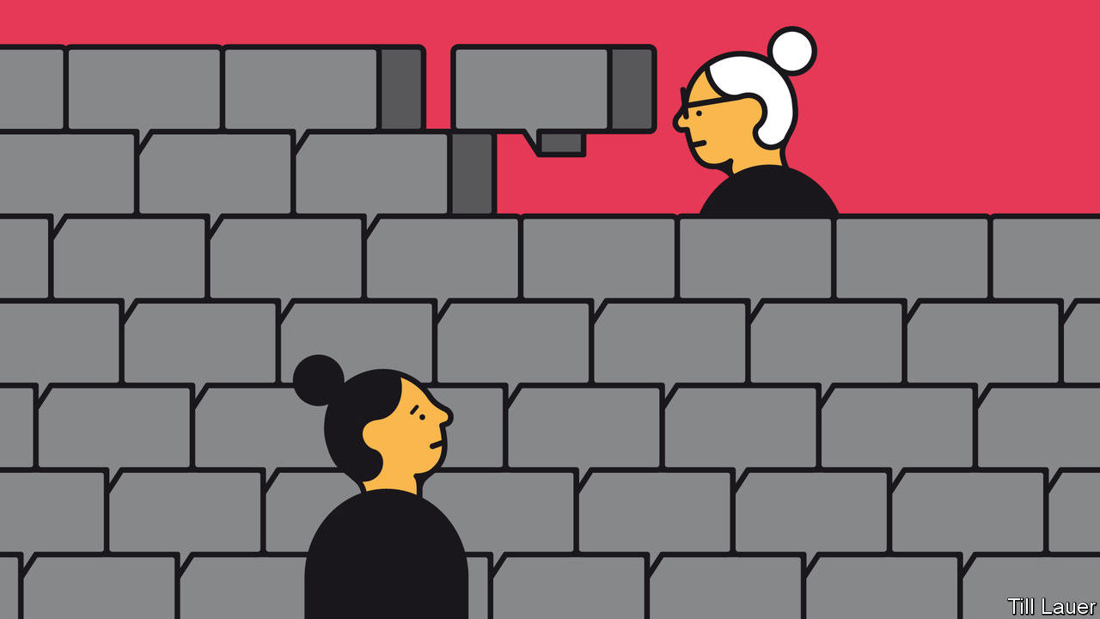

WHEN SANDY, a young Chinese Singaporean, learned that her grandmother was terminally ill, she signed up for a workshop in the Hokkien language run by LearnDialect.sg, a social enterprise founded to help Singaporeans communicate with the city-state’s older Chinese residents—including within their own families. Sandy is fluent in English and Mandarin, the official “mother tongue” of Chinese Singaporeans. Her grandmother spoke little of either. Before she died, Sandy thrilled her by asking in Hokkien, “What was your childhood like?” She was even able to understand some of the answer.

Their language barrier was the product of decades of linguistic engineering. English has been the language of instruction in nearly all schools since 1987, to reinforce Singapore’s global competitive edge. But, depending on ethnicity, pupils study a second language—typically Mandarin, Malay or Tamil. These are intended, as Lisa Lim of the University of Sydney puts it, to add “cultural ballast” vis-a-vis English. In the case of Mandarin, its acquisition has been reinforced by the government’s annual “Speak Mandarin Campaign”, started in 1979.

Mandarin is a standardised version of the language spoken by the people of the vast plains of northern China. Yet hardly any of the Chinese from whom Singaporeans are descended hailed from there. They came instead from the southern provinces of Fujian, Guangdong and Hainan, and so spoke different languages: Hokkien, Cantonese and Hakka, along with two Hokkien-related tongues, Teochew and Hainanese.

The Speak Mandarin Campaign sought to destroy Chinese Singaporeans’ real mother tongues, first by demeaning them as provincial “dialects” of Mandarin when they are in fact mutually unintelligible languages as different as English, German and Danish. Lee Kuan Yew, Singapore’s founding father, who started learning Chinese in his 30s, promoted the now discredited notion that humans have a tightly limited capacity for language: Hokkien and all the rest undermined the official bilingualism by hogging chunks of children’s memories. Further, the great tidier disliked the diversity embodied in these languages and wanted to forge a single Chinese identity—reason enough to foist on Chinese Singaporeans an alien language. Lee also thought that China’s opening promised riches to those who could speak its official language.

So dialects were disparaged. In the early 1980s television and radio programming in these languages all but disappeared, cutting many people adrift. “To speak dialect with your child,” the government warned, “is to ruin his future.” By the campaign’s own yardsticks, the success is striking. The use of Chinese vernaculars at home has collapsed, from 76% of Chinese households in 1980 to 16% in 2015. Over the same period, the use of Mandarin rose, from 13% of Chinese households to 46%. But the linguistic engineering has had an unintended consequence: the use of English is now increasing faster, especially among younger families: over 70% of households with children at primary school use it as their main language, undermining Mandarin and vernaculars.

And so a debate about the costs of language policies has grown since Lee’s death in 2015. The same year, the 50th anniversary of the nation’s founding was accompanied by an outpouring of sentimentality over Singapore’s roots. These days officials are a bit readier to tolerate Singapore’s linguistic variety. Lee Kuan Yew once called Singlish, the country’s vibrant mash-up of English, Malay and Chinese vernaculars, a “handicap”. Lee’s son, the prime minister, Lee Hsien Loong, claims to be proud of Singapore’s unique form of Mandarin. For instance, the Malay for “market”, pasar, has been imported as ba sha. That would be unintelligible to a mainland Chinese. Yet that only highlights a paradox Mr Lee does not acknowledge. On the one hand, he praises Singaporean Mandarin because it supposedly reinforces a Chinese Singaporean identity. On the other, he frets about others stealing a march in China because of their more fluent Mandarin.

Meanwhile, younger Singaporeans are embracing former mother tongues. Ski Yeo and Eugene Lee were motivated to found LearnDialect.sg upon seeing an elderly Cantonese-speaker in a nursing home struggle to communicate that she was cold. Health workers have signed up to their courses, while others want to say the right things at family gatherings over the lunar new year. There is an uptick in Hokkien television programming. And everyone admits that effete Mandarin is useless for swearing.

This article was downloaded by calibre from <https://www.economist.com/asia/2020/02/22/singapore-has-almost-wiped-out-its-mother-tongues>

|  |  |  |  |
| --- | --- | --- | --- |
| Previous | Articles | Sections | Next |

|  |  |  |
| --- | --- | --- |
| Asia | Sections | Middle East and ... |

China

The coronavirus epidemic: Casualties of war

.

Diplomatic rhetoric: Discovering Twitter

.

Chaguan: Putting faces to the numbers

.

|  |  |  |
| --- | --- | --- |
| Asia | Sections | Middle East and ... |

|  |  |  |  |
| --- | --- | --- | --- |
|  | Articles | Sections | Next |

#### Casualties of war

# In China, newly confirmed cases of coronavirus infection are falling

Yet many Chinese are still enduring tight quarantine

Feb 22nd 2020 | BEIJING

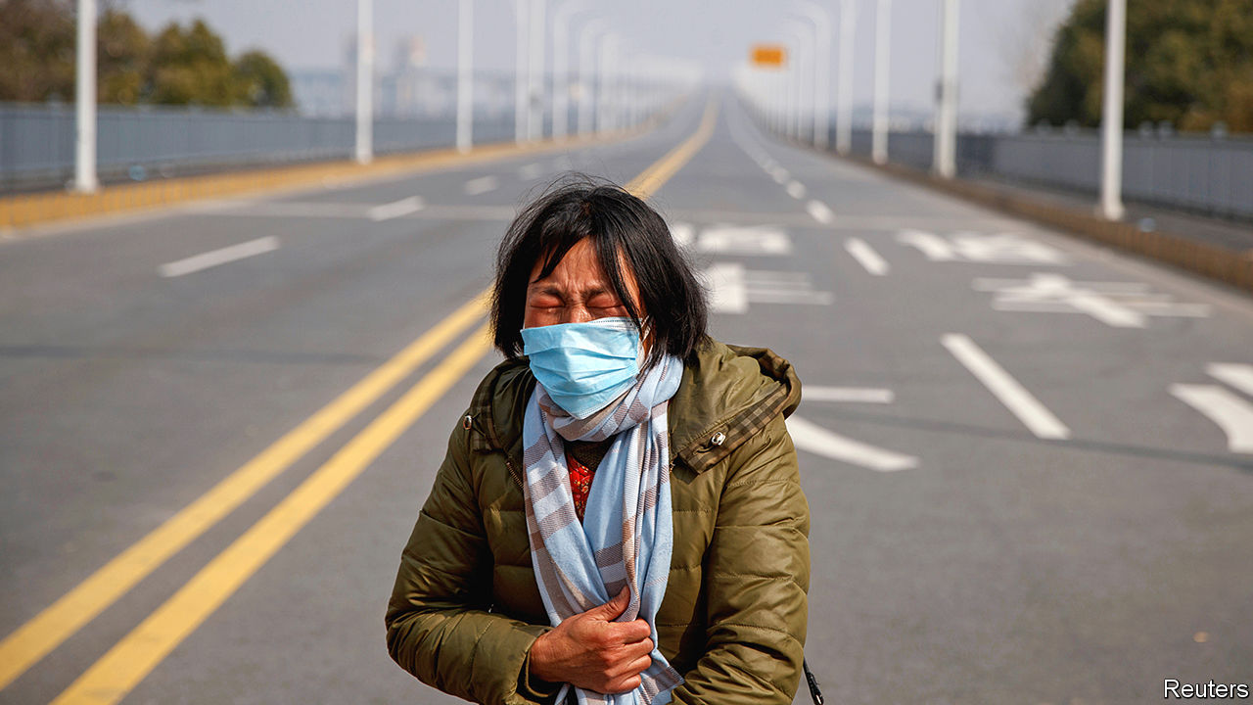

CHINESE OFFICIALS call it “waging war on two fronts”. One involves battling the coronavirus that has infected more than 74,000 people in China and killed about 2,100 since it was discovered in the central city of Wuhan in December. The other is a struggle to revive the economy. The daily number of newly diagnosed infections has mostly fallen since February 13th. But a month after imposing the most extensive quarantine measures ever enforced during an epidemic, most local governments are hesitant to ease up.

Some coastal cities have made it easier for businesses to obtain approval before resuming work and have eased requirements for returning workers to provide proof of their health. But controls remain harsh. Hubei province, of which Wuhan is the capital, is still under the tightest lockdown. Since late January it has been all but sealed off from the rest of the country. Until mid-February residents of Wuhan—a city more populous than London—had at least been allowed to stroll in the streets. But lately the authorities have stepped up the “wartime measures” that officials have put in place to fight the spread of covid-19, as the disease caused by the virus is known.

First, local officials began stopping people from leaving their homes more than once every two days. Then the government banned all non-urgent excursions, even for buying necessities. Local officials help to arrange the delivery of essentials to each home. One resident of Wuhan says that in his district, households must choose their food supplies from a short list of slightly differing parcels.

Many less-affected cities outside Hubei are also regulating their citizens’ comings and goings. In Zhengzhou, the capital of neighbouring Henan province, officials have issued households with exit passes to be shown at checkpoints at the entrances to their housing complexes. This is supposed to prevent non-essential outings. Similar restrictions are in place in several other big cities, including in the far-western region of Xinjiang. The New York Times calculates that, by February 18th, epidemic-related limits on outdoor movement were affecting about 150m people nationwide.

In the biggest cities, such as Beijing and Shanghai, controls are not as strict. But since people began returning from their extended lunar new-year holidays checkpoints have been set up in neighbourhoods to prevent access by non-residents (how strictly rules are applied varies according to the enthusiasm of whoever is on duty). On February 14th Beijing’s city government said that people who enter the capital from any other province will have to self-quarantine for two weeks, Beijingers included.

The longer such measures linger, the harder it will be for officials fighting on the economic front. Wuhan is an industrial centre and Hubei’s GDP is bigger than Poland’s. In an internal speech on February 3rd, made public 12 days later, China’s leader, Xi Jinping, said the country’s original economic targets for the year “must be fulfilled”. This is an ambitious goal. Many of China’s firms have been crippled by tight quarantine measures and have yet to resume normal business despite a supposed return to work on February 10th in most areas. Businesses in Hubei had been scheduled to reopen on February 21st. The date has been pushed back to March 10th.

For some people, the restrictions are a nightmare. Even in lightly affected regions, hospitals remain closed to all but the most urgent cases (a mother in Hubei is pictured, pleading with police to allow her daughter through a cordon to get cancer treatment). Some people in Hubei find it difficult even to travel to pharmacies to pick up essential medicine. A charity worker says he calls up local officials to alert them to the needs of disabled residents. But the bureaucrats are often flustered by the calls, he says, because they are so overworked.

Many Chinese say they are afraid of catching covid-19 and that the government’s measures are a necessary price to pay for the protection of their health. But there are also many who believe the authorities’ response to the epidemic was bungled, especially in the days leading up to the lockdown in Hubei when officials were slow to acknowledge the virus’s threat. The Communist Party worries that public anger could threaten social stability (the need to maintain it was a big theme of Mr Xi’s recently published speech). Censors have been struggling to control online criticisms, which surged earlier this month following the death from covid-19 of a doctor who had been reprimanded by police for warning of the danger. Access has been throttled to foreign virtual private networks, which some people in China use to circumvent the “great firewall”.

Mr Xi is also waging war on another front: against overseas critics (see [article](https://www.economist.com/node/21780474)). On February 19th China ordered three of the Wall Street Journal’s China-based reporters to leave the country. It is the largest expulsion of accredited foreign journalists in China in decades. Officials say it is in response to an opinion piece entitled: “China is the real sick man of Asia”. That headline caused widespread offence, for it repeats a slur used by western and Japanese imperialists about China. The Journal says it did not realise this, and that its words were a play on an old cliché used of the Ottoman Empire and commonly revived in headlines about various countries. The Economist, the Guardian and the Financial Times have all called Britain “the sick man of Europe”, notes the Journal.

Mr Xi will probably not have to worry about embarrassing questions at the annual session of China’s parliament, the National People’s Congress. It is due to start in early March, but senior delegates will meet on February 24th to discuss whether to postpone it. They are expected to do so. China’s leaders will not want to send the wrong message by convening the congress at a time when many Chinese are effectively confined to their homes and when officials (which many of the nearly 3,000 delegates are) should be on the front lines, fighting the epidemic.

But the publication of Mr Xi’s speech could be a sign that he is confident of victory. It revealed that he was giving orders on containing the virus as early as January 7th, two weeks before what had hitherto been his earliest-known comments on the outbreak. By letting this be known, the party may want to show that if there was any coverup at that early stage, it was the fault of local officials, not his. The outlines are becoming visible of the party’s strategy when the war is eventually over. ■

This article was downloaded by calibre from <https://www.economist.com/china/2020/02/22/in-china-newly-confirmed-cases-of-coronavirus-infection-are-falling>

|  |  |  |  |
| --- | --- | --- | --- |
|  | Articles | Sections | Next |

|  |  |  |  |
| --- | --- | --- | --- |
| Previous | Articles | Sections | Next |

#### Discovering Twitter

# China finds a use abroad for Twitter, a medium it fears at home

The country’s diplomats are learning to play rough online

Feb 22nd 2020 |

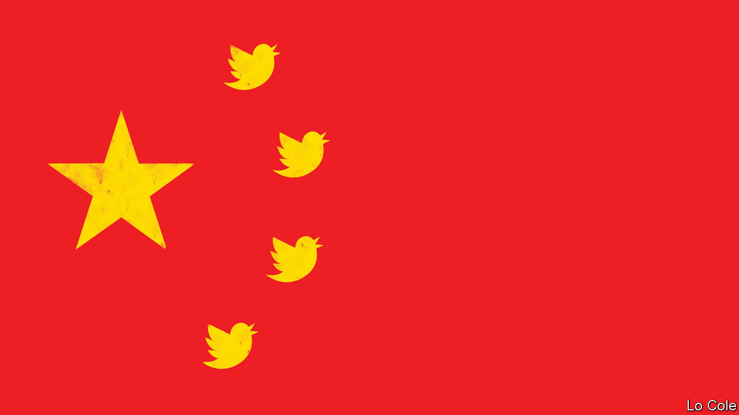

AS THE CRISIS deepened over the outbreak of covid-19, China’s leader, Xi Jinping, convened a meeting of the country’s most powerful body, the Politburo Standing Committee. One topic the seven men discussed on February 3rd was how to manage publicity. Officials, they agreed, must “tell the story of China’s fight against the epidemic, and show the Chinese people’s spirit of unity and togetherness”. In response, Chinese diplomats have been turning to a medium that most of them eschewed until just a year ago: Twitter. Blocked in China, it is fast becoming a favoured tool for the Communist Party as it tries to amplify its voice globally.

Two academics who study the Chinese foreign ministry’s use of social media, Zhao Alexandre Huang and Rui Wang, found only 17 Chinese diplomatic Twitter accounts in October 2018. Now they count more than 80. They are being used to promote the heroic work of China’s doctors and nurses and relay messages of support from Western leaders. “No winter lasts forever, every spring is sure to follow,” said China’s foreign ministry spokeswoman, Hua Chunying, on February 14th in her first ever tweet. They also go on the offensive. “You speak in such a way that you look like part of the virus and you will be eradicated just like virus. Shame on you,” said Zha Liyou, China’s consul-general in Kolkata, India, in a tweet on February 16th aimed at a critic of China’s handling of the outbreak.

Such spontaneous name-calling by Chinese diplomats was unusual until recently. But since Mr Xi became China’s leader in 2012, he has encouraged his diplomats to be more robust in their efforts to boost China’s “discourse power”. The Economist slid into the direct messages of several Chinese envoys to ask why they were turning to Twitter. Li Xiaosi, the ambassador to Austria, replied that Mr Xi had “asked Chinese diplomats to tell China’s stories well and present a true, multidimensional and panoramic view of China”. Mr Zha, in Kolkata, wrote that telling the “true story” of China was his “sole purpose”.

Before the epidemic, such diplomats often used Twitter to dismiss reports of human-rights abuses in Xinjiang. “Many westerners’ #COUNTER_TERRORISM logic: I drop bombs in sovereign countries which caused huge civilian casualties, I’m protecting human rights!” tweeted Cao Yi, a Chinese consul in Beirut on January 2nd. “You set up education&training centers to prevent extremism which made #Xinjiang free of terrorist attacks, you have no human rights!”

The tweets get noticed. In July one of the country’s most outspoken Twitter-diplomats, Zhao Lijian, who has about 240,000 followers, posted a message saying that white people avoid a mostly black district in Washington. Susan Rice, a former American ambassador to the UN, tweeted that Mr Zhao, who was then the deputy chief of mission in Islamabad, was a “racist disgrace”. She called on Cui Tiankai, China’s ambassador in Washington, to “do the right thing and send him home”. Mr Zhao fired back that she was “shockingly ignorant”. But Mr Cui asked that word be conveyed to Ms Rice that he did not approve of Mr Zhao’s tweet, that Mr Zhao did not work in Washington and that his Twitter account did not reflect China’s stance. The offending tweets were soon deleted.

Mr Zhao has since relocated to Beijing, where he is deputy chief of the foreign ministry’s Information Department. Part of the provocateur’s duties: getting more of China’s envoys to tweet. ■

This article was downloaded by calibre from <https://www.economist.com/china/2020/02/22/china-finds-a-use-abroad-for-twitter-a-medium-it-fears-at-home>

|  |  |  |  |
| --- | --- | --- | --- |
| Previous | Articles | Sections | Next |

|  |  |  |  |
| --- | --- | --- | --- |
| Previous | Articles | Sections | Next |

#### Chaguan

# Amid a virus lockdown, how are China’s migrant workers surviving?

A sense of powerlessness can hurt as much as dwindling savings

Feb 22nd 2020 |



“FAMILY IS HAPPINESS,” reads the motto over the front door of a village house in the north-west of Sichuan province. From the mahjong table beneath a velvet dust-cloth, to the child-sized chair facing a television flanked by pink plastic speakers, all is ready for a family reunion. The home’s owners, grandparents in their 50s, have had six weeks to clean and tidy, their longest break in years from lives of toil in Beijing. Alas, the couple did not choose this extended holiday, nor the loss of pay it involves. In common with many of China’s 173m long-distance migrant workers, their jobs have been halted by the new coronavirus. Worse, during this subdued lunar new year they have not seen their only child, a 32-year-old chef. Curbs on travel have left him stuck in the next-door province of Shaanxi with his wife and eight-year-old son.

In medical terms, covid-19 has largely spared this corner of Sichuan. As The Economist went to press there were 22 confirmed cases and no deaths in the nearest large city, Mianyang, and in the villages that surround it, with their fir trees and duck ponds and fields of yellow rapeseed. Still, quarantine restrictions have shut down bus services. Villages are closed behind checkpoints guarded by local officials and volunteers in masks and red armbands, wielding digital thermometers and disinfectant sprays.

China is a country of half-idled factories, of office towers emptied of white-collar staff, and restaurants without diners. Chaguan this week travelled to Sichuan, 1,700km south-west of Beijing, to meet a few of the blue-collar workers who are suffering the consequences. He found people who are at once more resilient and more vulnerable than their peers in the rich world. Migrants hunkered down in home villages talk of picking free vegetables, or bartering with neighbours. Less happily, meat prices are high. Pork prices have soared since herds were devastated by African swine fever, an animal pandemic that reached China in 2018. None of those who spoke to Chaguan questioned strict government controls, for the virus scares them. Neither they nor their village are named here. These are jumpy times in which Communist Party leaders have demanded that news reports should be filled with “positive energy”.

Chaguan chatted with workers on plastic stools outside a three-storey home built in 2008 at a cost of about 120,000 yuan ($17,130). It sits on land owned by a 54-year-old grandfather who works in Beijing as a casual painter and decorator. He is paid 3,000 yuan in a good month. His wife, also 54, cleans an insurance company’s offices, earning about two-thirds of that. Their combined earnings make them middle-income workers in China, but they watch every yuan. They rent a room in a shared apartment for a little over 1,000 yuan a month. They make packed lunches and take buses to work. The wife explains that, with underground train tickets starting at three yuan, “If I take the metro I won’t have any money left.” They have lived in Beijing since 2004 but have barely explored the city, apart from a visit to the Great Wall and another to see Mao Zedong in his mausoleum.

Each morning now, they check for a smartphone message from the cleaning firm that employs the wife, telling her to return to Beijing. As out-of-town arrivals to the capital they will have to spend two weeks in self-isolation, or face legal penalties. Loneliness does not worry them. “Quarantine isn’t that different from what we usually do, we just stay put,” shrugs the husband. Money is more of a concern, for he will earn nothing while isolated. In a good month the couple save just over 1,000 yuan after rent and living expenses. For years, their savings went towards building their house, which they will leave to their son. Now they regularly send money to help fund their grandson’s studies in Mianyang. “We have to. That’s how it is in the countryside,” says the wife.

Chinese savings rates are high by world standards—even the poor routinely save 20% of their disposable income. In contrast, a study in 2017 by America’s Federal Reserve found that 44% of Americans lack the savings to pay an unexpected $400 bill. China’s skimpy pensions and health insurance, notably in rural areas, explain much of that thrift. Westerners are helped with lots of costs, says a young man visiting the village from Mianyang. “Chinese people, we’re on our own,” he laughs. Life under lockdown is cheaper here than usual because social visits are banned. Every three households have been given a ticket, allowing one person to buy supplies for them all from the local market. For now, the grandparents who normally work in Beijing are spending savings. They could survive another half a year, they think, but no more.

## Needed but seldom heeded

A sense of powerlessness can hurt as much as dwindling funds. A visit to Mianyang’s almost-deserted railway station found a middle-aged couple heading, unhappily, back to Zhejiang province, where infection rates are rather high. They both work in Jiaxing, near Shanghai, at a factory that makes linings for much-needed face-masks, and so have been ordered to return. They do not know if they will be paid for the two-week quarantine that awaits them, which they have heard will be monitored via the GPS function on their phones. They do not even know whether their landlord will let them back into the room that they rent from him. Reports abound of migrants being denied entry to residential compounds, as local officials and property managers impose harsh rules, some of their own invention. If they are barred from their home the factory has offered dormitory beds, says the wife. “There is no option. We have to go back,” sighs the husband.

In truth, China’s economy needs migrant labour just as much as those workers need their pay. Hard, solitary lives explain why the average age of such workers is now over 40. The young often prefer to work nearer home. Though covid-19 would test any country, the epidemic is casting fresh light on a Chinese society divided by cruel inequalities of wealth, political clout and urban versus rural class. This is a crisis with many sorts of victim. ■

This article was downloaded by calibre from <https://www.economist.com/china/2020/02/22/amid-a-virus-lockdown-how-are-chinas-migrant-workers-surviving>

|  |  |  |  |
| --- | --- | --- | --- |
| Previous | Articles | Sections | Next |

|  |  |  |
| --- | --- | --- |
| China | Sections | Europe |

Middle East and Africa

American policy in Africa: A strategy on autopilot

.

Voting in Africa: Why the young and rich vote less

.

Delivering letters in Congo: The postman never rings at all

.

South Sudan: Inching towards peace

.

Jews in Egypt: Welcome back, sort of

.

Arab states and the IMF: A bit too austere

.

|  |  |  |
| --- | --- | --- |
| China | Sections | Europe |

|  |  |  |  |
| --- | --- | --- | --- |
|  | Articles | Sections | Next |

#### A strategy on autopilot

# How America deals with Africa, despite Donald Trump

The president is not interested. American diplomats must do their best

Feb 22nd 2020 | WASHINGTON, DC

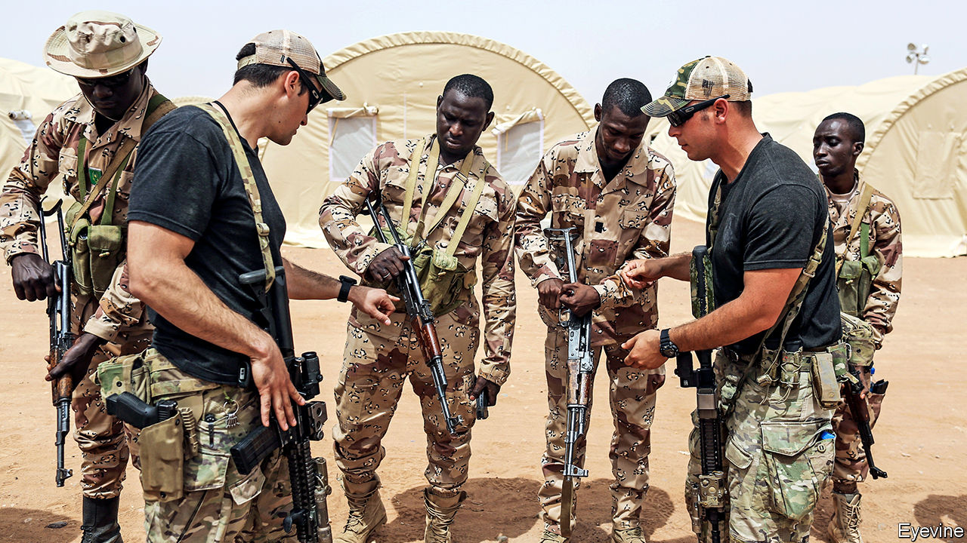

THESE DAYS it is notable when both Republicans and Democrats oppose a foreign policy of Donald Trump’s in strident unison. When it was reported that Mark Esper, the secretary of defence, was set to remove American forces from the Sahel, where jihadists have been wreaking havoc across a vast swathe of Africa, members of Congress reacted angrily together, arguing vigorously against such a course.

A few weeks later Mike Pompeo, the secretary of state, sounding ambivalent on the matter, set off on the first tour of sub-Saharan Africa by any member of Mr Trump’s cabinet for a year and a half. The carefully chosen countries were Senegal, Angola and Ethiopia. Mr Pompeo made friendly noises in all three. The Senegalese urged America not to withdraw from the Sahel. In oil-rich Angola Mr Pompeo encouraged trading with America rather than China and warned against corruption. In Ethiopia he praised the Nobel-prize-winning prime minister for making peace and privatising bits of the economy.

But few Africa hands reckon the recent visit will mark a change of policy in the White House. Donald Trump has made no bones about his lack of interest in Africa. The continent is full of what he has described as “shit-hole countries”, one of them apparently called “Nambia”. Mr Trump took a year and a half to appoint an assistant secretary of state for African affairs and even longer to find an ambassador to South Africa, one of the top diplomatic posts south of the Sahara. That appointee is known mockingly, even among Republicans, as “the handbag lady”, since her expertise is in fashion, not diplomacy (she has a country-club friendship with Mr Trump). In three years he has received only two of his African counterparts in the White House (Nigeria’s Muhammadu Buhari and Kenya’s Uhuru Kenyatta). Recently he has sharply restricted immigration from Nigeria and started talks about a free-trade deal with Kenya. Little wonder that no one seems to know what American policy towards Africa actually is.

The last time one took shape was two years into the presidential term, when John Bolton, then the national security adviser, spelt out a strategy. Its main shift from Barack Obama’s was to stress a virulently hostile attitude to China in Africa and a scarcely less bellicose one to Russia. “China uses bribes, opaque agreements, and the strategic use of debt to hold states in Africa captive to Beijing’s wishes and demands,” he said, deploring China’s “ultimate goal of advancing Chinese global dominance”. He also articulated a more transactional approach to Africa, in keeping with Mr Trump’s worldview. “All US aid on the continent will advance US interests,” he stated baldly. Democracy and human rights were barely mentioned.

Since Mr Bolton’s abrupt removal from office last year, this policy—in the absence of any other grand statements—is presumed to persist. But no one is sure. Mr Pompeo was careful, on his tour, not to express any change of heart within the administration. The only senior appointee who has made waves in Africa is Mark Green, the head of the US Agency for International Development (USAID), who has won plaudits across the political spectrum. “He’s a star,” says a senior Democrat involved in Africa.

The assistant secretary for Africa, Tibor Nagy, a 70-year-old career diplomat brought back from academia, has had to get on with promoting American interests as he sees best, so long as he does not clash with the perceived views of Mr Trump or Mr Pompeo. (It was apt that Rex Tillerson, Mr Pompeo’s predecessor, was sacked while in Kenya, on his only tour of Africa.)

In the past year the cautious but canny Mr Nagy has made some moves. Ahead of the more sceptical west Europeans, he has embraced Félix Tshisekedi as the Democratic Republic of Congo’s president, despite the blatantly rigged election that brought him to power. America’s desire to stop Congo falling into China’s lap trumped any worries about democracy.

By contrast Mr Nagy went out of his way to condemn President Paul Biya for his harsh treatment of Anglophones in Cameroon, suspending it from the African Growth and Opportunity Act, which gives certain African countries easier access to US markets. That was more of a finger-wag than a slap; Cameroon’s trade with America is tiny.

More recently he has entered the Sudanese imbroglio, hosting the new government’s promising prime minister, Abdalla Hamdok, in Washington, dangling the prospect of Sudan’s removal from America’s list of countries that sponsor terrorism. America has also sought to mediate tensions over Ethiopia’s Grand Renaissance Dam, which enrages Egypt and worries Sudan since it will alter the downstream flow of the Nile.

But it is Mr Esper’s threat to withdraw American troops from the Sahel that has put a new spotlight on American policy in Africa—or lack of it. In fact, America’s footprint in the Sahel (chiefly in Chad, Mali and Niger) has been light, concerned mainly with intelligence, logistics and drones, alongside small units of special forces. Several hundred American special-operations forces have already been withdrawn from the area. About 500 are still fighting jihadists in Somalia.

Mr Trump’s lack of interest in Africa may unwittingly have given professional Africanists more scope, argues Jeffrey Smith of Vanguard Africa, a pro-democracy outfit in Washington. The congressional subcommittee for Africa, which has remained firmly bipartisan, has refused for instance to accept the swingeing cuts in spending on State Department or UN programmes for Africa that the White House has demanded. Some of America’s ambassadors on the ground—for instance, in Zimbabwe, Zambia and Uganda—have proved their mettle, robustly criticising their host governments for violations of democracy or human rights. “Ambassadors are doing largely what they were doing before, but less comfortably, because they are not sure of getting backup if they need it,” says a veteran Africanist.

“You always need [political] air cover” if you are to make a difference, says Chester Crocker, the longest-serving assistant secretary for Africa (1981-89). So far Mr Nagy’s quiet diplomacy has kept the White House off his back. But Washington’s Africa lobby is glum. “The Africa Bureau has been eviscerated, morale is low, senior officers have walked away,” laments Johnnie Carson, Mr Obama’s first assistant secretary for Africa. “When [the administration] isn’t paying attention, things roll backwards.” There is no sense that Africa matters to America, except as a place where China and Russia must be confronted.

But how? Americans point to the enduring success of aid schemes such as George W. Bush’s big spending on AIDS treatment and prevention. Mr Trump’s Prosper Africa initiative, intended to provide $60bn to encourage private investment, has yet to make strides. American complaints about China only irritate African governments that accept Chinese largesse and retort that America seems unwilling or unable to offer viable alternatives. Mr Pompeo’s tour is unlikely to herald a change of mood or policy. Africans will continue to bemoan the American president’s indifference. ■

This article was downloaded by calibre from <https://www.economist.com/middle-east-and-africa/2020/02/22/how-america-deals-with-africa-despite-donald-trump>

|  |  |  |  |
| --- | --- | --- | --- |
|  | Articles | Sections | Next |

|  |  |  |  |
| --- | --- | --- | --- |
| Previous | Articles | Sections | Next |

#### The countryside counts

# Why young, urban or rich Africans are less likely to vote

Ruling parties find it easier to corral poor, old and rural voters

Feb 22nd 2020 |

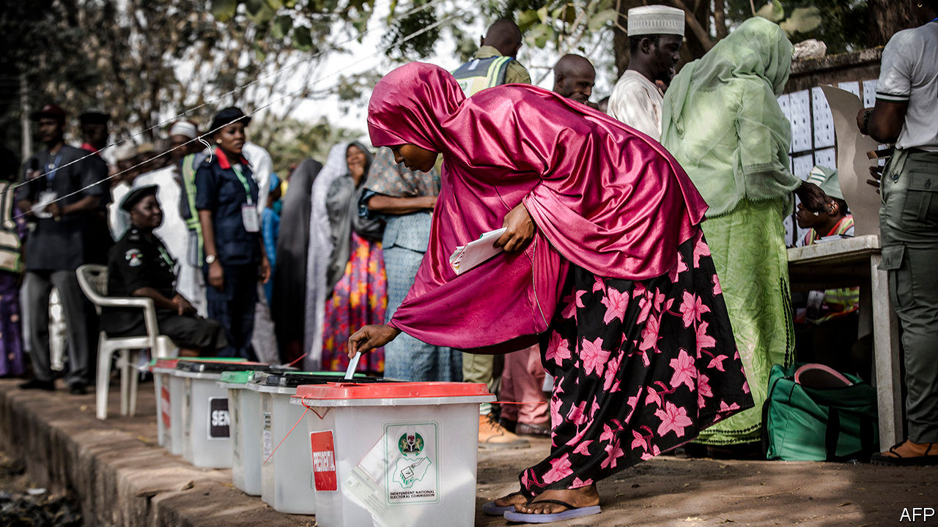

PURVEYORS OF BALLOT papers, indelible ink and polling booths will do well in Africa this year. No fewer than 18 countries are to hold general elections. Not all will be free and fair, but in many the stakes are high. In Ethiopia the popularity of Abiy Ahmed, a reformist prime minister, will be tested at the polls for the first time. Burkina Faso, which is battling jihadists, will hold only its second poll since Blaise Compaoré, a long-serving dictator, was overthrown in 2014. And in Ghana President Nana Akufo-Addo faces a tight race for a second term.

Given the stakes, one might expect voters to turn out in droves. Yet in Africa fewer tend to vote than elsewhere, even if the election is not rigged. More surprisingly it is the young, rich and urban who tend to stay away from the polls. Why?

In the West the rich vote more than the poor. But Kimuli Kasara of Columbia University and Pavithra Suryanarayan of Johns Hopkins University, who surveyed voting patterns in poor countries, many of them in Africa, found that the poorest fifth of citizens tended to vote more assiduously than the richest fifth. One possible reason for rich Africans’ lack of motivation to vote is that no matter who wins, they are unlikely to be taxed more. Rates may rise, but tax collection is ineffective. In sub-Saharan Africa tax revenue averages 17% of GDP compared with 34% in the OECD, a club of mostly rich countries.

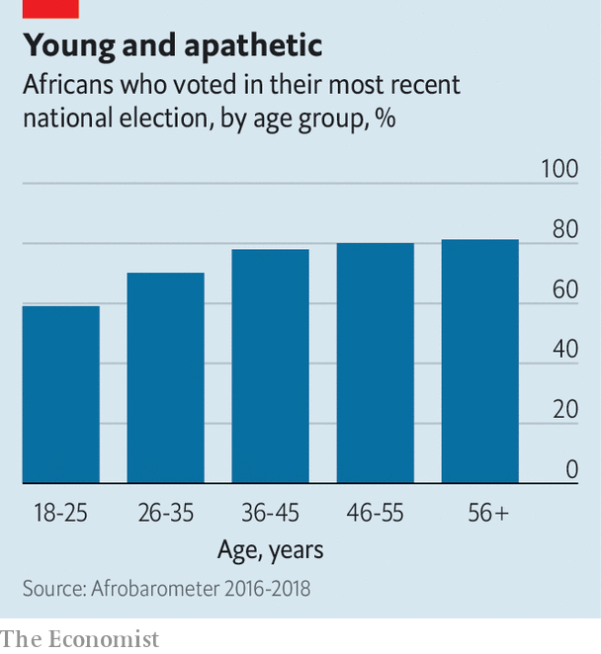

Where people live ought to affect whether they vote. Getting to the polling booth can be a slog for people in the sticks—only a third of rural Africans live within two kilometres of a good road. Yet despite this, rural Africans are more likely to vote than city slickers, by 77% to 67%.

One reason is that ruling parties find it easier to bribe or bully rural voters into turning out. In Zimbabwe, where the opposition dominates the towns, rural folk are often bludgeoned into attending rallies for Zanu-PF, which has run the country since 1980. Officials warn that villages which vote the wrong way will be denied food aid. Because rural voters are easier to corral, constituencies are often gerrymandered so that their votes count for more than urban ones. For example, electoral districts in Tanzania’s biggest city, Dar es Salaam, have three times as many people on average as those in the countryside.

Turnout among the young is strikingly low, no matter where they live. In its most recent election survey, Afrobarometer, a pollster, found that only 59% of 18- to 25-year-olds voted, compared with 80% of people who were 35 or older. Youngsters everywhere tend to vote less frequently than their grandparents. This matters far more in Africa, because 60% of the population is under 25, whereas in Europe just 25% are of a similar age. One reason why young Africans vote less is that registering for the first time can be confusing. Another may be that many of them (42% of 18- to 25-year-olds, according to Afrobarometer) plan to emigrate, so they give up on seeking to improve things at home.

Still, some politicians do try to shake things up by targeting youngsters in the cities. Bobi Wine, a singer turned opposition politician in Uganda, is doing so through music. “We are the youngest population in the world, we stand a chance,” he sings in “Zukuka” (Wake Up), a recent hit. “If we only come together we can change our destiny.” For that to happen, voter registration, gerrymandering and even tax collection may need to change first. ■

This article was downloaded by calibre from <https://www.economist.com/middle-east-and-africa/2020/02/22/why-young-urban-or-rich-africans-are-less-likely-to-vote>

|  |  |  |  |
| --- | --- | --- | --- |
| Previous | Articles | Sections | Next |

|  |  |  |  |
| --- | --- | --- | --- |
| Previous | Articles | Sections | Next |

#### The postman never rings at all

# Why delivering the mail in Congo is so hard

No street numbers, no wages and lots of rebels

Feb 22nd 2020 | GOMA

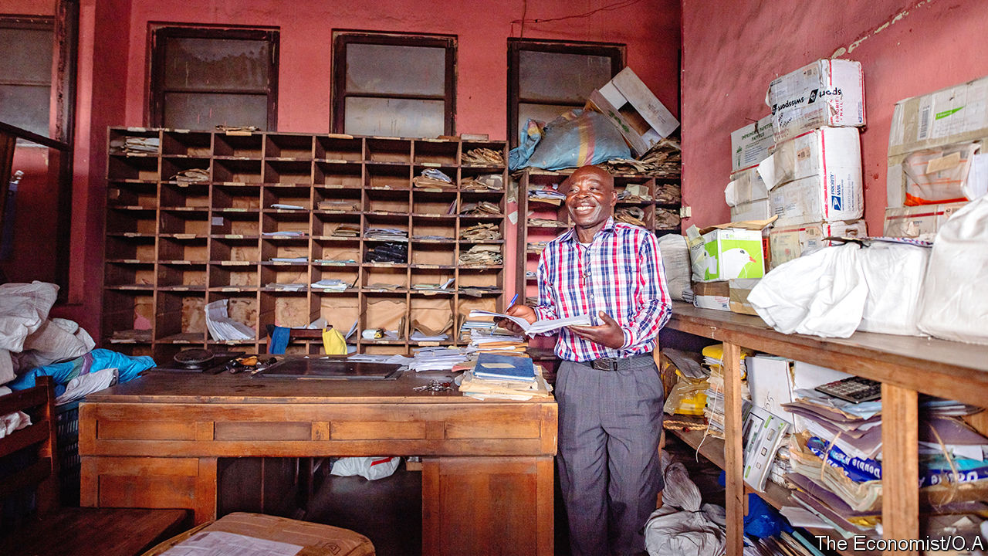

A HISTORIAN REMARKED, of the ancient Persian postal system, that “neither snow nor rain nor heat nor gloom of night stays these couriers from the swift completion of their appointed rounds.” Snow is not much of a problem in the Democratic Republic of Congo, but dozens of rebel groups make delivering the mail rather difficult. So do bad roads and a dysfunctional government.

The main post office in Goma, a city of 2m in eastern Congo, is a vast rectangle with turret and colonnade, built by the Belgian colonial government in 1955. Inside it a worker tips a sack of letters from Kinshasa, the capital, onto a table. He sorts them into wooden lockers according to their destined village, town or region. Most will never get there.

The post office’s director, Dominique Molisho, reckons that only 40% of letters reach their recipients. Many houses in Goma do not have addresses, he explains. Moreover, people move often. Matters are even trickier outside the city in the rest of North Kivu province, an area larger than Switzerland where more than 40 rebel groups lurk in the bush.

Just nine out of the province’s 19 post offices are still open. The rest have been looted or abandoned. Some were used as headquarters by rebel groups. In 2013 the M23, a Rwandan-backed militia, occupied one in Rutshuru. Troops from another militia, the FDLR, often slept on the floors of the Masisi branch. Back in 1996 Laurent Kabila, a Rwandan-backed warlord who marched on Kinshasa and declared himself president, used the Goma post office as his recruitment centre. Gunmen tend to leave little intact, says Mr Molisho. They rip out doors and shutters and use them for firewood.

Rural Catholic missionaries sometimes help, picking up bundles of post every week and pinning letters to the windows of parish buildings, where villagers come to collect them. The missionaries also sell stamps, and take letters to Goma on their return trip.

In its heyday, 100 years ago, the postal service was one of the most desirable employers in Congo. “Back then, everyone wanted to work here,” says Mr Molisho. Today its glory is as faded as the red paint on the walls of the Goma branch, where staff have not been paid for a year. They make ends meet by leasing adjacent land to small businesses.

Still, they are proud. “A letter is a letter, nothing can replace the post,” says Martin Wema, the immaculately dressed finance director. Before leaving, your correspondent is asked to leaf through a dusty pile of letters addressed to aid workers in Goma, in case she happens to know any of them. After spotting two familiar names on envelopes dating back a year she is sent away with a handful.

This article was downloaded by calibre from <https://www.economist.com/middle-east-and-africa/2020/02/22/why-delivering-the-mail-in-congo-is-so-hard>

|  |  |  |  |
| --- | --- | --- | --- |
| Previous | Articles | Sections | Next |

|  |  |  |  |
| --- | --- | --- | --- |
| Previous | Articles | Sections | Next |

#### A fraught path to peace

# South Sudan inches towards a unity government

After 12 deals that did not bring peace, will the latest prove lucky?

Feb 20th 2020 | ADDIS ABABA

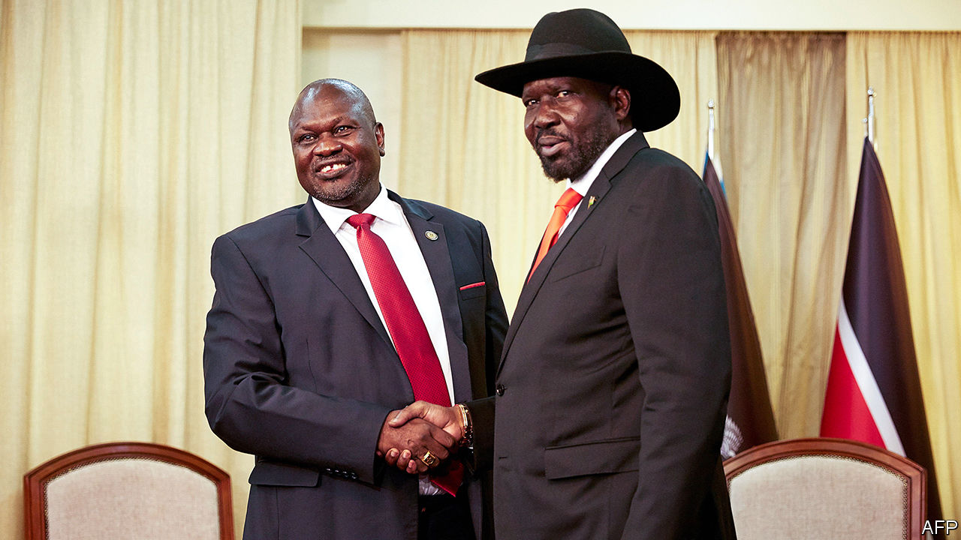

ONCE FETED as liberation heroes, South Sudan’s ageing leaders are now better known for fighting each other and failing to make up. The country won independence from Sudan in 2011, after a referendum, and plunged into civil war two years later. Since then, President Salva Kiir and his former deputy turned nemesis, Riek Machar, have struck no fewer than 12 agreements, none of which brought lasting peace. On February 22nd the two sides are supposed to form an interim government of national unity—nine months and two missed deadlines behind schedule. Many observers worry it will be Groundhog Day for South Sudan. But as the deadline approaches there are tentative signs that this time it might not.

Mr Kiir and Mr Machar (pictured on next page; Mr Kiir in a hat) both belonged to the Sudan People’s Liberation Movement, the political arm of the rebel army that fought for independence. Rivalries between the two men and their respective tribes—Dinkas and Nuers—have roiled the country for years. A peace deal signed in 2015 saw the return of Mr Machar to the capital, Juba, to take up his post as vice-president in a coalition government. But in 2016 fighting erupted again and Mr Machar fled. It has led to hundreds of thousands of deaths and the flight of more than a third of the population.

Since September 2018, when the latest peace agreement was signed, violence has subsided. Rebel generals visit government-held towns, aid reaches most of the country and civilians can move about more or less unhindered. The hope is that this will allow Mr Machar to return to Juba again as vice-president. Rebels and government forces are to be integrated into a national army of 83,000 men and elections are to be held in three years.

Prospects brightened following diplomatic pressure from neighbouring countries and threats of more sanctions from America. On February 15th Mr Kiir announced that he had cut the number of states from 32 to ten. This is seen as a big concession. The opposition has long decried the Dinka-dominated government’s unilateral division of South Sudan into 28 states (later 32) as ethnic gerrymandering. “Everyone is hopeful now,” says Jale Richard of Eye Radio, a broadcaster in Juba. It also helps that some rebel groups that were not part of the current peace agreement signed a truce last month.

But it is too soon to celebrate. Mr Kiir has not simply restored South Sudan’s ten original states, as Mr Machar had demanded. Instead he wants to form ten states and three “administrative areas”. One of these will be Ruweng, a Dinka enclave in Unity, Mr Machar’s home state. As it happens, Ruweng holds about 80% of South Sudan’s oil—the country’s only sizeable export.

On February 17th Mr Machar flew to Juba with Lieutenant-General Abdel Fattah Abdelrahman Burhan, the head of Sudan’s sovereign council, in a last-ditch attempt to reach a compromise with Mr Kiir. Even if one is reached, Mr Machar needs convincing that he can safely return to Juba. Wary of what happened in July 2016, when the government sent helicopter-gunships to kill him, Mr Machar wants a 3,000-strong joint protection force. “He considers having military manpower in Juba the same as having political power,” notes Ahmed Soliman of Chatham House, a think-tank in London. Although the government has agreed to this joint force, it is reluctant to remove its own troops from the capital. Alternatives such as peacekeepers supplied by African governments would require lengthy discussions.

Still, a unity government is most likely to take shape in the coming weeks. The question then is how long it will last. The process of integrating rebels into the national army, which is far behind schedule, will be fraught. “How are you going to get 83,000 men who have spent more than six years slaughtering each other to work together?” asks Peter Martell, the author of a recent book on South Sudan.

The bigger issue is that the latest deal, like those before it, aims to do little more than restore the balance of power between the president and his rival. “We’re essentially trying to reset the button to 2013—back to the very problem which kick-started this war,” says Mr Martell. ■

This article was downloaded by calibre from <https://www.economist.com/middle-east-and-africa/2020/02/20/south-sudan-inches-towards-a-unity-government>

|  |  |  |  |
| --- | --- | --- | --- |
| Previous | Articles | Sections | Next |

|  |  |  |  |
| --- | --- | --- | --- |
| Previous | Articles | Sections | Next |

#### Welcome back, sort of

# The Egyptian government is sending Jews mixed signals

The authorities have restored an old synagogue. But do they want it filled?

Feb 22nd 2020 | ALEXANDRIA



WHEN IT COMES to Egypt’s Jewish community, President Abdel-Fattah al-Sisi says all the right things. Only a minuscule fraction of the 80,000 Jews who once lived in Egypt remain in this Arab, Muslim country. Nonetheless, Mr Sisi promises a resurgence of local Jewry. He has invited back Jews who were pushed out after Israel’s invasion in 1956. He has listed dilapidated Jewish cemeteries as heritage sites and spent millions of dollars restoring what was once the world’s largest synagogue, Eliyahu HaNavi, in Alexandria.

On February 14th about 180 Jews of Alexandrian origin returned to rededicate the synagogue. They hammered a mezuzah onto its walls, danced with the Torah scrolls and sang psalms to the tune of “Inta Omri”, the anthem of Egypt’s most famous diva, Umm Kulthum. Old men sipped espressos at nearby Café Delice, still playing Edith Piaf’s “Non, je ne regrette rien”, and swapped faded wedding photos taken on the synagogue’s steps. They cried over memories of leaving Egypt, surrendering their passports and signing documents promising not to return. The service that followed was the largest in the synagogue for 60 years. The men promised to return a year later for a wedding—the first step to rebuilding a community which a century ago attracted more Jews than Palestine.

Security was tight at the event, for good reason. In recent years jihadists with links to Islamic State have targeted another religious minority: Christians. A phalanx of security vehicles with blaring sirens followed the Jews wherever they went. But the authorities also seemed keen to tamp down the celebration. Goons in balaclavas carrying machineguns kept the Jews more or less quarantined. They denied access to Muslims hoping to join their former classmates for the rededication. The American ambassador, who is Jewish, was prevented from attending the Torah reading.

Having spent so much money restoring the synagogue, it may seem odd for the government to mute its reopening. But, despite Mr Sisi’s words, the authorities remain ambivalent towards Jews and their sites. Egypt’s synagogues and Jewish cemeteries are perpetually locked. Over a decade ago the government restored the yeshiva of Moses Maimonides, the scholar who founded Orthodox Judaism in Cairo in the 12th century (and served as Saladin’s physician), but it is closed to the public. There are no signs directing people to the site. Many Egyptians with Jewish ancestry remain fearful of disclosing their origins.

Morocco, another Muslim country, offers an alternative model. Its Jewish community also shrank when the Arab-Israeli conflict was at its peak. But the Jews who remained now practise openly. King Muhammad VI has restored scores of synagogues and regularly hosts the diaspora at festivals where imams and rabbis sing together. Last month he inaugurated a Jewish heritage centre by touching the Torah and praying. “It was a first for a commander of the faithful [the royal title] in Islam,” says Andre Azoulay, the king’s Jewish adviser. ■

This article was downloaded by calibre from <https://www.economist.com/middle-east-and-africa/2020/02/22/the-egyptian-government-is-sending-jews-mixed-signals>

|  |  |  |  |
| --- | --- | --- | --- |
| Previous | Articles | Sections | Next |

|  |  |  |  |
| --- | --- | --- | --- |
| Previous | Articles | Sections | Next |

#### A bit too austere

# Lessons for Lebanon from its struggling neighbours

Why Arab states that have gone to the IMF for help remain in crisis

Feb 22nd 2020 | BEIRUT

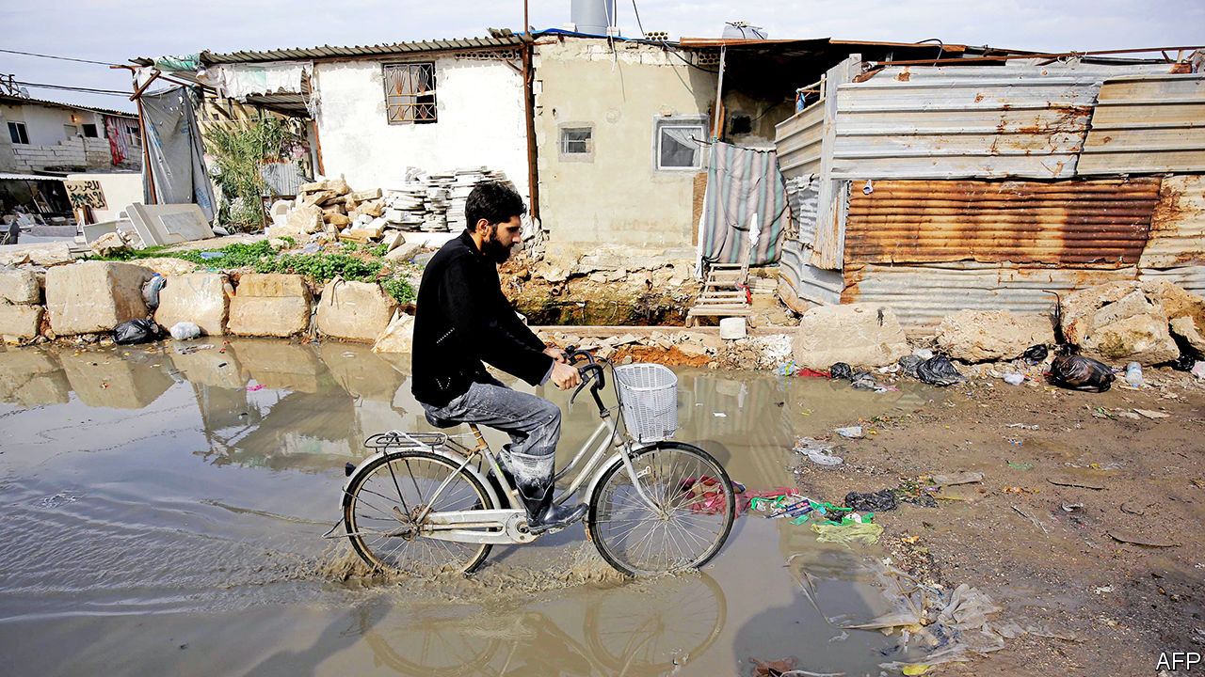

IT IS PROBABLY the first time in years that Lebanon has wanted to turn down a loan. With the economy in free fall the country’s new government, seated in January after months of horse-trading, has reluctantly turned to the IMF for help. They held a first round of talks on February 20th. For now Lebanon seeks only technical advice on managing a public debt that exceeds 150% of GDP. Politicians are keen to resist money from the fund, because it would come with strings attached. But it may be necessary. Economists fret that Lebanon could run out of hard currency by the end of the year, leaving it unable to pay for needed imports.

Before they negotiate an agreement, though, Lebanon’s leaders might look at their neighbours. Economic crisis has been the norm in several Arab states for the past decade. Three of them took loans from the IMF. Egypt signed a $12bn deal in 2016 and is discussing a follow-on programme, though probably a non-financial one. Jordan and Tunisia each received two loans. (Morocco was given several precautionary lines of credit but did not tap them.) Put another way, of the Arab states without significant oil and gas revenue, more than half have needed IMF support since 2010.

They have won praise for enacting difficult fiscal and monetary reforms. To meet the requirements of its loan Egypt floated its currency, which quickly lost half its value; imposed a 13% value-added tax (later raised to 14%); and cut fuel subsidies. Jordan reduced its fuel subsidies in 2012 to qualify for an IMF loan, causing some prices to soar by 50% overnight. Tunisia has raised taxes and allowed the dinar to depreciate. These changes, many of them overdue, helped to tame deficits.

Yet none of these countries looks to be emerging from crisis. Poverty is increasing. Unemployment remains high. Reforms were meant to unlock a flood of new investment, but it has yet to materialise. In 2011, as Arabs rose up in disgust against their leaders, Masood Ahmed, then-director of the IMF’s Middle East programme, acknowledged the need for more “inclusive growth” in the region. But the recipients of IMF loans have continued to focus on cuts rather than structural reforms.

In the short term the pain is predictable. Higher taxes and lower subsidies leave consumers with less purchasing power. A long-suppressed government report, finally released in July, found that Egypt’s poverty rate has climbed five percentage points since 2015, to 33%. Though it has enrolled more than 9m people in two new cash-transfer schemes, these cover less than one-third of poor Egyptians. Jordan stopped publishing its poverty rate in 2010. It is thought to have climbed six points since then, to 20%. The World Bank estimates that 15% of Tunisians live below the national poverty line.

No surprise, then, that businesses are struggling. The January purchasing managers’ index, a measure of economic activity, showed Egypt’s non-oil private sector contracting at its quickest rate in almost three years. The index has shown expansion in only six of the past 54 months. Firms blame weak sales. Rapid subsidy cuts can also make it prohibitive to run a business. After years of austerity, Jordan’s government abruptly changed tack in December and announced a stimulus package. It lowered electricity tariffs for industry and trimmed the tax on small firms.

When Egypt signed its deal with the IMF, the fund projected that foreign direct investment (FDI) would exceed $9bn a year by June 2017. Inflows have actually fallen since then, to $6.8bn in 2018, a 16% drop from two years before. Jordan drew a paltry $950m in FDI in 2018. Both countries are attracting less investor interest now than they did a decade ago.

Austerity measures are painful, but easy to implement. It is far harder to fix broken bureaucracies or unpredictable legal systems. There are a few positive signs, from new bankruptcy laws to simpler regulations. But many Arab states remain difficult places to do business. The World Bank ranks Egypt 171st for the ease of trading across borders: getting a shipment out of the country requires 136 hours of work, compared with 32 in Morocco, which has built a viable car industry. Starting a business in Egypt or Jordan needs more than two weeks and visits to six government offices. Entrepreneurs in the United Arab Emirates can get started in four days.

Decades of under-investment mean that workers struggle to compete. The World Economic Forum (WEF) ranks Tunisia 96th of 141 economies for the quality of its workforce. Egypt comes in 99th. With budgets tight, governments are doing little to fix the problem. Egypt’s constitution requires the state to spend at least 4% of GDP on education. It usually ignores that proviso. Per-person education spending is lower now than it was in 2011.

Arab governments hobble one another, too. Countries in the region export just 16% of their goods to each other, compared with 52% among Asian states and 63% in the European Union. A recent report by the WEF and Majid al-Futtaim, a Dubai-based retail giant, wagered that cutting tariffs and other trade barriers would unlock $130bn in new business for firms. “There are huge opportunities for growth in the region, but it requires a proper integration,” says Alain Bejjani, the firm’s CEO.

If Lebanon strikes its own IMF deal, there is plenty of fat to trim. The state wastes billions on electricity subsidies and make-work jobs. A currency peg, in effect since the 1990s, is costly and makes exports artificially expensive. But austerity will hit hard in a country where one-third of the population is poor. And it will not fix the underlying problems that impoverished Lebanon in the first place. ■

This article was downloaded by calibre from <https://www.economist.com/middle-east-and-africa/2020/02/22/lessons-for-lebanon-from-its-struggling-neighbours>

|  |  |  |  |
| --- | --- | --- | --- |
| Previous | Articles | Sections | Next |

|  |  |  |
| --- | --- | --- |
| Middle East and ... | Sections | Britain |

Europe

France’s economy: The president’s paradox

.

French puritanism: Liaisons dangereuses

.

China v Sweden: Shotgun diplomacy

.

Russia v Yukos: Much ado about “such”

.

Orthodox Christianity: The sound of schism

.

Turkish justice: Guilty of caring

.

Charlemagne: How to mess up immigration

.

|  |  |  |
| --- | --- | --- |
| Middle East and ... | Sections | Britain |

|  |  |  |  |
| --- | --- | --- | --- |
|  | Articles | Sections | Next |

#### The president’s paradox

# Emmanuel Macron’s reforms are working, but not for him

Unemployment in France is falling. So are the president’s poll ratings

Feb 22nd 2020 | SEINE-SAINT-DENIS

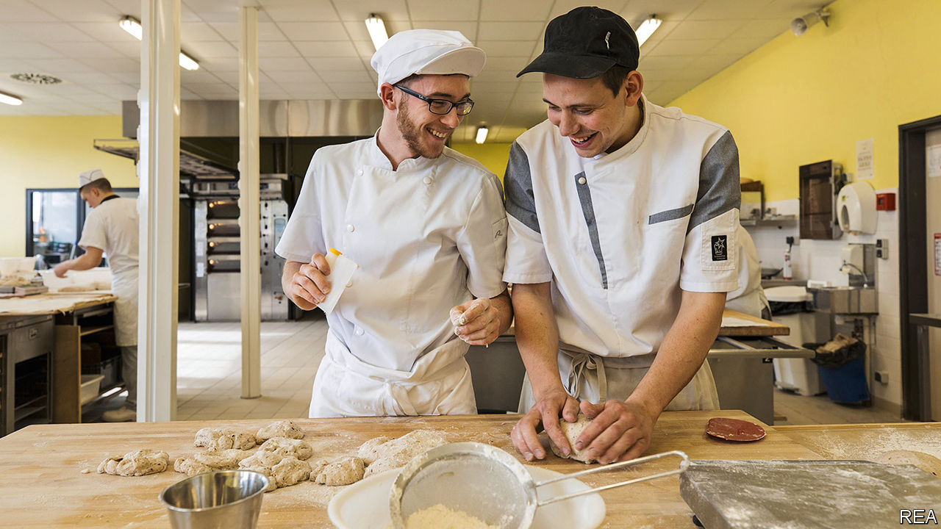

A BROAD GRIN spreads across Aboubacar Koumbassa’s face as he displays the result of his morning’s class: a tray of oven-hot pains-aux-raisins (currant pastries), which he and his classmates have baked for the first time. The 18-year-old, in a white chef’s cap and apron, had originally hoped for an apprenticeship as an electrician. But it was easier to secure one at a bakery. He now spends one week in three in the classroom, travelling over an hour by train. The other two weeks he is learning on the job. “I made the right choice,” he says, carefully inspecting his pastry, “because this is teamwork. Here we learn the theory, and at my firm we are really working.”

Apprenticeships offer a much-needed path out of France’s highly academic school system and into the world of work. The Campus des Métiers, where Mr Koumbassa studies, lies in the Paris suburb of Seine-Saint-Denis, a neighbourhood of brutalist tower blocks with a poverty rate twice the national average. The centre trains some 1,400 apprentices, in subjects ranging from car mechanics and plumbing to hairdressing and patisserie.

On the building’s first floor, hairdressing students are practising basic trimming and advanced colouring techniques on plastic model heads. “Whatever your level, what matters is your motivation,” the teacher they call Madame tells them: “If you want to, you will succeed.” Downstairs in the workshop for apprentice electricians, Souleymane is wiring an electrical-lighting circuit. When asked what he was doing before his apprenticeship, he looks up and grins: “I slept.” The course, says his tutor, “really opens the door to jobs, and makes people feel valued in a way they were not at school.”

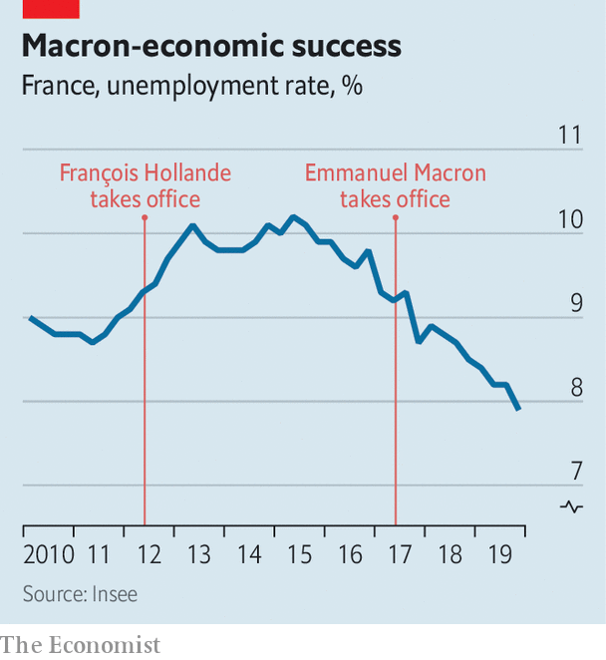

Traditionally, French educationalists have looked down on such vocational courses, which are open to pupils from the age of 16. Just 7% of young people are in apprenticeships in France, half the share in Germany. Last year, however, following a reform of the rules by Emmanuel Macron’s government, the total number of French apprentices increased by 16%, to a record high of 491,000. Anybody under the age of 30 can now apply. Part of the idea, said Muriel Pénicaud, the labour minister, was to change “negative stereotypes” associated with such contracts. She says that 70% of apprentices find jobs within seven months of completing their course.

Nearly three years after Mr Macron was elected president, the first results of his reforms seem to be coming through. Between 2017 and 2019, his government loosened labour-market rules to encourage hiring, redesigned professional training, expanded apprenticeships, and reworked benefit incentives to encourage the unemployed to return to work. These followed corporate tax cuts, a reduction in company payroll charges, and a big international marketing push, to persuade investors that France was open to business.

Since then, economic growth has been solid rather than stellar. French GDP grew last year by 1.2% (faster than in Germany), though it contracted in the fourth quarter. The French economy has been creating jobs and new businesses apace. In the year to September 2019, a net 260,000 jobs were created, up from 188,000 the previous year. Unemployment in the fourth quarter of 2019 fell to 7.9% in mainland France, its lowest level for 11 years.

French airwaves are no longer filled with relentless news of factory closures and redundancies. The number of new companies created surged to 815,000 in the fourth quarter of 2019, a 38% increase on the same period in 2017. Fully 84% of foreign investors now have a positive image of France, up from 36% in 2016, according to Ipsos, a polling group. Perhaps most important, disposable income grew last year by 2%, its fastest pace for 12 years.

Mr Macron can hardly take credit for all of this. France’s economy outperformed Germany’s partly because it is less export-dependent and more sheltered from trade volatility. One boost to growth was €17bn ($18.4bn) of income-support measures, implemented only as an emergency response to the gilets jaunes protests. Unemployment began to fall under the previous president, François Hollande. Much of the rich world is enjoying a jobs boom. Still, the turnaround is arresting. “The coincidence in timing between Macron’s labour-market reforms and the increase in job creation and the quality of jobs created strongly suggests they are a big part of the story,” says Philippe Martin, who heads the government’s Council of Economic Analysis.

All this should help Mr Macron improve his dismal approval ratings. Yet in January they fell another four points to 30%, according to Ifop, a pollster. The president has struggled to shake off a reputation for arrogance and for favouring the rich. His government has bungled the piloting of its last big domestic reform, that of the pensions system. Legislation to merge 42 regimes into a single system went to parliament on February 17th, even though its financing has yet to be agreed. Periodic strikes and protests continue.

Above all, Mr Macron has failed to craft a convincing and positive narrative around such results. It may be that his technocratic policymaking simply fits awkwardly with today’s debate. The birthplace of Enlightenment rationalism is proving as vulnerable as any country to distrust in facts, and to the populists who manipulate it. When INSEE, the official statistics body, unveiled the latest drop in unemployment, Marine Le Pen, a nationalist leader, tweeted: “What if we stopped lying to the French?” At a time when gut feelings trump bar charts, Mr Macron finds it hard to persuade people that his reforms are beginning to work. ■

This article was downloaded by calibre from <https://www.economist.com/europe/2020/02/22/emmanuel-macrons-reforms-are-working-but-not-for-him>

|  |  |  |  |
| --- | --- | --- | --- |
|  | Articles | Sections | Next |

|  |  |  |  |
| --- | --- | --- | --- |
| Previous | Articles | Sections | Next |

#### Liaisons dangereuses

# A sexting scandal makes France fret it is turning Puritan

A Paris mayoral candidate drops out. A Russian artist is to blame

Feb 22nd 2020 | PARIS

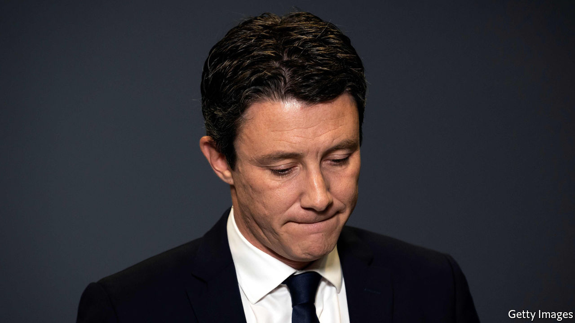

IN MATTERS OF sex and politics, French insouciance rules that the public interest stops at the bedroom door. Presidents have often kept mistresses. Public opinion shrugs off such dalliances. While in office, François Hollande was photographed astride a scooter visiting his lover. In 1899 Félix Faure died in his mistress’s arms at the Elysée Palace.

Yet on February 14th Benjamin Griveaux, Emmanuel Macron’s struggling candidate for mayor of Paris, made history by standing down after a private sex video he made was posted online. Mr Griveaux, a close ally of the president, did not dispute its authenticity. In 2018 he sent the clip via an app to a woman with whom he was having a consensual liaison. On February 12th the video was posted by Pyotr Pavlensky, a Russian political artist, on a pornographic website along with an article denouncing Mr Griveaux. Within 48 hours he resigned.

To some this marks a cultural shift: the end of French tolerance of sexual indiscretion in public life. It represents the “Americanisation” of French politics, wrote one commentator; the embrace of “puritanism”, said another. That it was an effort to bring down Mr Griveaux is not in doubt. Mr Pavlensky, who once nailed his scrotum to the cobblestones of Moscow’s Red Square and was granted political asylum in France, said he was out to expose Mr Griveaux’s “hypocrisy”. While campaigning, the candidate posed with his wife and used the hashtag #happyfamily. Was this a sting from the start? Who else was involved? In a twist, the recipient of Mr Griveaux’s video, Alexandra de Taddeo, is now romantically linked to Mr Pavlensky. The police have brought preliminary charges for breaching privacy laws against both.

Yet most public anger is directed at Mr Pavlensky and the perils of technology, which suggests sexual culture may not have changed that much. One in five French people say they have shared sexual images of themselves. The political reaction has been near-universal revulsion—not at Mr Griveaux’s behaviour, but at the way it was exposed, and the Russian link. “Odious”, tweeted Jean-Luc Mélenchon, a far-left leader who usually delights in Mr Macron’s woes. Others were darker still. The affair, warned Le Monde, carries the risk of “a fatal erosion of democratic life”.

This article was downloaded by calibre from <https://www.economist.com/europe/2020/02/22/a-sexting-scandal-makes-france-fret-it-is-turning-puritan>

|  |  |  |  |
| --- | --- | --- | --- |
| Previous | Articles | Sections | Next |

|  |  |  |  |
| --- | --- | --- | --- |
| Previous | Articles | Sections | Next |

#### Shotgun diplomacy

# How Sweden copes with Chinese bullying

“For our enemies, we have shotguns,” warns Beijing’s ambassador

Feb 22nd 2020 | STOCKHOLM

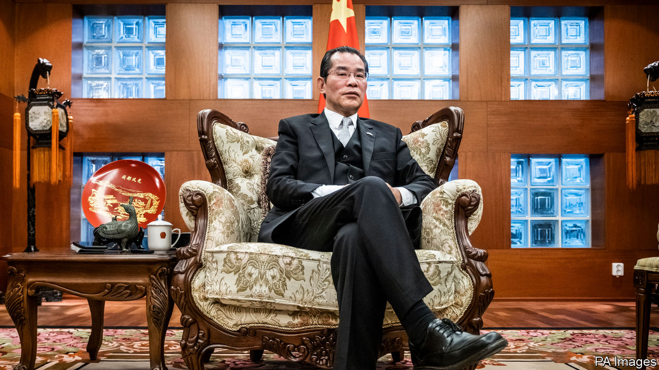

TRADITIONALLY, CHINESE ambassadors are restrained, colourless figures who emerge from the wallpaper only to object ritually that any criticism of their government is an insult to Chinese people. Gui Congyou, China’s ambassador to Sweden, has taken a different tack. He and his embassy denounce journalists and public figures for perceived slights on an almost weekly basis, a pace so unusual it has been studied by Swedish political scientists. He has been summoned to Sweden’s foreign ministry more than 40 times in two years.

But Mr Gui has only grown more outspoken. Interviewed on Swedish public radio in November, he sounded like a gangster: “We treat our friends with fine wine, but for our enemies we have shotguns.” Mr Gui offers a glimpse of a newly forceful brand of Chinese diplomacy (see [article](https://www.economist.com/node/21780474)). The regime is quicker to take offence, and retaliates more harshly.

Sweden has friendly business ties with Chinese companies: Volvo is now owned by a Chinese carmaker, and Swedes are happy with that relationship. But the two countries are at odds over human rights. In 2015 Gui Minhai (no relation to the ambassador), a Swedish national who was a bookseller in Hong Kong, disappeared in Thailand and reappeared months later in Chinese custody. His crime seemed to have been selling disparaging books about President Xi Jinping. Mr Gui was released in 2017, but was snatched again months later by plainclothes agents on a train from Shanghai to Beijing, while he was being escorted by Swedish diplomats. The Swedes have been repeatedly denied consular access to Mr Gui; China claims he does not wish to see them. The authorities say he tried to leak state secrets to foreigners.

The bookseller’s case has poisoned Chinese-Swedish relations. In November, when he received an award from the Swedish branch of PEN, a free-speech group, the Chinese embassy demanded it be rescinded. Then Ambassador Gui warned of “consequences” if Sweden’s culture minister participated in the ceremony. (The minister ignored the warning.) In December the ambassador warned that China would restrict trade with Sweden in retaliation.

All this bluster has won no concessions. Sweden’s government plans to subject Chinese investments in Swedish companies to more scrutiny. The business press has also turned more sceptical of Chinese investment. In November the parliament passed a law that allows for a national-security review of Huawei as a potential supplier to Sweden’s 5G network. That could mean favouring Ericsson, a Swedish native, over the Chinese firm. In December some opposition MPs called for Ambassador Gui to be declared persona non grata. The public is no more friendly: in a survey of 34 countries last year by the Pew Research Centre, 70% of Swedes had an unfavourable opinion of China. Only Japan was more hostile.

China may be using Sweden to send a message to the world—just as it shunned Norway for years after the Nobel Peace Prize was awarded to Liu Xiaobo, a man who argued that the Chinese people should be allowed to select their own rulers. Ambassador Gui recently remarked to a Swedish newspaper that, for all his talk of shotguns, Sweden was “not important enough to threaten”.

Still, the ambassador’s non-threats seem to have had an effect. Last year the United Nations Development Programme’s office in Stockholm cancelled a human-rights gala at the last minute; Chinese diplomats reportedly objected because it involved photos of the Dalai Lama. And a former Swedish ambassador to China will stand trial in March for allegedly arranging, without authorisation, talks between Chinese representatives and the daughter of the imprisoned Mr Gui, in an apparent effort to secure the daughter’s silence. Some China-watchers worry that the government secretly wanted the bookseller’s case shoved under the rug.

A rapprochement looks improbable, and it is hard to imagine Ambassador Gui helping to achieve one. He is described by Swedes who have met him as an old-school party apparatchik, less polished than some of his foreign-ministry colleagues. A Russian-speaker with little English whose previous post was in Moscow, he was an odd choice for Stockholm. Meeting with Swedish sinologists at his residence not long after his arrival in 2017, Mr Gui said he had no idea why he was sent there. He then offered a toast in Chinese over a glass of grain alcohol. “To Gui Minhai’s victim!” he declared, an apparent reference to the car accident for which the bookseller was nominally jailed, and emptied his tumbler. His appalled guests did not join him. ■

This article was downloaded by calibre from <https://www.economist.com/europe/2020/02/22/how-sweden-copes-with-chinese-bullying>

|  |  |  |  |
| --- | --- | --- | --- |
| Previous | Articles | Sections | Next |

|  |  |  |  |
| --- | --- | --- | --- |
| Previous | Articles | Sections | Next |

#### Much ado about “such”

# The $50bn Yukos judgment against Russia turns on a single word

Shareholders of an oil company dismantled by Vladimir Putin win big

Feb 22nd 2020 | THE HAGUE

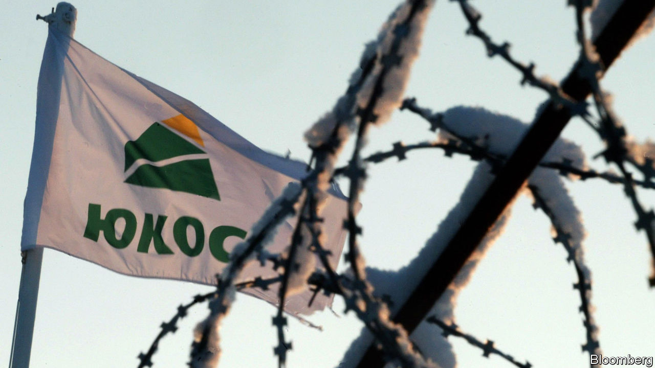

RARELY ARE the ramifications of a four-letter word so great as in the case of Yukos, a defunct Russian oil firm. On February 18th a Dutch appeals court ruled that the Russian state owes Yukos’s shareholders $50bn, one of the largest awards ever, for bankrupting the company using bogus tax-fraud charges. That reinstated a decision in 2014 by the Permanent Court of Arbitration (PCA), an international dispute-resolution court in The Hague. In 2016 a lower Dutch court had overturned the ruling, finding that the PCA lacked jurisdiction. The issue largely hinged on a single clause in an international energy treaty—specifically on how to interpret its use of the word “such”.

The seizure of Yukos was a turning-point in President Vladimir Putin’s consolidation of power. In 2003 Mikhail Khodorkovsky, then Yukos’s CEO and largest shareholder (and Russia’s wealthiest man), had begun financing opposition parties and hinted at running for president. Mr Putin confronted him, and the government charged the company with $27bn in tax violations. Mr Khodorkovsky went to prison for a decade. Yukos was broken up and sold to state-controlled firms at fire-sale prices.

As the company was being devoured, its owners and managers began filing lawsuits. They no longer included Mr Khodorkovsky, who during his trial had transferred his shares to a partner. The biggest case was the one launched at the PCA by a holding company called GML that represents Yukos’s biggest shareholders. GML claimed that Russia’s seizure had violated the Energy Charter Treaty, an international investor-protection agreement that prescribes arbitration in case of a dispute. Russia had signed the ECT in 1994 but never ratified it. But the treaty states that signatories agree to apply it provisionally until ratification, “to the extent that such provisional application is not inconsistent with [their] constitution, laws or regulations”.

Here things get tricky. Russian law, like that of many countries, does not normally allow arbitration between private entities and the state. Russia’s lawyers thus argued that the parts of the ECT providing for arbitration did not apply, and the PCA had no jurisdiction. But the PCA ruled that it did, because “such” provisional application refers to that of the treaty as a whole, including the bits about arbitration.

Russia appealed to a Dutch district court, which rejected the PCA’S interpretation because it would render the phrase “to the extent that” meaningless. But last week the appeals court found that the PCA was right. Russia plans to take the case to the Dutch Supreme Court, a lengthy process.

GML’s lawyers still have to recover the money. Their efforts to do so in 2015, after the initial PCA ruling, did not go well. In Belgium efforts to seize Russian embassy bank accounts ran up against diplomatic immunity. When they tried to claim a $700m French government payment to Roscosmos, the Russian space agency, French courts ruled it was a private company unconnected to state debts. Belgium and France have since passed “Yukos laws” making it harder to attach the assets of sovereign states. Russia is pushing through constitutional changes that subordinate international law to its own.

Russia’s low regard for international law was highlighted again last week in a report that fingered the FSB, Russia’s main spy agency, in the killing of a Chechen dissident in Berlin last August. The report by Bellingcat, a cyberforensic investigative group, and journalists at the Insider and Der Spiegel used leaked mobile-phone metadata to identify an FSB associate as the likely assassin. The Yukos case will be less violent; the Kremlin has threatened tit-for-tat retaliation against any country that upholds seizures of its assets. ■

This article was downloaded by calibre from <https://www.economist.com/europe/2020/02/22/the-50bn-yukos-judgment-against-russia-turns-on-a-single-word>

|  |  |  |  |
| --- | --- | --- | --- |
| Previous | Articles | Sections | Next |

|  |  |  |  |
| --- | --- | --- | --- |
| Previous | Articles | Sections | Next |

#### Thundering canons

# An Orthodox Christian schism in Ukraine echoes around the world

A Kiev-Moscow split ropes in Washington, Athens and Jerusalem

Feb 22nd 2020 |



ORTHODOX CHRISTIANS across the globe are bracing themselves for the Lenten fast, a seven-week period of vegan fare and prayer that starts on March 2nd. But few expect this annual ritual to close the rift that runs through eastern Christendom. A dispute that flared a year ago over the proclamation of an independent church in Ukraine has ricocheted across all the other countries where Orthodox Christianity is practised. Diplomats in Moscow, Washington and elsewhere are watching, because behind the arcane arguments over history and canon law lies a geopolitical standoff.

From the beginning, President Vladimir Putin and his supporters have denounced the new Ukrainian body as an encroachment on Russia’s spiritual sphere of influence and a machination of American diplomacy. The United States backs Ukraine’s right to ecclesiastical independence. Mike Pompeo, the American secretary of state, made a point of meeting the new Ukrainian primate, Metropolitan Epifaniy, when visiting Kiev on January 31st. Both deplored religious persecution in Russian-controlled bits of Ukraine and laid flowers in memory of slain Ukrainian soldiers.

The global row formally pits Bartholomew I, the Istanbul-based Patriarch of Constantinople who inaugurated the new Ukrainian body, against Patriarch Kirill of Moscow. The former has a historic role as “first among equals” in the Orthodox world; the latter boasts geopolitical heft. Bartholomew insists that he is the only legitimate Orthodox authority in Ukraine.

Both camps have had successes and disappointments as they work to influence the remainder of the Orthodox world. In a boost for Bartholomew, the churches of Greece and the Patriarchate of Alexandria, which is responsible for Africa, have followed his line over Ukraine and incurred the wrath of Moscow. Bishops in the ancient church of Cyprus are divided.

Russia seemed to score a point by inducing the Patriarch of Jerusalem, a Greek, to invite his fellow primates to a deliberation in Jordan scheduled for February 26th, in open defiance of Bartholomew. But the invitation has had fewer takers than expected, and most of the world’s senior ethnic Greek hierarchs will probably stay away. Prelates closer to Moscow, such as those in Belgrade and Damascus, are more likely to attend.

In the background is a chill in relations between Russia and Greece, whose common Orthodox faith has served over the centuries either as a bond or a point of competition. Recently, Greece has been disappointed by Russia’s pragmatic dealings with Turkey, including arms deliveries, and has drawn much closer to America and Israel in energy projects and military matters.

Greece’s foreign minister, Nikos Dendias, insisted on February 6th that efforts were being made to mend ties with the Russians, but he also ruffled their feathers by noting the persistence of their medieval aspiration to be the Third Rome (that is, the guardian of Christian dogma in succession to Rome and Byzantium). Meanwhile Moscow’s embassy in Greece this week complained that America is sponsoring a “schismatic construct” in Ukraine that is dividing the Orthodox family.

Russo-Greek rumblings are affecting parts of Greece where pious Russians venerate holy sites. The Patriarchate of Moscow has published a list of Greek dioceses, including Athens, which Russian pilgrims have “no blessing” to visit. These are the areas whose local bishops have signalled support for the new church in Ukraine.

In Ukraine itself, some ordinary churchgoers feel less passionate about the split than their spiritual masters do. A recent poll (excluding the Russian-held areas) found that 34% of Ukrainians identify with the new independent Orthodox church and 14% with the Moscow-aligned one. Another 28% say they are simply Orthodox and refuse to pick sides. ■

This article was downloaded by calibre from <https://www.economist.com/europe/2020/02/22/an-orthodox-christian-schism-in-ukraine-echoes-around-the-world>

|  |  |  |  |
| --- | --- | --- | --- |
| Previous | Articles | Sections | Next |

|  |  |  |  |
| --- | --- | --- | --- |
| Previous | Articles | Sections | Next |

#### Guilty of caring

# Turkey acquits the Gezi Park protesters, then rearrests one

Demonstrators against President Erdogan’s government do not go unpunished

Feb 20th 2020 | ISTANBUL



THE FINAL hearing in the trial of the environmental activists was rushed. Throughout the case, the court had failed to scrutinise evidence. So on February 18th, when the judge told the defendants they were acquitted, a stunned courtroom broke out in applause. The relief was short-lived. Ruling-party officials tweeted their disapproval, and by nightfall Osman Kavala, the best-known of the group, was arrested again.

The philanthropist, who has spent his fortune saving historic monuments and promoting dialogue with Armenians and Kurds, is now charged with aiding an attempted military coup in 2016. The new investigation lets the government ignore the European Court of Human Rights (ECHR), which in December ordered Mr Kavala to be freed and said his detention was meant to muzzle civil society.

In the protest case, the prosecution wanted Mr Kavala sentenced to life for allegedly masterminding anti-government protests sparked by plans to demolish Istanbul’s Gezi Park in 2013. The proof? He bought pastries and gas masks for protesters. Now he could face another life sentence. Prosecutors have yet to explain what the lifelong leftist was doing in a military uprising linked to an Islamist sect. But Turkey’s president, Recep Tayyip Erdogan, has used the attempted coup to justify thousands of dubious arrests. Turkey’s judiciary is ranked 109th out of 126 countries on the World Justice Project’s rule-of-law index.

Mr Kavala’s acquittal and re-arrest suggest a governmental power struggle. But such decisions “would never be made without President Erdogan’s consent”, says Garo Paylan, a leftist MP. The president says Mr Kavala takes orders from “the famous Hungarian Jew”, referring to his work with the Open Society Foundations founded by George Soros.

Gezi Park still stands, a scruffy patch of grass and trees. But Turkish civil society has melted away, as has any appetite for street protests. Seven years ago, the construction of a giant mosque near the park, one of Mr Erdogan’s pet projects, was a divisive issue. The mosque has since gone up without a whimper. Ahead of his acquittal, Yigit Aksakoglu, one of Mr Kavala’s co-defendants, described how the surreal trial had upended their lives. “I feel like I’ve been vacuumed into a movie,” he said. “Damn the park, let them build whatever they want to build.”

This article was downloaded by calibre from <https://www.economist.com/europe/2020/02/20/turkey-acquits-the-gezi-park-protesters-then-rearrests-one>

|  |  |  |  |
| --- | --- | --- | --- |
| Previous | Articles | Sections | Next |

|  |  |  |  |
| --- | --- | --- | --- |
| Previous | Articles | Sections | Next |

#### Charlemagne

# Poland is cocking up migration in a very European way

The Poles repeat Germany’s mistake: pretending immigrants will go home

Feb 22nd 2020 |

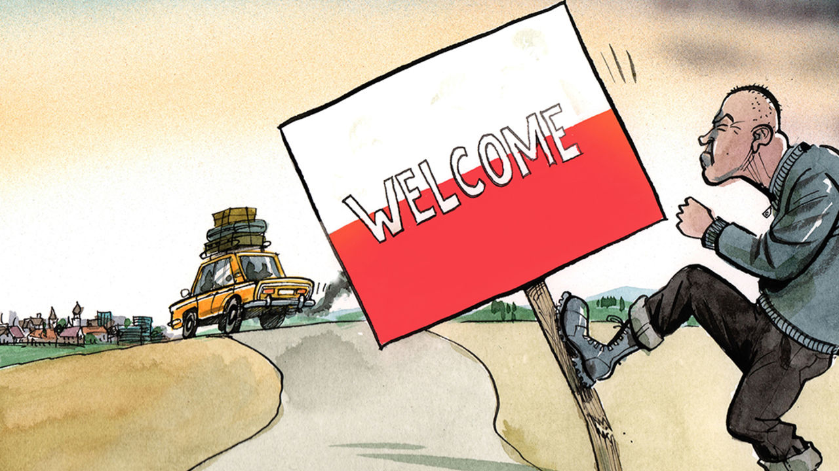

FOR A GLIMPSE of how immigration is changing Poland, head to Hala Koszyki, an Instagram-friendly food hall in the middle of Warsaw. Take an Uber and there is a good chance the driver will be from Belarus. Inside, Ukrainian waiters and chefs toil over sushi and tapas. Outside, straddling their scooters, a group of UberEats riders from India and elsewhere in South Asia wait to take orders from any Varsovians who fancy a night in.

Poland, one of the EU’s most homogenous countries, is becoming a country of immigration. It took in more workers from outside the EU in 2018 than any other country—nearly five times more than Germany—and is likely to have repeated the trick again in 2019. Nearly 2m Ukrainians have arrived since 2014, pushed by a ropy national economy and a war in the country’s east, and pulled by higher wages in Poland. They are not alone. In the past three years 36,000 Nepalese, 20,000 Indians and 18,000 Bangladeshis have moved to Poland. It is a big shift: Poland, a country of 38m inhabitants, had only 100,000 foreigners of any stripe in 2011. Migration is seen as a political faultline in the EU, with an open west set against a closed east. Yet Poland is, quietly, starting to look more like its peers in western Europe.

Unfortunately, Poland is being a bit too European about it. Western Europe turned to immigration during the post-war economic boom. Unemployment plunged from about 8% in the 1930s to 3% in the 1950s and barely 1.5% in the early 1960s, triggering a labour shortage. Poland is enjoying a similar economic surge now. Unemployment, which peaked at 20% shortly before it joined the EU in 2004, is just over 3% today. Facing the same problem, Poland’s nationalist Law and Justice (PiS) government has tacitly arrived at the same solution: immigration. Public policy ought to benefit from second-mover advantage. Governments can observe and avoid the mistakes made by others. When it comes to immigration, western Europe offers plenty of lessons. Yet Warsaw seems to be ignoring them and enthusiastically repeating other countries’ cock-ups.

The first error is a belief that temporary workers will remain temporary. Citizens of Ukraine, Belarus and some other former Soviet countries can work for up to six months in Poland without a visa. Polish officials refer blithely to Ukrainians working in the “grey market” and paying no social insurance. Tricky questions, such as how to integrate new arrivals, are ducked. Why bother thinking about such things if the newcomers will soon go home? Similar “guest worker” schemes have been tried before. Germany welcomed about 2m guest workers from the 1950s to the 1970s. When many turned out to be permanent, the government decided not to kick them out. Former chancellor Willy Brandt, a Social Democrat, said doing so would be “irresponsible, inhumane and entirely uneconomical”. Poland’s ruling party would have fewer qualms over deportation. But its leaders might be deterred by the expense and the damage to the economy.

Another mistake is the assumption that since (apart from the Ukrainians) migrants are relatively few, they will not be noticed by Polish voters. Small numbers can have a big impact. In 2019 Poland granted long-term visas to about 24,000 people from Nepal, India and Bangladesh, according to the Polish Economic Institute, a think-tank. By comparison, Britain accepted migrants from the Caribbean at an annual rate of about 16,000 in the 1950s. With a population of 52m at the time, Britain was hardly swamped. But it was enough to trigger the rise of racial politics. In 1955 Winston Churchill suggested “Keep England White” as an election slogan.

Some Polish officials think they need not worry about integration because Ukrainians are culturally very similar to Poles. They look the same, are mostly Christian and speak similar languages. However, similarities are an imperfect shield against prejudice. White, Christian, football-mad lager drinkers were hardly a rare breed in Britain before the arrival of hundreds of thousands of Poles in the noughties. Yet a backlash against immigration from eastern Europe boosted support for Brexit, which upended British politics. Confederation, a far-right Polish party, is crusading against foreign workers. Its MPs bluntly state that national “purity” matters more than prosperity. So far, there is little interest: an anti-Ukrainian march by another party in 2018 drew only 10 people. But Poland has not tasted recession for nearly a generation, and who knows what might happen if the economy were to stall.

In any case, Poland may not be able to rely on an influx of Ukrainian workers for long. An improving Ukrainian economy and looser German immigration rules, which come into force in March, may encourage youngsters in Kharkiv to turn elsewhere. Businesses are already looking farther afield to plug gaps. Personnel Service, a Polish recruitment agency, is opening an office in Singapore to manage workers from Asia. The kind of Poles who object to foreigners tend not to hang out in swanky food halls in central Warsaw. But the arrival of, say, 150 Nepalese or Indonesian workers in a factory in a small town in eastern Poland might grab their attention. Rapid ethnic change can upset domestic politics very quickly, as mainstream parties in western Europe have found.

## Noisy populists, quiet globalists

The Polish government’s most quintessentially European trait, when it comes to migration, is its unwillingness to discuss the topic and, more important, to make a case for it. Perhaps this is because the government is more hypocritical than most. PiS is one of Europe’s most illiberal governing parties, yet it has one of its most liberal immigration policies. It is like a dirty secret. When one minister admitted that immigration was necessary for the Polish economy to keep zooming along, he was fired. Like its neighbours to the west, Poland’s government has opted for a combination of naivety, deceit and hope that things will sort themselves out. Perhaps it is just the European way. But it is unlikely to work. ■

This article was downloaded by calibre from <https://www.economist.com/europe/2020/02/22/poland-is-cocking-up-migration-in-a-very-european-way>

|  |  |  |  |
| --- | --- | --- | --- |
| Previous | Articles | Sections | Next |

|  |  |  |
| --- | --- | --- |
| Europe | Sections | International |

Britain

Constitutional reform: Judging the judges

.

Brexit negotiations: Will Britain lose its marbles?

.

Immigration policy: Points mean prizes

.

Brexit negotiations: Why Britain isn’t Canada

.

Trade unions: Uncomradely behaviour

.

Reshuffle revisited: Revolving doors

.

Members’ clubs: More woke than coke

.

Bagehot: The imperial prime minister

.

|  |  |  |
| --- | --- | --- |
| Europe | Sections | International |

|  |  |  |  |
| --- | --- | --- | --- |
|  | Articles | Sections | Next |

#### Judging the judges

# Why pruning the British judiciary’s powers will prove tricky

The government’s new attorney-general wants to “take back control” from judges she sees as overmighty

Feb 22nd 2020 |

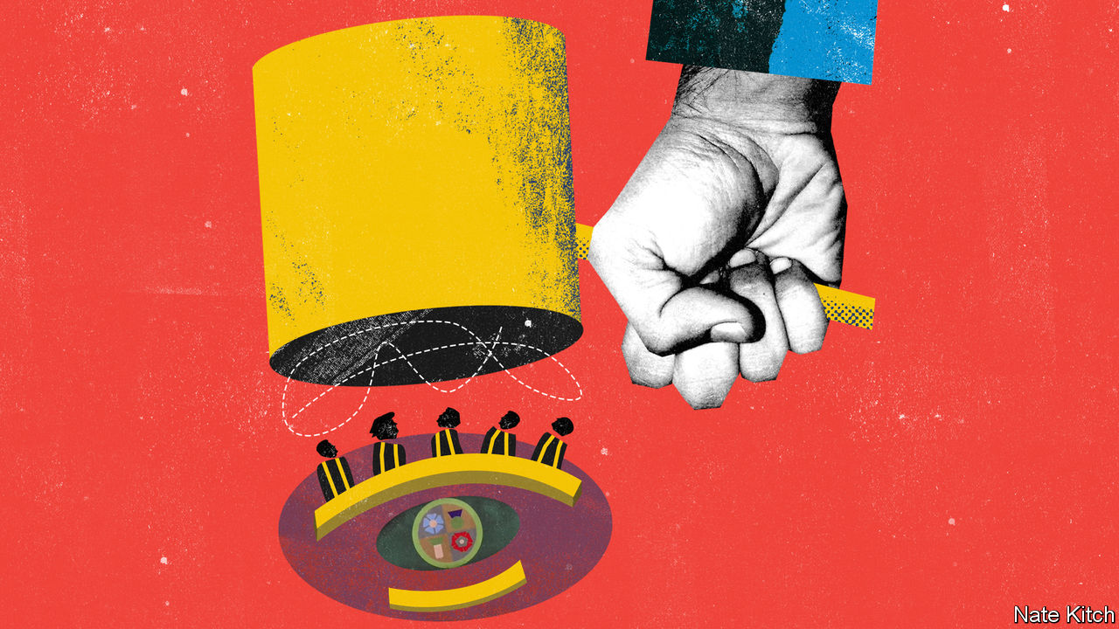

ENGLISH JUDGES are used to obscurity. Unlike their American counterparts, even the most senior can count on being recognised only in the warren of streets between High Holborn and the Thames that comprise London’s legal quarter. Their fondness for Latin does not help.

That changed last year when the Supreme Court ruled that Boris Johnson’s decision to suspend Parliament—prorogation, in the jargon—for five weeks was unlawful. Brenda Hale, the court’s then president, delivered the judgment live on television. Soon afterwards, a children’s book about “Judge Brenda” was published, declaring her “equal to everything”. The Guardian pronounced the spider brooch she wore to read the judgment the year’s “most potent accessory”.

The government is less taken with the court’s new-found fame. Mr Johnson criticised the prorogation ruling, despite accepting its legitimacy. Now that his Conservative Party has been re-elected with a large majority, he has the chance to act. He promises to establish a commission on the constitution, democracy and rights to review the separation of powers within months. Others in government prefer earthier phrases, reportedly talking of the need to “get the judges sorted”. You do not have to be a “superforecaster” of the sort championed by Dominic Cummings, the prime minister’s strategic adviser, to see trouble ahead.

Mr Johnson’s decision on February 13th to appoint Suella Braverman as attorney-general raised expectations that a battle is brewing. Her predecessor, Geoffrey Cox, shared the prime minister’s concerns about the judgment but attempted to dampen speculation about the commission’s scope, insisting the government would not “rush headlong into impetuous reform”. Ms Braverman, by contrast, has fanned the flames. She wrote last month that judges have made a “chronic and steady encroachment” on political turf. Invoking the Brexiteers’ favourite slogan, she urged Parliament to “take back control”.

What that means in practice is unclear. The commission’s terms of reference have yet to be published, but the judges’ critics are keen for it to consider pruning judicial review, the process for challenging the legality of executive actions, beefing up political oversight of judicial appointments and perhaps even whether the country’s most senior appeal judges ought to sit in the House of Lords, as they did until 2009, rather than in a separate Supreme Court. Nor does the commission have a chairman. One government cheerleader quipped that Lady Hale, now retired from the court, “shouldn’t wait by the phone”.

The government’s disdain for recent judgments has received the most publicity. Ms Braverman takes aim at the Supreme Court’s ruling, in 2017, that the government could not trigger Article 50, the mechanism by which it left the European Union, without a parliamentary vote. But its beef is not constrained to a handful of rulings, nor to the Supreme Court. Mr Johnson’s manifesto mooted changes to judicial review so that it is “not abused to conduct politics by another means”. Some Tories have long argued that interest groups have hijacked judicial review and that judges are straying from ensuring ministers stick to the law into evaluating the merits of policies. The title of the government’s main booklet of legal advice, “The Judge Over Your Shoulder”, paints its own picture.

Jonathan Sumption, a former supreme-court judge, lent that charge intellectual heft last year with a series of lectures on “law’s expanding empire”. Policy Exchange, a think-tank, runs a judicial power project, highlighting claims of “judicial overreach”. It is true that senior judges are doing more than in the past. The critics are right that the annual tally of judicial reviews has jumped, from a hundred or so in the 1970s to several thousand now. Judges are not immune: building work on the new Supreme Court was itself subject to an application for judicial review.

Others argue that the rise simply reflects the growing size of the statute book and the powers exercised by the state. Parliament passes 30 or so new laws a year, and they are growing chunkier. From 1930-50, the average act was 16 pages long. It now typically runs to 86 pages. Some cases are the “inevitable consequence of the development of people’s individual rights”, says Charles Falconer, a former lord chancellor. Tabloids are fond of accusing judges of placing too much emphasis on the human rights of prisoners or terrorists, but politicians instructed them to do so. Under the Human Rights Act of 1998, judges must evaluate whether or not domestic law is “compatible” with the European Convention on Human Rights.

The biggest growth category is immigration. In fact, apart from such cases, the number of judicial reviews has remained roughly flat since the millennium. It is hardly surprising that, since successive governments have introduced more immigration laws, Home Office decisions are more regularly being challenged in court, says Joe Tomlinson of the University of York. The data do not suggest widespread abuse of the system. An academic study commissioned by the Public Law Project, a charity, found that only 3% of a sample of judicial reviews were brought by activist groups. Though several more may have been brought by people acting on behalf of such groups, most claims are made by individuals. Paul Craig of Oxford University accuses judges’ critics of cherry-picking cases. Academics will always disagree about interpretations of the law in particular cases, he says; that does not amount to evidence of systemic failure. Besides, since the courts have no power to strike down legislation—as they do in America—Parliament is always free to clarify its wishes with a new law.

One difficulty the commission will face is that the critics of the current dispensation do not agree on their diagnosis of the problem. For instance, Richard Ekins, another Oxford don who runs the judicial power project, reckons the prorogation judgment was a “pretty shocking” example of judges’ willingness to remake constitutional law on the fly. Lord Sumption thinks it was perfectly sound.

Nor do the critics agree on the prescriptions for reform. Mr Ekins wants a Constitutional Restoration Act to reverse the effects of the prorogation judgment, rename the Supreme Court and increase ministerial involvement in judicial appointments. Lord Sumption, meanwhile, essentially wants the judges to have a stiff word with themselves.

The government should tread carefully. Lord Sumption is right to warn that “judges are famously resistant to having their wings clipped”. Previous attempts to reform judicial review have been dropped or scaled back. And there is no guarantee that the public will support reforms. Some might decry individual judgments, but judges are pretty popular on the whole. According to a poll by IPSOS Mori, more than four-fifths of Britons trust them to tell the truth, while less than a seventh say the same of politicians. If ministers are seen to be interfering with the independence of the judiciary, they will be judged harshly. ■

This article was downloaded by calibre from <https://www.economist.com/britain/2020/02/22/why-pruning-the-british-judiciarys-powers-will-prove-tricky>

|  |  |  |  |
| --- | --- | --- | --- |
|  | Articles | Sections | Next |

|  |  |  |  |
| --- | --- | --- | --- |
| Previous | Articles | Sections | Next |

#### Exploiting Brexit talks

# Will Britain lose the Elgin marbles?

Greece sets its own conditions for any future EU trade deal with Britain

Feb 22nd 2020 |

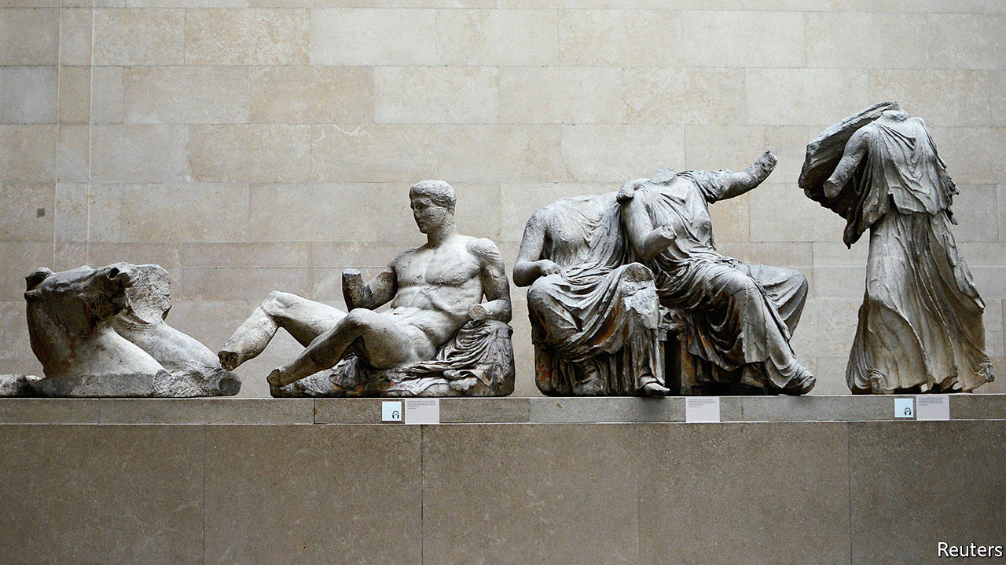

LIKE PRIZE fighters before a bout, the EU and UK are taking up ever tougher stances ahead of upcoming trade talks. On February 17th David Frost, the British negotiator, said Britain’s rejection of any EU supervisory role was not a negotiating tactic but the point of the whole Brexit project. A day later his EU counterpart, Michel Barnier, reiterated that any deal would require acceptance of some EU rules. Meanwhile EU member states are gleefully adding conditions of their own to the negotiating mandate.

One is a proposal by Greece, backed by Cyprus and Italy, to demand “the return or restitution of unlawfully removed cultural objects to their country of origin”. The Greeks insist piously that this refers solely to the fight against trade in stolen artefacts, since London is a centre for antique dealing. But EU diplomats note that the Greek government thinks that the Parthenon marbles in the British Museum were stolen by Lord Elgin in the early 1800s. And Greece’s culture minister has said that Brexit increases European support for their return.

The British Museum strongly supports the fight against trade in illicit antiquities. But it also insists the sculptures were acquired legally. The government says it will not even discuss their return, which would require a special act of Parliament. What this spat really shows is the use of Brexit talks to pursue other grievances. Spain is going after Gibraltar. Several countries want to keep on catching British fish. France talks of getting rid of British passport controls at Calais. Since any trade deal needs unanimous approval, why not pile on other conditions? At least it creates bargaining weapons to use in an eventual showdown in what look like being rancorous negotiations running up to the deadline at the end of the year.

This article was downloaded by calibre from <https://www.economist.com/britain/2020/02/22/will-britain-lose-the-elgin-marbles>

|  |  |  |  |
| --- | --- | --- | --- |
| Previous | Articles | Sections | Next |

|  |  |  |  |
| --- | --- | --- | --- |
| Previous | Articles | Sections | Next |

#### Points mean prizes

# Britain’s post-Brexit immigration rules worry business

Ballerina with a PhD? Come on in

Feb 20th 2020 |

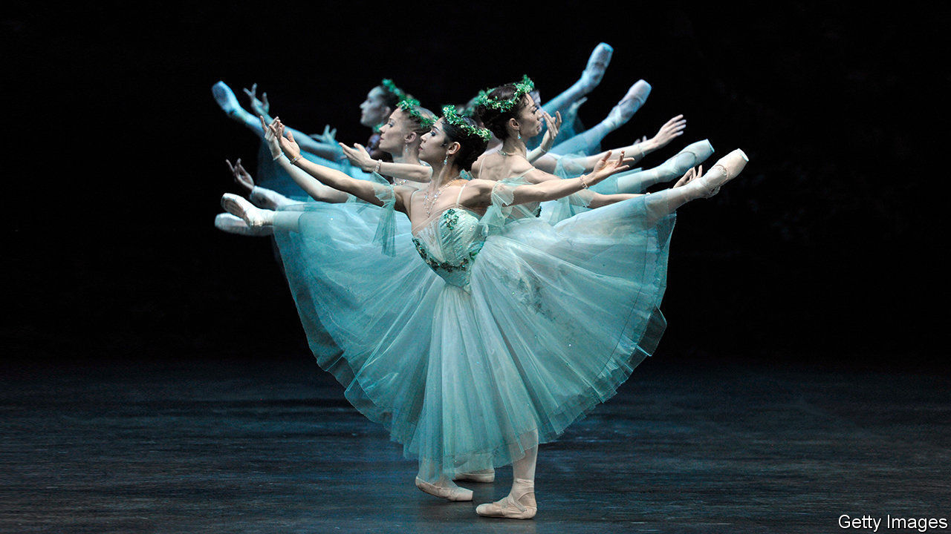

BRITAIN NEEDS more ballerinas, biochemists and welders—but only “high integrity pipe welders” with at least three years’ experience. These are among the occupations which appear on the official “shortage occupation list” (SOL), which is central to the government’s planned new immigration rules.

The new system will treat migrants equally, regardless of where they hail from. Europeans will no longer benefit from freedom of movement, but the bar to entry from the rest of the world will fall: prospective migrants will require the equivalent of A-levels, not degrees. The government claims it will let in more talented folks while reducing total numbers.

The plan was billed as a “points-based system”, but it is not as flexible as that implies. Most migrants will need to speak English and have a job offer with a prospective salary of more than £25,600 ($33,245). Exceptions to the threshold will only be made for brainiacs with PhDs and those with jobs on the SOL. English-speaking ballerinas with a doctorate are in luck.

Firms have welcomed the removal of a cap on migrant numbers, the opening up of routes for skilled workers and the lowering of the £30,000 salary threshold initially mooted. But they fret about shortages in some industries. The unemployment rate is just 3.8% and there are more than 800,000 unfilled job vacancies in Britain. Firms worry about cutting off the flow of lower-skilled European migrants at a time of what looks like full employment.

A recent report by The UK in a Changing Europe, a think-tank, estimated that the combination of nixing freedom of movement and adopting a relatively liberal scheme for skilled workers would cut overall net migration by only around 35,000, from the current 212,000. Work by the government’s own Migration Advisory Committee (MAC) found that the new rules would slightly reduce overall GDP but marginally increase GDP per head. Fewer unskilled workers might put some upward pressure on wages but the minimum wage, which is now the seventh highest out of the 27 members of the OECD that have minimum wages, has more effect.

Those who employ a lot of low-paid EU workers are troubled. The IPPR, a think-tank, reckons that 66% of the current EU workers in health and social care and 85% in hotels and hospitality would be ineligible for visas under the new system. The government hopes to encourage British people back into the labour market to meet the need. Priti Patel, the home secretary, argues that “we have over 8.45m people in the UK aged between 16 and 64 who are economically inactive”. But most of them are studying, retired, sick or looking after family. Only 1.9m say they want a job.

Britain’s farmers are concerned for next year’s harvest. Although the government announced that this year’s seasonal worker scheme will be expanded from 2,500 to 10,000 places, no commitment has been given for 2021. Picking soft fruits such as strawberries is tricky to automate.

But the impact of the changes will spread beyond low-skilled, low-productivity sectors. Manufacturing bosses in the north and the Midlands, where skilled technicians often earn below the £25,600 threshold, worry that the new rules will make it easier for firms in the south-east, where technicians tend to earn over the threshold, to expand. That is hardly what a government committed to “levelling up” wants to see. Businesses also worry about the costs of becoming registered as employment-sponsors, which firms that only employ EU workers are not currently required to do.

Under the new system an A-level qualified entrant with good English and job offer at £21,000 would score only 50 points, but if their role was on the SOL they would hit the required 70. So many businesses are now likely to start lobbying the MAC to get themselves covered. A liberalising measure risks generating more bureaucracy. ■

This article was downloaded by calibre from <https://www.economist.com/britain/2020/02/20/britains-post-brexit-immigration-rules-worry-business>

|  |  |  |  |
| --- | --- | --- | --- |
| Previous | Articles | Sections | Next |

|  |  |  |  |
| --- | --- | --- | --- |
| Previous | Articles | Sections | Next |

#### Brexit negotiations

# Why Britain isn’t Canada

The EU explains its rejection of Britain’s position in a chart

Feb 22nd 2020 |

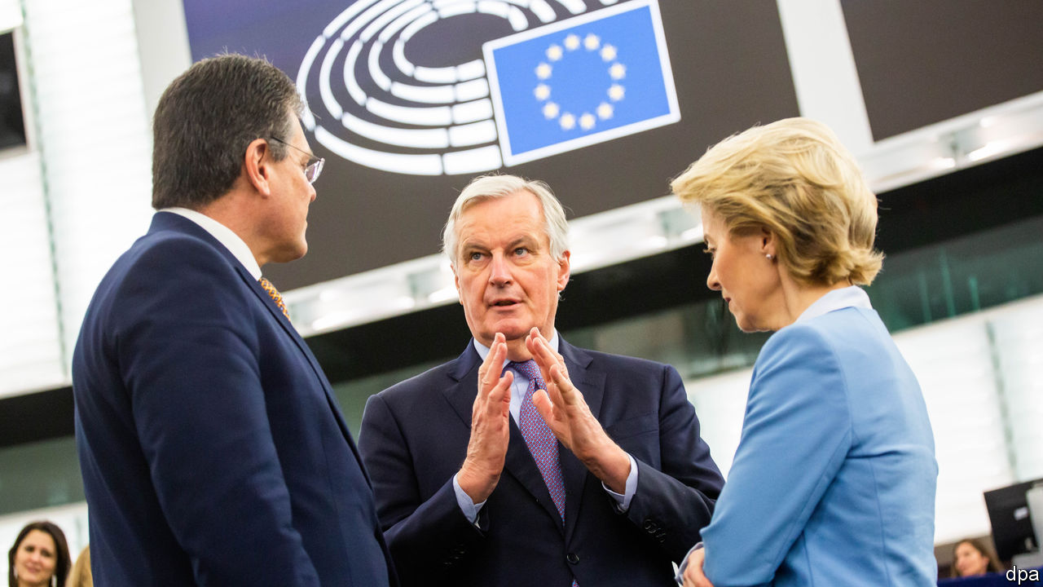

BREXIT NEGOTIATIONS are all about Canada at the moment. The government says it wants the kind of free-trade agreement that the eu has with Canada, and accuses the European Commission of changing its terms by suddenly demanding a level playing-field of rules on state subsidies and social, environmental, labour and other regulations to prevent unfair competition—conditions not required of Canada. The commission retorts that Boris Johnson accepted “robust commitments to ensure a level playing-field” in the political declaration attached to the Brexit withdrawal agreement. It also tweeted a slide showing just why Britain is not like Canada: the bigger the trade flows and the shorter the distance, the more substantial the risk of being undercut by looser rules.■

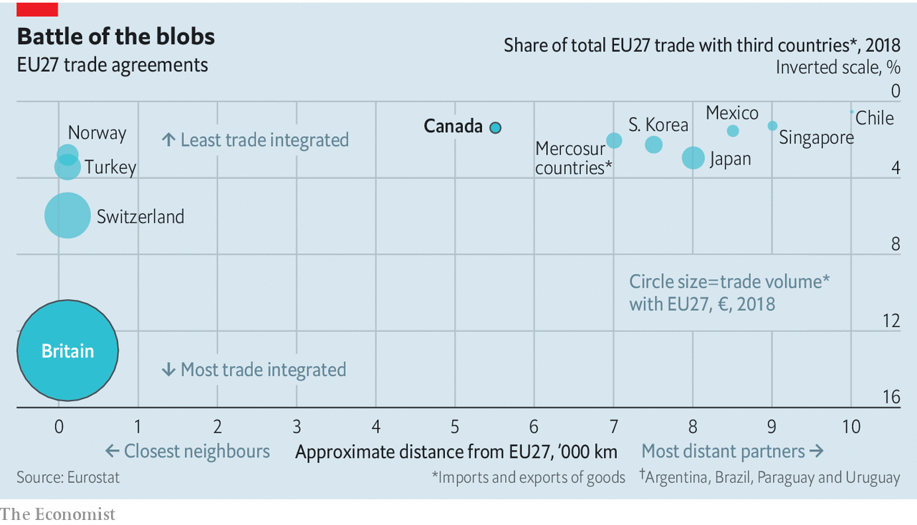

This article was downloaded by calibre from <https://www.economist.com/britain/2020/02/22/why-britain-isnt-canada>

|  |  |  |  |
| --- | --- | --- | --- |
| Previous | Articles | Sections | Next |

|  |  |  |  |
| --- | --- | --- | --- |
| Previous | Articles | Sections | Next |

#### Uncomradely behaviour

# With money tight, competition between Britain’s unions is getting dirty

Why attract new workers when you can just poach your rivals’ members?

Feb 22nd 2020 |

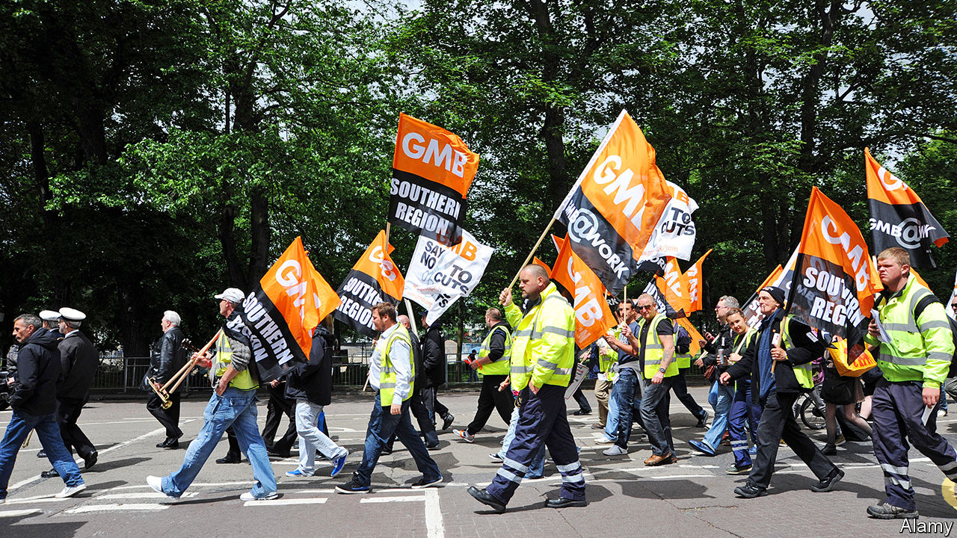

IN A NORTH LONDON supermarket, rival trade-union officials are caught in a bitter feud. A representative from Usdaw, the shopworkers’ union, has been running up against Unite organisers, whose desperation for members has reached boiling point. “I was recently asked by a Unite rep to not come into ‘their’ store to help out an Usdaw member,” says the Usdaw shop steward. “I just laughed and gave out a load of membership forms—apparently we got about 50 people to sign up!”

For a sector that prides itself on solidarity, competition between trade unions has become downright uncomradely. There are now 6.4m union members in Britain, representing less than a quarter of all workers, and down from a peak of 12m in the early 1980s. Tougher rules on organising—including a 50% turnout requirement for strike ballots—make it harder to win the goodies that attract new members. Many workers do not see the benefits of unionising, and competition for those that do has become increasingly fierce.

Feuds usually remain behind closed doors. When one goes public, it can take longer to resolve. Last year, Unite-backed bin workers in Birmingham went on strike over allegations that secret payments had been made to non-striking staff represented by GMB, a rival outfit. As rubbish piled on the streets, the unions did battle through frantically typed press releases. GMB argued that the accusations about payments were “nothing short of a grotesque slur”.

GMB, the country’s third-biggest union, faces competition on numerous fronts. It claims the National Education Union (NEU) is poaching teaching assistants which it has no ability to negotiate for. “We are concerned that our members are being used as cannon fodder by the NEU,” says one official. “There has always been a degree of intra-union conflict,” he adds, but “now some unions are getting desperate.”

The Trades Union Congress, which arbitrates disputes, admits it is buckling under the weight of petty squabbles. Calming down infuriated officials has “become a full-time job,” sighs a senior bureaucrat. The organisation’s guide to disputes is a 44-page document, of which two pages are devoted to disputes with employers and the rest to disputes between unions. The Usdaw shop steward complains that the problem for the labour movement, “is the overzealous reps that don’t realise we’re on the same side.”

In theory, the “Bridlington Principles”, drawn up by union bosses in a Yorkshire hotel in the 1930s, are supposed to restrain overzealous types. In practice, “greenfield organising”—the recruitment of entirely new members—is expensive and time-consuming. Poaching members from other unions is more straightforward, since the work of selling them the benefits of trade union membership has already been done and, best of all, someone else has paid for it. As a result, few pay much attention to rules drawn up 80 years ago. One union official explains that rivals will watch individual branches for signs of division so they can then step in and recruit en masse. “If there is a ballot and it’s a 60-40 split,” he says, “then the 40% who voted against that might be open to switch sides”.

Competition has only increased as the sector has become more concentrated. A series of mergers has blurred traditional boundaries between job-specific unions. In education two of the previous three big players combined in 2017 to form the NEU. Unite, Britain’s largest union, was formed by a merger of the Transport and General Workers’ Union and Amicus, which represented high-skilled workers. Like many “super-unions”, its revenue has flatlined over the past five years despite growing spending. And these behemoths now worry about disruption from smaller, tech-savvy outfits like the IWGB, which was founded in 2012 and recruits members working in the gig economy.

The hope was that politics would come to the rescue. Trade unions poured money into the Labour Party before the general election. Unite alone gave £3m ($4m) during the campaign, and regional branches were told to get door-knocking. Union bosses expected that Jeremy Corbyn would make their life easier once in Downing Street. Indeed, the Labour Party manifesto promised looser restrictions on strikes and a new ministry responsible for “employment rights”, which would roll out collective bargaining across the economy. But the British public failed to deliver a Labour government, and the socialist nirvana was put on hold. Unfortunately for exhausted union reps, that means there are probably many more feuds to come. ■

This article was downloaded by calibre from <https://www.economist.com/britain/2020/02/22/with-money-tight-competition-between-britains-unions-is-getting-dirty>

|  |  |  |  |
| --- | --- | --- | --- |
| Previous | Articles | Sections | Next |

|  |  |  |  |
| --- | --- | --- | --- |
| Previous | Articles | Sections | Next |

#### Reshuffle revisited

# British ministers come and go almost as often as football managers

Secretaries of state change jobs too frequently—and the talent pool they are drawn from is too shallow

Feb 22nd 2020 |

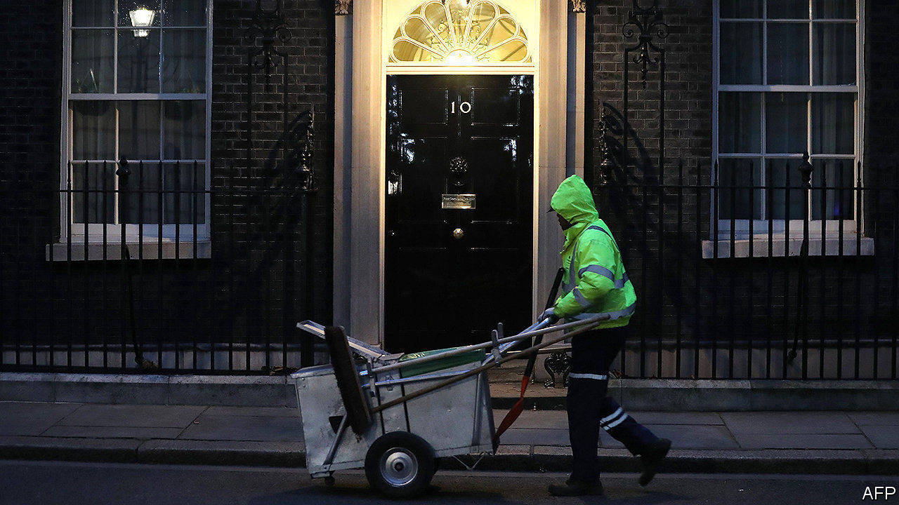

THE BIG story of Boris Johnson’s first ministerial reshuffle on February 13th was the unexpected loss of his chancellor, Sajid Javid. But another feature is the acceleration of the ministerial merry-go-round. The Institute for Government (IFG), a think-tank, calculates that the average length of service of a senior minister in the past decade has fallen to less than two years—closer to that of a football manager than of a company boss (see chart). Junior ministers typically last even less time, frequently moving on after only a year.

Government suffers from such rapid turnover. There have been five justice ministers in the past five years, and ten housing ministers in the past decade (Esther McVey, the ninth, was sacked last week after serving six months). It is hard to recall policy successes in either department, and easy to spot failures. Nor is political churn offset by official stability. The IFG reports that the turnover rate among senior civil servants has risen as well.

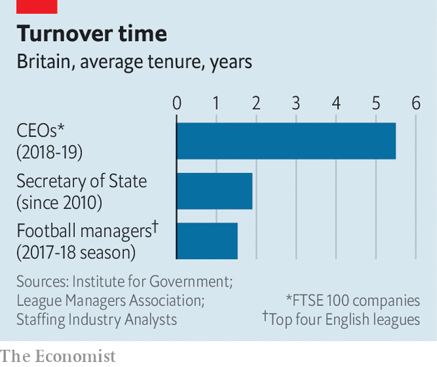

The absence of training for ministerial office exacerbates the problem. A recent book* by Peter Riddell, a former head of the IFG, quotes many former ministers bemoaning their lack of preparation and saying it often took them two years to learn their job—at which point they were expected to move on and start all over again. Experience as a special adviser and then an MP—which is all many ministers have—is insufficient training for managing a complex department.

Britain is rare among rich democracies in requiring that all ministers must come from its legislature, which means that the talent pool is essentially limited to the ruling party’s backbenchers. Outsiders can be brought in through the House of Lords. But this has often been unsuccessful in practice, and MPs also complain that they cannot hold peers to account. Discounting those MPs whom one Tory chief whip memorably described as “the bad, mad, drunk and over the hill”, the talent pool becomes even shallower.

This could be a problem for Mr Johnson. Despite his 80-seat majority, he has many enemies inside his party. His reshuffle benefited keen Brexiteers in particular. Many political analysts reckon that this meant rewarding the compliant over the competent. The sacking of Julian Smith, the Northern Ireland secretary, fresh from his success in getting the province’s assembly up and running again, was widely criticised. As previous prime ministers have found, disgruntled big beasts lurking on the backbenches instead of in the cabinet can be destabilising.

Here at least Mr Johnson’s reshuffle featured one welcome innovation: bringing back those whom he had earlier sacked. Penny Mordaunt, a former defence secretary, and James Brokenshire, a former housing and local government secretary, have returned to more junior posts in other departments. Not all former cabinet ministers will feel able to swallow their pride after falling out with the prime minister and his Downing Street team. But the precedent of ministerial return may at least keep the talent pool that Mr Johnson has to draw from in future a little deeper.■

*”15 minutes of power: the uncertain life of British ministers”. By Peter Riddell, Profile Books, 2019.

This article was downloaded by calibre from <https://www.economist.com/britain/2020/02/22/british-ministers-come-and-go-almost-as-often-as-football-managers>

|  |  |  |  |
| --- | --- | --- | --- |
| Previous | Articles | Sections | Next |

|  |  |  |  |
| --- | --- | --- | --- |
| Previous | Articles | Sections | Next |

#### Clubbing together

# The rise of Britain’s woke members’ clubs

Out with cocaine-fuelled hedonism, in with gender politics

Feb 22nd 2020 |



NAMED AFTER Marx, who famously did not want to belong to any club that would accept him as a member, the Groucho sold itself as the “antidote” to the gentlemen’s clubs of London’s St James’s district when it opened in 1985. With a heavy drinking culture, artistic spirit and cocaine-driven largesse, the club captured the zeitgeist. Of late it has been swept up in Soho’s commercialisation, and is now owned by a private-equity firm. Despite offering reduced fees for under-30s and a vegan menu, it is not the magnet for youth it once was.

Today’s antidote is a breed of clubs promoting values rather than loucheness. They offer a similar aesthetic to those of the 1980s and 1990s: all have adopted the velvet chesterfields and modern British art customary at the Groucho Club and Soho House, another club popular among media types. The new ingredient is “wokeness”.

In October The Wing, a glossy feminist utopia that does not admit men, opened its first branch outside America, where there are ten. Candidates to join the new outpost in Fitzrovia are asked, for instance, to describe how they have “promoted or supported the advancement of women” and what they think is the “biggest challenge facing women today”. At the clubhouse, oil paintings of Phoebe Waller-Bridge and Mary Beard (feminist heroes in acting and academia respectively) line the walls, the library is free from books written by men, and badges dispensed at reception allow everyone to indicate their preferred personal pronoun. Members are described either as “the cohort” or “the witches” (liked for its connotations of subverting male power).

The Wing’s native British equivalent is AllBright. There are two in London, and there will be three in America by the end of the year. Like The Wing, it offers an additional service beyond somewhere stylish to socialise and work: self-help. At The Wing, recent events have covered self-sabotage, boundary-setting and how to be “sober and social”. At AllBright, group sessions have discussed impostor syndrome and how to overcome fear. Cognitive behavioural therapy and psychoanalysis are available by the hour. Mindless hedonism is off the menu.

For mixed company, “people passionate about driving positive impact” can join The Conduit in Mayfair, opened by a former chairman of Soho House, which claims to be “a platform for catalysing and supporting new ideas and collective action”. For eco-enthusiasts there is Arboretum in Covent Garden, a leafy idyll where “people who care about the planet convene, create and collaborate”. Its deli promises dishes free from dairy, refined sugars, additives and chemicals.

Other than the offer of cheap drinks by some traditional clubs to attract younger members, little has stirred in St James’s. As a result, clubland is increasingly diverse. There are ever more clubs for a modern Marx to be rejected by, and even more reason to reject them.

This article was downloaded by calibre from <https://www.economist.com/britain/2020/02/22/the-rise-of-britains-woke-members-clubs>

|  |  |  |  |
| --- | --- | --- | --- |
| Previous | Articles | Sections | Next |

|  |  |  |  |
| --- | --- | --- | --- |
| Previous | Articles | Sections | Next |

#### Bagehot

# Britain’s imperial prime minister

Boris Johnson is busy accumulating power in Number 10

Feb 22nd 2020 |

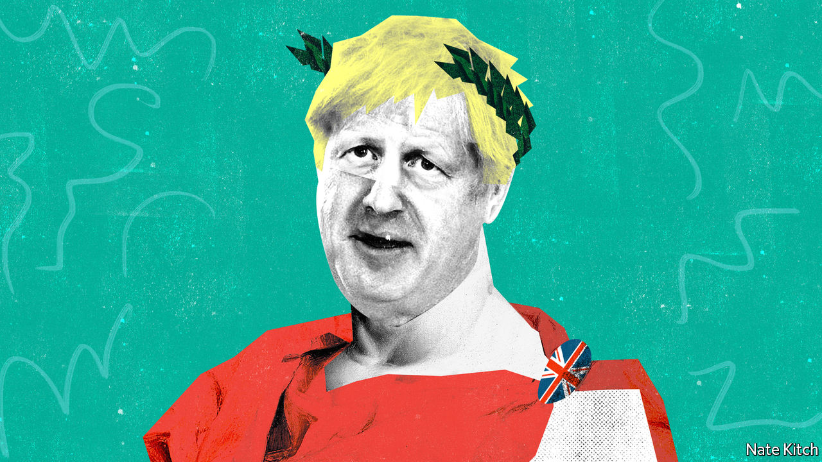

THE EMPEROR NERO was reportedly in the habit of dipping dissidents in tar and using them to light his dinner parties. Boris Johnson has not so far shown an inclination to use his ministers as human torches, but there is nevertheless something imperial about his progress. He dispenses with colleagues with a chilling nonchalance. He barrels into prime minister’s questions every Wednesday, his shirt-tail flapping behind him, to the cheers of the massed Tory benches. A recent cabinet meeting opened with a bizarre call-and-response chant, with the prime minister bellowing a series of questions—“How many hospitals are we going to build?” and so on—and ministers replying in unison.

The American presidency is imperial by nature. Presidents live in a big white house and get ferried about town in an armoured car nicknamed “the Beast”. Directly elected by the people, they are exceedingly hard to remove from office. The British prime ministership is more malleable: Herbert Asquith, a Liberal who held the office in the early 20th century, observed that it is ultimately “what the holder chooses, and is able, to make it”. Prime ministers have few resources—they work with a small staff in a poky town house—and their autonomy is limited, since they serve at the pleasure of their party. Theresa May spent three years being tormented by her fellow Tories before her miserable demise.

Three things determine whether they will be emperors or wimps: the nature of their personality, the quality of the people sitting around the cabinet table and the size of their majority. In Mr Johnson’s case all three dials are turned to “maximum imperial”. His biography of Britain’s greatest prime minister, Winston Churchill, was a disguised mission statement. He also has an imperial taste for vengeance. He cites “The Godfather” as his favourite film, for “the multiple retribution killings at the end”.

While Margaret Thatcher had big figures such as Geoffrey Howe and Nigel Lawson (who eventually assassinated her) around her cabinet table, and Tony Blair had his nemesis Gordon Brown, this Churchill wannabe has nobody who can stand up to him. He is not so much primus inter pares (Walter Bagehot’s description of a prime minister) as primus inter poodles. His only powerful colleague, so far, is his chief strategist and consigliere, Dominic Cummings, whom he can sack at will.

Mr Johnson’s 80-seat majority has also issued him with a blank cheque. The majority is in many ways a personal one: millions of people voted Tory, many for the first time, because of the combination of his personality and his message of getting Brexit done. It enables him to steamroller opposition.

This willingness to assert power goes along with a sense of fragility. Mr Johnson is in office thanks to the votes of people who had lost faith in politics. He knows that he will retain their support only if he can deliver for them, which is why the word “delivery” is on every minister’s lips these days. That means delivering not just Brexit but also the things for which Brexit is a surrogate: a better deal for the north; more police and hospitals; government support for the just-about managing. Mr Johnson calculates that in order to honour his promises to the electorate he needs to assert the supremacy of Number 10 and to treat departments of state less as centres of power than as delivery mechanisms.

Mr Cummings is at the heart of this centralisation project. He is pushing forward with his long-cherished plan of turning ministers’ special advisers, or “spads”, into a sort of New Model Army that sees its primary loyalty as being to Number 10 rather than to individual ministers. On February 13th the chancellor of the exchequer, Sajid Javid, resigned rather than agree to the merger of Number 11’s advisers with those at Number 10. Mr Cummings is also succeeding in spreading fear across Whitehall. “When the Eye of Sauron is off the Whitehall machine”, a “senior Downing Street figure” told the Sun newspaper in menacing Cummings-speak, “things stop working.”

What are we to make of Mr Johnson’s imperial turn? Critics worry that the last thing an over-centralised country needs is more centralisation of power. Other experiments with hyperactive regimes in Downing Street had lamentable side-effects: Mrs Thatcher left local government shrivelled. They also worry about destroying the checks and balances that prevent Number 10 from making big mistakes or spending money that the country doesn’t have. But these worries need to be set against two considerations.

The first is that there is nothing inherently sinister about Mr Johnson’s plan to encourage Numbers 10 and 11 to work more closely together. On the contrary: the Treasury’s traditional practice of keeping Number 10 in the dark about its budget and spending plans has led to embarrassments, as when Philip Hammond raised taxes on the self-employed only to have to reverse himself almost immediately because he had forgotten a manifesto pledge. The idea that Number 10 will steamroller the Treasury because its spads sit on a committee with Treasury spads is absurd. The Treasury has more than a thousand civil servants to rely on. The power of the chancellor depends largely on his abilities, and Rishi Sunak, the new chancellor, is more talented than his predecessor.

The second point is that beefing up Number 10 is no bad thing, at least in the short term. The government is confronted with two of the biggest problems Britain has faced since the second world war: taking Britain out of the EU and addressing the political discontent that led to Brexit. It needs a thriving policy unit to develop an economic model to replace, or at least to adjust, the one that has prevailed since the 1980s. It needs an updated version of Mr Blair’s delivery unit to monitor the government’s success or otherwise in achieving its goals.

The real problem with Emperor Boris is not that he is gathering power. He probably needs to do more of it. It is that his government is frittering away its authority by picking fights with judges and journalists rather than focusing on delivering its core promises. ■

This article was downloaded by calibre from <https://www.economist.com/britain/2020/02/22/britains-imperial-prime-minister>

|  |  |  |  |
| --- | --- | --- | --- |
| Previous | Articles | Sections | Next |

|  |  |  |
| --- | --- | --- |
| Britain | Sections | Special report |

International

Covid-19: Watchful waiting

.

|  |  |  |
| --- | --- | --- |
| Britain | Sections | Special report |

|  |  |  |  |
| --- | --- | --- | --- |
|  | Articles | Sections | Next |

#### Watchful waiting

# Experts predict that covid-19 will spread more widely

The world is getting ready. Poor countries are especially vulnerable

Feb 22nd 2020 | GOMA AND KAMPALA

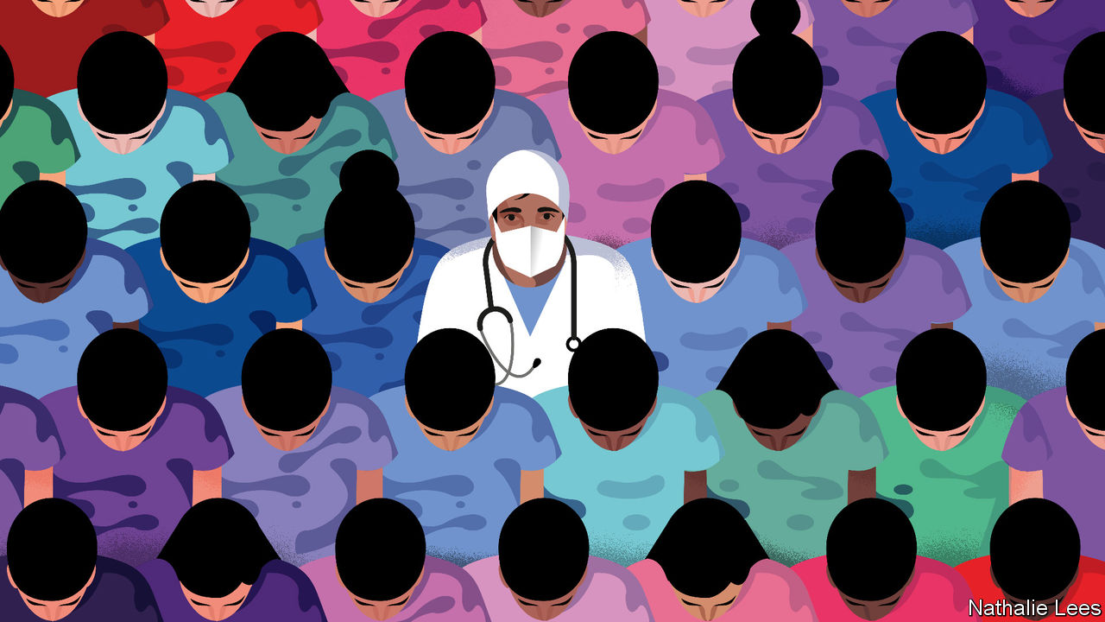

“THERE ARE so many crises in Congo.” Gervais Folefack, who co-ordinates the emergency programmes run by the World Health Organisation (WHO) in the Democratic Republic of Congo, has mastered the art of the understatement. The country has been shattered by war and corruption. “All the time we are responding to crises,” says Dr Folefack. He lists the most recent: Ebola, measles, cholera. To them, he may well have to add covid-19, a respiratory disease that originated in China. Those who would need to respond to a surge in covid-19 cases are already busy with the Ebola outbreak that began in 2018. “We are trying to prepare,” continues Dr Folefack, but there is simply not enough time.

So far 99% of confirmed cases of the new coronavirus have been in China. Of the 1,000-odd cases outside mainland China, more than half have been on the Diamond Princess, a cruise ship docked in Japan; the rest are scattered among 27 countries, mostly in Asia. Covid-19 has spread rapidly in China despite the government locking down entire cities for weeks. China’s efforts, along with the travel restrictions that many countries have imposed on its citizens, have slowed the virus’s progress. But many experts fear that it will inevitably become a pandemic. Health authorities are frantically trying to prepare.

On February 12th Nancy Messonnier of America’s Centres for Disease Control and Prevention (CDC) said America should be prepared for the virus “to gain a foothold” in the country. Doctors in South Africa are on high alert, says Cheryl Cohen of the National Institute for Communicable Diseases. More than 850 medics in all nine of the country’s provinces have been taught to spot the disease. The WHO is sending surgical masks, gowns and gloves to hospitals in more than 50 countries. It is teaching health workers across Africa how to use them to prevent covid-19 infections—and how to treat those who have the disease.

Growing numbers of countries are screening passengers at airports and borders for signs of covid-19. But when a virus starts travelling around the world, says Michael Ryan of the WHO, its real point of entry is a busy emergency room or a doctor’s surgery. In the 2003 outbreak of SARS (severe acute respiratory syndrome), another coronavirus which spread to more than 20 countries, about 30% of the 8,000 people infected were health-care workers. Many, if not most, of the SARS outbreaks around the world—from Toronto to Singapore— started in a hospital with a single patient who had been infected abroad.

In countries where covid-19 cases are still rare doctors are, for now, trying to identify suspected patients by asking those with a cough and fever about recent travel to countries with outbreaks of the disease and then testing them. In America if patients test negative for seasonal flu, laboratories are starting to test for covid-19 (the country has so far identified 29 cases).

Confirming a suspected infection in a laboratory can take days. Some small European countries have just one or two laboratories able to process covid-19 tests. Europe’s entire supply of test kits is shipped from the two main laboratories of the European Centre for Disease Prevention and Control (ECDC), the EU’s public-health agency. America’s supply all comes from the CDC in Atlanta. It will be several months before commercial tests are available.

Tests could soon run short if other countries experience covid-19 epidemics like China’s. Delays in getting the results would increase. A lab technician must first prepare the samples. After that, processing each test through a molecular-analysis machine can take an hour and a half. These machines also run tests for the seasonal flu and other diseases. A covid-19 epidemic in the middle of winter—peak season for the common flu—would quickly overwhelm laboratories in most countries. Rapid diagnostic tests for the new virus that are as quick to carry out in doctors’ offices as pregnancy tests were at the top of the wishlist at a WHO meeting about research priorities for covid-19 in February.

Once an epidemic is in full swing, extensive testing to find everyone who might have the disease is less useful, says John Hick, an emergency co-ordinator at the Hennepin County Medical Centre in Minneapolis. At that point, he says, doctors will start to diagnose probable cases by symptoms alone—which is common practice for many illnesses, including the flu. Medics in parts of China are already doing this.

As with other contagious diseases, covid-19 patients in hospitals must be isolated to prevent its spread. When patients become too numerous to contain in isolation rooms, shared rooms, wings or entire floors may be set aside for covid-19 patients only. The Vrije University hospital in Amsterdam has dusted off its plans for doing this, including where to put “do not cross” lines to separate such sections, says Rosa van Mansfeld, who oversees infection prevention there. When all Dutch hospitals are overwhelmed, the lights will be turned on at the country’s “calamity hospital”, a fully equipped facility in Utrecht that is otherwise shut (it last opened to care for the victims of a terrorist shooting in 2019). In Kinshasa, Congo’s capital, an empty Ebola treatment centre will be used when covid-19 cases are identified.

Dr Hick says the biggest challenge if the disease starts to circulate widely in Minneapolis will be staffing. With no vaccine to protect them, many doctors and nurses will be infected. Others will need to stay at home to look after their children because schools may be closed. In its disaster planning, the hospital where Dr Hick works considered offering child care on-site for its staff. But he admits that people may be reluctant to bring their offspring to a hospital during an epidemic.

Hospitals will encourage people who do not seem to be seriously ill to stay away, as they do during the peak of seasonal flu. In part, that is to prevent them from straining the capacity of hospitals that are already overwhelmed. Doctors have no treatment to offer those with mild symptoms but in a hospital they can infect other patients or medics. Such people will be advised to isolate themselves at home. Others with mild symptoms may in fact have a different bug—but if they flock to hospitals, they may contract covid-19 for real.

Hospitals in both rich and poor countries are worried that in the event of an epidemic they will quickly run out of masks, gowns and gloves. Guidelines by the ECDC say that 24 disposable sets per day may be needed for a covid-19 patient in an intensive-care unit. The WHO says that a global shortage is already occurring, with a 20-fold rise in prices for some types of equipment. Surging demand in Asia, stockpiling by hospitals and disrupted production in China have all contributed to shortages of surgical masks.

Some hospitals are trying to conserve supplies. Dr van Mansfeld says that nurses in her hospital in Amsterdam are being reminded not to use the high-protection respirator masks if they are caring for patients for whom the guidelines say ordinary surgical masks suffice. At some point, says Dr Hick, medics may have to start reusing respirator masks judiciously. Instead of throwing them away after each patient, they could remove them, handling them particularly carefully so that any germs on the outer surfaces are not transferred to their mouths or noses, and re-use them.

The swine-flu pandemic, which was caused by the H1N1 virus and infected 16% of the world’s population in 2009, brought home the message that doctors would have to make such tough decisions when big epidemics strike, says Dan Hanfling of In-Q-Tel, an American organisation that invests in national-security technology. Between the first and the second wave of H1N1 infections in America, the country’s National Academies of Sciences developed a set of “crisis standards of care”. These specify what doctors should do as shortages of medical supplies become worse.



One course of action is to substitute treatments with near-equivalents, such as drugs that have a similar effect. Another is to adapt what is available for different uses. For example, simpler breathing machines from ambulances may be used as substitutes for the sophisticated machines in intensive-care units. Medics may have to clean and re-use equipment, such as catheters, rather than throw it away after each use (as doctors in poor countries do every day, Dr Hanfling points out).

The hardest decisions would come when all these options are exhausted. Few countries have discussed how doctors would choose which patients get ventilators when there are not enough for everyone who needs one. If doctors have one patient who is on a ventilator but clearly getting worse, and another who is healthier and more likely to survive, they can justify reallocating the ventilator to the second patient. But such decisions would be particularly hard to make with covid-19, based on what doctors already know about the disease. A patient may be on a ventilator for several weeks and show little improvement but still make a good recovery.

## Be prepared

America is ahead of most countries in planning for such things, says Dr Hanfling. Disasters such as Hurricane Katrina—when many patients died in hospitals that were unprepared for disaster—laid bare the need to prepare for the worst. Each year the federal government gives states and hospitals about $1bn specifically for disaster preparedness. That is more than the national health budget of many African countries. Other countries’ recent experience may help them. Kerala, the only state in India to have confirmed cases of covid-19, swiftly contained an outbreak of Nipah, a nasty virus, in 2018 and has since bolstered its health system. Uganda has held back the spread of Ebola from next-door Congo and in the process built up stocks of protective clothing for health-care workers.

But poor countries would be hit particularly hard by outbreaks of covid-19. Uganda is used to dealing with diseases transmitted through blood, mosquitoes or parasites. Covid-19, if it comes, could spread quickly and unpredictably, which would test a cash-strapped health-care system. Ian Clarke, chair of a private health federation based in Uganda, worries that the mortality rates could be higher in Africa than they are in China because many people already have weakened immune systems as a result of HIV or poor nutrition. SARS mostly skipped Africa; the continent may not be so lucky with the new virus.■

Correction (February 20th): An earlier version of this article misstated the name of Ms. Messonnier. Sorry.

This article was downloaded by calibre from <https://www.economist.com/international/2020/02/22/experts-predict-that-covid-19-will-spread-more-widely>

|  |  |  |  |
| --- | --- | --- | --- |
|  | Articles | Sections | Next |

|  |  |  |
| --- | --- | --- |
| International | Sections | Business |

Special report

The data economy: Mirror worlds

.

Economics: Digital plurality

.

Infrastructure: Spreading out

.

Business: The new AI-ssembly line

.

Geopolitics: Virtual nationalism

.

Policy: And the winner is…

.

|  |  |  |
| --- | --- | --- |
| International | Sections | Business |

|  |  |  |  |
| --- | --- | --- | --- |
|  | Articles | Sections | Next |

#### The data economy

# A deluge of data is giving rise to a new economy

Ludwig Siegele asks how it will work

Feb 22nd 2020 |



A N ARMY OF doppelgangers is invading the world. Digital copies of aircraft engines, wind turbines and other heavy equipment came first. Now the electronic ghosts of smaller and larger things are joining them in the virtual realm, from toothbrushes and traffic lights to entire shops and factories. Even humans have begun developing these alter egos. In America the National Football League is planning to design an electronic avatar for every player.

These “digital twins”, as geeks term them, are far more than replicas of the original. Think of them more as shadows that are, thanks to a multitude of sensors and wireless connectivity, intimately linked to their physical selves, and every day producing oceans of data. If something happens in the real world, it is rapidly reflected in this shadow realm. Some digital twins already come with the laws of nature programmed in. They double as a database of everything that has ever happened to the original. This makes it possible to look into their future. Sports coaches, for instance, will be able to run simulations, predict when an athlete might get injured and adjust training routines to avoid problems.

Digital twins are just one part of a vast shift in the world’s economy. They populate what David Gelernter of Yale University long ago forecast as “mirror worlds”: a new dimension of human life based on and fuelled by data. Year by year, ever more parts of the physical realm are coming to be represented and simulated in the virtual world—an inversion of Plato’s theory that real-world objects are just imperfect copies of their true being in the spiritual realm. The emergence of these mirror worlds will bring about a distinct economy. This development will require new markets, institutions, infrastructure, businesses and even geopolitical arrangements. It is the promises and pitfalls of the new “data economy” which will be the focus of this special report.

Mirror worlds are not mere mathematical representations of real ones. They also give new meaning to the adage that knowledge is power. Increasingly, digital copies are taking on lives of their own and acting on the physical world. They can be used to optimise everything, from the acoustics of a headset to an entire national railway network. They will enable all sorts of artificial-intelligence (AI) algorithms to recognise objects and faces, understand speech and even distinguish smells. And they make possible new business models: why buy heavy equipment if its wear and tear can be measured in detail and it can thus be rented by the minute?

A good place to start analysing any economy is by measuring it. A robust methodology has yet to be developed, but the data economy is already large. Statistics Canada, a government agency, last year tried to estimate the value of the country’s data (its stock plus related software and intellectual property in the field). The result was between C$157bn and C$218bn ($118bn and $164bn). If that number is close—a big “if”—the value of all the data in America, whose GDP is 12 times that of Canada, could amount to $1.4trn-2trn, which would be nearly 5% of America’s stock of private physical capital.

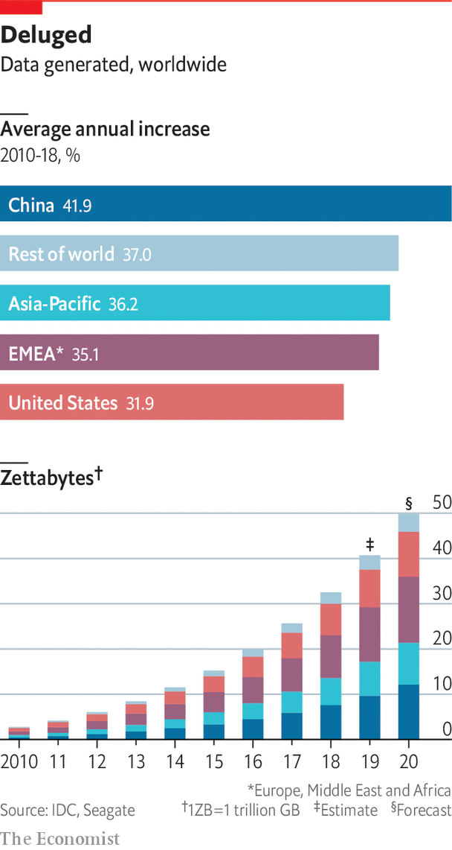

If the amount of data generated around the world is any guide, this new economy is growing fast. The first human genome (three gigabytes of data, which nearly fills a DVD) was sequenced 17 years ago; in April, 23andMe, a firm which offers genetic testing, claimed more than 10m customers. The latest autonomous vehicles produce up to 30 terabytes for every eight hours of driving (or some 6,400 DVDs). IDC, a market-research firm, estimates the world will generate about 90 zettabytes (19trn DVDs) this year and next (see chart), more than all data produced since the advent of computers.

Yet even more striking than the rapid growth of the data economy are the tensions and trade-offs it produces. Take its economics. In some ways, data are a natural resource, much like oil, which can be owned and traded (this newspaper called data the “world’s most valuable resource” in 2017). But data also have characteristics of a public good, which ought to be used as widely as possible to maximise wealth creation. New institutions must be created to reflect this tension, as was the case for intellectual property.

The infrastructure of the data economy, too, is torn between two poles. Currently, it mainly consists of huge data centres packed with servers where data are stored and crunched. Yet such centralisation has drawbacks, not least because it consumes huge amounts of energy and creates privacy risks. A decentralising counter-movement is already under way: more data are processed at the “edge”, closer to where they are collected.

Businesses are also facing a digital reversal. Many firms want to use data to infuse their corporate applications with AI. They have built central repositories such as “data lakes”, which hold all kinds of digital information. Such systems are of limited use, however, if a firm and its employees lack the required skills, refuse to believe the data or even to share them internally.

Finally, the geopolitics of data will not be simple, either. Online giants in particular have assumed that the data economy will be a global affair, with the digital stuff flowing to where processing is best done for technical and cost reasons. Yet governments are increasingly asserting their “digital sovereignty”, demanding that data not leave their country of origin.

This special report will tackle these topics in turn. It will conclude by discussing what is perhaps the biggest conundrum of the mirror world: the risk is that the wealth it creates will be even more unequally distributed than in its terrestrial twin.■

This article was downloaded by calibre from <https://www.economist.com/special-report/2020/02/22/a-deluge-of-data-is-giving-rise-to-a-new-economy>

|  |  |  |  |
| --- | --- | --- | --- |
|  | Articles | Sections | Next |

|  |  |  |  |
| --- | --- | --- | --- |
| Previous | Articles | Sections | Next |

#### Economics

# Are data more like oil or sunlight?

The question highlights the many different faces of data

Feb 22nd 2020 |



PASSIONATE GRAMMARIANS have long quarrelled over whether data should be singular or plural (contrary to common usage, this newspaper is sticking with the latter, for now). A better question is why are data so singularly plural? That is, why do they have so many different faces?

For an answer, start with the many metaphors used to describe flows of data. Originally they were likened to oil, suggesting that data are the fuel of the future. More recently, the comparison has been with sunlight because soon, like solar rays, they will be everywhere and underlie everything. There is also talk of data as infrastructure: they should be seen as a kind of digital twin of roads or railways, requiring public investment and new institutions to manage them.

The multiplication of metaphors reflects the malleable economics of data. First, they are “non-rivalrous”: since they are infinitely copyable, they can be used by many people without limiting the use by others. But they are also “excludable”: technologies like encryption can control who has access to them. Depending on where one sets the cryptographic slider, data can indeed be private goods like oil or public goods like sunlight—or something in between, known as a “club good”.

This in turn means that there is not just one data economy, but three more or less distinct ones, each with its own ideology. And the big question is whether one will come to dominate, or whether the mirror world will be as much of a mixture as the real one.

If oil is still the most-used metaphor, it is because comparing data to the black stuff is easy. Like oil, data must be refined to be useful. In most cases they need to be “cleansed” and “tagged”, meaning stripped of inaccuracies and marked to identify what can be seen, say, on a video. This has spawned a global industry employing hundreds of thousands of people, mostly in low-wage countries. Scale AI, a startup in San Francisco, employs 30,000 taggers around the world who review footage from self-driving cars and ensure the firm’s software has correctly classified things like houses and pedestrians.

Before data can power AI services, they also need to be fed through algorithms, to teach them to recognise faces, steer self-driving cars and predict when jet engines need a check-up. And different data sets often need to be combined for statistical patterns to emerge. In the case of jet engines, for instance, mixing usage and weather data helps forecast wear and tear.

The oil metaphor also rings true because some types of data and some of the insights extracted from them are already widely traded. Online advertising is perhaps the biggest marketplace for personal data: clicks are bought and sold based on a detailed digital profile of each viewer. It was worth $178bn globally in 2018, according to Strategy&, a consultancy. Data brokers, which can track thousands of data points for each individual, do brisk business with personal information, too. They sell it to everyone from banks to telecoms carriers, generating annual revenue of more than $21bn, says Strategy&.

Offering insights from mining data can be very profitable, too. On Kaggle, a website owned by Google that hosts machine-learning contests, thousands of teams of data scientists compete against each other to see who can come up with the best algorithms to predict a building’s energy consumption or to detect “deepfake” videos, with prizes sometimes exceeding $1m. That is also Facebook’s and Google’s way to make money. They hardly ever sell data, but they do sell insights about who is the best target for advertising.

Yet data have failed to become “a new asset class”, as the World Economic Forum, a conference-organiser and think-tank, predicted in 2011. Most data never change hands, and attempts to make them more tradable have not taken off. To change this, especially in Europe, manufacturers are pushing to secure property rights for the data generated by their products. Others want consumers to own the data they create, so they can sell them and get a bigger cut from their information.

Again, economics gets in the way. Although data are often thought of as a commodity, corporate data sets, in particular, tend not to be fungible. Each is different in the way it was collected, and in its purpose and reliability. This makes it difficult for buyers and sellers to agree on a price: the value of each sort is hard to compare and changes over time. A further barrier to trading is that the value of a data set depends on who controls it. What might simply be data exhaust to one firm could be digital gold to another. “There is no true value of data,” says Diane Coyle of the University of Cambridge.

As for personal data, defining property rights is tricky, because much information cannot be attributed to one person. Who, for instance, owns the fact that a dating site has matched a couple? The couple themselves? Or the service? Complicating matters, data have plenty of externalities, both positive and negative, meaning that markets often fail. Why should a social network, say, buy the data of an individual if it can make quite accurate predictions about him by crunching data from other users?

Although data are unlikely ever to be traded as widely as oil, tech firms keep trying to make this easier. Amazon Web Services (AWS), the cloud-computing arm of the e-commerce giant recently launched a marketplace that aims to make trading in data as easy as possible. It works a bit like an online store for smartphone apps: buyers subscribe to feeds, agree to licensing conditions, and AWS processes the payment.

## Light stuff not black stuff

Champions of the “open-data” movement push organisations to give away their data

As the oil metaphor is seen as increasingly problematic, the comparison to sunlight or similar resources, such as air and water, has risen in favour. Many people who prefer this metaphor ask if data do not really lend themselves to be turned into a tradable good, then why even try? Would it not instead be better to ensure that data are used as much as possible? After all, this will maximise social wealth. In other words, nobody puts up curtains and tries to charge for sunlight.

This line of argument has already given birth to what is known as the “open-data” movement. Its champions push organisations and universities to give away their data so they can be widely used, for instance by startups. Today, most governments, national or otherwise, boast an open-data project, although the quality of the data made available varies greatly.

More recently, companies have started to publish their data, too. Several firms that work on self-driving cars have shared some of the information collected by their vehicles. “For researchers to ask the right questions, they need the right data,” according to Dragomir Anguelov, principal scientist at Waymo, a firm owned by Alphabet, Google’s parent, that is one of the companies that has done this. Others are working on technology to make such data-sharing easier: Microsoft and other software makers will soon start to implement what it calls the “open-data initiative”.

Some see such efforts as the beginning of an open-source movement for data, much like the approach that now rules large parts of the software industry. And Microsoft, in particular, is keen to see this happen. “We need to democratise AI and the data on which it relies,” writes Brad Smith, the firm’s president and chief legal officer in his recently published book, “Tools and Weapons”. Unsurprisingly, this position also smacks of self-interest: Microsoft does not make much money from data directly, but does from tools and services that handle data.

Like the oil comparison, however, the data-as-sunlight analogy breaks down: open data, too, can go only so far. For personal data, the main limitation is increasingly strict privacy laws, such as the EU’s General Data Protection Regulation (GDPR), as well as the California Consumer Privacy Act (CCPA), which will start being enforced in July. For corporate data the checks are economic in nature: generating good data is expensive and they can reveal too much about a firm’s products. “Companies will make very strategic decisions about what data sets they will make public and which ones they will keep to themselves,” explains Michael Chui of the McKinsey Global Institute, a consultancy think-tank.

Separating what can be safely shared from what should be closely guarded will be tricky, but technology should, in time, make such decisions easier. Something called “differential privacy”, for instance, replaces one data set with another that includes different information, but has the same statistical patterns. “Homomorphic encryption” allows algorithms to crunch data without decrypting them. And blockchains, which are the special databases of the sort that underlie many digital currencies, enable people and companies to manage in minute detail who is allowed to access what data and to track who has done so.

Slowly these technologies are being deployed. DECODE, an initiative financed until last year by the European Union, has used a combination of them to create tools that allow people to control the data they generate and collect about their environment, for instance, on noise levels and air quality. They are being tested in Amsterdam and Barcelona. Oasis Labs, another startup in San Francisco, has built something similar for health data. Its first service, which will launch soon, will let users donate genetic information to research projects.

Such data-dividing technologies are also grist to the mill of those who liken data to infrastructure. You have to travel many digital roads—and combine many data sets and streams—to get to new insights, says Jeni Tennison, who heads the Open Data Institute, a research outfit based in Britain. Some will be private toll roads, others public multi-lane highways, but many need to be operated as shared digital resources managed in a “club” by users.

Yet technology alone will not be enough to create these “club goods”. They also need institutions that provide what Ms Tennison calls “data stewardship”. Data trusts, data co-operatives, personal data stores—all are different in detail, but the idea is essentially the same: they provide a governance structure to organise access to data in a way that takes into account the interests of those producing and using a particular sort of data.

It is early days, but such data clubs have started to pop up in many places. MIDATA is a Swiss co-operative that collects and manages members’ health-care data. In Taiwan Audrey Tang, the digital minister, has created an ongoing “Presidential Hackathon” to set up “data collaboratives”, including several for environmental data. In Finland, Sitra, a policy outfit, has launched a similar competition to help get “fair data exchanges” off the ground.

## New thing on the old continent

Most projects are still small and live on the public dime, which raises doubts about whether they will ever be a big part of the data economy. But whether they are successful or not is a question of political will, says Francesca Bria, the founder of the DECODE project. Cities in particular, she argues, need to create alternatives to the big online platforms, which treat data they collect as their own. A former chief technology officer of Barcelona, she turned the city into a model of what is possible, which is now copied elsewhere in Europe. Not only can Barcelona’s citizens control the data the city holds on them, but its suppliers must add the information they gather while delivering services to the municipal data commons.

Given their respective limitations, none of the three sorts of data economies will dominate, but they are likely to have strongholds. In America data are treated like oil: whoever extracts them owns them. China—although it, too, has data-hungry online platforms of its own, including Alibaba and Tencent—is an extreme example of a place where data are public goods. They are ultimately controlled by the government, which is pushing firms to pool certain types, such as health data. In Europe, many regulators have come to see data as infrastructure. The new European Commission in Brussels has big plans to support the creation of data trusts.

This sounds as if the EU is about to condemn itself to remaining a tech laggard. But this need not be the case. A “fair data-economy”—one that takes into account the interests of citizens and consumers, who will generate much of the fuel of the future—may prove to be quite competitive, says Luukas Ilves, the co-author of a report for Sitra in Finland. If people, as well as firms, can trust the continent’s data infrastructure, they will be willing to share more and better data, which means better services for everyone. If such a “virtuous cycle” were to take off, it would be quite a reversal of the old world’s fortunes.■

This article was downloaded by calibre from <https://www.economist.com/special-report/2020/02/22/are-data-more-like-oil-or-sunlight>

|  |  |  |  |
| --- | --- | --- | --- |
| Previous | Articles | Sections | Next |

|  |  |  |  |
| --- | --- | --- | --- |
| Previous | Articles | Sections | Next |

#### Infrastructure

# Should data be crunched at the centre or at the edge?

“Edge computing” is on the rise

Feb 22nd 2020 |



ONCE A YEAR the computing cloud touches down in Las Vegas. In early December tens of thousands of mostly male geeks descend on America’s gambling capital in hope not of winnings but of wisdom about Amazon Web Services (AWS), the world’s biggest cloud-computing provider. Last year they had the choice of more than 2,500 different sessions over a week at the shindig, which was called “Re:Invent”. The high point was the keynote featuring AWS’s latest offerings by Andy Jassy, the firm’s indefatigable boss, who paced the stage for nearly three hours.

But those who dare to walk the long city blocks of Las Vegas to the conference venues can connect to the cloud, and thus the mirror worlds, in another way. Push a button to request a green light at one of thousands of intersections and this will trigger software from SWIM.AI, a startup, to perform a series of calculations that may influence the traffic flow in the entire city. These intersections do not exist just in the physical realm, but live in the form of digital twins in a data centre. Each takes in information from its environment—not just button-pushing pedestrians, but every car crossing a loop in the road and every light change—and continually predicts what its traffic lights will do two minutes ahead of time. Ride-hailing firms such as Uber, among others, can then feed these predictions into their systems to optimise driving routes.

AWS represents a centralised model where all the data are collected and crunched in a few places, namely big data centres. SWIM.AI, on the other hand, is an example of what is being called “edge computing”: the data are processed in real time as close as possible to where they are collected. It is between these two poles that the infrastructure of the data economy will stretch. It will be, to quote a metaphor first used by Brian Arthur of the Santa Fe Institute, very much like the root system of an aspen tree. For every tree above the ground, there are miles and miles of interconnected roots underground, which also connect to the roots of other trees. Similarly, for every warehouse-sized data centre, there will be an endless network of cables and connections, collecting data from every nook and cranny of the world.

To grasp how all this may work, consider the origin and journey of a typical bit and how both will change in the years to come. Today the bit is often still created by a human clicking on a website or tapping on a smartphone. Tomorrow it will more often than not be generated by machines, collectively called the “Internet of Things” (IOT): cranes, cars, washing machines, eyeglasses and so on. And these devices will not only serve as sensors, but act on the world in which they are embedded.

Ericsson, a maker of network gear, predicts that the number of IOT devices will reach 25bn by 2025, up from 11bn in 2019. Such an estimate may sound self-serving, but this explosion is the likely outcome of a big shift in how data is collected. Currently, many devices are tethered by cable. Increasingly, they will be connected wirelessly. 5G, the next generation of mobile technology, is designed to support 1m connections per square kilometre, meaning that in Manhattan alone there could be 60m connections. Ericsson estimates that mobile networks will carry 160 exabytes of data globally each month by 2025, four times the current amount.

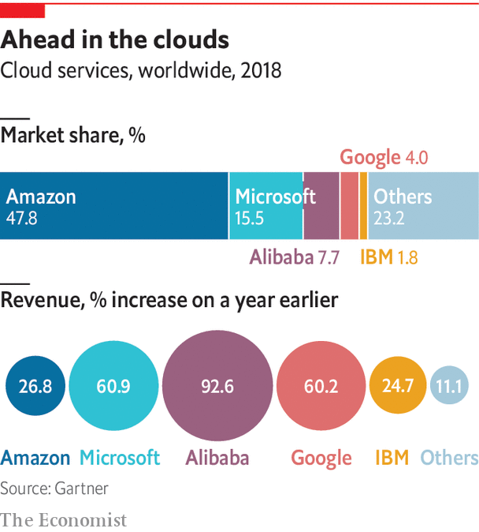

The destination of your average bit is changing, too. Historically, most digital information stayed home, on the device where it was created. Now, more and more data flow into the big computing factories operated by AWS, but also its main competitors, Microsoft Azure, Alibaba Cloud and Google Cloud. These are, in most cases, the only places so far with enough computing power to train algorithms that can, for instance, quickly detect credit-card fraud or predict when a machine needs a check-up, says Bill Vass, who runs AWS’s storage business—the world’s biggest. He declines to say how big, only that it is 14 times bigger than that of AWS’s closest competitor, which would be Azure (see chart).

What Mr Vass also prefers not to say, is that AWS and other big cloud-computing providers are striving mightily to deepen this centralisation. AWS provides customers with free or cheap software that makes it easy to connect and manage IOT devices. It offers no fewer than 14 ways to get data into its cloud, including several services to do this via the internet, but also offline methods, such as lorries packed with digital storage which can hold up to 100 petabytes to ferry around data (one of which Mr Jassy welcomed on stage during his keynote speech in 2016).

The reason for this approach is no secret. Data attract more data, because different sets are most profitably mined together—a phenomenon known as “data gravity”. And once a firm’s important data are in the cloud, it will move more of its business applications to the computing skies, generating ever more revenue for cloud-computing providers. Cloud providers also offer an increasingly rich palette of services which allow customers to mine their data for insights.

Yet such centralisation comes with costs. One is the steep fees firms have to pay when they want to move data to other clouds. More important, concentrating data in big centres could also become more costly for the environment. Sending data to a central location consumes energy. And once there, the temptation is great to keep crunching them. According to OpenAI, a startup-cum-think-tank, the computing power used in cutting-edge AI projects started to explode in 2012. Before that it closely tracked Moore’s law, which holds that the processing power of chips doubles roughly every two years; since then, demand has doubled every 3.4 months.

Happily, a counter-movement has already started—toward the computing “edge”, where data are generated. It is not just servers in big data centres that are getting more powerful, but also smaller local centres and connected devices themselves, thus allowing data to be analysed closer to the source. What is more, software now exists to move computing power around to where it works best, which can be on or near IOT devices.

Applications such as self-driving cars need very fast-reacting connections and cannot afford the risk of being disconnected, so computing needs to happen in nearby data centres or even in the car itself. And in some cases the data flows are simply too large to be sent to the cloud, as with the traffic lights in Las Vegas, which together generate 60 terabytes a day (a tenth of the amount Facebook collects in a day).

One day soon, debates may rage over whether data generation should be taxed

How far will the pendulum swing back? The answer depends on whom you ask. The edge is important, concedes Matt Wood, who is in charge of AI at AWS, but “at some point you need to aggregate your data together so that you can train your models”. Sam George, who leads Azure’s IOT business, expects computing to be equally spread between the cloud and its edge. And Simon Crosby, the chief technologist at SWIM.AI, while admitting that his firm’s approach “does not apply everywhere”, argues that too much data are generated at the edge to send to the cloud, and there will never be enough data scientists to help train all the models centrally.

Even so, this counter-movement may not go far enough. Given the incentives, big cloud providers will still be tempted to collect too much data and crunch them. One day soon, debates may rage over whether data generation should be taxed, if the world does not want to drown in the digital sea.■

This article was downloaded by calibre from <https://www.economist.com/special-report/2020/02/22/should-data-be-crunched-at-the-centre-or-at-the-edge>

|  |  |  |  |
| --- | --- | --- | --- |
| Previous | Articles | Sections | Next |

|  |  |  |  |
| --- | --- | --- | --- |
| Previous | Articles | Sections | Next |

#### Business

# Integrating data is getting harder, but also more important

The search is on to find “digital truth”

Feb 22nd 2020 |



GEEKS ARE not known for being poets. But sometimes even they have a way with words, for example when trying to describe the main challenge of dealing with data. It is the search, they say, for “a single version of the truth”.

This also nicely describes what has been the goal of corporate information technology since it emerged 60 years ago. And the adage encapsulates the main tension for businesses in the data economy: finding digital truth—that is, identifying and combining data that accurately represent reality—is becoming more difficult and more important. More difficult because data and their sources are multiplying. And more important because firms need to get their data house in order to benefit from AI, which they must to stay competitive. AI boosts revenues and profits, according to a recent survey by McKinsey, a consultancy (see chart).

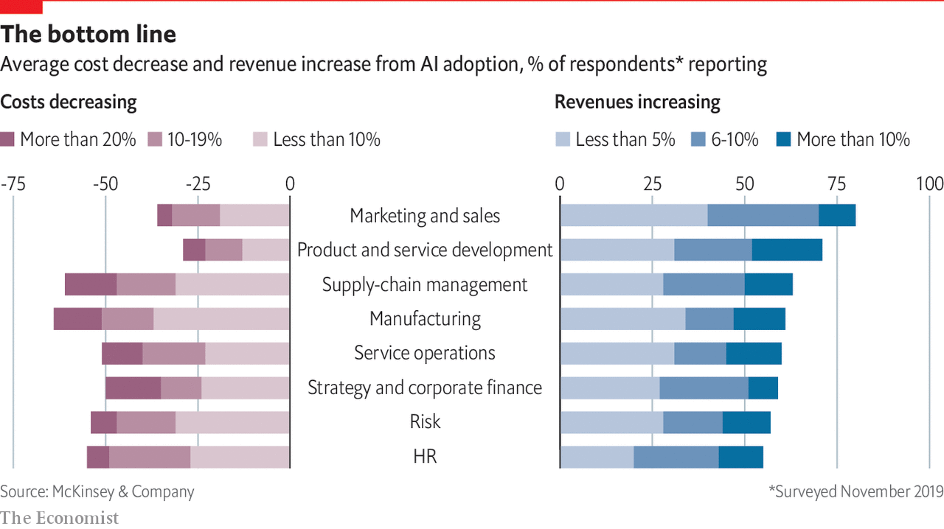

Happily, technology is coming to the rescue. Data-handling software and cloud computing are increasingly enabling what George Gilbert, an investor and veteran observer of the IT industry, calls the “AI-ssembly line”—in reference to what happened a hundred years ago, when electricity replaced steam as the main source of power in factories. Before, machines had to be grouped closely around the power source—a steam engine. Electricity then allowed power to be distributed to where it was needed, which made assembly lines feasible. What is happening now, however, is actually the inverse: the machines of the digital age—a firm’s business applications and software to build these—are virtually regrouping around a new power source: central digital repositories known as “data warehouses” or “data lakes”. In time this may allow companies to build entire digital twins of themselves.

Finding digital truth is hard because the data come from many sources and in a staggering variety of formats—which makes them hard to integrate. Even simple things such as a customer’s name can be defined and stored in many different ways. Companies can have thousands of software applications, each with its own database. Failed attempts to consolidate or link these digital repositories have cost armies of chief information officers their jobs.

Integrating data was already a major problem when IT existed mainly to keep track of a firm’s “transactions”, such as processing an order or managing the supply chain. It has only become more difficult since. In the 1990s firms started using their data to work out how they have been doing, something called “analytics”. A decade ago, they turned to mining their data to make predictions about their business, an approach first dubbed “big data” and now AI. Today a firm’s data are often not just spread across many local databases, but live in different cloud services and stream in from third parties and connected devices.

It is the data warehouses and data lakes that are now making it easier to use the digital stuff. They differ in the way they structure information—the first takes a more rigid approach than the second, although the differences are getting smaller—both can now live in the cloud. This makes them not only cheaper to manage, but they can more easily be fed with data from many different sources and used by many different users. One such is made by Snowflake, another startup, which has turned its data warehouse into what it calls a “data platform” that can stretch across different computing clouds. Big cloud providers such as Amazon Web Services and Microsoft Azure offer similar products.

A second improvement is specialised databases, which take care of certain types of data. Since data often no longer come in the form of static blocks, but rather real-time digital streams, they have to be treated differently, explains Jay Kreps, the chief executive of a startup appropriately named Confluent. It sells cloud services based on Apache Kafka, an open-source program, which analyse these streams and dump them into data lakes. Bosch, a German conglomerate, uses Confluent to gather and mine data from power tools to manage repair services and construction sites.

Yet it is a third group of software and services that turns all this into Mr Gilbert’s “AI-ssembly line”. Some of these tools prepare data for crunching, others make it easy to design and train an AI algorithm, deploy it in an application to automate decisions and continuously improve it. Enel, a utility, has used such tools to develop a service that helps it identify the power thieves it needs to go after first. Shell, an oil company, has designed algorithms that ensure that its thousands of spare parts are always available around the world. And Kiva, a non-profit lender, has built a data warehouse with Snowflake that allows it to make better decisions about who should receive its loans.

Many other firms were not so lucky, forgetting that technology is always only part of the solution. Motivated by studies that found that AI boosts profits and, in some cases, panicked by the possibility of being disrupted by a startup, some tried to cobble together an AI-assembly line themselves, but failed. They did not have the right type of developers and data scientists—or did not want to pay their exorbitant salaries. This has created an opening for IT vendors to sell more or less pre-packaged versions of AIassembly lines, but each coming at it from a different direction.

## Meanwhile, at the refinery

Take incumbents first, which are trying to build on their strengths. In the case of the granddaddy, IBM, this is services. It helps firms build what Arvind Krishna, soon its new boss, calls a “data plane”, a collection of programs to develop AI applications. It has also become a data refiner itself: for example, it collects and sells granular weather data that insurers can use to calculate rates, and utilities to predict where power cuts may occur. And it offers a range of AI services, including visual recognition and translation, that other firms can plug into their products.

Oracle, the world’s leading vendor of relational databases, still the workhorses of corporate IT, aims to extend that position by providing what it calls an “autonomous database”. This type of service combines and automates all sorts of digital repositories, plus bits of AI, so customers do not have to put together all these programs themselves. “It’s many data engines in a single engine,” explains Paul Sonderegger, the firm’s senior data strategist, adding that such integration will be key to increasing a firm’s “data productivity—increasing the dollar output per data input”.

As for younger IT firms, they are increasingly offering to help firms to get their digital ducks lined up, too. Salesforce, which grew up as a web-based service to manage customer relations, has spent billions in the past two years to develop its own AI technology, called Einstein, and acquire two big-data companies, MuleSoft and Tableau. The idea, says Bret Taylor, Salesforce’s president and chief operating officer, is to allow firms to consolidate and link their data so they can have a “single view of their customers”. This makes it easier for firms to anticipate what their customers will do, personalise offers and always recognise them, whether they show up in a retail store or online.

Then there is a host of smaller firms. Databricks has put together an AI platform, complete with tools to cleanse data, build algorithms and deploy them. C3.ai offers something similar, but mainly aims to help big firms through their digital transformation. Qlik is known for analytics and data visualisation, but has recently moved into AI.

But despite such tools, many AI projects still disappoint, says Debra Logan of Gartner, a market-research firm. One big problem is data silos which reflect a firm’s internal boundaries. Different departments within a company, afraid of relinquishing power, are loth to share their data or change what they collect and how (making the point that data structures are often just thinly veiled power structures). This has kept many firms from developing a coherent “data strategy” that would ensure they actually collect and analyse the information they need to achieve their business goals.

“We think data are objective, but they are actually as interpretable as Shakespeare”

To overcome such digital divisions, some companies have made organisational changes. A growing number have appointed a “chief data officer” who can knock heads together to ensure that the IT department and business units work together, which they must to build anything resembling an AI-assembly line. Yet changes at the top, as well as in technology, are not worth much, if the rest of the company is not ready. “Poor data literacy” is the second biggest barrier to corporate data projects, preceded only by “cultural challenges to accept change”, according to a recent survey by Gartner. Changing this does not mean that all employees have to become data scientists, but that they have a basic grasp of what data can be used for and what not, says Mike Potter, the chief technology officer of Qlik.

Data, he argues, are never neutral and must always be questioned: they may be collected for political reasons or in a way that hides things. “We all think that data are so objective,” he says, “but they are actually as interpretable as Shakespeare.” Despite all the tech, there may never be a single version of the truth. ■

This article was downloaded by calibre from <https://www.economist.com/special-report/2020/02/22/integrating-data-is-getting-harder-but-also-more-important>

|  |  |  |  |
| --- | --- | --- | --- |
| Previous | Articles | Sections | Next |

|  |  |  |  |
| --- | --- | --- | --- |
| Previous | Articles | Sections | Next |

#### Geopolitics

# Governments are erecting borders for data

Data sovereignty is rapidly becoming a big issue

Feb 22nd 2020 |



SOMEWHERE DEEP in the bowels of Microsoft’s campus in Redmond near Seattle, a jumble of more than 100 buildings, there is a special kind of room. The size of a school gym, its walls are covered with big screens. One shows the “health” of the firm’s cloud-computing services, collectively called Azure. Another displays people’s “sentiment” about the system, as expressed on social media. A third one, a large map of the world, tells visitors how many “denial-of-service” (DOS) attacks, which amount to flooding a customer’s online presence with bits to shut it down, are currently being dealt with. The counters on this Thursday morning in early December show 80 in Asia, 171 in Europe and 425 in the Americas.

It would be fair to assume that the room is a NOC, a “network operations centre”, to manage Azure. But nothing gets controlled here; that happens elsewhere. Instead, the room, called the Cloud Collaboration Centre (CCC), serves two other purposes. One is, in the words of Anja Ziegler, who manages the location, to “put a face on the cloud”—giving customers an idea what Azure and the mirror worlds it powers are about. But more important, the room serves as a place for Microsoft employees to discuss how to reshape the cloud in response to legal changes in the data economy.

One of the first projects to be tackled in the CCC was how to make Azure compatible with the General Data Protection Regulation (GDPR), the EU’s tough privacy law that went into effect in 2018. The room has only become busier since: privacy and other data-related legislation is multiplying around the world. Sometimes virtual borders need to be erected, so that data do not leave or enter a certain country. Or a new data centre needs to be built to give the digital stuff a local home. If this trend holds, Microsoft may soon have to upgrade the CCC’s world map—to show the planet’s many different data zones, rather than just DOS attacks.

The CCC is thus a place where another tension of the data economy is playing out. Data were supposed to float freely around the world to where they are most efficiently crunched. But flows are increasingly blocked by governments which seek to protect their country’s people, sovereignty and economy. And these first rustlings of digital protectionism, predicts Ian Hogarth, a noted British entrepreneur and writer, could turn into fully fledged “AI nationalism”, as countries go beyond just defending their data assets and try to build a data economy of their own.

Just as with the internet itself, there were not supposed to be any trade-offs in the cloud. The “cosmopolitan ideal” was that the free flow of data would make the world if not a better place, at least a more efficient one, observes Andrew Woods of the University of Arizona, who is writing a book about data sovereignty. It would allow digital stuff to end up in data centres located in places near many users, with lots of connectivity and where land and energy are cheap and the air cool and dry. (Cloud data centres can be several football fields large and consume huge amounts of energy, about half of which is used for cooling.)

## Whose cosmopolitan ideal?

In practice this has meant that the biggest clouds have risen over America, which so far has set the rules of the data economy. It not only boasts the biggest and most innovative tech companies, but plenty of potential customers, fibre-optic cables, cheap power and land to build cavernous data centres. To get an impression of the concentration of computing power in America, one need only drive a few hours west of Microsoft’s campus to Quincy, Washington, a town with a population of not even 8,000. This is home to two dozen large data centres, many operated by Microsoft.

As long as computing clouds were small, this uneven distribution did not matter much. But, starting with the intelligence leaks by the American security expert Edward Snowden in 2013 which revealed widespread snooping by America’s spy agencies, governments have begun to understand the importance of this global infrastructure—and, by extension, the data economy. Citizens’ privacy is not the only worry. Data may also reveal things about a country’s defences. If digital evidence is stored abroad, law enforcement might be inhibited. Data should be kept close, some governments think, lest other countries benefit from them.

As a result, in recent years virtual borders have been going up in the digital cloud. The GDPR allows personal data to leave the EU only if firms have appropriate safeguards in place or if the destination country has “an adequate level of protection”. India blocks payment information from leaving the country and may soon require that certain types of personal data never leave the country. Russia requires that data be processed and stored on servers within its territory. China blocks most international data flows. And the EU is discussing creation of a single market in data, like the one it already has for goods.

These growing and unco-ordinated efforts to regain data sovereignty have already triggered debates at the highest level of international diplomacy. In July the G20, a group of 20 developing and rich countries, launched the “Osaka Track”, named after the Japanese city where the decision was taken. The idea, which Abe Shinzo, Japan’s prime minister, floated early last year is to come up with some global rules for “data governance”, guided by the rather fuzzy concept of “free flow of data with trust”.

It is still unclear where all this will lead. What will the world map in Microsoft’s cloud centre look like a decade hence? Will it resemble today’s global maps, showing as many data zones as there are countries? Or will it display a few digital trade zones (known as “data spheres”) or something completely different?

The need to export data from the EU has pushed some to stricter data-protection rules

The first possibility is rather unlikely. To prevent all data from flowing, countries would essentially have to cut their connection to the internet: it would be the only way to ensure that data really stays put. Russia may be willing to accept the huge economic costs of such a digital secession. But most countries will probably shy away from the drawbacks of even less draconian measures. An overly protectionist country could see cloud-computing providers refuse to serve their market because it is too small. Building a domestic cloud is both tricky and expensive.

The second scenario is far more likely. In fact, this is already happening. Coalitions for different types of data have begun to form. The GDPR’s adequacy requirement effectively created one: the need to export personal data from the EU pushed a dozen countries, including America and Japan, to agree to strict data-protection rules. America has started a similar club with the Cloud Act, a bill passed in 2018 to allow the government to negotiate reciprocity agreements with other countries. If these allow American law enforcement to access data stored in partner territory more rapidly than is possible today, agencies in those countries can get easier reciprocal access, too. Britain has already signed such an agreement; the EU is expected to do so soon.

Although the Osaka Track talks are meant to come up with global rules, they could end up creating another data coalition. The initiative started life as a proposal by the Japanese government to form an alliance with America and the EU to promote the free flow of data between members and to limit access by countries which indulge in data protectionism, notably China. If that is still the agenda, it could push China and others to create their own data club, warns Justin Sherman of New America, a think-tank. In an early sign of what this may mean, India and a few other developing countries have refused to sign up to the Osaka Track.

The third possible future of the global data sphere is again less likely, but the most intriguing. Somewhat unexpectedly, it is rooted in Germany and comes by the name of GAIA-X, referring to the goddess of Earth in Greek mythology, with the X being a placeholder for future specialisation (GAIA-Health, GAIA-Mobility). Rightly feeling that the country is behind in cloud computing and risks losing control of its data economy, the German government first considered building something like an “Airbus Cloud”, like a repeat of Europe’s successful aeroplane consortium. Realising that this would probably fail, however, the government has settled on another approach. It hopes to assemble what the Federal Ministry for Economic Affairs calls a “federated data infrastructure”, essentially a club of clouds whose members have to comply with a set of rules and standards.

The main aim is still one of industrial policy: seeding the formation of an “über-cloud”, a legal-cum-software layer that would insulate German firms and government agencies from the power of big foreign clouds by minimising “lock-in”. Although details have yet to be worked out, it would probably allow firms to move data and computing workloads between rival clouds more easily. GAIA-X could be a tool to implement granular national data policy, instead of resorting to crude digital protectionism. It could help solve the problem of American or Chinese firms dominating the global data infrastructure. The project also includes an initiative called “International Data Spaces” to make data-sharing between firms and across borders easier.

Yet it is not clear how the German government intends to will this über-cloud into existence, says Stefan Heumann of the Stiftung Neue Verantwortung, a think-tank in Berlin—nor how it does not end up being a lowest common denominator or held up by lengthy negotiations. The plan is to have a “proof of concept” ready by the second quarter of this year, but don’t hold your breath.

Still, the idea may gain momentum. The German government intends to push the concept when it takes over the presidency of the European Council later this year. France has already signalled support; other countries are expected to join. And some 100 firms and organisations have already joined the effort, including the big cloud providers. The only notable exception, until recently, had been Microsoft. This was a surprise: Azure is the most compatible with Germany’s vision. Whether because it has always had many governments as customers or the fact that it does not make money by hoarding data, from the start Microsoft has built its cloud for a world with a data space fragmented along national lines.

If the vision of GAIA-X comes to pass, how will Microsoft display this on the screens of its CCC? Rather than showing a few data “blocs” in bright colours—China red, America blue, for instance, as during the cold war—it may need lots of shades and other graphic tricks to represent the new diversity of the data world.■

This article was downloaded by calibre from <https://www.economist.com/special-report/2020/02/22/governments-are-erecting-borders-for-data>

|  |  |  |  |
| --- | --- | --- | --- |
| Previous | Articles | Sections | Next |

|  |  |  |  |
| --- | --- | --- | --- |
| Previous | Articles | Sections | Next |

#### Policy

# Who will benefit most from the data economy?

It is already unequal and that inequality could get worse

Feb 20th 2020 |



THE DATA economy is a work in progress. Its economics still have to be worked out; its infrastructure and its businesses need to be fully built; geopolitical arrangements must be found. But there is one final major tension: between the wealth the data economy will create and how it will be distributed. The data economy—or the “second economy”, as Brian Arthur of the Santa Fe Institute terms it—will make the world a more productive place no matter what, he predicts. But who gets what and how is less clear. “We will move from an economy where the main challenge is to produce more and more efficiently,” says Mr Arthur, “to one where distribution of the wealth produced becomes the biggest issue.”

The data economy as it exists today is already very unequal. It is dominated by a few big platforms. In the most recent quarter, Amazon, Apple, Alphabet, Microsoft and Facebook made a combined profit of $55bn, more than the next five most valuable American tech firms over the past 12 months. This corporate inequality is largely the result of network effects—economic forces that mean size begets size. A firm that can collect a lot of data, for instance, can make better use of artificial intelligence and attract more users, who in turn supply more data. Such firms can also recruit the best data scientists and have the cash to buy the best AI startups.

It is also becoming clear that, as the data economy expands, these sorts of dynamics will increasingly apply to non-tech companies and even countries. In many sectors, the race to become a dominant data platform is on. This is the mission of Compass, a startup, in residential property. It is one goal of Tesla in self-driving cars. And Apple and Google hope to repeat the trick in health care. As for countries, America and China account for 90% of the market capitalisation of the world’s 70 largest platforms (see chart), Africa and Latin America for just 1%. Economies on both continents risk “becoming mere providers of raw data...while having to pay for the digital intelligence produced,” the United Nations Conference on Trade and Development recently warned.

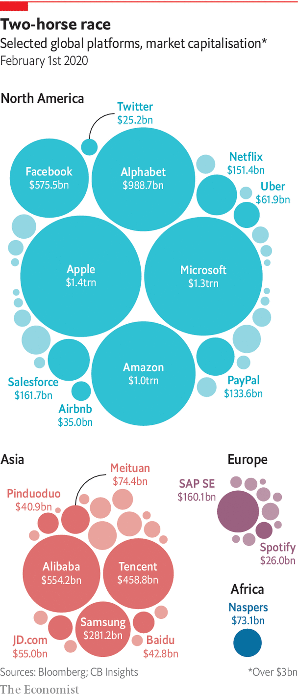

Yet it is the skewed distribution of income between capital and labour that may turn out to be the most pressing problem of the data economy. As it grows, more labour will migrate into the mirror worlds, just as other economic activity will. It is not only that people will do more digitally, but they will perform actual “data work”: generating the digital information needed to train and improve AI services. This can mean simply moving about online and providing feedback, as most people already do. But it will increasingly include more active tasks, such as labelling pictures, driving data-gathering vehicles and perhaps, one day, putting one’s digital twin through its paces. This is the reason why some say AI should actually be called “collective intelligence”: it takes in a lot of human input—something big tech firms hate to admit.

If history is any guide, the risk is not so much that humans will automate themselves away. Previous technological disruptions have at times even increased labour’s share of income, as new types of jobs emerged. The question is rather how much such data workers will be paid. As things stand, their work may become systematically undervalued, reckons Glen Weyl of Microsoft. One reason is the structure of online markets: big platforms are not just monopolies, but monopsonies, meaning that they have the power to hold down wages for data labour. Tellingly, none has ever really considered paying users for the data they generate. The economics of data, too, put pressure on the price of data labour: why, for instance, should a firm pay a high price for an individual’s data if it can infer them cheaply from another person’s information?

A data economy in which those who produce a large part of the main input are perennially underpaid is unlikely to be a healthy economy. Those with the greatest expertise, such as radiologists who can check the accuracy of an algorithm that recognises medical images, might hold back their knowledge and refuse to participate. Data workers with low pay and no say in the use of the information they generate will increasingly feel alienated, which could lower the quality of their work. And solving the problem through redistribution—as Gavin Newsom, California’s Democratic governor, wants to do with a “digital dividend” to be levied from tech giants and disbursed to the state’s citizens—would be a burden on the data economy and lead to trade conflicts. Such subsidies would be vulnerable to cuts as the political winds change.

All these complications explain why another proposed remedy keeps popping up: creating property rights on personal data to increase people’s bargaining power. Yet this in itself would not help much. If most people understandably ignore the complex privacy policies that come with online services, how can they be expected to shop around for the best price for their data? And property rights could actually make things worse. Since most personal data are fundamentally a social construct to which more than one person has the right, individuals could engage in a race to the bottom. Each member of a family, say, could sell their genetic information and by doing so reveal much of their relatives’ DNA.

Instead of giving citizens individual control over their data, they should hold it collectively, argues Mr Weyl. He and an activist organisation he helped found, RadicalxChange, want everyone to join what they call “data co-operatives”. These would act much like trade unions in the conventional economy. They would, among other things, negotiate rates for data work, ensure the quality of members’ digital output, bill data firms that benefit from this output, and distribute the proceeds.

Like data trusts, robust data co-operatives will not emerge overnight. They need support from all involved. There are early signs that this may be forthcoming. Some Western countries may soon discuss a “Data Freedom Act”, based on a draft by RadicalxChange, which would create a new regulated entity for that purpose. In a first for a tech-giant boss, Satya Nadella, the chief executive of Microsoft, at the World Economic Forum in Davos in January called on the industry to show more respect for “data dignity”—meaning to give people more control over their data and a bigger share of the value these data create. The public, for its part, is getting ever more concerned about what happens with its data. Roughly eight in ten Americans, for instance, now think they have very little or no control over the data which companies collect about them.

Expect debates about such ideas as data co-operatives to become more heated as the data economy grows. Encouragingly, as Mr Arthur points out, humanity has overcome a similar conundrum before. In the 1850s, the Industrial Revolution brought big increases in production, along with Dickensian social conditions. It took 100 years for societies to adapt; some never did. In the data economy, too, it will take a long time to build the appropriate mechanisms and institutions. No one yet worries that revolutions and wars will be fought over data, but there is no guarantee.■

This article was downloaded by calibre from <https://www.economist.com/special-report/2020/02/20/who-will-benefit-most-from-the-data-economy>

|  |  |  |  |
| --- | --- | --- | --- |
| Previous | Articles | Sections | Next |

|  |  |  |
| --- | --- | --- |
| Special report | Sections | Finance and ... |

Business

Business and the next recession: Downturn, disrupted

.

Tech regulation: The Brussels effect, continued

.

Apple in China: Red plateau

.

Force majeure: A force to be reckoned with

.

Bartleby: Cutting the pie

.

Schumpeter: The CEO who loved me

.

|  |  |  |
| --- | --- | --- |
| Special report | Sections | Finance and ... |

|  |  |  |  |
| --- | --- | --- | --- |
|  | Articles | Sections | Next |

#### Downturn, disrupted

# Business and the next recession

When economies change, so do recessions. What will the next one look like?

Feb 20th 2020 | PARIS



CAST YOUR mind back to 2007. Flashy types were showing off their first-generation iPhones. Netflix sent DVDs through the post for people who did not have the time to drop into a branch of Blockbuster. The biggest firms in the world were old-economy stalwarts such as General Electric and Royal Dutch Shell. Myspace ruled online. That seemingly distant era was when America, followed by Europe and most of the rich world, last fell into recession. Since then the way people buy products, entertain themselves, move around and borrow money has altered and in some cases been revolutionised by a mighty band of global technology titans.

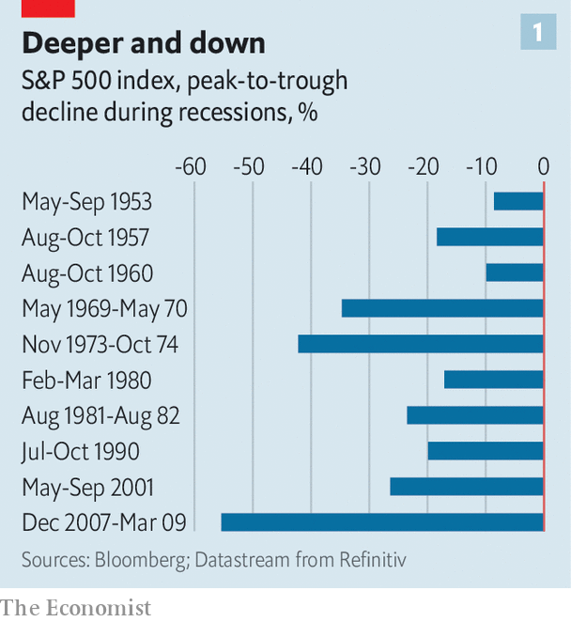

“The composition of the economy has changed since 2007, and hence so will the nature of recessions,” says Douglas Elliott of Oliver Wyman, a consultancy. Working out the impact of the next recession is important because one is on the way, sooner or later. Past recessions have been costly. The Economist calculates that in the most recent downturn 11m people lost their jobs in rich economies and profits of big listed firms in Europe and America dropped by 51% and 30%, respectively. Stockmarkets always take a battering when the economy turns (see chart 1). Recessions matter to governments and central banks, which must work out how to respond, and to firms and investors, because downturns sort the wheat from the chaff. In the past three recessions the shares of American firms in the top quartile of each of ten sectors rose by 6% on average, while those in the bottom quartile fell by 44%.

In some important ways the corporate world looks similar to the picture in 2007. American firms are big earners, with corporate profits steady at 8.5% of GDP, and many industries are relatively highly concentrated. In Europe profitability and concentration remain lower. As in 2007, Western firms remain highly globalised despite the trade war. Big listed firms in America make 31% of their sales outside their home market, while for large European companies the figure is 53%.

Much has also changed. First, the digital world is more dominant. An economic bounceback has fuelled the rise of global tech giants that have disrupted incumbents in retail, taxis, hotels and many other businesses. The example of tech upstarts has seeped through to non-tech firms, which are now more asset-light. Managers have shifted IT spending from buying servers to renting them through the cloud, for example. The second change is that bosses may have less room to cut costs. Third, some firms have heaped on debt and engaged in accounting puffery, increasing what John Kenneth Galbraith, an economist, called “the bezzle”: money no one is aware has gone missing. Boom times paper over cracks, for instance by allowing firms to delay writing down the value of misfiring acquisitions.

Start with the first change, the rise of digital technology. The most visible difference is in the nature of the largest firms: seven of the ten most valuable firms in the world are now tech outfits, up from two in 2010 (see chart 2). In America the top five —Alphabet, Apple, Amazon, Facebook and Microsoft—account for 13% of the profits of S&P 500 firms. This is forecast to rise to about 20% in five years’ time. At less than 5%, their share of S&P 500 employment is small but they have become America’s largest investors, ploughing $189bn into the economy last year (including research and development), equivalent to 17% of investment by big publicly listed companies.

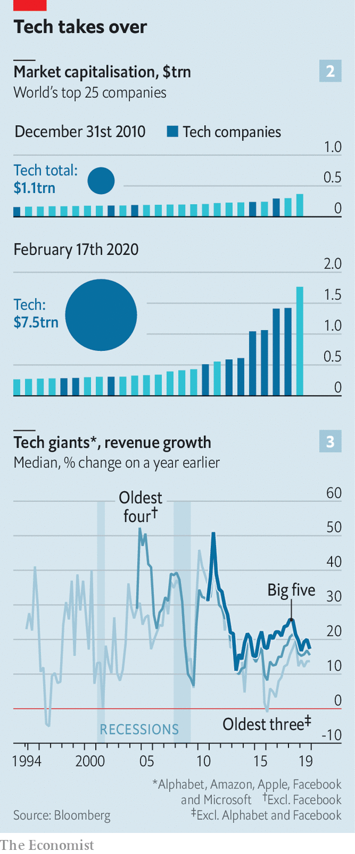

How the tech giants weather a recession is thus of great importance. Investors may view these firms as impregnable, but they are heavily exposed to revenues that are cyclical (see chart 3), including advertising, consumer spending and business IT spending, which were all sensitive to the economic mood in the pre-digital age. Novel business models may offer some protection. Perhaps Facebook users will spend more time online if they lose their job? Maybe advertisers will slash spending on TV, newspaper and billboard advertising before taking the knife to digital spending.

There is evidence that the pain could be acute. In downturns in 2000-02 and 2007-08 sales growth at Amazon and Microsoft slowed sharply. Smartphone sales have already slowed. A recession may see consumers hanging on to devices for longer rather than trading up to the newest handset. Fortress balance-sheets offer a measure of safety: the big five tech firms have $270bn of net cash.

Beyond the giants, insurgents have emerged. Airbnb and Uber have turbocharged the matching of buyers and sellers. Financial innovators such as LendingClub and SoFi facilitate millions of loans by connecting people who need money with those with some to spare. Subscription offerings have flourished, delivering anything from ready-made meals to makeup. For many this will be their first downturn; for some it may be their last.

Not all will be hit as badly as might be expected. A recession in Brazil in 2015-16 hit demand for Uber rides hard, but higher unemployment meant more cash-strapped drivers were available, reducing costs and improving service. Likewise a downturn could help Airbnb win market share from hotels if it means more people make their homes available for rent in search of cash. A crisis may not so much impact tech companies as accelerate the decline of the “old”, non-digital economy.

The tech darlings that look most vulnerable are those that offer “micro-luxuries”: discretionary spending consumers can quickly forgo. Expect Deliveroo (food delivery), Bird (electric-scooter rentals) and Peloton (subscription exercise bikes) to feel the pinch. Those with high fixed costs will be especially exposed as demand falls. WeWork, a tech-tinged property firm, is committed to $47bn of lease payments over the next 15 years or so. Such firms may not be good at retreating. “If you’re a 30-year-old tech founder, who has never been through a recession, you think things grow forever. Cutting costs isn’t part of your playbook,” says Tom Holland of Bain, another consultancy.

While it is not Silicon Valley’s forte, ruthless cost-cutting has always been part of the playbook for companies outside the tech industry when the economy slumps. In the last recession the labour costs of American firms dropped by 7% in total as they laid off workers and squeezed wages to protect shareholders and avoid default.

## The austerity game

Room for manoeuvre is now more limited. In some cases this is because cost structures have changed. Over $200bn of annual corporate IT spending, for example, has shifted to cloud-computing providers such as AWS and Microsoft. Costs that used to come in lumps (on a big server once a decade) now arrive as a quarterly bill for software-as-a-service. This could help. If a firm is going bust it may find it easier to pay its cloud bill than to flog unwanted hardware. But firms are losing flexibility to preserve cash by delaying capital spending.

Meanwhile the social context has shifted. In 2019 the heads of 181 of the largest firms in America said they shared a “fundamental commitment” not just to their owners but to their customers, employees, suppliers and communities, too. Many CEOs privately regard these kinds of declarations as decorative fluff. This will be tested in a downturn as laying off workers and outsourcing jobs abroad come under more political fire. “You don’t want to be seen firing people, especially if you’re still profitable,” says one European boss. “It will be more of a last resort. We may have to take a bit more pain before announcing lay-offs.”

The final change is that a long period without a downturn has encouraged bad habits that mean some firms are too indebted, or are hiding nasty secrets. Such problems are usually spotted once it is too late to fix them. The Asian crisis of 1997 featured crony-capitalists crippled by debt-currency mismatches; in 2000-01 it was imploding dotcom firms and frauds at Enron and WorldCom; and in 2007-09 banks built on rotten foundations crumbled.

Predicting these fiascos is hard but there are some general warning signs. After a long bout of dealmaking, goodwill (the difference between what the acquirer pays for a target and its book value) is at a record high of $3.6trn for S&P 500 firms. This can indicate trouble. In 2000-01 and 2007-09 firms made huge goodwill write-offs as they confessed to dodgy deals.

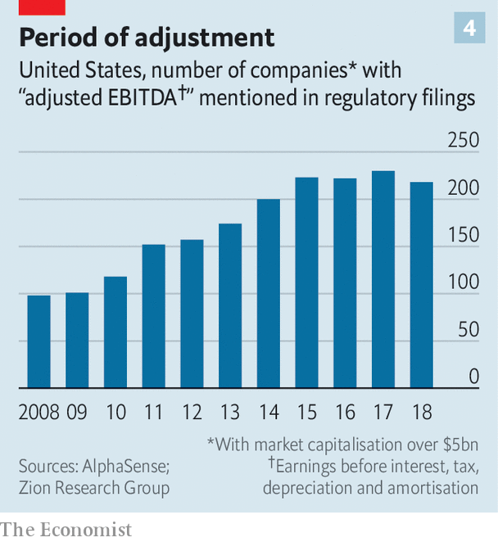

In America 97% of firms in the S&P 500 in 2017 presented at least one metric of their performance in a way that was inconsistent with Generally Accepted Accounting Principles, or GAAP, up from 76% before the last downturn, according to Audit Analytics, a consultancy. The number of large American firms mentioning “adjustments” to profits has more than doubled since the last recession (see chart 4).

Over 60% of American mergers and acquisitions were financed last year with loans that include “add-backs”, a rapidly rising accounting phenomenon. These allow buyers to ignore inconvenient expenses more or less at will, for example by assuming merging firms will successfully cut costs once combined. Loan documents are drawn up using the fiddled profit figures as a baseline.

Often the losers are firms with too much debt. If a recession is triggered by rising interest rates they get hit just before the downturn begins and again once it is in full swing, as sales slide and they struggle to meet interest costs or refinance loans. Since 2007 overall corporate debt has risen. In Europe non-financial corporate debt now stands at nearly 110% of GDP, compared with under 90% in 2007. In America businesses are now borrowing more than households for the first time since 1991.

Much of the money has gone to companies with far less ability to repay their current debts, let alone when a downturn strikes. In the rich world one in eight established companies makes too little profit to pay the interest on their loans, let alone the principal. That is up from one in 14 in 2007, according to the Bank for International Settlements. A recession half as bad as the 2007-09 slump would result in $19trn of corporate debt—nearly 40% of the total—being owed by such straitened companies, according to the IMF. Janet Yellen, a former chair of the Federal Reserve, has warned that “if we have a downturn in the economy, there are a lot of firms that will go bankrupt, I think, because of this debt. It would probably worsen a downturn.”

Optimists argue that the structure of debt has become more flexible. Banks are in better shape thanks to new (albeit largely untested) regulations enacted since 2008, and so should be able to keep lending if the economy sours. Businesses have been able to secure loans with fewer strings attached, for example if they look like they may struggle to repay the money. In America, businesses now borrow increasingly from lenders outside the banking system, such as the private offices of rich families, or pension funds. These, some say, can knock heads together quickly and help firms recover. It is best to take such statements with a pinch of salt. A mini-panic in late 2018 saw the price of many private-debt instruments plunge, suggesting the system is fragile.

## Winners and losers

Who will be the winners? Every recession has them. Warren Buffett picked up assets on the cheap in 2007-09, while JPMorgan Chase cemented its place as America’s leading bank as the industry retrenched. Firms that thrive in downturns tend to have the clarity of purpose and financial muscle to keep investing and growing as others pull back, says Martin Reeves of the BCG Henderson Institute. It is a test of management and culture but also requires strong balance-sheets: 15% of firms in the S&P 500 have more cash than debt, including Apple and Monster Beverage. Investors with money are watching and waiting. The private-equity industry has some $2trn of cash. Mr Buffett sits on $128bn.

A recession will come, eventually. When it does it will batter companies that have been sustained only by low interest rates. The churn as those businesses are sold, restructured or dissolved will extract an economic and human toll. Recriminations will fly, then abate. In time, the more productive firms that survived will think of ways to invest money profitably. That will lead to new jobs, then economic growth, then exuberance—and the cycle will start all over again. ■

This article was downloaded by calibre from <https://www.economist.com/business/2020/02/20/business-and-the-next-recession>

|  |  |  |  |
| --- | --- | --- | --- |
|  | Articles | Sections | Next |

|  |  |  |  |
| --- | --- | --- | --- |
| Previous | Articles | Sections | Next |

#### The Brussels effect, cont

# The EU wants to set the rules for the world of technology

On data protection, artificial intelligence, competition and more

Feb 20th 2020 | BERLIN AND SAN FRANCISCO

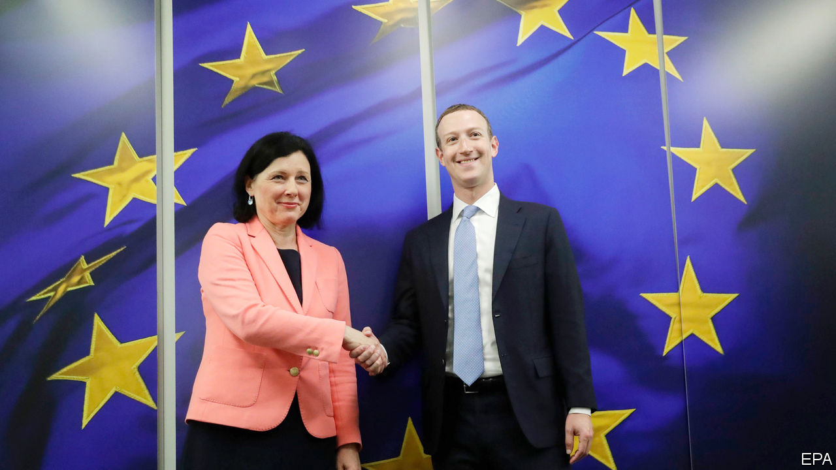

MARK ZUCKERBERG might not have liked everything he heard, but Facebook’s boss got the timing right for a recent visit to Brussels. He was among the first outsiders to hear about the European Union’s ambitious plans to keep the technology industry in check, outlined in a series of documents made public a few days later, on February 19th. His visit is an admission that political paralysis in Washington, DC, has handed the EU the opportunity to become the world’s most important source of tech regulation.

Europe is both gnome and giant in the tech world. The continent has lots of cutting-edge technology but hardly any significant digital platforms. It accounts for less than 4% of the market capitalisation of the world’s 70 largest platforms (America boasts 73% and China 18%). At the same time, the EU is a huge market, with a population of more than 500m, which no tech titan can ignore. It contributes about a quarter of the revenues of Facebook and Google.

This combination has given rise to what Anu Bradford of Columbia Law School calls, in a new book of the same name, the “Brussels effect”. Digital services are, in her words, often “indivisible”. It would be too expensive for big tech firms to offer substantially different services outside the EU. As a result, most have adopted the General Data Protection Regulation, Europe’s strict privacy law, as a global standard. Governments, too, have taken more than a page from the EU’s data-protection book. About 120 countries have now passed privacy laws, most of which resemble the GDPR and its predecessors.

The European Commission wants to repeat the trick in other areas. The main document presented this week, a white paper on artificial intelligence, is a grab bag of measures to foster the use of AI in Europe and to limit its perceived dangers. The commission also released a “strategy” to promote the use of data, the most important input for AI applications. The idea is to create a “single European data space” in which digital information flows freely and securely. To make that happen, the commission wants, among other things, to eliminate legal barriers that keep firms from sharing data, as well as investment in cloud services that facilitate sharing.

Both papers are part of the EU’s overall “digital strategy”, which was also presented. Later this year the commission will put forward a draft of a “Digital Services Act”. Dominant tech firms should expect stricter rules not only about how they police the content that users generate, but the extent to which they can discriminate against rivals that use their services. All this is rounded up by a review of competition policy. Details are scarce, but proposed legislation in Germany indicates the direction of travel: data will become far more important for determining whether a company is dominant and whether it has abused its market power.

There are signs that the Brussels effect will work its magic again. Facebook is not the only tech giant to accept Europe as the world’s main source of tech regulation for some time to come. Sundar Pichai, the boss of Alphabet, Google’s parent, recently paid a visit to the Belgian capital. He called for “sensible regulation” of AI. Brad Smith, Microsoft’s president, is a regular guest. America’s tech titans also increasingly use the EU to influence the debate at home. It saves some lobbying there, if they can help shape widely adopted regulations that emanate from Europe.

But the Brussels effect may be less effective than in the past. The ground on which the debate over privacy legislation was conducted had been long established before the GDPR, but regulation in AI is nascent. Experts still quarrel over such basic questions as what AI actually is. And the EU, where politicians tend to favour stricter regulation, may overdo it. This could push the tech giants to differentiate their regional offerings after all (and stymie Europe’s startups). Worse, the data strategy could easily turn protectionist.

If the EU’s digital plans became restrictive policy driven by protectionism, that would limit Europe’s ability to set global rules which could help to give its firms a much-needed leg up. It would also make it much harder for the EU to establish what the digital world will badly need, should regulation of tech remain stalled in America even after the presidential election. At risk is Europe’s role as a third “techno-sphere”—one that is not controlled by a handful of tech titans, as it is in America, or by the Chinese state.■

This article was downloaded by calibre from <https://www.economist.com/business/2020/02/20/the-eu-wants-to-set-the-rules-for-the-world-of-technology>

|  |  |  |  |
| --- | --- | --- | --- |
| Previous | Articles | Sections | Next |

|  |  |  |  |
| --- | --- | --- | --- |
| Previous | Articles | Sections | Next |

#### Red plateau

# Apple’s Chinese troubles

The coronavirus is just the start

Feb 22nd 2020 |

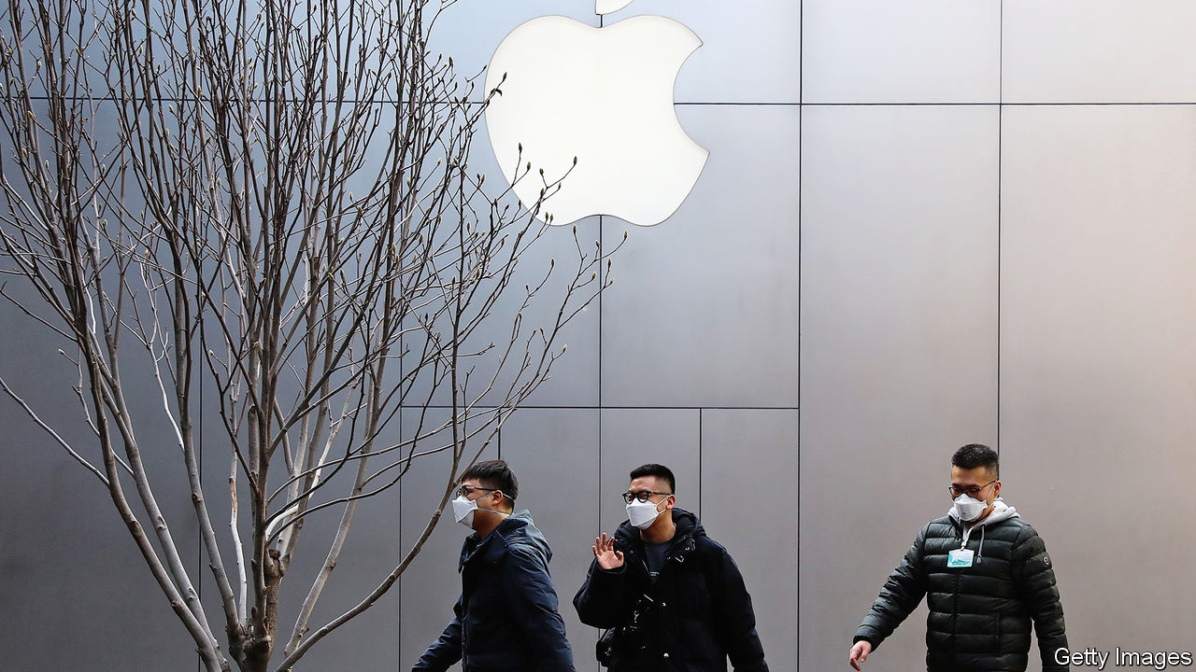

NO AMERICAN COMPANY makes as much money in China as Apple. While few make that much money at all, Apple raked in $44bn of revenues in Greater China during the 2019 financial year, mostly from selling iPhones. That is more than the global sales of United Airlines and Nike and about as much as Tencent, a domestic tech giant. Few countries have as much power as China to shape Apple’s fortunes.

The virus that has swept across the country is doing just that, hurting both manufacturing operations and sales of iPhones in Apple’s second-biggest market. Many of the migrant workers on whom Apple and its contract manufacturers depend have not yet returned to their posts as the movement of people is restricted by the government. Shoppers have not yet returned to the streets. As a result, on February 17th Apple warned investors that it would miss its revenue guidance for the quarter. The firm’s shares, which have been on the ascent since last summer, dropped by nearly 2% after the announcement.

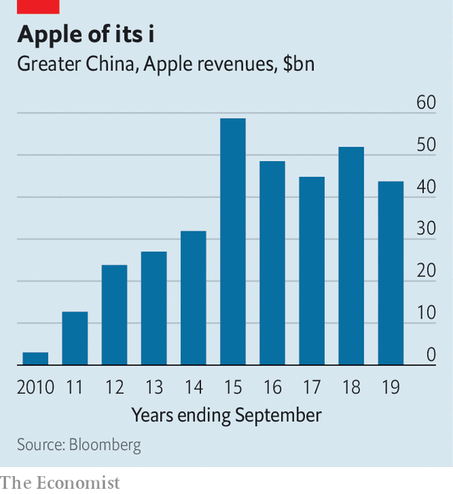

The short-term threat to Apple’s business in China is best understood against the backdrop of the firm’s longer-term success. Apple’s Chinese fortune was built in the first half of the past decade, when its revenues in the country grew from $2.8bn in 2010 to $59bn in 2015. Sales have slipped in subsequent years (see chart), but were still sufficient for the Chinese market to account for 18% of Apple’s total revenues over the past ten years, second only to America. Apple says that it is gradually reopening its retail shops and that all of its iPhone manufacturing sites have reopened too, although their ramp up is going more slowly than it anticipated. Even if the virus outbreak proves to be no more than a blip, the 2020s are unlikely to treat Apple so well.

Its vital Chinese manufacturing operations are threatened by conflict with America over trade and technology. The trade war may also have damaged Apple’s brand. The number of iPhones it sells in China is plummeting. Most importantly Apple’s new strategy for growing revenue by selling subscriptions to services is far more complicated in China than selling iPhones. Apple’s engine of growth may not just be dormant, but extinct.

Start with supply chains. Apple is deeply dependent on China’s high-tech manufacturing ecosystem. Only China offers the labour and infrastructure needed to manufacture hundreds of thousands of devices a day, the volume Apple must produce in the run up to the release of a new phone. During Apple’s China boom Foxconn, a Taiwanese contract manufacturer, was the driving force behind the building of a new factory town near Zhengzhou in Henan province, to support iPhone manufacture. No other contract manufacturer could get close to that scale. The local government shelled out $1.5bn to help build factories and housing for 400,000 workers, and $10bn for a new airport.

That dependency leaves Apple’s manufacturing base exposed to the economic and technological conflict between America and China. Smart lobbying has kept its products outside America’s tariffs regime so far, but other threats loom. America’s Department of Commerce is working on new rules that would curtail the export of technical components to China. Such barriers could cripple Apple’s manufacturing there. It has nowhere else to turn. Efforts to establish a manufacturing base in Brazil failed. Indian operations have proved more fruitful, but are still small. Apple is bound to China and the virus shows how strongly.

Sales of Apple’s core product, the iPhone, are also on the wane in China. According to Canalys, a research firm, iPhone sales in China dropped by 21% in 2019, to 27.5m, even after price cuts, a tactic that Apple rarely employs. Selling fewer phones means not only lost sales but also deprives Apple of future revenues. Sales of services, like app-store purchases and Apple Music, and wearables like AirPods and watches, designed to integrate with the device, are linked to iPhone sales. Though Apple still has plenty of Chinese iPhone users, slipping sales put a cap on the future revenue.

Apple must also grapple with the Chinese government. The firm has always walked a fine line, quietly making compromises like agreeing to store users’ cloud data on Chinese servers. The company’s leaders are adamant that the devices which Apple sells in China come with the same encryption, security and privacy mechanisms that are offered in the rest of the world. But the government’s desire to control information and data means that there are products that Apple cannot offer to Chinese iPhone users, denting revenues and making its devices less appealing.

China’s Communist Party has proved surprisingly adept at stuffing the genie of a free internet back into its bottle. Apple has had to help. In 2017 the firm removed virtual-private-network apps from its Chinese app store. These let Chinese netizens jump through cracks in the Great Firewall and out onto the wider internet. Anything where Apple plays a more explicit editorial role, like its new curated news and streaming services, is beyond the pale. Not being able to sell its full range of services in China means Apple is leaving money on the table for every active iPhone in the country. App Store sales make up most of Apple’s services revenue, and while those are growing in China, the complete absence of its latest service plays will matter in future.

Apple’s latest quarterly results, released on January 28th (before the scale of the virus outbreak was clear), showed worldwide iPhone sales rebounding after a disappointing performance the previous year. Apple says that it is “fundamentally strong, and this disruption to our business is only temporary.” Revenues grew by 9% to $91.8bn. Sales of accessories and services that cluster around the iPhone grew too. Tim Cook, Apple’s boss, said that Apple had seen “double-digit” growth from sales of iPhones, services and wearables in mainland China. Although some specific product categories grew fast, overall sales in China were up by just 3% for the quarter, slower than anywhere but Japan, where sales shrank.

There is one ray of light in China. The 5G iPhone, with much faster connectivity, is reportedly due to go on sale in late 2020. But will it provide a sales bonanza? What a 5G iPhone will offer to well-heeled Chinese customers that they do not already have is unclear. Chinese consumers in large cities are used to high-quality mobile-phone connections. It is common to see an entire metro carriage of commuters streaming high-definition video on the move, something that few American or European networks can handle. Phones made by Huawei, a Chinese tech giant, are as good or better than anything Apple offers.

Even the success of a 5G iPhone would only be a temporary salve. As the decoupling of the American and Chinese technological ecosystems grinds on, it will only get harder for Apple to tap into the Chinese market and run its Chinese supply chains efficiently. That Apple was the first large American company to issue a revised forecast as a result of the virus shows just how dependent the firm is on China, for both supply and demand. Opportunities elsewhere may make up for some lost revenues—selling streaming services to Americans is a good business, if competitive. But it will be almost impossible for Apple to find a new growth engine quite as powerful as China.■

This article was downloaded by calibre from <https://www.economist.com/business/2020/02/22/apples-chinese-troubles>

|  |  |  |  |
| --- | --- | --- | --- |
| Previous | Articles | Sections | Next |

|  |  |  |  |
| --- | --- | --- | --- |
| Previous | Articles | Sections | Next |

#### A force to be reckoned with

# Chinese firms use obscure legal tactics to stem virus losses

The virus has lead to firms trying to get out of contracts

Feb 22nd 2020 | NEW YORK

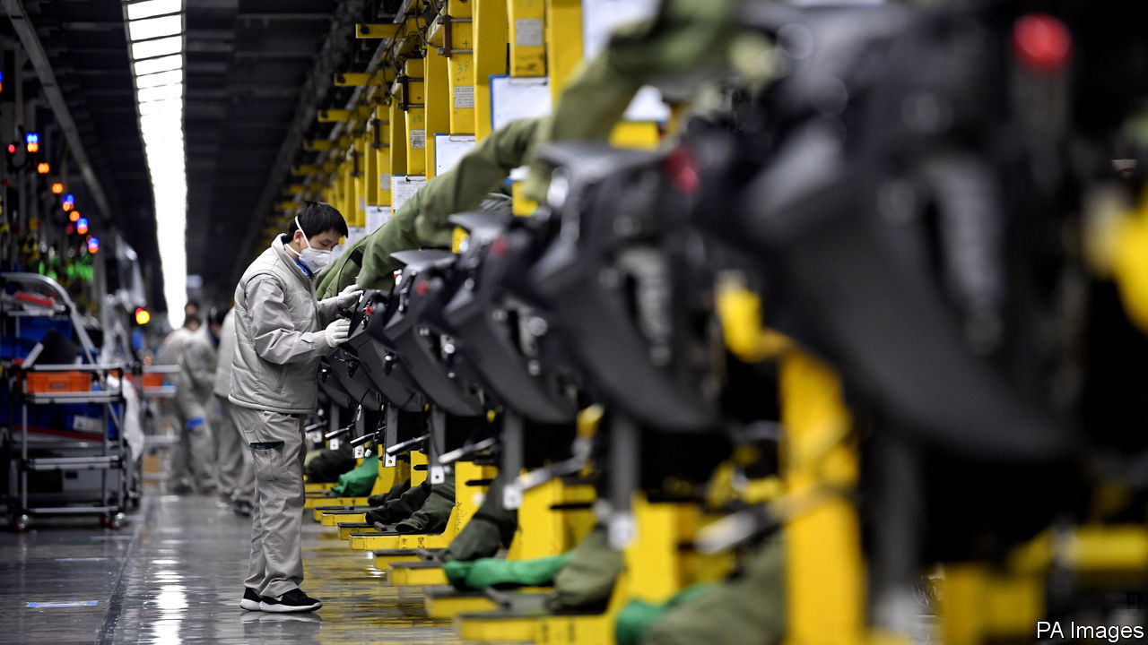

“IT IS GOING to be an almighty legal mess for months and years to come.” That grim prognosis of the potential legal and business consequences of the viral outbreak in China comes from a veteran of the country’s business scene. Dan Harris of Harris Bricken, an American law firm, worries that today’s trickle of mainland suppliers declaring force majeure (FM), an obscure legal manoeuvre used to get out of contracts, could turn into a tidal wave.

The crisis has certainly put many firms in a bind. If this were a normal year, most factories would have shut for a week or so in early February so that migrant workers could return to their villages to celebrate Chinese new year. By now, plants would be roaring at full capacity. But because of a lockdown of a large area around Wuhan, the outbreak’s centre, and ongoing restrictions on travel, workers are only slowly trickling back. Morgan Stanley, an investment bank, reckons that production may reach only 60% to 80% of normal levels by the end of February.

The result is that the supply chains of global firms, which often rely on “just in time” deliveries of stocks, are being disrupted. Chinese buyers of imported commodities are also hurt, thanks to weak local demand. Nomura, a Japanese bank, thinks Chinese year-on-year economic growth could plunge to 3% in the first quarter, down from 6% the previous quarter.

China Inc is panicking. Firms are starting to invoke FM to avoid paying non-performance penalties on contracts. On February 17th, the China Council for the Promotion of International Trade (CCPIT), an official body, revealed that it has already issued over 1,600 “FM certificates” to firms in 30 sectors covering contracts worth over $15bn. These give official support to its invocation. More are likely to come.

All this raises several questions. First, since this clause typically refers to “acts of God” like earthquakes and hurricanes, does it really apply to an epidemic probably caused by humans eating exotic animals and to the heavy-handed government response to it? Second, even if deemed relevant, will FM really work in practice? And finally, is a lengthy legal tangle inevitable?

On the first question, common sense suggests no but precedent and officialdom say yes. David Buxbaum of Anderson & Anderson, a lawyer who has worked in China since 1972, reports that some suppliers successfully invoked FM in local courts in the wake of the SARS virus outbreak of 2003. On February 10th, the National People’s Congress ruled that policies implemented to control the virus (such as production curbs and city lockdowns) that interfere with contracts should be considered FM.

On whether invoking this clause will really work, legal opinion is divided. Many trading contracts fall under international jurisdictions less friendly to this claim than China with courts not overly impressed by FM certificates. Earlier this month, CNOOC, a Chinese state-run oil firm, invoked FM in refusing to accept a shipment of liquefied natural gas from Royal Dutch Shell and Total—a claim rejected by the European oil giants. Traders whisper that mainland firms are using the viral outbreak to try to renegotiate terms, a tactic they deride as “price majeure.”

“FM is a recognised doctrine in civil-law systems like that of China but is not a doctrine of common-law systems, like English law,” observes Simmons+Simmons, a British law firm. It is typically only respected by courts in London and Hong Kong if the contract has a specific FM clause. So local firms are likely to get a more sympathetic hearing in mainland courts. Mr Harris thinks that even if a foreign firm gets a favourable ruling overseas, it may still need to get it enforced by a Chinese court. That court will see the FM certificate and likely rule for the mainland firm.

Tobias Larsson of Resilience360, a German supply-chain consultancy, thinks that invocation of FM could help make the fallout from the virus the “biggest supply-chain disruption since Japan’s earthquake.” Mayer Brown, an American law firm, worries that use of FM and other legal tactics “may be passed along supply chains around the world, causing firms based in other jurisdictions to seek similar relief.”

Still, there is a reason to think legal chaos might be avoided. Unlike during the SARS epidemic, when multinationals could easily shift sourcing, Chinese firms are now critical (and sometimes the only) suppliers of vital parts to many industries. John Hoffecker of Alix Partners, a consultancy, says that his clients are more concerned about being the first to receive parts as factories restart than about FM. So foreign bosses may agree to renegotiate terms with certificate-waving vendors through gritted teeth rather than risk losing them altogether through bitter legal battles.■

This article was downloaded by calibre from <https://www.economist.com/business/2020/02/22/chinese-firms-use-obscure-legal-tactics-to-stem-virus-losses>

|  |  |  |  |
| --- | --- | --- | --- |
| Previous | Articles | Sections | Next |

|  |  |  |  |
| --- | --- | --- | --- |
| Previous | Articles | Sections | Next |

#### Cutting the pie

# Executives are rewarded handsomely

Is there a better way of dividing the corporate spoils?

Feb 20th 2020 |

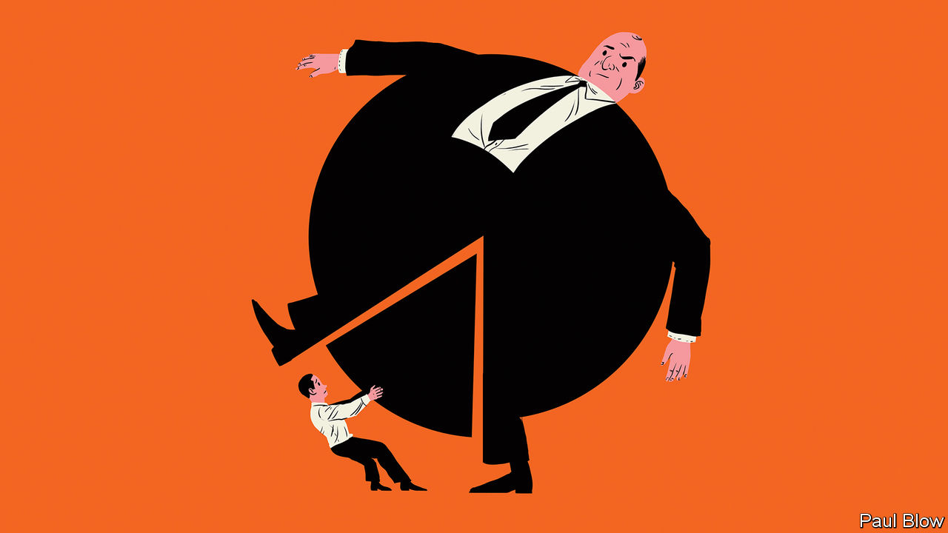

ONE OF THE issues at the centre of the debate about inequality is the meteoric rise of executive pay. The ratio between the pay of American CEOs and ordinary workers rose from 20:1 in 1965 to 278:1 in 2018, according to the Economic Policy Institute, a think-tank. The London Business School (LBS) recently held a conference on what caused the rise, and whether it is justified.

At the conference, Dirk Jenter of the London School of Economics pointed out that the pay of chief executives in America was largely flat between the 1940s and the 1970s. It then rose spectacularly in the 1980s and 1990s before flattening out. What changed in the 1980s was that executive rewards began to be more focused on company performance and share options. The performance-related element rose from 16% of executive salaries in the 1970s to 26% in the 1980s and 47% in the 1990s.

This shift coincided with the great equity bull market of the 1980s. As Western economies recovered from the stagflationary problems of the 1970s, shares were repriced. The cyclically adjusted price-earnings ratio (a measure which compares share prices with a 10-year average of profits) rose from less than 9 at the start of 1980 to 44 in 1999. Little wonder that executives with share options made out like bandits. But was this down to their skill, or to the policies of Alan Greenspan and Ronald Reagan?

Most investors were doing extremely well during this period, so executive pay seemed a matter of little consequence to them. Even now, if CEOs were to work for free, this would not represent a huge boost to shareholder returns. Average CEO pay of S&P 500 companies in 2018 was $14.5m, meaning that executives collectively took home $7.25bn. In contrast, the companies they worked for returned $1.26trn to investors in dividends and buy-backs that year.

The principal-agent problem plays a key role. Most shares are owned by professional investors who work for big fund-management groups and are well paid themselves. They have little incentive to demand big changes in pay structure, unless salaries look particularly egregious.

The underlying investors—ordinary savers—have not always done so well. Take, for example, members of corporate pension funds. Stockmarket gains have not been shared equally with them. When share prices were booming, many companies stopped making pension-fund contributions. Then in the 2000s, when markets fell and the cost of funding final-salary pensions soared, companies closed such schemes and switched to “defined contribution” plans. These are much less generous to workers. It is not just that workers’ pay has not kept pace with that of executive remuneration over the past 40 years; their pension rights have deteriorated.

A broader justification for high CEO pay might be that businessmen have been able to make their companies more efficient and thus transform economic growth. However, the fastest period of economic and productivity growth in the Western world was in the 1950s and 1960s when CEO pay was much lower than it is today. As CEO pay has rocketed, productivity growth has slowed down.

In a thoughtful new book, “Grow the Pie; How great Companies Deliver Both Purpose and Profit”, Alex Edmans of LBS argues that the wealth accrued by a boss does not necessarily come at the expense of others. “Visionary leaders can transform a company, growing the pie for the benefit of all” he writes.

This makes perfect sense at the level of the individual firm but is it true in aggregate? Executives may have prospered since 1980 but this has not always trickled down to workers. Real median household income in America grew at an average annual pace of just 0.5% between 1979 and 2016, before taxes and transfers.

Mr Edmans’s view of pie-growing is nuanced. He advocates an approach to business with the primary aim of creating value for society. Profits are not the main goal but a welcome side effect.

It is not pie in the sky. Mr Edmans conducted research about the companies ranked the “best to work for”, a measure of whether firms are looking after the interests of employees as well as investors. Shares in the firms with the best rankings outperformed in subsequent years, even when controlling for factors like business size and industrial sector.

It is still going to be a big challenge to persuade companies to reward their executives on the social value they add. If that ever happens, the list of best-paid CEOs might be a completely different from the one today.

This article was downloaded by calibre from <https://www.economist.com/business/2020/02/20/executives-are-rewarded-handsomely>

|  |  |  |  |
| --- | --- | --- | --- |
| Previous | Articles | Sections | Next |

|  |  |  |  |
| --- | --- | --- | --- |
| Previous | Articles | Sections | Next |

#### The CEO who loved me

# Spies often use businesses as cover

It can end in tears

Feb 22nd 2020 |

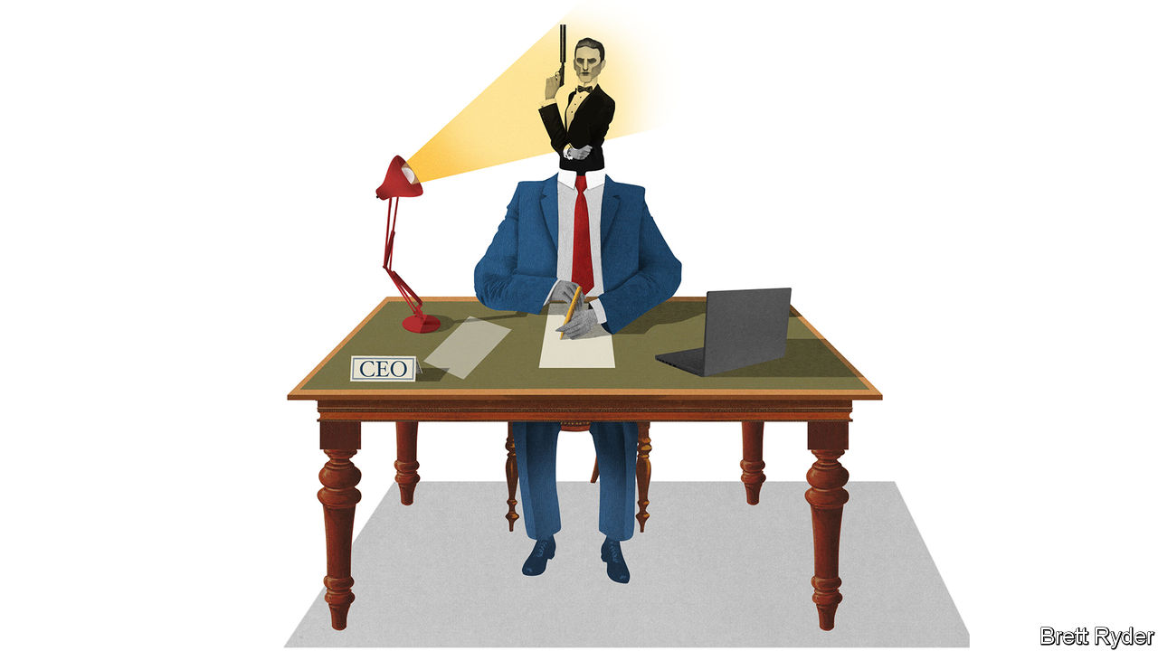

ESPIONAGE AND business have long been entangled. In “Live and Let Die”, Ian Fleming’s second novel, James Bond masquerades as a businessman working for Universal Export, a flimsy front company for MI6 that occupies a “big, grey building near Regent’s Park”. In “On Her Majesty’s Secret Service”, published almost a decade later, the game is up. “As cover, solid cover, Universal was ‘brûlé’ with the pros”, rues Bond. “It had been in use too long. All the secret services in the world had penetrated it by now. Obviously Blofeld knew all about it.”

Ernst Blofeld, head of Spectre, a global criminal syndicate—a man in need of secret communications—would doubtless also have been wise to Crypto AG, a Swiss company that rose to dominate the global market for cipher machines after the second world war. By the 1990s it was apparent that the firm was in bed with the National Security Agency (NSA), America’s eavesdroppers. The truth, it turns out, was even more remarkable. From 1970 to the 2000s, at least, Crypto AG was wholly owned by the CIA and, until 1993, the BND, Germany’s spy agency, according to the Washington Post. “It was the intelligence coup of the century,” crowed a CIA report. “Foreign governments were paying good money…for the privilege of having their most secret communications read.”

The history of intelligence is littered with such front companies, used to collect intelligence or carry out covert skulduggery. “Active Measures: The Secret History of Disinformation and Political Warfare”, a forthcoming book by Thomas Rid, describes how the CIA seed-funded and controlled a printing house in Berlin in the 1950s to spread propaganda in the Soviet bloc. It published political pamphlets and news magazines, forged and real, as well as a lonely-hearts newsletter, a women’s magazine, and even publications devoted to astrology and jazz. It was one of many publishing houses and publications around the world that were covertly subsidised by the CIA and KGB to spread influence.

Some fake firms have been devilishly crafty. In the 1970s, at the height of the Troubles, the British Army established a brothel and launderette in Belfast. Not only could soldiers use laundry vans to move around discreetly, but IRA suspects’ clothes could be tested for explosive residue (both operations were eventually exposed and shot up). MI6 similarly operated a bogus travel agency that would lure republicans to Spain with free holidays, where they could be recruited as double agents. In the 1980s Mossad, Israel’s spy agency, ran a Sudanese beach resort that was used to smuggle out thousands of Jews from neighbouring Ethiopia.

As well as creating sham companies, spies have also cultivated a cosy relationship with the real corporate world. MI6 and the CIA were both reputed to have close dealings with oil companies and the press. Kim Philby, a Soviet double-agent in MI6, served briefly as this newspaper’s correspondent in the Middle East shortly before his defection. More recently, American telecoms firms have been paid hundreds of millions of dollars a year to co-operate with the government, often going beyond legal obligations to do so; the NSA has lauded AT&T for its “extreme willingness to help”. American spies are also reported to have paid RSA, a security company, $10m to use a flawed technique that made it easier to break a widely used form of encryption (the company denies this).

Such clandestine suborning is even simpler for dictators. The KGB would occasionally divert flights by Aeroflot, the Soviet national airline, to collect intelligence from the air. Today, America fears that Huawei, a Chinese telecoms giant that wants to build Western 5G networks, could help China’s espionage efforts.

In some respects, the private sector is more important to spooks than ever. Tech companies hold more personal data than state-owned telecoms firms ever did. And as the use of biometric border controls makes it trickier for spies to travel under an alias—fingerprints are harder to fake than passports—the CIA and others have relied increasingly on recruiting and placing employees in legitimate companies so they can travel under their real names with commercial cover.

What is in it for the suits? Money, for a start. Before it was bought outright, Crypto AG was handed large sums of cash both to buy its loyalty and to ensure that its back-doored cipher machines would have an edge over competitors. Companies might also get access to secrets. MI6 would funnel useful titbits to national champions like BP and British Airways, according to a former intelligence officer. Today the CIA provides pliant corporate partners with “special, tailor-made briefings”, according to a recent report by Jenna McLaughlin and Zach Dorfman for Yahoo News.

## Live and let die

Yet cloak-and-dagger arrangements can go badly wrong. Companies that collaborate with spooks can put—often unwitting—employees abroad at risk. In 1992 Hans Buehler, a salesman for Crypto AG, was detained in Iran for nine months and freed only after a $1m ransom payment (he claimed he knew nothing of the firm’s back doors). Then there are the reputational costs. An aggrieved Mr Buehler went to the press, and the firm’s secret trickled into the open, prompting German spies to walk out of the deal (with a tidy five-fold return on the original investment). Crypto AG was wound up in 2018; its once-illustrious brand name is now destroyed.

A worse fate befell Ferranti, a British engineering firm that purchased International Signal and Control (ISC), an American arms contractor that turned out to be a CIA front for rampant gun-running. Ferranti went bankrupt in short order. When James Guerin, ISC’s CEO, was convicted of fraud and illicit arms dealing, Bobby Ray Inman, a former deputy director of the CIA, wrote to the judge with a character reference: “Mr Guerin displayed patriotism toward our country…even though it could have risked unfavourable publicity for his company.” Alas, gratitude from the spooks is scant consolation for aggrieved shareholders.■

This article was downloaded by calibre from <https://www.economist.com/business/2020/02/22/spies-often-use-businesses-as-cover>

|  |  |  |  |
| --- | --- | --- | --- |
| Previous | Articles | Sections | Next |

|  |  |  |
| --- | --- | --- |
| Business | Sections | Science and ... |

Finance and economics

The Bundesbank: Spheres of influence

.

Labour hoarding: Are there too many central bankers?

.

HSBC pivots east, again: The incredible shrinking bank

.

Michael Milken: Friends in high places

.

Buttonwood: The cash bug

.

Cross-border capital flows: Following the money

.

Young, gifted and in the red: Student debt in America amounts to over $1.5trn

.

Free exchange: Shock therapy

.

|  |  |  |
| --- | --- | --- |
| Business | Sections | Science and ... |

|  |  |  |  |
| --- | --- | --- | --- |
|  | Articles | Sections | Next |

#### Spheres of influence

# The Bundesbank is caught between a doveish ECB and a suspicious public

Its influence over policy has waned, but it is still popular at home

Feb 22nd 2020 | FRANKFURT

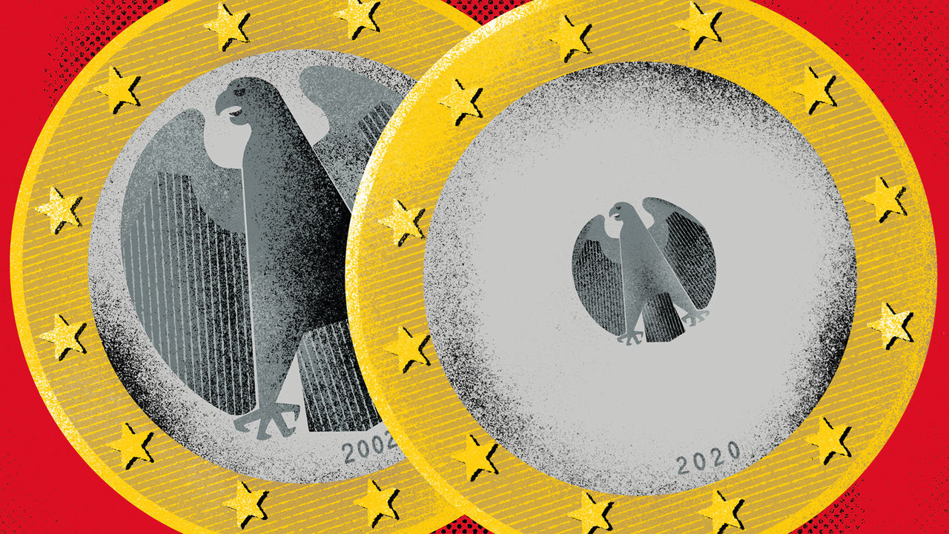

FRANKFURT IS BLESSED with not one but two central banks. In the north loom the brutalist headquarters of the Bundesbank—a raw-concrete structure that is three times wider than it is tall. Ascend to its higher floors and you get a splendid view of the city’s skyline to the south—including a gleaming glass tower completed in 2014. This is the European Central Bank (ECB), which in 1999 supplanted the Bundesbank as the monetary policymaker for Germany and much of Europe. Decisions made at the Bundesbank once sent tremors through the continent’s financial markets. Now, like the central banks in other euro member states, it has one seat out of 25 on the ECB’s governing council.

Though the ECB began life modelled on the Bundesbank, the past decade or so has seen fierce clashes between the two institutions over monetary policy. The hawkish Bundesbank sat on the sidelines as doves at the ECB, led by Mario Draghi, its boss in 2011-19, enacted extraordinary monetary stimulus. Now the Bundesbank is at an important moment. The euro-zone economy is floundering again and the German public is increasingly mistrustful of ECB policy, suggesting the risk of further fights over monetary loosening. But the arrival of a new boss, Christine Lagarde, at the ECB in November, and her year-long review of the ECB’s strategy, provides the Bundesbank with a chance to regain some influence over monetary policy.

The Bundesbank came into being in 1957 with a laser-like focus on monetary stability. Time and again it exercised its prized independence from politicians, provoking recessions in order to tame inflation. On its watch Germany had lower inflation than other rich countries, prompting many in Europe to peg their currencies to the Deutschmark. By the 1990s, many saw a common currency as a way to harness the bank’s credibility.

In order to sell the idea to the German public the ECB was located in Frankfurt. It also drew on German expertise. Otmar Issing, its first chief economist, and the architect of its strategy, was an old Bundesbank hand. Under him the ECB began life with a “reference value” for money-supply growth and a flinty view of inflation.

In some respects the Bundesbank still has heft at the ECB. It brings expert knowledge on the euro area’s largest member state to the ECB’s governing council. That is in part thanks to its 10,000 employees, nearly three times as many as the ECB (see article). Germany’s size, and Frankfurt’s status as the euro area’s biggest financial centre, also means that the Bundesbank plays an outsize role in the euro system. Together with its Italian counterpart it maintains the infrastructure for TARGET2, which settles high-value payments between national central banks. Germany’s TARGET2 system processes half of the volume of payments made in the euro area.

But when it comes to monetary-policy decisions, the Bundesbank has suffered a loss of influence. The ECB’s reference value for money supply has fallen by the wayside. A German has always occupied one of the six seats on the ECB’s executive board. But a Harvard-educated Irishman is now its chief economist; other top officials include a Belgian and an Italian.

Once admired for its willingness to act, in the past decade or so the Bundesbank has sought inaction. Mr Draghi derided its boss, Jens Weidmann, as saying “Nein zu allem” or “no to everything”. Various bond-buying programmes have gone ahead despite its objections.

In part the dissent stemmed from an old-fashioned view of inflation. The ECB’s price-stability target, of inflation “close to, but below 2%”, is asymmetric, reflecting the Bundesbank’s aversion to inflation. But the ECB has come to view its target as symmetrical. The Bundesbank has a higher tolerance for low inflation. It was nervous that loose monetary policy could cause inflation to snap back. But despite all the easing it has averaged 1% in the past five years.

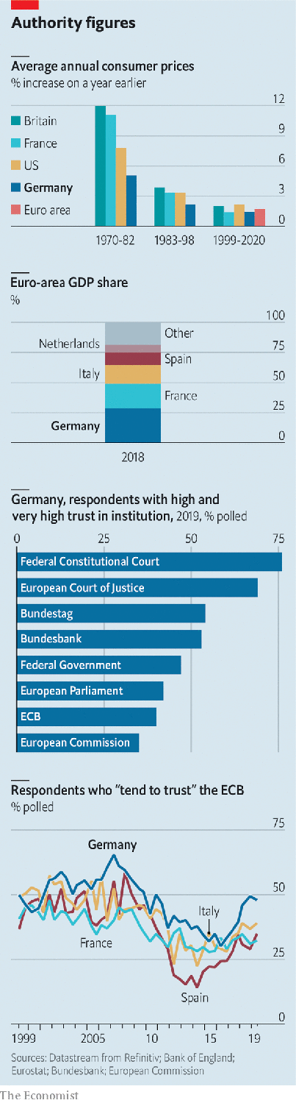

Another reason for dissent was the Bundesbank’s views on the job of a central bank. It is part of the mainstream German economic tradition, which frets that making borrowing cheaper encourages laxity. The legitimacy of both Mr Draghi’s promise in 2012 to buy unlimited bonds of troubled sovereigns and the ECB’s quantitative-easing scheme has been questioned in German courts. (Mr Weidmann gave evidence against the former, though he now accepts a ruling by the European Court of Justice on its legality.)

As the euro zone’s economy has weakened, the Bundesbank has been determined that monetary policy not be seen as the only game in town, and that fiscal policy shoulders the burden of ginning up the economy. Mr Weidmann has urged Germany’s government not to “fetishise” its “black-zero”, or balanced-budget, rule. Doveish types, too, want governments to act. But they would argue that the ECB cannot afford to engage in a game of chicken with investors or governments, if the risk is a downturn or even a crisis.

Being part of a monetary union may have allowed the Bundesbank to become more dogmatic, knowing that the ECB will nevertheless act to avoid crisis. Despite its reputation for being uncompromising before the euro, it was in fact pragmatic from time to time, notes Adam Posen of the Peterson Institute for International Economics. It even briefly conducted asset purchases in the 1970s. Later on, Germany’s export-oriented growth model allowed its economy to outperform others in the euro zone during the sovereign-debt crisis of 2009-15. As Germany fared so well under the status quo, notes Mr Posen, the Bundesbank may have found it easy to oppose monetary loosening.

But its intransigence also stems from a desire to maintain public trust. A survey by the Bundesbank finds that it is held in higher esteem in Germany than the ECB and the federal government. Retaining that trust, though, is getting harder. The German press increasingly paints the ECB’s negative interest rates as an attack on the country’s savers. Mr Weidmann supported the latest round of interest-rate cuts in September, and has defended negative rates in interviews. But when he has dissented he has not been above using his press appearances to put pressure on the governing council. That may have given the public the impression that ECB policy hurts Germany.

Without change, further rows over policy loosening seem likely. But the relationship between the two institutions could well be at a turning point. Ms Lagarde is not an economist, and is therefore likely to be less of an influence on the details of policy than Mr Draghi. She also wants to be more consultative. That would give Mr Weidmann space to air his dissent within the ECB’s governing council rather than outside it. Her review of the ECB’s framework could clarify its inflation target and align views on when the bank should act.

And Germany’s appointment of Isabel Schnabel, a more consensus-minded economist than Mr Weidmann, to the ECB’s executive board might help the bank communicate directly with the public. In a speech on February 11th she tackled common misperceptions around negative interest rates.

A bigger shift at the Bundesbank could even come through adversity. Germany’s growth model is looking increasingly shaky, warns Mr Posen. In 2019 its economy fared better only than Italy’s in the euro zone; a repeat performance is expected in 2020. That would give the Bundesbank something to fight for.

This article was downloaded by calibre from <https://www.economist.com/finance-and-economics/2020/02/22/the-bundesbank-is-caught-between-a-doveish-ecb-and-a-suspicious-public>

|  |  |  |  |
| --- | --- | --- | --- |
|  | Articles | Sections | Next |

|  |  |  |  |
| --- | --- | --- | --- |
| Previous | Articles | Sections | Next |

#### Labour hoarding

# Are there too many central bankers?

Euro-area banks look especially flabby

Feb 22nd 2020 |

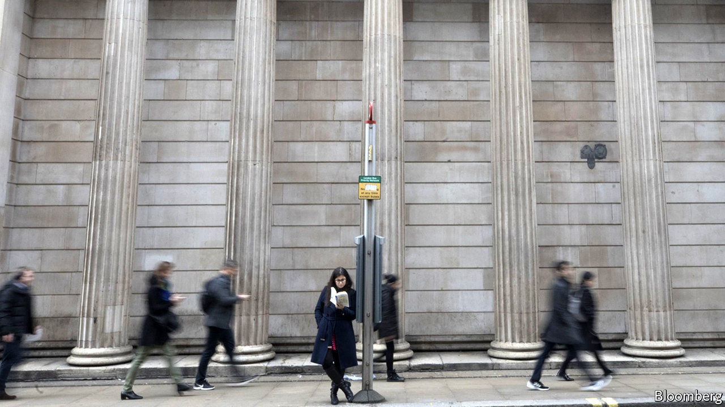

CENTRAL BANKERS around the world have long pondered the causes of a slowdown in productivity. Might they be part of the problem? Many national central banks in the euro area have shed staff in the two decades since they ceded many of their responsibilities to the ecb. Yet they still look flabby: the central banks of Germany, France and Italy have many more employees than the Bank of England, whose duties have grown over the same period. In their defence the Europeans could point to the payroll of America’s Federal Reserve system. Its Board of Governors in Washington, dc, where most responsibility resides, had about 2,800 employees at the last count. But its network of less important reserve banks had another 19,500.■

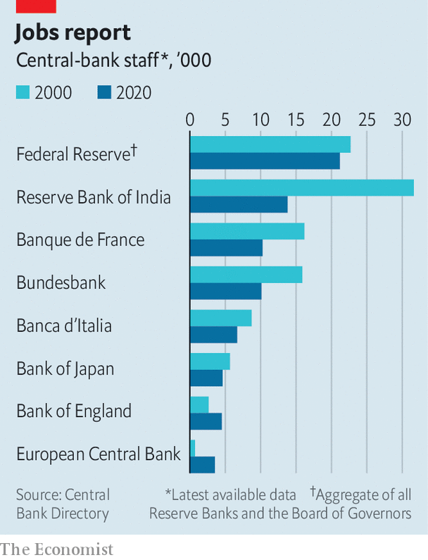

This article was downloaded by calibre from <https://www.economist.com/finance-and-economics/2020/02/22/are-there-too-many-central-bankers>

|  |  |  |  |
| --- | --- | --- | --- |
| Previous | Articles | Sections | Next |

|  |  |  |  |
| --- | --- | --- | --- |
| Previous | Articles | Sections | Next |

#### The incredible shrinking bank

# HSBC undergoes yet another overhaul. It still may not be enough

Europe’s largest bank has a new strategy—but no permanent boss

Feb 20th 2020 |

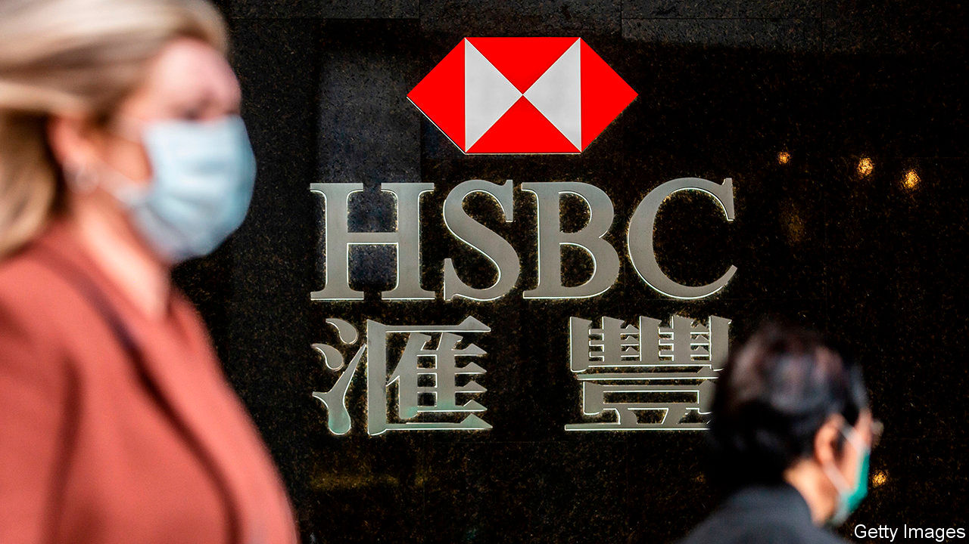

LAST AUTUMN the board of HSBC asked Egon Zehnder, an executive-search firm, to find it a new chief executive. The bank had fired John Flint in August, after 18 months in the job, for being too shy about pursuing profits. HSBC then dodged the decision, appointing Noel Quinn, a no-nonsense insider, only on an interim basis. Mr Quinn soon made it clear he wanted the job permanently. He seemed a shoo-in.

Yet six months on his appointment is less certain. On February 18th HSBC, Europe’s largest bank by assets, unveiled results that fell short of already pale expectations. Hobbled by write-downs of $7.3bn (mainly at its global investment bank and European commercial bank), its profit slumped by a third in 2019, to $13.3bn. Its return on tangible equity (ROTE) slipped to 8.4%, down from 8.6% in 2018 (investors reckon 10% is par). And the chairman, Mark Tucker, said nothing about the top job.

Undaunted, Mr Quinn announced “one of the deepest restructuring and simplification programmes in our history”. The 155-year-old bank is to shed 35,000 of its 235,000 staff. It intends to cull risk-weighted assets by over $100bn, out of a total of $843bn, by 2022. Its investment bank, its European arm (where assets will shrink by 35%) and its American business (where it will shed 30% of branches) will bear the brunt of $4.5bn in annual cost cuts. It will thus become even more focused on Asia, where it already makes 90% of its profits.

Investors were unimpressed: the share price lost nearly 6% on the day. The overhaul is HSBC’s third since the global financial crisis of 2007-09. They had hoped that the bank would at last be able both to aim for higher returns and to hand out some of the bounty to its owners. Yet HSBC set its ROTE target for 2022 at 10-12%—in effect, no different from its previous objective of 11%. Worse, it said it would suspend share buy-backs for 2021 and 2022. Investors feel HSBC is “running to stand still”, says Tom Rayner of Numis Securities, a broker.

But even standing still may be difficult. Asia is feeling the chill of a global economic slowdown, and disruption caused by the coronavirus infection is likely to harm growth further. The bank estimates that the epidemic will cost it $200m-500m in the first quarter of 2020. Analysts expect more loans to sour in Hong Kong and mainland China. Elsewhere, commercial property is also starting to look iffy in post-Brexit Britain; negative interest rates are eating banks’ margins in Europe.

A bigger worry for investors is whether the bank can do as it promises. Joseph Dickerson of Jefferies, an investment bank, says the overhaul marks HSBC’s first real stab at trimming its bloated middle office. But controlling costs is becoming more difficult. For its previous round of scalpel-wielding, in 2015, which was aiming to generate about $5bn in annual cost cuts, HSBC booked $4.5bn in restructuring charges. The latest plan looks to generate similar savings, yet the bank this time expects to incur costs totalling $7.2bn.

Boosting sales while cutting expenses is not easy to pull off. Demoralised staff may be hesitant to launch new products. Scale matters in banking, and losing it will make it harder to gain an edge. The asset sales may compound the problem. Reinvesting $100bn in proceeds could take some time: HSBC’s Asian risk-weighted assets have barely budged since 2017. It also wants to grow its retail and wealth-management arms, but most investment banks, penalised by heftier capital requirements, are earlier at it. In the interim parking the cash in low-yielding, liquid alternatives, like money-market funds, may reduce income, notes Daniel Tabbush of Tabbush Report, a research firm.

The uncertain outlook makes HSBC’s dithering over its new chief executive all the more surprising. Mr Tucker has not yet entrusted Mr Quinn with the authority a boss needs to enforce a painful overhaul; yet recruiting an external candidate, after such a thorough restructuring has been announced, will be hard. Mr Tucker should make his choice, sharpish.■

This article was downloaded by calibre from <https://www.economist.com/finance-and-economics/2020/02/20/hsbc-undergoes-yet-another-overhaul-it-still-may-not-be-enough>

|  |  |  |  |
| --- | --- | --- | --- |
| Previous | Articles | Sections | Next |

|  |  |  |  |
| --- | --- | --- | --- |
| Previous | Articles | Sections | Next |

#### Friends in high places

# Michael Milken receives a presidential pardon

The junk-bond king gets a ratings upgrade

Feb 22nd 2020 |

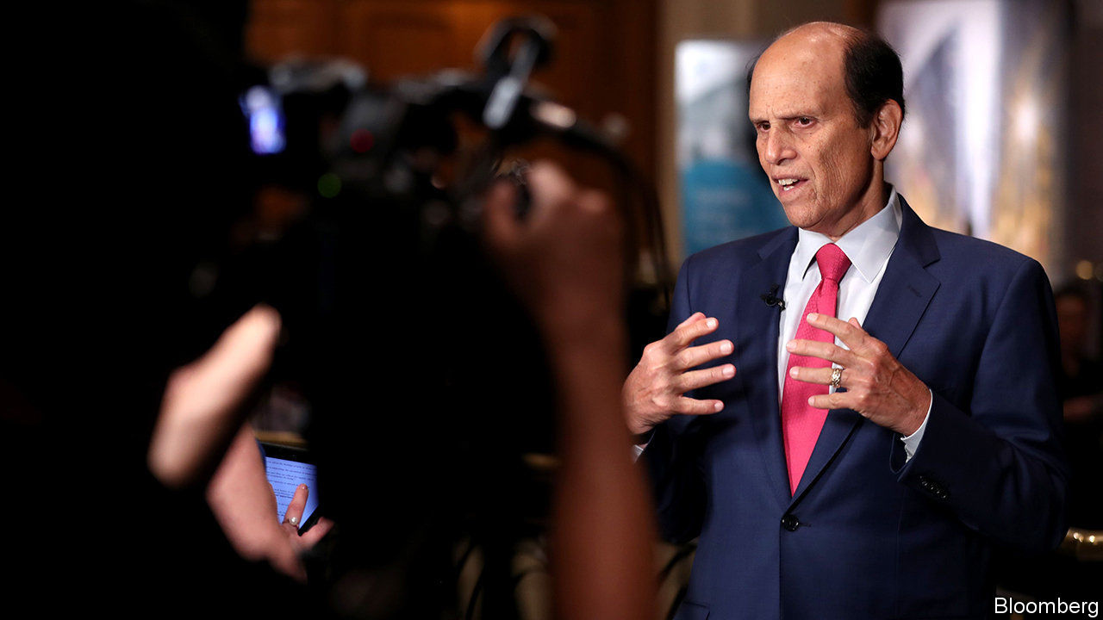

ON FEBRUARY 13TH 1990 Drexel Burnham Lambert, which only a few years earlier had been America’s most profitable investment bank, filed for bankruptcy. Its death knell had sounded ten months earlier when Michael Milken, who created the junk-bond market on which the bank’s success was founded, was indicted for fraud. He would plead guilty to six counts and serve 22 months in prison.

Thirty years on, Mr Milken has been pardoned by President Donald Trump. Among his petitioners was Rudolph Giuliani, the president’s personal attorney, who had led the investigation into Drexel three decades ago. The pardon was much sought after. Many of the people who worked at Drexel have long felt that the prosecution of Mr Milken was, in essence, a vendetta. Drexel was an upstart firm. It unsettled corporate America by supplying junk-bond finance to a new breed of corporate raiders. It used its dominance of high-yield-bond trading, which Mr Milken had built up in the 1970s and early 1980s, to push into mergers and acquisitions and underwriting. That put noses on Wall Street out of joint. “We were not very humble about our success,” says a former colleague. So when the Feds came for him, Mr Milken had few friends in high places and a lot of enemies. He made a handy scapegoat for the savings-and-loan crisis.

If that was the reality then, things are quite different now. A statement from the White House listed 33 names of the great-and-goodish behind Mr Milken’s appeal. And the fresh-faced MBAs who flocked to work with Mr Milken in the 1980s are now the financial establishment. The Drexel diaspora is a roll-call of the leading lights in the world of private-equity and private-credit markets.

What is striking about the diaspora is their enduring reverence for “Mike”. Part of this is a recollection of an exciting time, when visiting entrepreneurs would pitch madcap ideas: a 24-hour-news channel; a casino with a fake volcano. If you had an idea and a sliver of equity, Mike and his team would raise the necessary debt. It is also—perhaps mostly—a form of gratitude for a unique education in markets and in the importance of understanding a company’s capital structure, its mix of debt and equity finance. The skills acquired in the buy-out boom of the 1980s are perfectly tailored for today’s boom in private equity. The diaspora owe their lucrative careers to what they learned from Mike.

The question naturally arises as to why a pardon could possibly matter now. Mr Milken pleaded guilty. He served time. So central was he to the network of issuers and buyers in the junk-bond market that it would seem a minor miracle if he had not transgressed some aspect of securities law. Mr Milken is already applauded for his philanthropy. He is now 73. An official exoneration may permit a kinder judgment of his legacy: as a financier who widened access to corporate credit. When Wall Street sneered at “junk bonds, junk people”, Mr Milken would remind his apostles that anything AAA-rated can only go down. But anything rated as junk can always improve its standing. ■

This article was downloaded by calibre from <https://www.economist.com/finance-and-economics/2020/02/22/michael-milken-receives-a-presidential-pardon>

|  |  |  |  |
| --- | --- | --- | --- |
| Previous | Articles | Sections | Next |

|  |  |  |  |
| --- | --- | --- | --- |
| Previous | Articles | Sections | Next |

#### Buttonwood

# The appeal, and the flaws, of cash-based accounting

Earnings are fiction and cash is supposedly fact. But what is the truth?

Feb 20th 2020 |

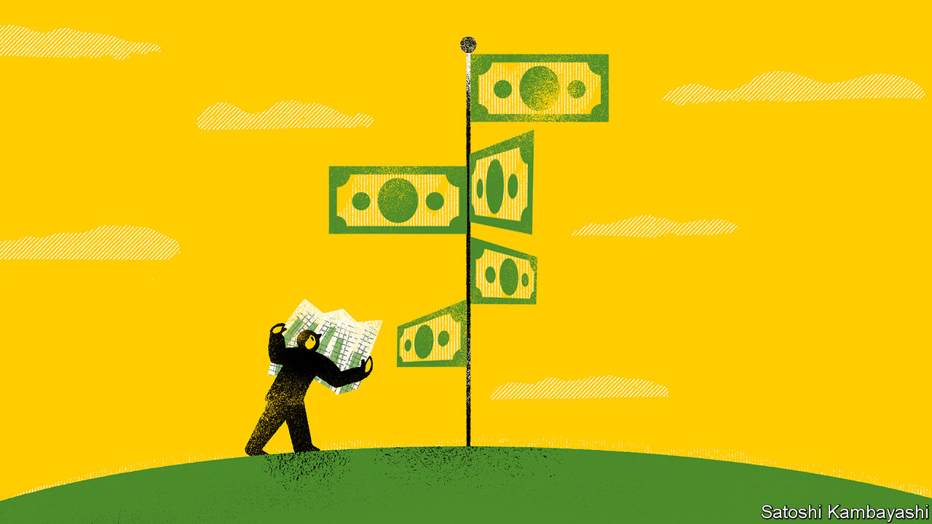

EVERY NEW form of payment, from cheques to contactless cards, is heralded as the end of cash. Your friend, the one with the fat wad of banknotes, like an old-school bookmaker, knows different. Cash has unique attributes, he says. It leaves no trace so transactions stay private. It requires no fragile infrastructure to process payments. You can pay for groceries in a power cut or get a drink at the bar when the card machine fails. Cash is non-negotiable. It is why it is readily accepted.

If gold obsessives are gold bugs, then your friend is a cash bug. There is a version of him in the business of stock-picking. This sort would not dream of using reported earnings as a guide to anything. They are too ripe for manipulation by bosses. But you can’t monkey with hard cash. You either have it or you don’t. Earnings are fiction; cash is truth.

Or is it? It is foolish to look for the true value of a company in a single measure, whether that is cash balances; the book value of assets on the balance-sheet; or earnings in the profit-and-loss account. All have flaws. Book value understates a company’s worth if it is tied up in its brands and know-how (“intangibles”). Reported earnings are pliable. Even cashflow can be manipulated. Indeed cashflow turns out to be more negotiable than your fat-walleted friend thinks.

Cash bugs yearn for the simple economics of the lemonade stand. A venture is sound if it takes in more from sales than it pays out in costs, such as lemons and wages. If more cash comes in than goes out, the business is good. By contrast, earnings are slippery. They are what is left of profits after accounting for “accruals” ie, non-cash revenues and costs. Some of this reflects sales that have been booked but not yet been paid for. Much of it consists of costs that are not a drain on cash right now, but which surely will be: depreciation of plant and machinery; charges against pension promises; allowances for bad debts; and so on.

The trouble is that it is hard to arrive at a true number for such costs. No one knows the working life of an Apple Mac or an Airbus A380; so how quickly should such assets be written off? The ultimate cost of a company’s pension scheme depends on assumptions about investment returns. So companies are given a lot of discretion over how they account for such accruals. This leaves lots of scope for the massaging of earnings; hence the appeal of cash-based accounting.

Changes in a company’s cash balance do not tell you much about its operating business. It may have gone up because a company issued a bond or sold an asset. That is why analysts look instead at “free cashflow”. This ignores non-cash items in the earnings statement, such as depreciation and amortisation. But it recognises capital costs, such as spending on buildings, equipment and inventories. It is therefore a decent shorthand measure of the profits a company’s owners can lay claim to—the cash left over after the spending needed to sustain the business.

It sounds like an ideal guide to a firm’s value. But it is not tamper-proof. One way to give free cashflow a boost is to defer payments to suppliers: pay the bills in 90 days, rather than 30 or 60 days. How capital spending is financed—the choice to buy or lease—also matters a lot. Lumpy asset purchases are a drain on cash when they occur; lease payments are altogether smoother. But as with renting a flat or leasing a car, it is not always clear whether buying will use up more or less cash in the long run.

The Footnotes Analyst, a blog on accountancy, uses Amazon’s accounts to highlight how leases distort cashflow measures.* The company itself provides three measures of free cashflow in its 2018 accounts. They varied from $8.4bn to $19.4bn, depending on the accounting treatment of leases. A fourth measure, calculated by the Footnotes Analyst, finds that free cashflow was negative to the tune of $3.4bn. All of these are valid figures. None can be claimed to be the whole truth.

The cashflow statement only gets you so far. As do reported earnings, or the balance-sheet. You need all three to understand a company, says Nathan Cockrell, of Lazard Asset Management, just as you need three co-ordinates (longitude, latitude and altitude) to know where anything is with precision. To say that cashflow never lies is itself a lie. After all, when your friend with the bulging money clip keeps boasting about how flush he is, you start to wonder if he might actually be skint.

*Footnotesanalyst.com/free-cash-flow-amazon

This article was downloaded by calibre from <https://www.economist.com/finance-and-economics/2020/02/20/the-appeal-and-the-flaws-of-cash-based-accounting>

|  |  |  |  |
| --- | --- | --- | --- |
| Previous | Articles | Sections | Next |

|  |  |  |  |
| --- | --- | --- | --- |
| Previous | Articles | Sections | Next |

#### Following the money

# Cash sloshes around the world in unexpected ways

Economists are getting better at tracing cross-border capital flows

Feb 22nd 2020 |

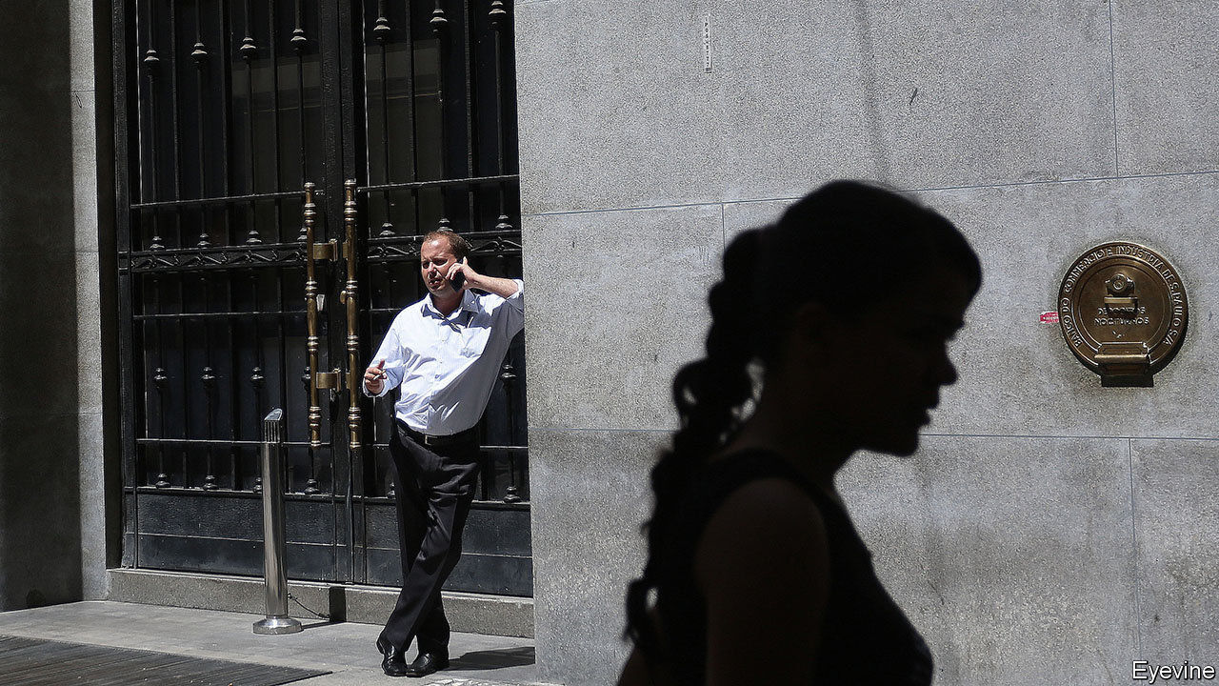

MONEY MAKES the world go round. But where in the world is it going? In theory the answer lies in statistics published by the likes of America’s Treasury Department and the International Monetary Fund (IMF), which track cross-border flows of debt and equity investments. In practice creative corporate accounting mucks up the official figures. A growing body of research is trying to clean up the mess.

Accounting for corporate behaviour would be simple, if it could be organised neatly according to national boundaries. Petrobras, a Brazilian oil giant, would sell its bonds directly to American or European investors. In reality many companies raise funds through foreign subsidiaries set up for the purpose. Petrobras raises debt through its subsidiary Petrobras Global Finance BV, based in the Netherlands.

Such financial contortions cloud economists’ view of global investments. When a subsidiary transfers the cash from the loan to its parent, this can show up (misleadingly) as foreign direct investment (FDI). A recent study by Jannick Damgaard of the Danish central bank, Thomas Elkjaer of the IMF and Niels Johannesen of the University of Copenhagen estimated that as much as 40% of measured FDI flows were in fact “phantom” flows through shell companies.

Another recent study by Antonio Coppola of Harvard University, Matteo Maggiori of Stanford University, Brent Neiman of the University of Chicago and Jesse Schreger of Columbia University also tries to estimate just how much these financial gymnastics are distorting the official figures. Their motivation is the dramatic rise in the share of cross-border investments flowing through tax havens between 2007 and 2017, from around 40% to 55% for debt and from 10% to 50% for equity capital.

The authors stitch together seven data sets, including information on investor portfolios and the relationships between parent companies and their subsidiaries. Both debt and equity investments funnelled through tax havens are reallocated to the location of the parent company. What the official figures count as an American loan to Petrobras Global Finance BV in the Netherlands, the researchers reclassify as a loan to Petrobras in Brazil.

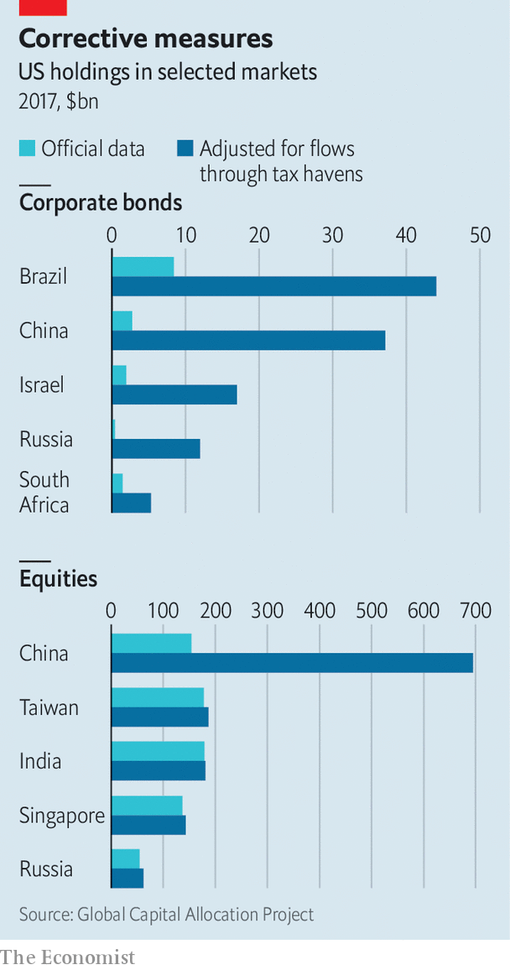

This amounts to a large adjustment to the official data. Around 12% of what looks like American investors’ holdings of foreign bonds turns out to be their holdings of domestic ones, mostly in the form of bundled corporate loans. American holdings of corporate bonds in emerging markets are revised up too: from $8bn to $44bn in the case of Brazil, and from $3bn to $37bn for China (see chart). As these bonds do not tend to be issued in the parent company’s currency, the adjustments bump up emerging markets’ exposure to foreign-currency debt, from 20% to 50% of Brazilian debt securities held by foreigners, and from 30% to 60% for Russian securities.

One of the most drastic revisions is to American holdings of equities in China, which official figures suggest were worth $160bn in 2017. That relatively low figure reflects the fact that the Chinese government restricts ownership in some key sectors. But it does not reflect Americans’ true financial stakes. In order to skirt the controls, Chinese companies set up “variable-interest entities”, which attempt to replicate the benefits of raising equity capital without falling foul of the rules. After the authors’ adjustments, Americans’ stake in Chinese equities rises to $700bn.

All this shows that rules often lead only to financial gymnastics. The findings also expose risks. Some large emerging markets are much more exposed to currency depreciations against the dollar than the official data suggest. If a crisis hits, governments will have to sort through the tangle of loans owed by domestic companies but held outside their jurisdiction. Mr Coppola and his co-authors call attention to American retail investors’ exposures to Chinese financial vehicles, which China’s government could rule as illegal (and worthless) on a whim. Economists may find incorporating these cross-border financial connections into their models hard. But without them, the picture is grossly misleading. ■

This article was downloaded by calibre from <https://www.economist.com/finance-and-economics/2020/02/22/cash-sloshes-around-the-world-in-unexpected-ways>

|  |  |  |  |
| --- | --- | --- | --- |
| Previous | Articles | Sections | Next |

|  |  |  |  |
| --- | --- | --- | --- |
| Previous | Articles | Sections | Next |

#### Young, gifted and in the red

# Student debt in America amounts to over $1.5trn

Mike Bloomberg is the latest politician to promise to tackle the problem

Feb 22nd 2020 |

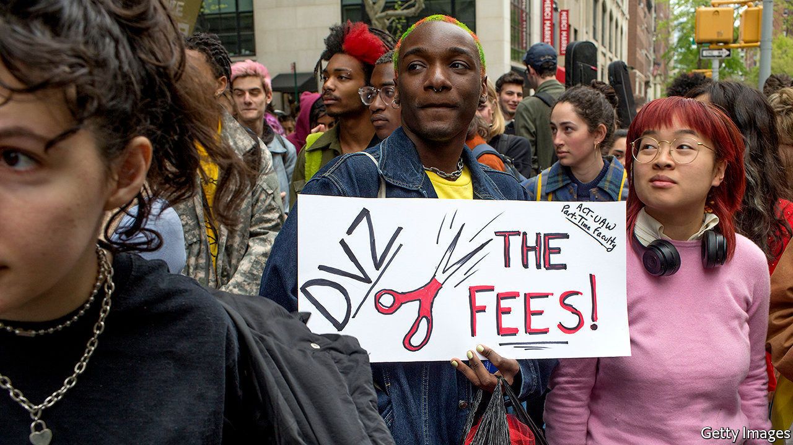

ON FEBRUARY 18TH Mike Bloomberg became the latest Democratic presidential candidate to promise to tackle student debt in America. The stock of loans amounts to over $1.5trn, around 7% of GDP. Fully 45m Americans owe an average of $37,000; a fifth are struggling to make repayments. Despite making up 56% of the student population, women owe two-thirds of total debt.■

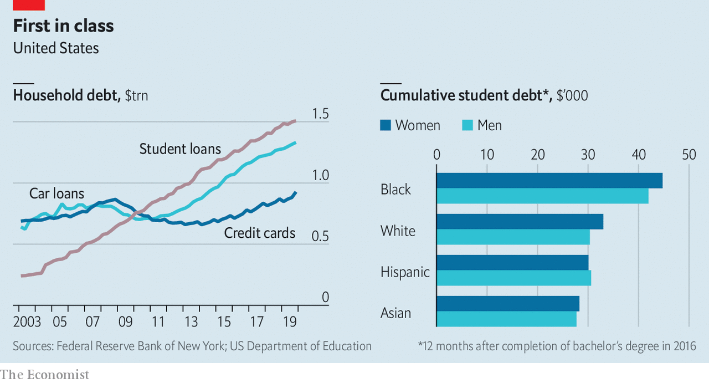

This article was downloaded by calibre from <https://www.economist.com/finance-and-economics/2020/02/22/student-debt-in-america-amounts-to-over-15trn>

|  |  |  |  |
| --- | --- | --- | --- |
| Previous | Articles | Sections | Next |

|  |  |  |  |
| --- | --- | --- | --- |
| Previous | Articles | Sections | Next |

#### Free exchange

# Covid-19 presents economic policymakers with a new sort of threat

It mixes demand and supply effects

Feb 22nd 2020 |

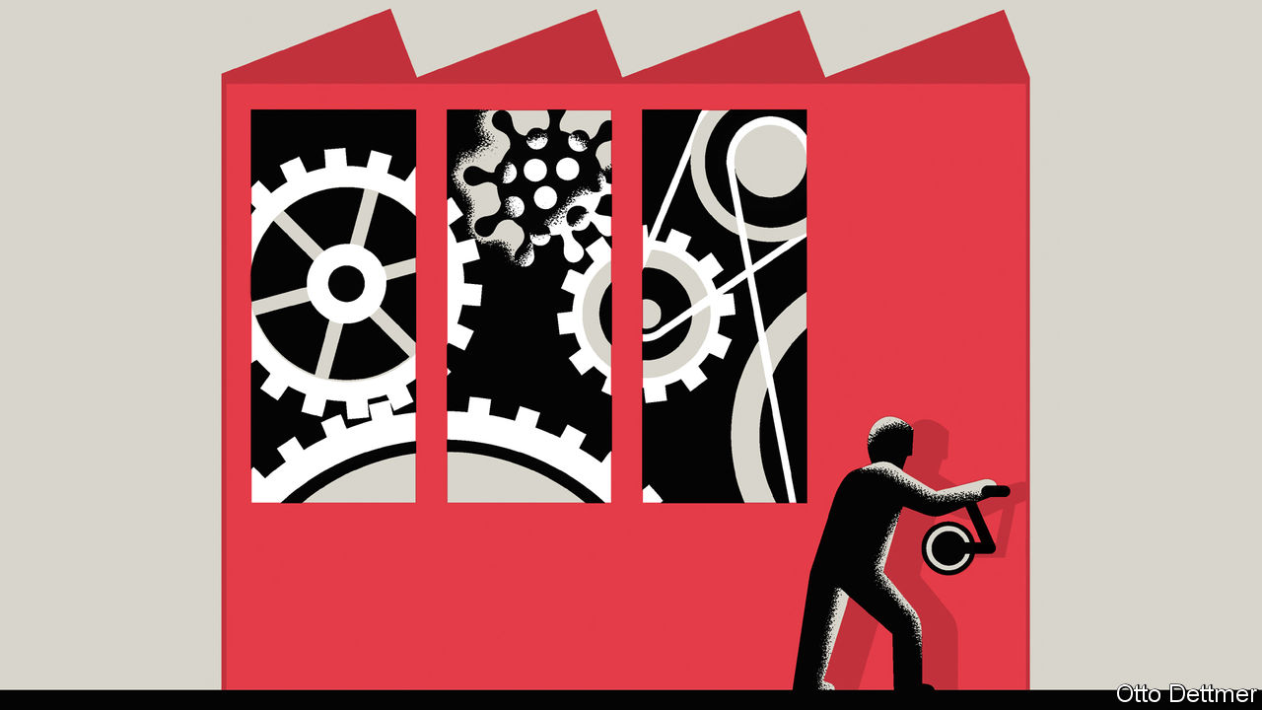

THE ONLY thing we have to fear is fear itself, or so reckoned Franklin Roosevelt. In many an economic downturn that is true—an anxiety-induced reluctance to spend is the main threat to prosperity. For now, the world is treating the outbreak of covid-19, a disease caused by a coronavirus that is now responsible for more than 2,000 deaths, as no exception. Central banks across Asia are easing monetary policy while governments prepare spending programmes to limit the economic damage.

Covid-19, however, is not a conventional economic threat. Efforts to contain the virus are limiting activity by shutting factories and disrupting supply-chains. Such shocks to supply are harder to manage than anxiety-induced frugality among firms and investors. When people stop spending, growth slows and inflation falls. But when supply is constrained, prices can accelerate even as the economy wobbles. Economists first grappled with supply shocks in the 1970s, when reductions in food and oil supplies ended three decades of unprecedented growth and ushered in “stagflation”. Supply shocks divided the profession. Predictably, there was a row over whether governments should prioritise fighting rising unemployment or high inflation. In a victory that would shape central banking for decades, the inflation hawks eventually won.

Like the oil and food shocks of the 1970s, the covid-19 epidemic poses an unexpected threat to a mainstay of global production. For as long as the mobility of Chinese workers is limited, shops, offices and factories in the world’s largest exporter will sit idle. As a result, firms dependent on supplies from China are running down inventories and curtailing operations. On February 17th Apple warned investors that supply-chain problems were limiting iPhone production and would reduce its revenues (see article). Hyundai, a carmaker, has cut production in South Korea because of parts shortages. On February 18th Jaguar Land Rover, a British carmaker, said that it could start to run out of parts in two weeks’ time, and that it had flown in emergency supplies from China in suitcases.

But whether the understanding of supply shocks forged in the 1970s still applies is unclear. In practice, the distinction between shocks to demand and those to supply is fuzzy. In a paper published in 2013 that revisited the era of stagflation, Alan Blinder of Princeton University and Jeremy Rudd of the Federal Reserve argue that supply alone cannot explain the soaring unemployment of the 1970s. In fact, they say, price increases had demand effects that mattered more. They raised uncertainty, reduced households’ disposable income and eroded the value of their savings.

Subsequent experience supports this more nuanced view of the effect of supply shocks. Soaring oil prices in 2007 gutted household consumption in America and helped push its economy into recession. The earthquake, tsunami and resulting nuclear disaster that struck Japan in 2011 dealt a blow to Japanese industry which, like China’s, occupies important supply-chain niches. The catastrophe led to a sharp decline in output and exports (and a long-term shift in economic activity away from the most affected regions), but despite the disruptions Japan remained in deflation. Higher tariffs should, in theory, disrupt supply and boost prices. But to date the main economic effect of the trade war being fought by America and China has been dented confidence, derailed business investment and tumbling interest rates. The covid-19 outbreak is hitting China’s demand for commodities and its tourists’ travel plans. Both effects drag down global demand in a conventional way, as they did after the outbreak of SARS in 2003.

Circumstances today are also very different from the 1970s. Crucially, global inflation remains oddly subdued. That means policymakers can provide stimulus without exacerbating an ongoing inflation problem. Support seems warranted in China, where lost sales could give way to lay-offs, further cuts to spending, and a deep slump. Economies with close links to China are also moving, rightly, to shore up spending. Japan’s decision to raise consumption tax last year, a move that contributed to an annualised decline in GDP of 6.3% in the fourth quarter of 2019, looks spectacularly ill-timed in hindsight.

Should covid-19 sweep across the world, the global economy as a whole will surely need a dose of stimulus, much as China does today. The main complication then would be a lack of central-bank ammunition, as interest rates are already low. But even if the virus stays contained, governments of less affected countries could have their hands full. Policymakers facing temporary supply shocks must reassure the public that growth and inflation will eventually return to normal—as modern central banks now try to do when oil prices spike. Continued disruption, though, requires adjustment. New suppliers must be tracked down, new contracts written and new customers found. Frustrated firms could decide the time is right to wash their hands of China. The effects of such changes are hard to predict.

## Ill at ease

If China’s economy slumps further in response, it could exert a deflationary pull on economies in the West. But if decades of economic integration, which many economists credit with holding down global inflation for the past two decades, goes into reverse, then dormant price pressures could awaken. Macroeconomic policymakers could once again be confronted with the painful decision of whether or not to fight rising inflation during an economic downturn.

For policymakers beset by unknowns, both overreaction and underreaction present serious risks. The time to build more resilience into production chains and financial systems has sadly passed. Perhaps the most important lesson of the 1970s is one the world ought to have appreciated before the arrival of the epidemic—shocks happen, and can transform well-worn economic terrain into something less familiar with frightening speed. ■

This article was downloaded by calibre from <https://www.economist.com/finance-and-economics/2020/02/22/covid-19-presents-economic-policymakers-with-a-new-sort-of-threat>

|  |  |  |  |
| --- | --- | --- | --- |
| Previous | Articles | Sections | Next |

|  |  |  |
| --- | --- | --- |
| Finance and ... | Sections | Books and arts |

Science and technology

The American Association for the Advancement of Science: Is there anybody out there?

.

Soil microbiology: Three’s company

.

Psychology: Face blind

.

Cell biology: An atlas of the innerverse

.

|  |  |  |
| --- | --- | --- |
| Finance and ... | Sections | Books and arts |

|  |  |  |  |
| --- | --- | --- | --- |
|  | Articles | Sections | Next |

#### Is there anybody out there?

# The search for extraterrestrial intelligence moves up a gear

And we might even get answers soon

Feb 20th 2020 | SEATTLE



IN 1990, A year into the journey to Jupiter of an American spacecraft called Galileo, Carl Sagan, a well-known astronomer, turned the probe’s instruments back towards Earth. He wanted to find out whether it was possible to detect evidence of life on the planet from a distance.

Galileo took spectrographic measurements of sunlight streaming through Earth’s atmosphere and found methane and oxygen, both indicators of living processes. The probe also took photographs of Earth at different wavelengths and uncovered something called the “red edge”—a sharp change in the reflectance of the planet at red wavelengths, which Sagan ascribed to the presence of photosynthetic plant life on the surface.

There was, however, a third clue—and an indicator that life not only exists on Earth, but has also developed intelligence. This came from the narrowband electromagnetic radiation that was streaming from Earth’s surface—in other words television and radio channels leaking into space. “That, as far as we know, is an unmistakable indicator of technology and an unmistakable indicator of life,” says Andrew Siemion, an astrophysicist at the Berkeley SETI Research Centre in California. “And indeed, it is the most detectable signature of life on this planet as viewed from a distant vantage.” Sagan’s experiment thus confirmed what those engaged in the search for extraterrestrial intelligence (which is what SETI stands for) had suspected—that the best way to find aliens is to look for unnatural radio signals.

That search is accelerating. As Dr Siemion told this year’s meeting of the American Association for the Advancement of Science (AAAS), in Seattle, better telescopes, faster computers, the discovery of thousands of planets circling stars other than the sun, and an influx of money and scientific talent are transforming the field. What was once a fringe activity has now become mainstream. The next decade, he reckons, will allow astronomers to improve their search for signals from outer space a thousandfold.

SETI began 60 years ago with Project Ozma. This was led by Frank Drake, an astronomer at Cornell University. It was an attempt to listen for radio waves that might be coming from intelligent life in the vicinity of two nearby sun-like stars, Tau Ceti and Epsilon Eridani. Further projects along this line followed, but no little green men were detected. By the turn of the 21st century people were starting to lose interest and financial support for the endeavour was dwindling.

The tide turned, though, in 2009 with the launch of Kepler, an American probe designed to look for planets orbiting other stars. It found them. In spades. Astronomers have now confirmed the existence of more than 4,000 such exoplanets. Moreover, their models suggest that virtually every star has a planetary system. With so many potential habitats, and more being discovered every month, the prospects of finding alien life suddenly brightened.

They will brighten further with the launch, in 2021, of the James Webb Space Telescope and the opening of new observatories on the ground, such as the Extremely Large Telescope (ELT) in Chile. These will be able to repeat, for some nearby exoplanets, the first of Sagan’s experiments with Galileo—the search for biosignatures. But, even if they find them, exciting as that would be, it would say nothing about the crucial final letter in SETI, the “I” for intelligence.

The search for intelligence was boosted in 2015 with the launch of Breakthrough Listen, a project paid for by Yuri Milner, a software billionaire with a background in physics. This enterprise, on which Dr Siemion is chief scientist, is planned to last ten years and expected to cost $100m. It is intended to survey the 1m nearest stars in detail, scan the entire plane of Earth’s home galaxy, the Milky Way, and also listen for messages from the 100 closest galaxies. It is paying for astronomers interested in SETI to have time on more than a dozen big radio observatories around the world, and it collects in a day an amount of data that used previously to take a year to gather.

## Hello?

Nor is Breakthrough Listen alone. On February 13th the SETI Institute, a not-for-profit organisation in California, and America’s National Radio Astronomy Observatory, announced a collaboration. The observatory operates the Very Large Array (VLA), a radio telescope in New Mexico that features in the film “Contact”. The collaboration allows SETI researchers to tap the entire stream of data the VLA records as it carries out its routine experiments.

The partnership will become even more useful for SETI researchers if the VLA gets a proposed upgrade that would greatly enhance its sensitivity. This next-generation instrument would be good enough to detect electromagnetic radiation leaking from planets, similar to the television and radio channels that Sagan measured leaking from Earth.

Nor, despite the importance of radio waves, will future SETI searches stick to that part of the spectrum. Alien civilisations might, for example, use laser flashes as optical beacons to signal their presence. If a nanosecond-long pulse of such light were pointed in the direction of Earth, it could be made energetic enough to seem brighter to human instruments than any of the stars in the same part of the sky.

Moreover, as observatories get better, astronomers will also be able to spot small, potentially pertinent features in and around exoplanets. These might be rings of satellites above a planet’s equator—or even structures surrounding a planetary system’s star, put there to capture that star’s light as a source of energy.

Even a single space station, were it big enough, might be detectable using methods similar to those employed to spot exoplanets. A space station the size of Earth’s moon (admittedly, a huge space station) would stop enough of the light of its star from reaching Earth to produce a perceptible dip in that light. This “transit” method is how Kepler spotted its prey and, as instruments improve, should one day be sensitive enough to spot exomoons too. The way to tell the difference between a moon and a moon-sized space station, says Dr Siemion, would be that the former would orbit regularly whereas the latter might be able to move around at will.

More standard searches for chemical biosignatures could also be useful for SETI. A system of particular interest is Trappist-1, 40 light-years from Earth, where seven rocky worlds orbit a red dwarf. Three of these are within the star’s “habitable zone”—a region where planets could have liquid water on their surfaces.

The next generation of instruments will reveal whether the planets in Trappist-1 have atmospheres or oceans. If there are atmospheres, they will also reveal what gases are within them—possibly showing biosignatures of the sort Sagan spotted on Earth.

Meanwhile, the Breakthrough Listen dataset continues to grow. In a study discussed in Seattle, a team of astronomers used it to look for radio transmissions from 20 stars in the so-called “Earth transit zone”—the part of the sky from which Earth itself would be detectable by the transit method. The hypothesis is that, if intelligent beings do exist in that region, they might thus have discovered Earth and be aiming transmissions at it. So far, the skies have been quiet. But SETI researchers are patient people. And they live in hope.■

This article was downloaded by calibre from <https://www.economist.com/science-and-technology/2020/02/20/the-search-for-extraterrestrial-intelligence-moves-up-a-gear>

|  |  |  |  |
| --- | --- | --- | --- |
|  | Articles | Sections | Next |

|  |  |  |  |
| --- | --- | --- | --- |
| Previous | Articles | Sections | Next |

#### Soil microbiology

# Knowing how plants and microbes work together can boost crop yields

They have a complex relationship

Feb 22nd 2020 | SEATTLE



INTERACTIONS WITH microbes in the soil are crucial to the health of plants. Some bacteria turn nitrogen from the air into ammonia, and thence into nitrates, thus “fixing” that element in a form which plants can absorb and turn into proteins. Others, by secreting antibiotics, protect plants from pathogens. Others still, through the formation of colonies called biofilms on the surfaces of soil particles, help trap water in the soil. And fungi, which consist of long networks of hyphae that often penetrate plant roots, facilitate the uptake by those roots of nutrients from the soil

Also this means that soil microbes affect crop yields. Indeed, they are one of the most important influences on crop growth that has yet to be exploited systematically to raise those yields. But that will soon change, if researchers who study the rhizosphere, (as the zone of interaction between plants’ roots and microbes is known) have anything to do with it. This study is hard, for the rhizosphere is a habitat as complex, in its way, as a rainforest or a coral reef. It just operates at a smaller scale. As a group of researchers told the AAAS meeting in Seattle, the first step to understanding the rhizosphere is therefore to simplify it.

Previous investigators have known this, but have taken simplification too far, by isolating and studying single microbes. That, Jo Handelsman of the University of Wisconsin–Madison told the meeting, is where they have gone wrong. Soil microbes interact. And mixtures of species can do things individual bugs cannot manage. As an example, she gave an ecological triangle that her laboratory has been working on.

This triangle, which Dr Handelsman calls THOR (The Hitchhikers Of the Rhizosphere), consists of three species, Pseudomonas koreensis, Flavobacterium johnsoniae and Bacillus cereus. Each represents one of three main bacterial phyla found in the soil. Dr Handelsman, who was working on P. koreensis as part of her research (it kills organisms called oomycetes, which are serious pathogens of plants) decided on this trio because she found that when she tried to isolate samples of her target organism from the soil, the other two often came along for the ride, as hitchhikers.

Her experiments with THOR have found a strong interdependence between the three. In particular, the stability of the triangle depends on the fact that the Bacillus protects the Flavobacterium by reducing the production of antibiotics by the Pseudomonas. The advantage to its members of this triple alliance is that, acting together, the three organisms create a biofilm which can move about as a single entity. This presumably assists their feeding by allowing them to travel collectively to pastures new. None of this information would have emerged by studying the organisms in isolation, or even by pairwise comparison.

Even a triangle, however, is probably too much of a simplification. A typical soil sample contains hundreds or thousands of bacteria and fungi. A number of workers in the field think, though, that it is possible to strip things down to viable communities with a couple of dozen members.

One of these optimists is Kirsten Hofmockel of the Pacific Northwestern National Laboratory, in Richland, Washington. She has created simplified microbe communities by selecting for those dependent ultimately on a single food stuff. She started with chitin, the second most abundant carbohydrate polymer after cellulose. She mixed this material with sterile soil and then added an inoculum of organisms from natural soil, to see what survived. What emerged was a mixture of 20 organisms that subsequent experiments have shown live well together as a community.

Having proved her method, she then repeated the process with five other complex carbohydrates. The result is a set of ecological “cassettes” that can be used for experiments that do things like varying soil acidity and chemical composition, to see what thrives in which conditions.

Dr Hofmockel’s simplified communities are a step forward because they provide a basis for standardisation. This allows experiments to be repeated in different laboratories and the results compared meaningfully. Standard organisms make it easier for researchers to build on each others’ work. This is why fruit flies, small nematode worms, cress plants and mice are used so often in biology labs.

Standardised procedures are equally important. And, to that end, Trent Northen of Lawrence Berkeley National Laboratory described his EcoFAB to the meeting. This is a transparent silicone apparatus in which soil microbes can be brought into contact with plant roots in controlled conditions. Dr Northen hopes it will become ubiquitous, in the way that things like Petri dishes have, and has designed software that will direct a 3D printer to make plastic moulds from which the EcoFAB can be created by anyone who chooses to download the program.

The fruit of all this effort, researchers hope, will be ways to make soil healthier. There is already a market for so-called biofertilisers, which are enriched in micro-organisms reckoned to be good for the soil. But these products are like herbal medicines: sometimes they work and sometimes they don’t. And nobody really knows why. Dr Handelsman, Dr Hofmockel, Dr Northen and their numerous colleagues intend to bring rigour to the subject, just as chemists once turned willows, poppies and foxgloves into aspirin, morphine and digitalis. Then, by direct inoculation, or by the use of suitable chemicals to encourage some microbe species and discourage others, soils can be kept healthy and suitable for the crops growing in them.■

This article was downloaded by calibre from <https://www.economist.com/science-and-technology/2020/02/22/knowing-how-plants-and-microbes-work-together-can-boost-crop-yields>

|  |  |  |  |
| --- | --- | --- | --- |
| Previous | Articles | Sections | Next |

|  |  |  |  |
| --- | --- | --- | --- |
| Previous | Articles | Sections | Next |

#### Emotional states

# Do not rely on facial expressions for how people are feeling

A smile does not always mean someone is happy

Feb 22nd 2020 | SEATTLE

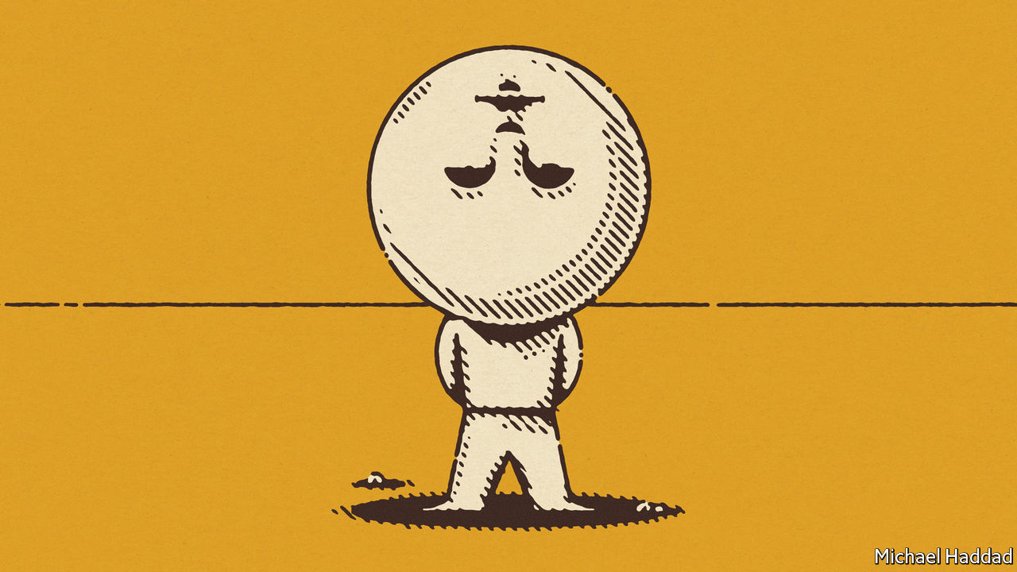

ARISTOTLE RECKONED the face was a window onto a person’s mind. Cicero agreed. Two millennia on, facial expressions are still commonly thought to be a universally valid way to gauge other people’s feelings, irrespective of age, sex and culture. A raised eyebrow suggests confusion. A smile denotes happiness. A frown indicates sadness.

Or do they? An analysis of hundreds of research papers that examined the relationship between facial expressions and underlying emotions has uncovered a surprising conclusion: there is no good scientific evidence to suggest that there are such things as recognisable facial expressions for basic emotions which are universal across cultures. Just because a person is not smiling, the researchers found, does not mean that person is unhappy.

As Lisa Feldman Barrett, one of the authors of the study, published in Psychological Science in the Public Interest, told the AAAS meeting in Seattle, “We surprised ourselves”. Dr Feldman Barrett is a psychologist at Northeastern University in Boston, Massachusetts, and along with her colleagues she found that, on average, adults in urban cultures scowled when they were angry 30% of the time. Which meant that some 70% of the time they did not scowl when angry. Instead, they did something else with their faces. People also scowled when they were not angry. “They scowl when they’re concentrating, they scowl when someone tells them a bad joke, they scowl when they have gas, they scowl for lots of reasons,” says Dr Feldman Barrett.

A scowl, the researchers concluded, is certainly one expression of anger. But it is not the only way people express that emotion. The ambiguous nature of facial expressions was not restricted to anger, but seemed valid for all six of the emotional categories that they examined: anger, disgust, fear, happiness, sadness and surprise.

All this raises questions about the efforts of information-technology companies to develop artificial-intelligence algorithms which can recognise facial expressions and work out a person’s underlying emotional state. Microsoft, for example, claims its “Emotion API” is able to detect what people are feeling by examining video footage of them. Another of the study’s authors, however, expressed scepticism. Aleix Martinez, a computer engineer at Ohio State University, said that companies attempting to extract emotions from images of faces have failed to understand the importance of context.

For a start, facial expression is but one of a number of non-verbal cues, such as body posture, that people use to communicate with each other. Machine recognition of emotion needs to take account of these as well. But context can reach further than that. Dr Martinez cited an experiment in which participants were shown a close-up picture of a man’s face, which was bright red with his mouth open in a scream.

Based on this alone, most participants said the man was extremely angry. Then the view zoomed out to show a football player with his arms outstretched, celebrating a goal. His angry-looking face was, in fact, a show of pure joy.

Given that people cannot guess each other’s emotional states most of the time, Dr Martinez sees no reason computers would be able to. “There are companies right now claiming to be able to do that and apply this to places I find really scary and dangerous, for example, in hiring people,” he says. “Some companies require you to submit a video CV, and then this is analysed by a machine-learning system. And depending on your facial expressions, they hire you or not, which I find really stunning and not only based on the wrong hypothesis, but a dangerous hypothesis.”■

This article was downloaded by calibre from <https://www.economist.com/science-and-technology/2020/02/22/do-not-rely-on-facial-expressions-for-how-people-are-feeling>

|  |  |  |  |
| --- | --- | --- | --- |
| Previous | Articles | Sections | Next |

|  |  |  |  |
| --- | --- | --- | --- |
| Previous | Articles | Sections | Next |

#### Cell biology

# Mapping cells to build a complete atlas of the human body

An international team makes progress

Feb 22nd 2020 | SEATTLE



BODIES ARE made of cells. Lots of them. An average adult human contains about 37.2trn cells, 100 times as many as the number of stars in the Milky Way. Clearly, trying to map the location of every one of these cells would be a futile endeavour. But cells are not identical. They are divided into many types, each specialised for different tasks. Mapping the location of each of these types is a more tractable problem. And that is the objective of the Human Cell Atlas project, a collaboration of researchers from 1,029 institutes in 71 countries around the world. Work on the atlas began in 2016, and its organisers hope to complete the effort by the end of this decade. Several of those involved gave a progress report to the AAAS meeting in Seattle.

As Aviv Regev of the Massachusetts Institute of Technology explained, compiling the atlas has been made possible by a technique called single-cell transcriptome sequencing. This looks, a cell at a time, at the messenger molecules which carry instructions from a cell’s nucleus to the protein-making machinery in its cytoplasm. These messengers are made by transcribing genes into a DNA-like chemical called RNA. All an organism’s cells have more or less the same DNA. What makes them different from each other is which bits of that DNA are being actively transcribed, and thus what proteins are being made. This means identifying and counting the RNA messengers shows what sort of cell it is.

One early discovery the project’s researchers have made is that there are many more types of cell than the text books suggest. Human cells have about 20,000 protein-coding genes and so possess 20,000 different possible messengers. One way to classify cells, Dr Regev explained, is to devise a graph that has 20,000 axes, each corresponding to a gene’s activity, and then plot particular cells as points on this graph. Clearly, such a graph would in a physical form be impossible, but it can exist and be manipulated in a computer. Plotting cells out in this way reveals how they cluster together. Those clusters are cell types.

Based on cells’ appearance under a microscope, and their reactions with chemical stains used to make them visible to microscopy, early histologists came up with about 300 cell types in a body. Single-cell RNA sequencing is multiplying that number by showing that cells which look similar under a microscope often turn out to be chemically different from one another. It has also found previously unknown cell types so rare that microscope studies have missed them.

One example Dr Regev proffered concerns the lining of the airways of the lungs. This tissue, pulmonary epithelium, is more easily sampled pre mortem than many others, so was an early candidate for investigation. The text books suggest it has six types of cell in it. RNA analysis showed that three of these six can themselves be divided into three, and that there are also two minor cell types previous investigators had overlooked. This turned out to be an important discovery, because one of the minor types proved to be where the gene involved in cystic fibrosis, a fatal hereditary disease of the lungs, is active.

Having identified individual cell types in this way, it is then possible to locate them within tissue samples. Fluorescent chemicals attached to molecular tags that will stick only to particular RNA messengers show up the cells containing those messengers. This permits construction of three-dimensional maps into which an observer may zoom to reveal ever finer levels of detail, in the same way that the zoom control works on an internet map of Earth.

That makes understanding the microscopic details of anatomy much easier. Shannon Hughes, of America’s National Cancer Institute, illustrated this with the example of skin cancer. Tumours are particularly good targets for transcriptome sequencing because they are caused by genetic mutations that show up in the RNA messengers. This has led to a parallel effort to the Human Cell Atlas, the Human Tumour Atlas, a network devoted specifically to studying cancer. And, like the lining of the lungs, the skin is easily sampled. Dr Hughes and her colleagues have been able to detect pre-cancerous skin cells (those without the full complement of mutations needed to make them cancerous), and observe how these are already attracting the attention of immune-system cells called T-lymphocytes, which burrow through the skin tissue to attack their targets.

Kerstin Meyer of the Wellcome Sanger Institute in Britain, meanwhile, trailed the publication of a complete map of an organ called the thymus. This has subsequently appeared on February 20th as a paper in Science, the AAAS’s house journal,

The thymus, located just above the lungs, is where T-lymphocytes develop. By looking at 25 thymuses from embryos, fetuses, children and adults, Dr Meyer and her colleagues have constructed a map that stretches through time, as well as space. Their transcriptome sequencing distinguishes more than 40 cell types, and they can follow the ebb and flow of these at different stages of life.

The thymus is, admittedly, but a small continent in the world that is a human body. Mapping it is, however, an important advance for the cellular cartographers. Bigger organs will follow soon. The result will be the most granular view yet obtained of human anatomy.■

This article was downloaded by calibre from <https://www.economist.com/science-and-technology/2020/02/22/mapping-cells-to-build-a-complete-atlas-of-the-human-body>

|  |  |  |  |
| --- | --- | --- | --- |
| Previous | Articles | Sections | Next |

|  |  |  |
| --- | --- | --- |
| Science and ... | Sections | Economic and ... |

Books and arts

Histories of the web: Paradise lost

.

Jean history: Rhapsody in blue

.

Mountaineering wars: Summit diplomacy

.

Kurdish art: Remember, remember

.

Russian lives: The grey zone

.

|  |  |  |
| --- | --- | --- |
| Science and ... | Sections | Economic and ... |

|  |  |  |  |
| --- | --- | --- | --- |
|  | Articles | Sections | Next |

#### Paradise lost

# Whose internet is it anyway?

Memoirs by an alumna of Silicon Valley and an internet user chart the web’s history

Feb 22nd 2020 |

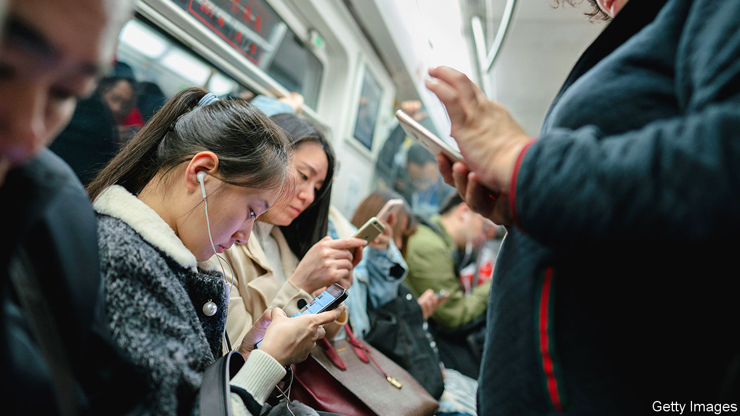

Uncanny Valley. By Anna Wiener. MCD Books; 288 pages; $27. Fourth Estate; £16.99.

Lurking: How a Person Became a User. By Joanne McNeil. MCD Books; 288 pages; $28.

IN THE PAST decade the number of people using the internet has leapt from 1.8bn, or a quarter of the world, to 4.1bn, well over half. Internet companies grew with their user bases. Ten years ago Facebook had roughly 2,000 employees; today 45,000 people work for it full-time, mostly in Silicon Valley. Google went from 24,000 staff to 119,000 in the same period. Add in other big firms such as Apple and Netflix, dozens of unlisted “unicorns” and thousands of startups, and the head-count in the valley is equal to a fair-sized city.

Who are these people? A handful are stereotypical wunderkinds, too busy building apps that improve the human condition to waste time on human emotions (or finish their degrees). But many—all the normal folk in sales, marketing, HR, customer support—are like Anna Wiener, the author of “Uncanny Valley”, a memoir about working in the tech industry of the 2010s. Like most people, the condition they mainly want to improve is their own.

In her telling, Ms Wiener, a sociology major who had the misfortune to graduate into the global financial crisis, starts her professional career as an assistant to a literary agent in New York. Tired of being privileged yet “downwardly mobile”, she joins a tech startup on the east coast, flubs it, but fails upwards to a better-paid job in San Francisco. Once there she observes first-hand the absurdities and extravagances of the industry. One of her employers is a meritocracy-obsessed cult with a name-your-own-salary policy that leads to an enormous gender pay gap. It marks its first round of venture-capital funding by building an exact replica of the Oval Office.

Another outfit unironically releases a sinister feature called Addiction which, as Ms Wiener ghostwrites in the blog post announcing it, “allows companies to see how embedded they are into other people’s lives”. She is at her best when describing the carelessness that would give the tech industry its well-deserved reputation for hubris. “Don’t be evil” is a blithe motto if the definition of “evil” is unexamined.

In New York, Ms Wiener recalls, “I had never considered that there were people behind the internet.” But in San Francisco “it was impossible to forget”. After all, she was one of them. Occasionally she has pangs of conscience, asking a friend, “Do you think I work at a surveillance company?” But such concerns fall by the wayside in a cloud of ecstasy and clean air, as she finds the twin millennial grails of a decent salary and comprehensive health care. Ever the ingénue, Ms Wiener does not set out to straddle the world like a colossus. She and legions like her are content merely to peep about from under the legs of digital history’s great men—men like the founder of “the social network everyone hated”, as she periphrastically refers to him.

“Of course, I hate [Facebook]. Who doesn’t?” writes Joanne McNeil in “Lurking”, a memoir of using, rather than making, the internet. She is almost apologetic about this judgment, noting that her lapse from reasoned criticism to diatribe is reserved for this single platform, a “digital cesspool” that is “one of the biggest mistakes in modern history”. The passage comes after more than 200 pages of reminiscences about the internet of yore—a place where people could choose to be “private or public, anonymous or named, factual or make-believe”. Ms McNeil covers niche New York chat rooms; the web’s early suburbs, known as GeoCities; and the proto-social networks of Friendster and Myspace, guiding readers, Virgil-like, to the Zuckerberg inferno.

## Mon semblable, mon frère

What happened? How did the web become “a hell that is fun, ruled by idiots and thieves”? The key is the smartphone, which brought the internet into everyday life. When Steve Jobs unveiled the iPhone in 2007, “the internet” and “real life” were still separate domains; people had to “get online” to move from one to the other. That was a disincentive, and anyway many had better ways to spend spare time than sit in front of a screen. A decade later, smartphones in hands, the distinction had evaporated. Suddenly anyone could be online—and they were, everywhere and all the time.

The people behind the internet continued to believe that most users were versions of themselves, “white, male, age 25 to 34, college-educated”. In reality the internet is more diverse, says Ms McNeil, taking in women and users of other ages, LGBT folk, ethnic minorities and all combinations thereof. True—but her idea of diversity is itself a narrow one. In fact, in the period she chronicles, the average internet user became poorer, older, less white and less likely to speak English. Seen through this lens, bemoaning the decline of “the internet” is a bit like complaining that flying has lost its glamour, or that a favourite bar has been overrun by strangers. Nobody goes there any more—it’s too crowded, as Yogi Berra once quipped.

America developed the internet, powerful American companies still run big swathes of it, and jobsworth American workers like Ms Wiener merrily push pixels around inside those behemoths. Yet just 6% of the world’s internet users are American. A vanishingly small proportion ever hung out in the AOL chat rooms or LiveJournal blogs of Ms McNeil’s lost nirvana. And the cultural influence of those early American users is steadily waning.

Perhaps the starkest example of this is the rise of TikTok, an app that lets people create and share short, goofy videos. It is owned by ByteDance, a giant Chinese startup; last year, several American senators speculated that it might pose a national-security risk. TikTok denied allegations that its moderators took account of Chinese sensitivities, insisting it had never been asked to remove content by China’s government (and would not comply if it were).

TikTok is unusual. When your home market is small or poor (as in much of the world), or hived off into a separate silo (like China’s), it is hard to build global firms. All the same, even if the business of the internet remains anchored in California, its culture—the movies and music, flirtations and conversations—is expanding all the time, confounding the Silicon Valley types who thought they owned it. There is no longer such a thing as “the internet”, but many internets, belonging to many people, distinct but overlapping. It is not dying, as Ms McNeil fears, just respawning. ■

This article was downloaded by calibre from <https://www.economist.com/books-and-arts/2020/02/22/whose-internet-is-it-anyway>

|  |  |  |  |
| --- | --- | --- | --- |
|  | Articles | Sections | Next |

|  |  |  |  |
| --- | --- | --- | --- |
| Previous | Articles | Sections | Next |

#### Rhapsody in blue

# The legend of Levi Strauss

An exhibition in San Francisco shows how American denim conquered the world

Feb 22nd 2020 | SAN FRANCISCO



HE WAS BORN in a Bavarian village in 1829, fleeing anti-Semitism with his family at 17. From New York he caught a steamer to California, a newly minted American citizen, with a view to expanding the family’s dry-goods business. But these were the heady days of the Gold Rush, and the young man dreamed of making it big. His initiative paid off so well that you may be wearing his invention now: his name was Levi Strauss.

Technically, the entrepreneur who went by “Uncle Levi” didn’t invent the copper rivets on denim “waist overalls” that became his firm’s stock-in-trade. The idea came from a tailor in Nevada who bought cloth from Strauss to make work clothes for labourers. In 1872 Jacob Davis persuaded him to jointly file for a patent for an “improvement in fastening pocket openings”, and to shift from selling fabric to finished trousers. The rest is a history of marketing genius—documented in the largest-ever public display of artefacts from the Levi Strauss & Co. archive.

“Levi Strauss: A History of American Style” at the Contemporary Jewish Museum in San Francisco deftly weaves together corporate, cultural and social trends to tell the story of one of the country’s most famous exports. When Strauss died in 1902 he was eulogised as one of San Francisco’s foremost philanthropists and a pillar of the Jewish community. Nobody could have anticipated that the firm he bequeathed to four nephews would define America’s style and become a global juggernaut. It did that by cannily roping its product to two mythic American figures: the cowboy and the rebel.

Levi’s 501 jeans were tough. The oldest pair on display dates to 1890; another was used to tow a car. Marketed originally to farmers, mechanics and miners, they became the garb of choice for Western horsemen. It wasn’t long before John Wayne and Clark Gable were wearing them into the sunset, followed by glamorous hoodlums played by Marlon Brando and James Dean.

The brand’s advertising rode the countercultural wave, capitalising on its status as a badge of coolness and freedom. Marilyn Monroe wore Levi’s; Andy Warhol immortalised them. Even Albert Einstein was spotted in a Levi’s bomber jacket. Jeans that graced the haunches of the famous—including Patti Smith, Madonna and Beyoncé—fill the gallery and span the decades.

At any given moment a big chunk of humanity is wearing blue jeans, the show’s curators observe. Levi’s have been coveted behind the Iron Curtain and fetishised in Japan; they have been ripped, embroidered and covered in ink. Not too shabby for a kid from Bavaria.

This article was downloaded by calibre from <https://www.economist.com/books-and-arts/2020/02/22/the-legend-of-levi-strauss>

|  |  |  |  |
| --- | --- | --- | --- |
| Previous | Articles | Sections | Next |

|  |  |  |  |
| --- | --- | --- | --- |
| Previous | Articles | Sections | Next |

#### Summit diplomacy

# A race to the top of the world

In the 1930s great-power rivalry played out in the Himalayas

Feb 20th 2020 |

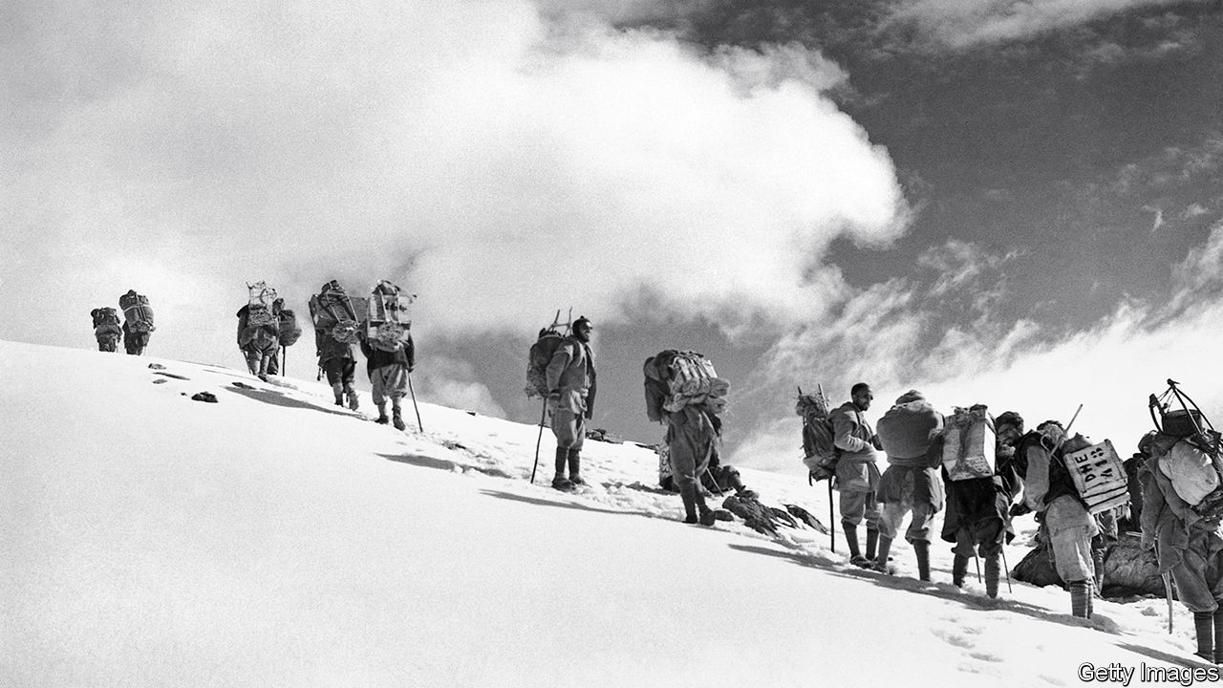

The World Beneath Their Feet. By Scott Ellsworth. Little, Brown; 416 pages; $30. John Murray; £25.

IN 1933, WHEN Maurice Wilson decided to pilot a single-propeller aeroplane from London to the Himalayas, crash land on a 14,000-foot glacier and ascend to the summit of Mount Everest by himself, he did not reckon on the forbidding challenge of British bureaucracy. After flying more than 5,000 miles (8,050 kilometres), the amateur aviator and mountaineer was denied a permit to cross Nepali airspace and grounded in British India. Undeterred, Wilson secretly slipped across the border into Tibet on foot, disguised as a Buddhist monk. The last entry in his diary, found near his body 2,300 metres below Everest’s peak, reads: “Off again, gorgeous day.”

Persistently optimistic—and perhaps completely mad—Wilson shared the determined idealism of the world’s best mountaineers. In his lively new book, “The World Beneath Their Feet”, Scott Ellsworth profiles the single-minded climbers who scaled the Himalayas’ tallest peaks in the 1930s. With war on the horizon, teams from Britain, the United States and Germany raced to plant their national flags on the “roof of the world”.

By the 1930s high-altitude mountaineering had become as much a source of national prestige as space exploration would be in the 1960s. “We ought not to treat the climbing of Mount Everest as a domestic issue,” argued a piece in theLondon Morning Post in 1936. “It is an issue of National and Imperial importance.” In Berlin the Reichssportführer demanded the conquest of Nanga Parbat “for the glory of Germany”; Nazi officials wondered whether mountaineering missions could facilitate high-altitude aircraft tests over the Himalayas.

The 23 expeditions undertaken between 1931 and 1939 invariably entailed extreme trials—among them perilous icefalls, pounding hail and fingers and toes lost to frostbite. The British Everest expedition of 1933 began with a 300-mile walk from Darjeeling to Base Camp in Tibet, where one climber felt the cold “must be that of interstellar space”. Not that these efforts were entirely without luxury. The failed French Himalayan expedition of 1936 was weighed down by eight tonnes of supplies, including 72 fillettes of champagne and “countless” tins of foie gras.

Many of these adventures ended in tragedy. Seven climbers and nine porters were buried by an avalanche during a German expedition to Nanga Parbat in 1937; it was, at the time, the worst disaster in the history of mountaineering. But for those who succeeded, the payoff was astonishing. “The horizon surrounded us in one unbroken ring,” wrote the American climber Terris Moore in his diary after reaching the summit of Minya Konka, “and I fancied that I could see the curvature of the Earth.”

Mr Ellsworth presents a gripping history, despite the occasional cliché (“Whether or not mad dogs and Englishmen could stay out of the noonday sun was debatable. But Englishmen…simply couldn’t keep out of the hills”). He takes care to describe the experiences and contributions of Nepali sherpas—including a young man named Tenzing Norgay—who were hired to support expeditions. Even as European and American mountaineers relied on their expertise, they typically maintained strict divisions between sherpa and sahib. Sherpas were nearly always allocated inferior equipment and lodging.

When war broke out in 1939, the mountaineers were forced to abandon the Himalayas for the front. But the race was merely on hold. In 1953, after seven failed attempts by British expeditions, Tenzing and Sir Edmund Hillary made the first successful climb to the summit of Everest. From the mountaintop, Tenzing waved the flag of the United Nations. “I like to think that our victory was not only for ourselves”, he reflected, “but for all men everywhere.” ■

This article was downloaded by calibre from <https://www.economist.com/books-and-arts/2020/02/20/a-race-to-the-top-of-the-world>

|  |  |  |  |
| --- | --- | --- | --- |
| Previous | Articles | Sections | Next |

|  |  |  |  |
| --- | --- | --- | --- |
| Previous | Articles | Sections | Next |

#### Remember, remember

# A Kurdish artist memorialises the experiences of his people

Osman Ahmed trekked with the Peshmerga, armed only with a pencil and a sketch-book

Feb 22nd 2020 | SULAYMANIYAH

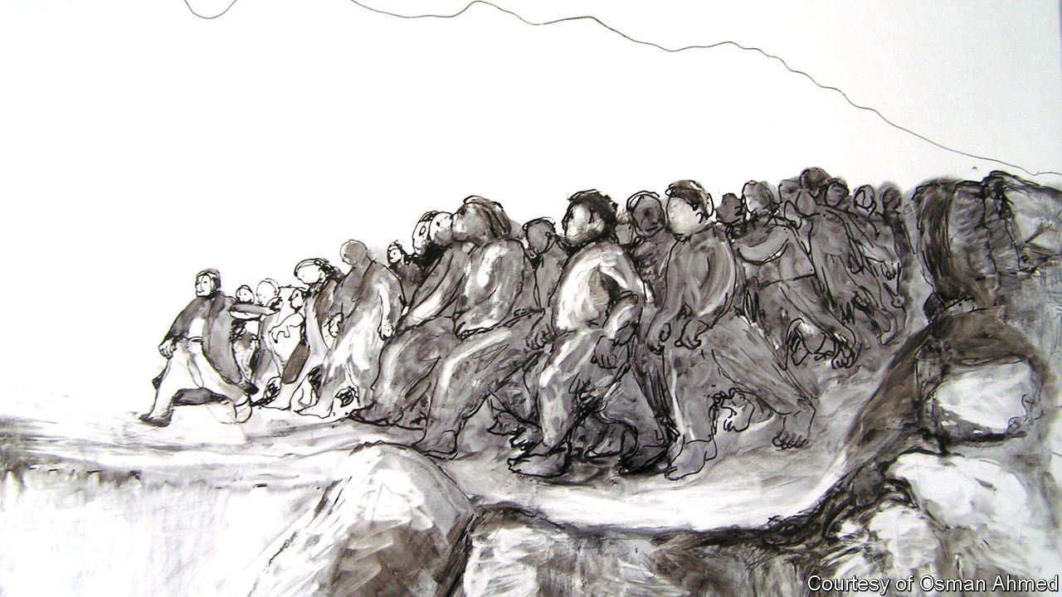

“I REMEMBER IT was so cold and raining heavily,” recounts Osman Ahmed, “and somehow in the mountains it was snowing.” It was November 1985, and Mr Ahmed was making an arduous journey that would lead to an artistic one. He had been trekking across northern Iraq with Kurdish Peshmerga, to escape Baathist persecution during the Iran-Iraq war. Unusually for a militiaman, he refused to carry a weapon and was armed only with a pencil and a sketch-book. Making it across the Iranian border to Tehran, he discovered libraries replete with images of European art. But his subsequent efforts to reach Europe landed him in prison and refugee camps; reluctantly, he went back to Kurdistan.

It seemed to Mr Ahmed that no one was documenting the horrors of the conflict. He remembers his anguish, after returning to the mountains with the Peshmerga, to find that no radio station in the region was covering the destruction of Kurdish settlements. Then in 1988, during the last phase of Saddam Hussein’s genocidal Anfal campaign, government forces unleashed the worst-ever chemical-weapons attack on civilians in the village of Halabja. “If I make it through this war alive,” Mr Ahmed vowed, “I will make sure that the whole world knows about this.”

He has since become one of Kurdistan’s best-known artists; his pictures, which memorialise the suffering of his people, have appeared in galleries across the Middle East and Europe, including Tate Britain in London. His emotionally raw work is sometimes compared to Goya’s, though friends describe him as a Kurdish Toulouse-Lautrec, partly because of his small stature, but mostly for his observational style. For the PhD he completed in London in 2013, he documented Anfal in line-drawings based on the memories of survivors. Despite the grave subject matter, the drawings’ sense of movement—like the vibrancy of his earlier, modernist-inspired paintings—imbues his oeuvre with an air of resilience and vitality.fs

“I was shocked to see such vivid and lively works,” says Shad Abdulkarim, a collector who plans to include some of Mr Ahmed’s early paintings in the contemporary-art museum he is opening in the Kurdish city of Sulaymaniyah this year. That is one of the institutions now springing up to safeguard a culture that has helped sustain the Kurds’ stateless nation through centuries of conflict. Another is the Culture Factory, an expansive new arts hub that, with support from the Kurdistan Regional Government, is being developed in a formerly derelict tobacco factory in Sulaymaniyah. An exhibition of Mr Ahmed’s drawings opened in one of its galleries in December.

“Our political situation repeats every ten years,” says Dara Ola, the show’s curator and a co-founder of the Culture Factory. Mr Ahmed’s theme “of Halabja, refugees, of fleeing home—it’s always current.” Indeed, the parallel with Turkey’s recent attacks on Kurds in Syria is stark. Mr Ola suspects that younger Kurds, tired of politics and war, need to be reminded of their history, and thinks Mr Ahmed’s pictures can help. “It’s a different experience to see artwork about this subject rather than a documentary or photos,” he reckons. For his part, Mr Ahmed now abjures colour in his art. “Black and white”, he says, “is the best language to bring the pain out.” ■

This article was downloaded by calibre from <https://www.economist.com/books-and-arts/2020/02/22/a-kurdish-artist-memorialises-the-experiences-of-his-people>

|  |  |  |  |
| --- | --- | --- | --- |
| Previous | Articles | Sections | Next |

|  |  |  |  |
| --- | --- | --- | --- |
| Previous | Articles | Sections | Next |

#### The grey zone

# Compromise and survival in Vladimir Putin’s Russia

Joshua Yaffa’s book charts the territory between defiance and collusion

Feb 22nd 2020 |

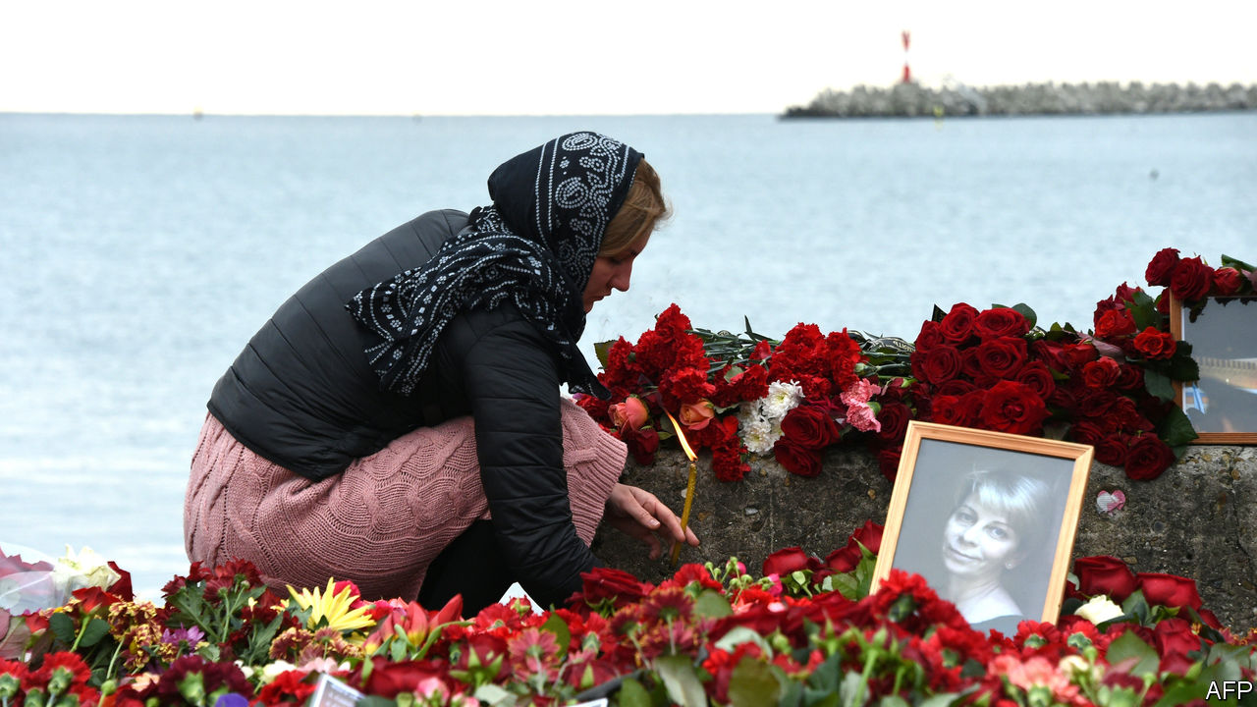

Between Two Fires. By Joshua Yaffa. Tim Duggan Books; 368 pages; $28. Granta Books; £20.

PEOPLE WHO devote themselves to helping the unfortunate are not always loved by the more comfortable. They are a pain in the conscience; they can be gratingly pious. But in her heyday as a friend of Moscow’s dying and destitute, Elizaveta Glinka, a medical philanthropist known as Doctor Liza, was likeable as well as inspiring. Whether she was ministering to rough sleepers at a Moscow railway station or visiting patients facing lonely deaths at home, her style was both sensitive and practical. She could cajole awkward bureaucrats and relieve the afflicted. She frankly acknowledged her own fear of death; it came to her three years ago, when a flight carrying visitors to the Russian garrison in Syria crashed into the Black Sea.

Among the tales of integrity and compromise in Vladimir Putin’s Russia that Joshua Yaffa narrates in his wonderfully insightful new book, Glinka’s story is the most poignant. In a process minutely traced by Mr Yaffa, an American journalist and previously a contributor to The Economist, things changed for her when Russian-backed fighters staged their rebellion in Ukraine in 2014. She began organising the evacuation of children, many of them wounded, from the war zone, dealing pragmatically with both sides of the deadly conflict. But her apolitical, common-sense approach, effective as it had proved in Moscow, came to entail moral hazards on the battlefield.

As Glinka’s national profile rose, so did her connections with the Russian elite, and she was obliged to collude with the fiction that the Kremlin bore no blame for the unfolding mayhem in Ukraine. Her powerful contacts, including Mr Putin himself, abetted her humanitarian work and tried to bask in her moral glow. Her older, liberal-minded friends concluded that she had sold out to the country’s rulers. Those rulers lamented her death loudly, proclaiming her a quasi-saint; more long-standing acquaintances mourned with an extra tinge of sadness, feeling she was a good person whose record was ultimately tainted.

All Mr Yaffa’s well-told and neatly interlinked stories describe individuals whose response to Russia’s authorities belongs somewhere on the spectrum between defiance and calculating collusion. His subjects include Kirill Serebrennikov, a theatre director who was placed under house arrest; and an entrepreneurial zookeeper in Crimea who, after the peninsula was annexed, initially expected to benefit but fell foul of the new Russian masters. In a revealing exchange, the director of a prison-camp-turned-museum in Perm tries to persuade Mr Yaffa, and perhaps herself, that its response to official pressure—evolving from a warning against totalitarianism to a softer take on the Soviet era—is justified, if only because closure might be the alternative. As Glinka seemed to do in the final part of her life, the director makes a utilitarian case for compromise.

Some compromise reluctantly, others with apparent eagerness. One of Mr Yaffa’s profiles is of the television boss Konstantin Ernst, who after a mildly bohemian youth used his cinematographic talents to hone Mr Putin’s image as Russia’s strong-willed saviour. Some readers will wish that Mr Yaffa had devoted more space to characters who preserved their integrity to the end, even if that meant paying a heavy penalty. He does offer one striking portrait of a person who fits firmly in that category: the dissident Russian Orthodox cleric Father Pavel Adelgeim, who was murdered in 2013 by a mentally deranged man.

In his youth, Adelgeim had endured travails for his Christian faith. He was sent to a labour camp for professing “anti-Soviet” opinions, where he suffered a work accident which cost him a leg. Later he learned that a fellow-seminarian, who would go on to make a decent career as an ecclesiastical diplomat, had denounced him. By telling the priest’s life-story, Mr Yaffa is able to sketch in outline the recent history of the Russian Orthodox church—from a precarious existence under communism, to a phase of flourishing in new-found freedom, to one of symbiosis with the state.

Adelgeim was one of the few clerics who challenged this trend. In particular, he questioned the harshly authoritarian power structures that emerged within the church, mirroring those of the secular regime. This stance enraged the bishop under whom he served in north-western Russia, and the cleric found himself demoted and isolated in the church, though still revered by his flock. Some admirers called him “the last free priest” in Russia. That is an over-simplification. Last year, for instance, around 200 priests signed a petition of protest against the incarceration of people who had taken part in anti-government demonstrations.

It is to Mr Yaffa’s credit that in general he avoids simplifying. Even when he describes people who seek cynical advantage from the powerful, the picture is never completely dark; when he portrays moral heroes, he never presents them as infallible. That is how things are in life, perhaps nowhere more so than in Russia. ■

This article was downloaded by calibre from <https://www.economist.com/books-and-arts/2020/02/22/compromise-and-survival-in-vladimir-putins-russia>

|  |  |  |  |
| --- | --- | --- | --- |
| Previous | Articles | Sections | Next |

|  |  |  |
| --- | --- | --- |
| Books and arts | Sections | Graphic detail |

Economic and financial indicators

Economic data, commodities and markets

.

|  |  |  |
| --- | --- | --- |
| Books and arts | Sections | Graphic detail |

|  |  |  |  |
| --- | --- | --- | --- |
|  | Articles | Sections | Next |

# Economic data, commodities and markets

Feb 22nd 2020 |

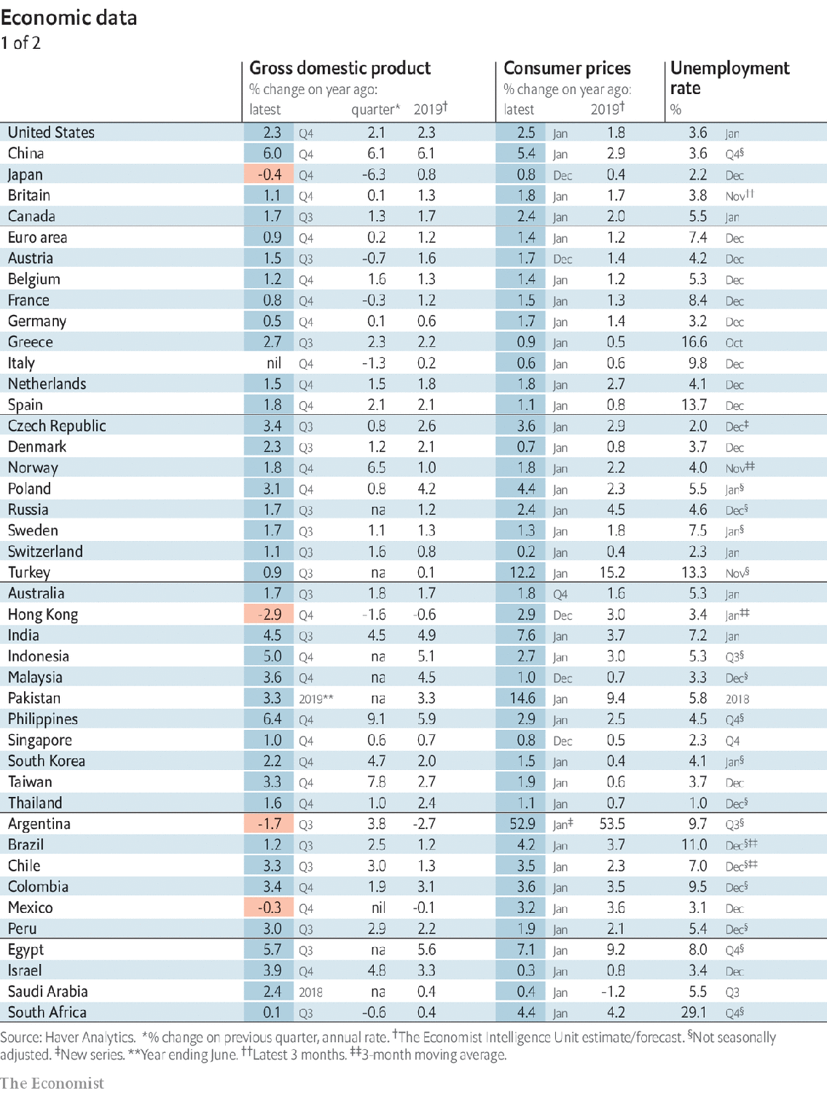

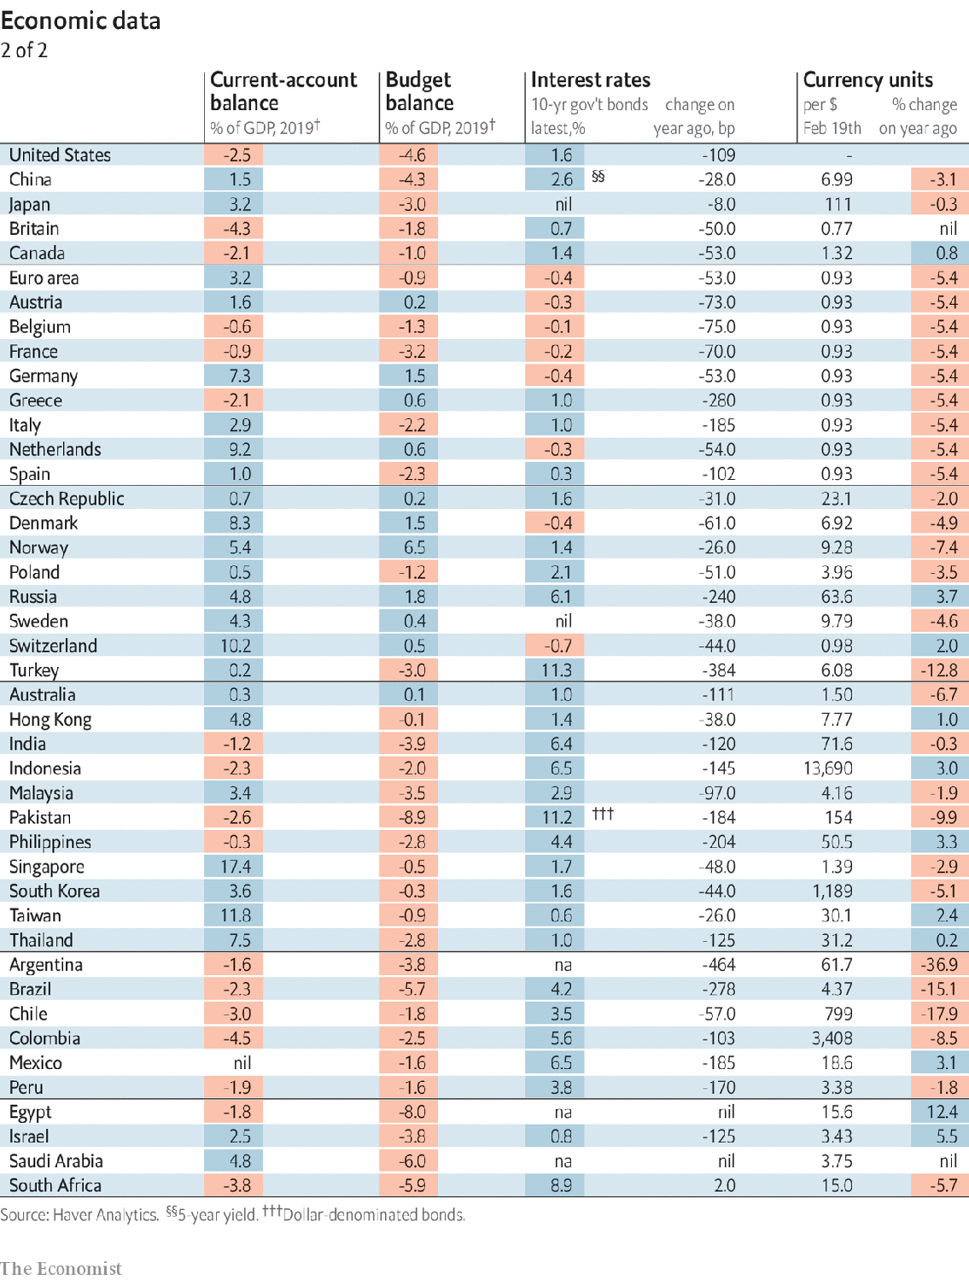

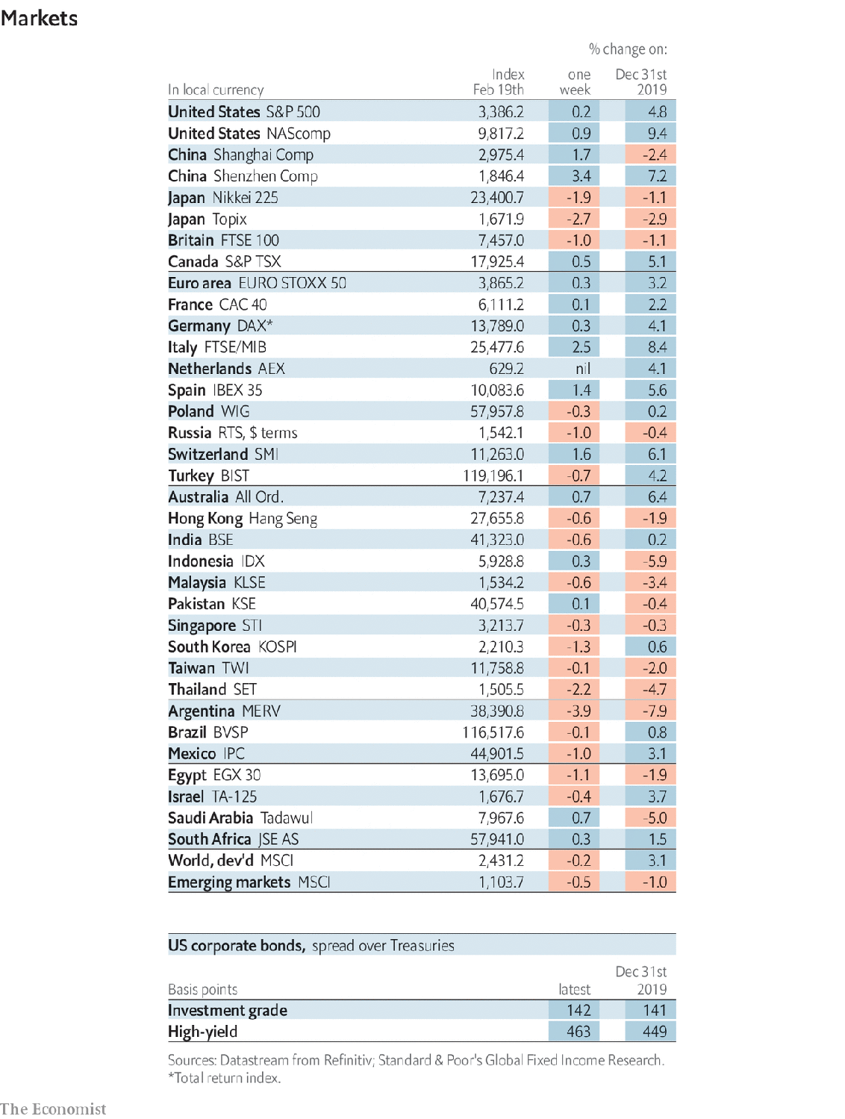

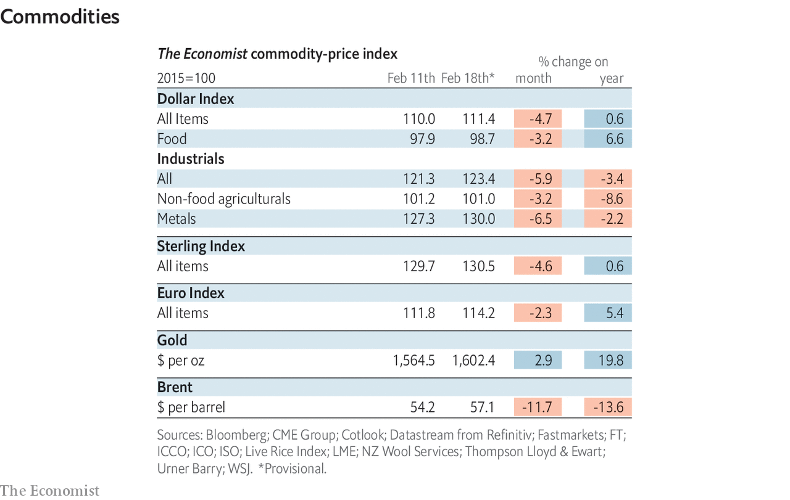

This article was downloaded by calibre from <https://www.economist.com/economic-and-financial-indicators/2020/02/22/economic-data-commodities-and-markets>

|  |  |  |  |
| --- | --- | --- | --- |
|  | Articles | Sections | Next |

|  |  |  |
| --- | --- | --- |
| Economic and ... | Sections | Obituary |

Graphic detail

Discrimination in China: Call me maybe

.

|  |  |  |
| --- | --- | --- |
| Economic and ... | Sections | Obituary |

|  |  |  |  |
| --- | --- | --- | --- |
|  | Articles | Sections | Next |

#### Call me maybe

# China’s minorities have a tough time finding jobs

Discrimination towards Uighurs means they are three times less likely to be called back by employers

Feb 22nd 2020 |

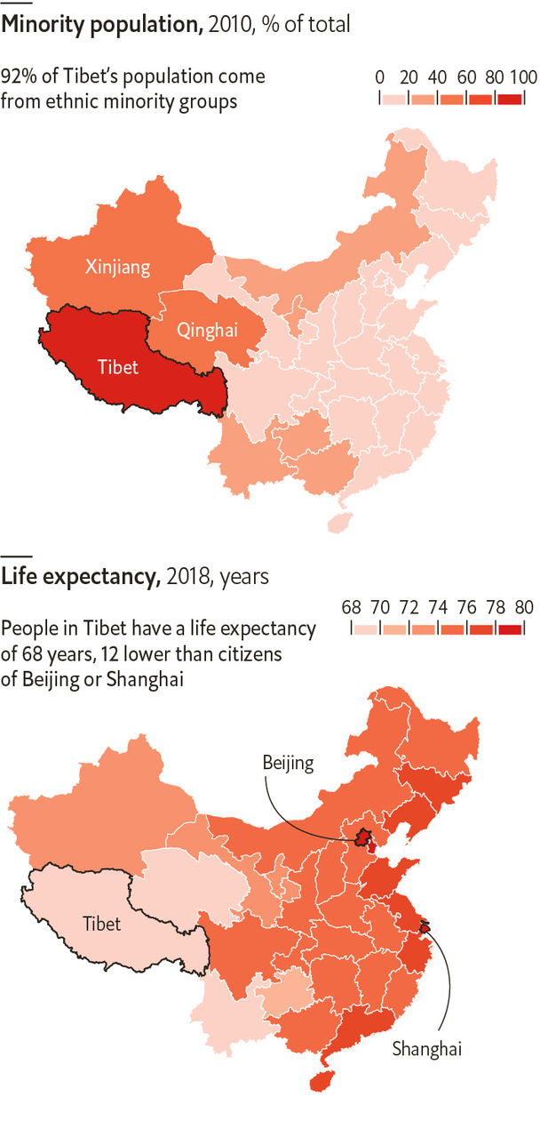

IT IS EASY to think of China as monolithic. But the government’s repression in Tibet and “re-education camps” in Xinjiang, in which perhaps 1m Uighurs have been incarcerated, are reminders that not everyone receives equal treatment. New research shows that discrimination against China’s ethnic minorities, who make up 8% of the country’s population, is pervasive, even in cosmopolitan megacities.

One common way to measure how much racial discrimination there is in a society is by conducting “résumé experiments”, in which researchers send off thousands of fake job applications and count the number of responses by ethnicity. A recent paper by Yue Hou, Chuyu Liu and Charles Crabtree, three political scientists, applies this method to employers in China to see how well job applicants of three of China’s ethnicities fare: the Han, who are the majority, and Uighurs and Huis. The latter two are mainly Muslim minority groups, though the Huis are culturally much closer to the Han than Uighurs.

The study shows that on average, Hui job-seekers had to send twice as many applications as Han applicants do to hear back, and Uighurs nearly four times as many. The gap was even greater for highly educated workers: Uighur candidates who were in the top 1% academically needed to send six times as many applications as equally qualified Han candidates. This difference was also similar in both smaller cities and in the provincial-level regions of Guangdong, Beijing and Shanghai. State-owned enterprises, which have an official mandate to hire more minority workers, appeared at least as biased as other firms.

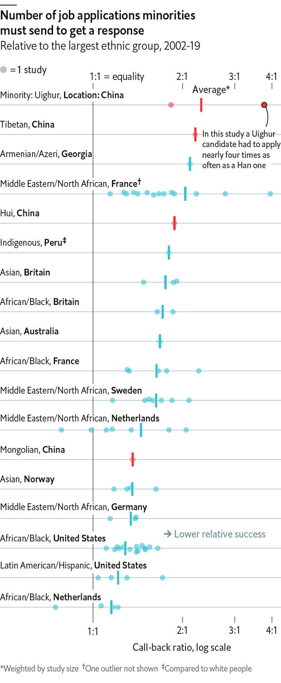

These figures are especially troubling when placed in an international context. The Economist tracked down over 100 résumé experiments conducted in 15 countries over the past 20 years. These experiments have mainly been done in Western countries where research funding is readily available. Still, we find that Tibetans and Uighurs in China have a much tougher time looking for jobs than minorities in any other countries with reliable data.

Unemployed minorities in China hoping the state will help might well be disappointed. One study, also based on a randomised experiment, found that government officials were 33% less likely to respond to information requests about a cash-transfer programme for the poor if they were signed with a Uighur name. ■

Sources: Hou, Liu and Crabtree, 2019; Quillian et al., 2019; Bertrand and Duflo, 2017; Distelhorst and Hou, 2014; Maurer-Fazio, 2012; government statistics; The Economist

This article was downloaded by calibre from <https://www.economist.com/graphic-detail/2020/02/22/chinas-minorities-have-a-tough-time-finding-jobs>

|  |  |  |  |
| --- | --- | --- | --- |
|  | Articles | Sections | Next |

|  |  |  |
| --- | --- | --- |
| Graphic detail | Sections |  |

Obituary

“Mad Mike” Hoare: Living dangerously

.

|  |  |  |
| --- | --- | --- |
| Graphic detail | Sections |  |

|  |  |  |  |
| --- | --- | --- | --- |
|  | Articles | Sections | Next |

#### Living dangerously

# “Mad Mike” Hoare died on February 2nd

The commander of the “Wild Geese” mercenaries in Congo was 100

Feb 22nd 2020 |

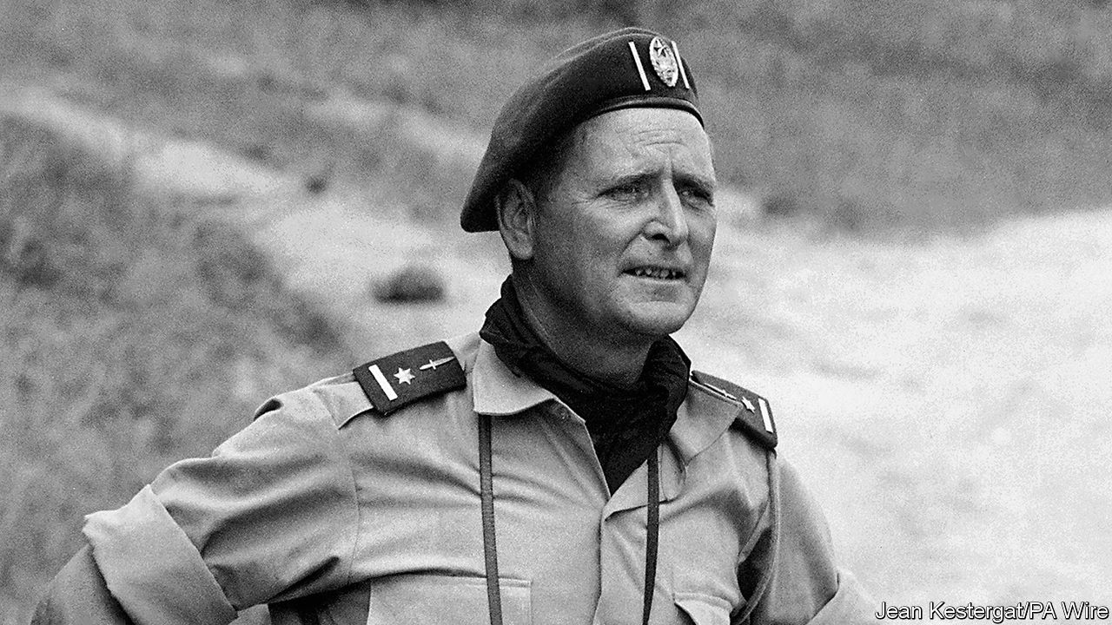

WHEN HE WAS back in civvy street, Mike Hoare was an accountant. It may have been a liking for neat columns on a page that made him so insistent on a trim troop. As the man in charge of 5 Commando, he did not tolerate beards or swearing. The men’s hair had to be as short as his own, barely showing below the black beret—which, combined with his wiriness and hawkishness, gave him a decent resemblance to Montgomery of Alamein. On Sundays, boots cleaned, they lined up for church parade.

They looked as good as any regular regiment. Yet they were soldiers for hire. The clue was on their flag and shoulder patches, which showed a wild goose flying. They were his Wild Geese, named after the fabled Irish mercenaries of the revolutionary wars. (He was Irish himself, both parents, and all the more so when he got sentimental.) Their job was to carry out operations ordinary armies could not. In 1964 and 1965 he and 5 Commando, at the invitation of Moise Tshombe and for up to $1,100 each a month, helped rid Congo of communists after independence. They stabilised breakaway Katanga province, defeated the Simba rebels and mopped up resistance in the east; most strikingly they helped retake Stanleyville (later Kisangani), rescuing nearly 2,000 hostages, most of them priests and nuns. These exploits made them, and him, world-famous. He was “Mad Mike” to Fleet Street, and in 1978, in “The Wild Geese”, Richard Burton played a mercenary heavily based on him. All that certainly beat totting up sums every day.

His task, though, had not been simple. He had to find recruits through small ads in the Johannesburg and Salisbury newspapers, appealing for men who both loved combat and were “tremendous romantics”—like himself. After wartime service in Burma and India he had married and settled in Durban, but stayed restless. He did marathon walks, rode a motorbike from Cape Town to Cairo and searched for the Lost City of the Kalahari. But none of this was living dangerously enough. In his 40s, when the Congolese invitation came through a business contact, he was ready.

He had fought before, under orders. Now he could lead men. Not ruffians, but hard men who could march 20 miles a day (nothing finer than a good march) and not grumble. To have control over their lives and deaths moved him in a strange way. Yet they were a ragbag of misfits when they arrived. Some were German, ex-Nazis, one still sporting his Iron Cross. All were white. Many, coming from apartheid countries, were racists. (He himself described African soldiers as realists whose main aim was to survive and, if ordered to go out and possibly get killed, would not do it; he was far ruder about the foul-mouthed, swaggering Belgian mercenaries he met.) Some recruits melted under fire. If that happened he might set an ostentatiously cool example, such as opening out his maps in the middle of an enemy ambush and calmly consulting them. If they misbehaved, he disciplined them ruthlessly. When a mutiny threatened, he plucked out the leader and pistol-whipped him. That proved a watershed in his life, the moment when everything stood or collapsed. Luckily for him, his authority stood.

He wanted his Wild Geese to look respectable. The word “mercenaries” annoyed him; they were “volunteers”. Money was not the point, or not for him. He was given a brick of gold once, when they stumbled on an abandoned mine, but was relieved when someone stole it. Glory was his purpose, not plunder. His men seized opportunities, as when they captured a United Nations helicopter, disassembled it and sold it back to the UN as spare parts. They took trophies, decorating their trucks with the spears, shields and heads of Simba warriors. After liberating Stanleyville they went on a rampage, draining hotel bars and dynamiting bank safes, while he stood by. But this was not, he thought, a shooting matter. It was their finest hour, having just released hostages so bruised and beaten that some no longer resembled human beings.

Other rescues had been carried out up-country, on his own initiative. He often went beyond instructions. Hijacking boats, piloting them himself under heavy fire, was his speciality: a role that pleased him, as his father had been a river pilot on the Hooghly in Calcutta. A commando unit had that flexibility. Were there atrocities? a reporter asked him once. Extremely few, he said; the savagery of the tribal revenge-killings he had witnessed, when fighting alongside the Congolese army, had been more than enough to see. Executions? Only after courts martial. Wholesale butchery happened only when Simba rebels, assured by their witch doctors that bullets would turn to water, attacked them en masse.

In eastern Congo, where he sent the Simbas’ Cuban officers packing, he dislodged Che Guevara too. That made him, he reckoned, the only man up till then to beat Che in a battle. It was one more part of the romantic history he liked to weave around him. By saving Congo he had helped save Africa, and hence the West, from the greatest cancer, communism. He reckoned the Wild Geese had killed 5,000-10,000 communists in 20 months of combat. But that was not enough; so in 1981, though retired to The Old Vicarage in Durban, he took up an invitation from the ex-president of the Seychelles to remove by force the leftist who had usurped him.

Since the Wild Geese had long flown, he recruited 46 brawny men to pose as ex-rugby players on a charity flight to the Seychelles to take toys to children. Beneath the toys, in each kit-bag, were disassembled AK47s. All went well until one of these was found at the airport. A gun battle broke out, during which a Boeing 707 landed to refuel; he and his men hijacked it to return to South Africa, drinking champagne on board, only to be arrested on arrival. They ended up in prison and, worse, ridiculed on every side. Most hurtfully, he was expelled from the Institute of Chartered Accountants.

His sentence was ten years. He served 33 months, memorising Shakespeare from a volume he had smuggled in. Such immersion suited him, since the man he had most wanted to be was Sir Francis Drake: the intrepid voyager and terror of Spaniards whose outrages were all forgotten when, on his return, he knelt before the queen and, though a robber, was made a knight. ■

This article was downloaded by calibre from <https://www.economist.com/obituary/2020/02/22/mad-mike-hoare-died-on-february-2nd>

|  |  |  |  |
| --- | --- | --- | --- |
|  | Articles | Sections | Next |